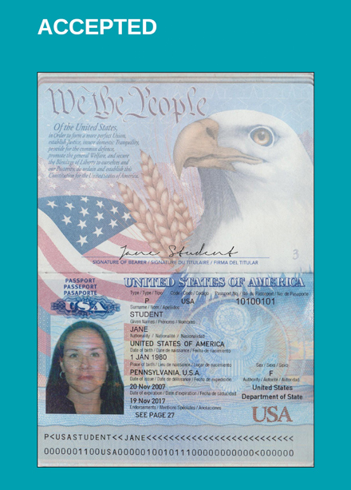

Make sure there is six months validity after the end date of travel. You **cannot** travel on an expired passport.

All numbers are clear, photo is clear (We would be able to ID Jane Student in real life)

Passport is signed!