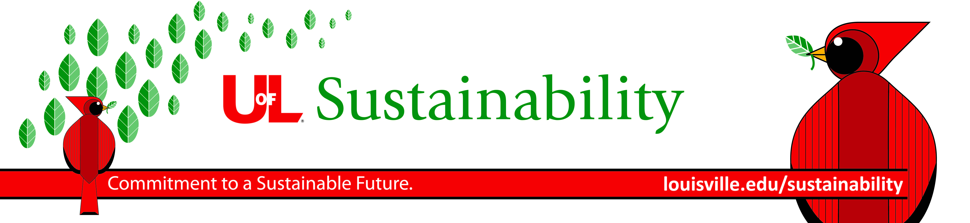

Green Threads and Green Tapestries 2024 Workshop

Sewing Threads of Sustainability across the Curriculum,
Weaving Collaborations throughout Campus

The 2024 Workshop will be held during either the week after Spring Classes May 6-10,
OR the week before Fall Classes August 12-16, depending on participant availability.

Green Threads is a teaching enrichment program designed to broaden instructors’ understanding of sustainability, introduce “threads” of sustainability education into existing courses, and support the development of new sustainability courses at UofL. Green Threads participants receive individualized support and feedback, information about local and regional sustainability issues and opportunities, resource materials, a campus sustainability tour, and access to over 100 Green Threads alumni. Any UofL faculty or graduate-student instructor is eligible to participate. Previous participants have evaluated this workshop as intellectually stimulating, exciting, and providing a valuable new network of faculty interested in sustainability from across the disciplines!

Green Tapestries is a program that links Green Threads alumni, new participants, and their courses through collaborative teaching. Participants identify a collaborator and a collaborative teaching project (e.g., course module or team-taught course), which they plan to develop with at least one other Green Threads alumni or new participant. Green Tapestries participants receive individualized attention and resources for their collaborative project.

$500 Honorarium: Upon successful completion of the program, participants receive a $500 honorarium, which can be used towards course development or other expenses.

Workshop: Participants in either program participate in an all-day workshop led by organizers from the UofL Sustainability Council, along with a panel of invited experts and other collaborators throughout UofL. The process of bringing faculty from all disciplines together to discuss sustainability across the curriculum was pioneered at Northern Arizona University (The Ponderosa Project) and Emory University (The Piedmont Project), and was adopted by UofL in 2009. The program has graduated over 90 faculty and instructors!

Applications: Please submit your application (see form on page 2), with your department Chair’s approval, to Brent Fryrear <bfryrear@louisville.edu> by March 22, 2024.
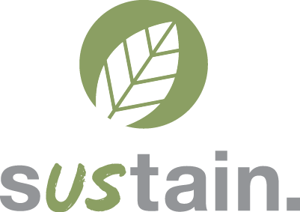
We look forward to hearing from you!

Best,
Brent Fryrear, Director, Partnership for a Green City & Chair, UofL Sustainability Council
Justin Mog, Assistant to the Provost on Sustainability Initiatives

Green Threads: Sustainability across the Curriculum
2024 Workshop Application

Please complete and send to Brent Fryrear <bfryrear@louisville.edu> by March 22, 2024.

Part 1: Applicant Information

Name: Phone:
Department: Email address:
Position: UofL ID #:

Part 2: Applicant Availability for the full day, in-person workshop (typically 8:30am-4pm on Belknap Campus)

__ I am available May 6-10, 2024
List any known limitations to your availability May 6-10: _____________________________________________________
__ I am available August 12-16, 2024
List any known limitations to your availability Aug. 12-16: ____________________________________________________

Part 3: Please indicate which program you are applying to:

__ Green Threads (new applicants). You agree to:
- Submit a syllabus for the revised/new course and a paragraph describing your proposed course development.
- Read a brief packet of educational materials on sustainability education prior to the workshop.
- Participate in the day-long workshop, from 8:30am – 4pm.
- Attend the Green Threads Reunion at the end of the year (typically early December) to report back to the group on progress with a presentation.

__ Green Tapestries (Green Threads Alumni, or sponsored applicant). You agree to:
- Identify at least one collaborator (alumni or new participant). You will submit the application jointly. Describe your roles and contributions to the joint project (in the brief proposal).
- Submit a 1-page proposal describing the joint teaching activity (e.g., course module, team teaching course) that you wish to develop with your collaborator, and timeline.
- Read a brief packet of educational materials, relevant to collaborative teaching in sustainability.
- Participate in the day-long workshop, from 8:30am – 4pm, with your collaborator and Green Threads participants.
- Attend the Green Threads Reunion at the end of the year (typically early December) to report back to the group on progress with a presentation.

Part 4: Course and Instructor Descriptions (approximately 1 page).

A. In your application/proposal describe your anticipated plans to change an existing course, develop a new course (Threads), or develop a joint teaching project with a collaborator (Tapestries). Include information about the course(s): course number, title, description, frequency of offering, typical enrollment, and student audience (e.g., required for majors, fulfills GEN ED requirement, elective). If you are creating a new course, please also describe how it would fit into the curriculum (your department’s, your college/school’s, the university’s). Include your existing or draft syllabus with your application.

B. Briefly describe any additional information regarding your application (e.g., previous experience with courses which included service learning, community engagement; special academic background).

Part 5: Applicant and Chair Signatures.

Please sign below and have your chair sign as well. To receive the $500 honorarium, workshop participants agree to offer the modified or new course(s) during or before academic year 2025-2026.

Applicant Signature: ________________________ Dept. Chair Signature: _________________________

