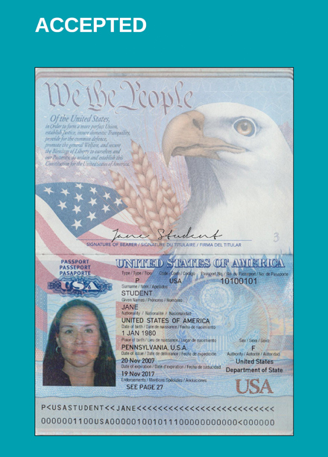

Passport is signed!

All numbers are clear, photo is clear (We would be able to ID Jane Student in real life)