How to Build and Utilize Social Media on Campus
Glenn Gittings, Ph.D.
UofL Parents Association
facebook.com/UoflParentsAssociation

- Set up a meeting with Jeff Rushton
- Jeff Provides a “social media in a box” set of hints and tips
- Jeff will give you a good review of basics for connecting with your potential audience and how to best leverage social media.

- Focus on One Social Media Channel
- Unless your office is a big brand, it’s unlikely your followers are scattered across multiple social media channels.
- Therefore, to make the most of your limited resources, find the one channel that is densely populated with your ideal followers and inhabit it like no other.
- Find where your audience is at and start there.
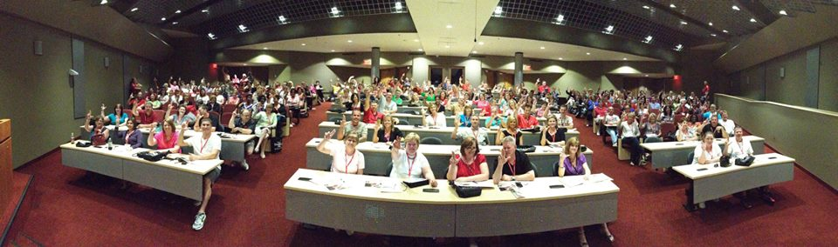

- Deliver Content Consistently
- One of the best ways to grow your following and increase engagement on social media is to be there consistently. The first step is to put the right systems in place to keep your posts relevant, interesting and valuable for your audience.
- Jeff always said, at minimum do 3-4 posts per week and be short with your content
- The 3 steps to doing social media engagement right are being proactive, always listening, and being engaging
- You can also schedule repeat posts indefinitely, so your content schedule never runs dry.
- Maximize Social Media Real Estate With Images
- “Every second, on average, around 6,000 tweets are tweeted on Twitter, which corresponds to over 350,000 tweets sent per minute, 500 million tweets per day and around 200 billion tweets per year.”
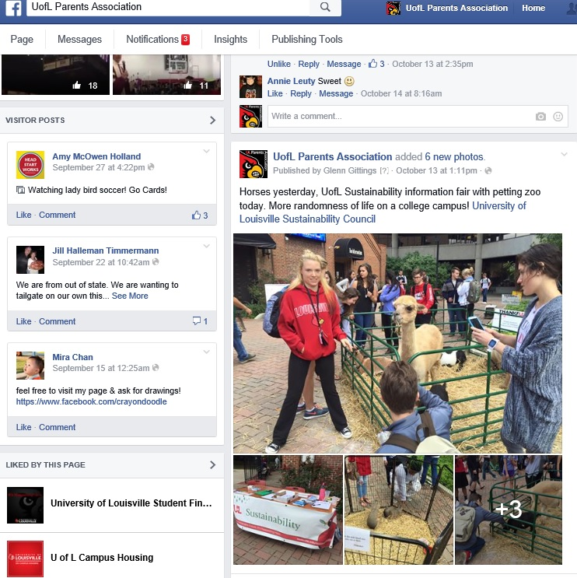
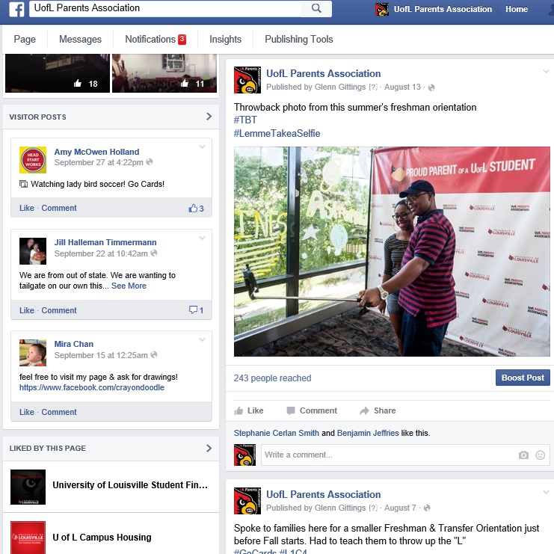
- Creating the best possible tweet has never been more important. Adding visual appeal to your tweet is a very smart way to get your most important content noticed.
- Optimize Visual Content with Links or Actionable Tasks
- Visual content can act as a “gateway” to more valuable content. When planning visual content to post on social platforms, think in terms of how it can drive traffic back to your website or attendance at your event.
  - Family Weekend
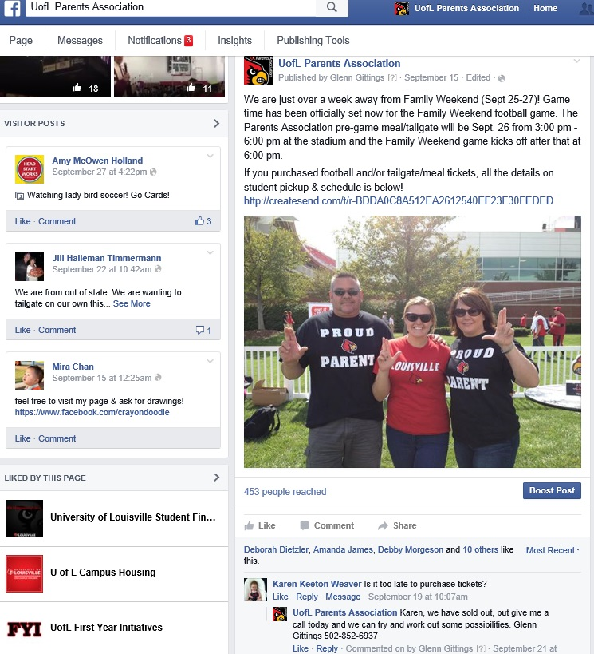
  - Newsletter
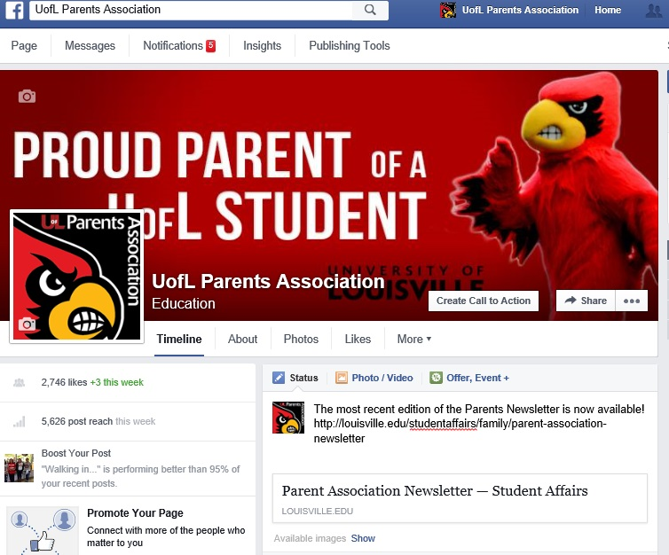
  - Proud Parent Shirt
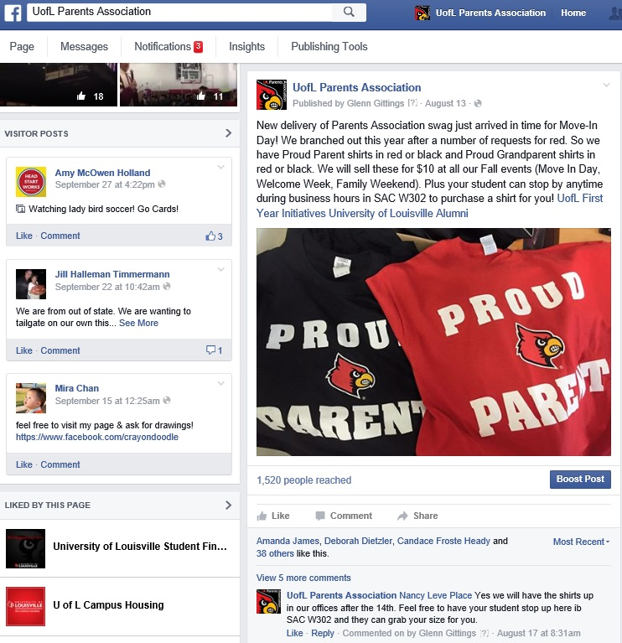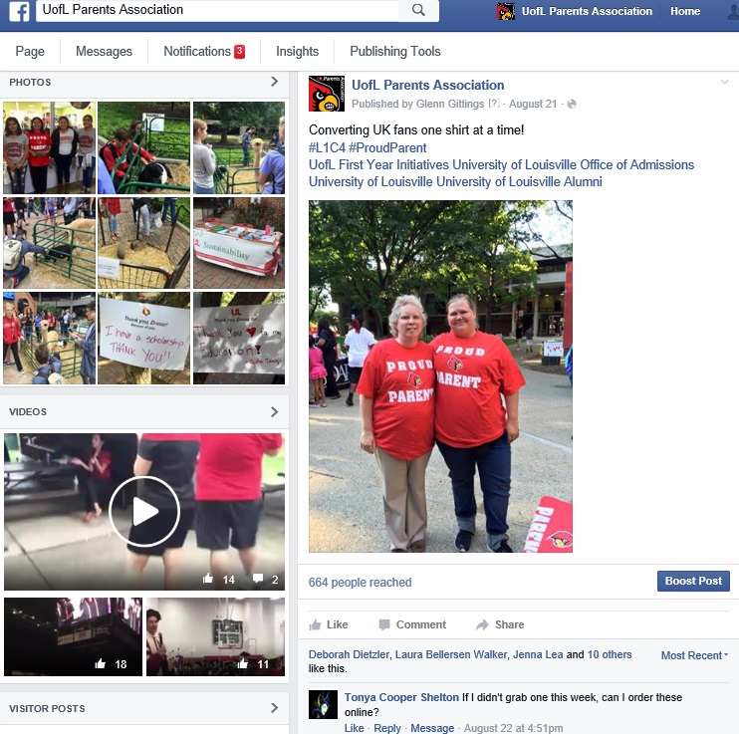
- Think in terms of creating gateways to more valuable content when you plan your visuals!

- Give Context to Pinnable Images
- We live in an age of information overload and short attention spans. When it comes to capturing your audience’s attention, take full advantage of every chance to communicate your message in a way that they’ll engage with!
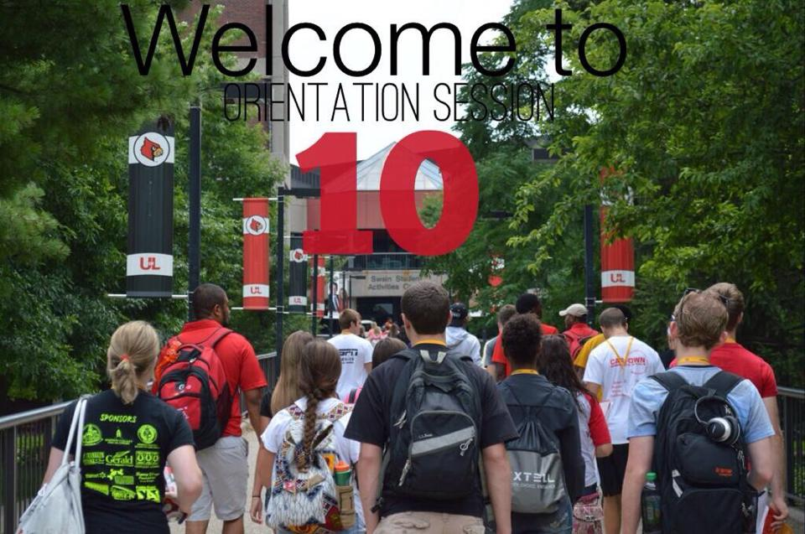

- Tag Other Campus Pages to Increase the Reach of Your Post
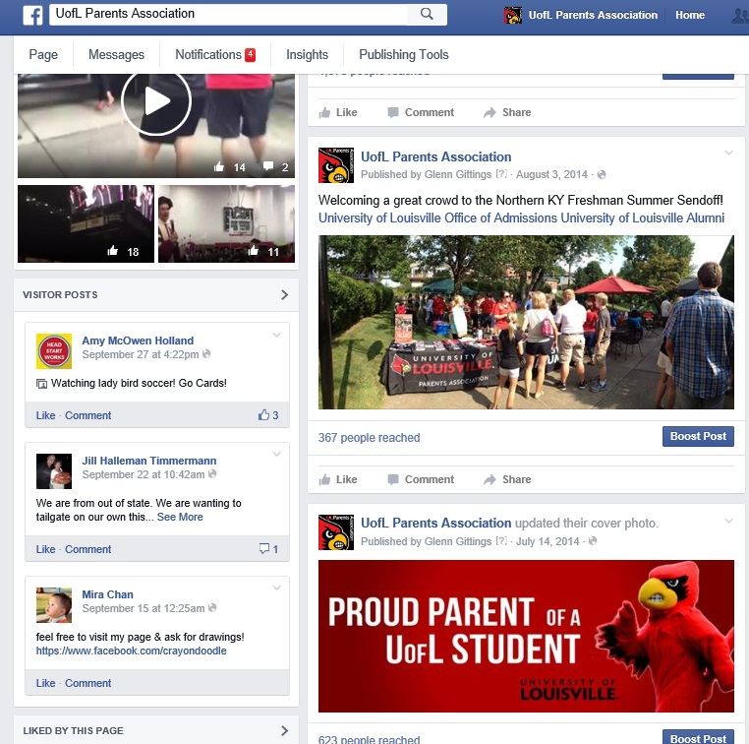

- Become a Resource on Facebook
- Build a page your customers would enjoy and then use that platform to delight them. Deliver posts that educate, entertain, inspire and inform to reach a wide Facebook audience.
- Analyze Past Content to Improve Posts
- Find what had the most impact or reach (images, type of content, time or day delivered, etc.)
- Automate Curated Content
- Creating or curating content can be relegated to the back burner. The problem is that an erratic publishing schedule can alienate your audience and break trust. Hootsuite or Tweetdeck could be a good resource for you.

References
- Simply put: Jeff Ruston is a key resource
- Some content was utilized from the following article:
  - 20 Social Media Marketing Tips From the Pros
By Cindy King
Published November 18, 2014
http://www.socialmediaexaminer.com/social-media-marketing-tips-pros/

