Your Name_________________________________ Mentor Name____________________________________ Date___________

Describe your plan for communicating regularly. Include frequency and method.

Mentoring SMART Goals (Specific, Measurable, Attainable, Realistic, Time-Bound)
1.
2.

3.

Goal#1_________________________________________________________________

- Resources available to you now:

- Resources you need to look for:

What action steps that you should take? | Timeline: By when? (Day/Month) | How can your mentor help you?
Step1:
Step2:
Step3:

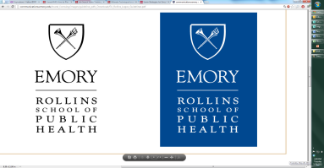

Office of Career Services
Rollins School of Public Health
Emory University

Goal#2_________________________________________________________________

- Resources available to you now:

- Resources you need to look for:

What action steps that you should take? | Timeline: By when? (Day/Month) | How can your mentor help you?
Step1:
Step2:
Step3:

Goal#3_________________________________________________________________

- Resources available to you now:

- Resources you need to look for:

What action steps that you should take? | Timeline: By when? (Day/Month) | How can your mentor help you?
Step1:
Step2:
Step3:

