**Your Name_________________________________ Mentor Name____________________________________ Date___________**

**Describe your plan for communicating regularly. Include frequency and method.**

**Mentoring SMART Goals** (Specific, Measurable, Attainable, Realistic, Time-Bound)

**1.**

**2.**

**3.**

**Goal#1_________________________________________________________________**

1. Resources available to you now:
2. Resources you need to look for:

|  |  |  |
| --- | --- | --- |
| **What action steps that you should take?** | **Timeline: By when? (Day/Month)** | **How can your mentor help you?** |
| **Step1:** |  |  |
| **Step2:** |  |  |
| **Step3:** |  |  |
|  |  |  |

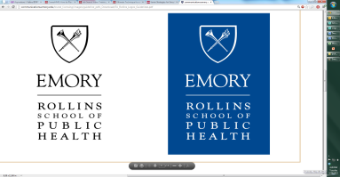

### 

Office of Career Services  
Rollins School of Public Health  
Emory University

**Goal#2_________________________________________________________________**

1. Resources available to you now:
2. Resources you need to look for:

|  |  |  |
| --- | --- | --- |
| **What action steps that you should take?** | **Timeline: By when? (Day/Month)** | **How can your mentor help you?** |
| **Step1:** |  |  |
| **Step2:** |  |  |
| **Step3:** |  |  |
|  |  |  |

**Goal#3_________________________________________________________________**

1. Resources available to you now:
2. Resources you need to look for:

|  |  |  |
| --- | --- | --- |
| **What action steps that you should take?** | **Timeline: By when? (Day/Month)** | **How can your mentor help you?** |
| **Step1:** |  |  |
| **Step2:** |  |  |
| **Step3:** |  |  |
|  |  |  |