Encryption Best Practices
Hibernation Instructions for Windows 8 Laptops

Background: Because laptops are capable of maintaining power after being unplugged it is important to note that the data on them is only fully protected by encryption when the machine is powered off or in hibernation mode. That is why it is also important to ensure that the power saving settings on laptops are modified to ensure that the data is hibernated when not in use for extended periods of time.
Once the Symantec PGP encryption client is installed on your laptop it is recommended that you modify the default power settings. This document contains instructions for setting your laptop up in hibernation mode. These changes will ensure that when it’s left unattended for long periods of time, and when the lid is closed, the data will be securely encrypted. This is particularly important to consider when traveling with a machine that contains sensitive data.

To change settings that affect all of your power plans (system settings)
In Power Options, some of the links in the left pane open System Settings. When you make changes on this page, changes are automatically made to all of your power plans. By changing system settings, you can do the following:
- Help secure your computer by requiring a password to unlock it when it wakes from sleep.
- Choose what your computer does when you press the power and sleep buttons on your keyboard or laptop frame or, with some laptops, when you close the lid. For example, when you press the power button, the computer can either do nothing or it can shut down. If the computer supports sleep and hibernate, pressing the power button can also put the computer into one of those power-saving states.
- Open Power Options by clicking the Start button , clicking Control Panel, clicking System and Security, and then clicking Power Options.
- In the left pane, click Require a password on wakeup, Choose what the power button does, or Choose what closing the lid does (available only on laptops).
- On the Define power buttons and turn on password protection page, choose the settings that you want to use when your computer is running on battery (if applicable), and when it's plugged in.
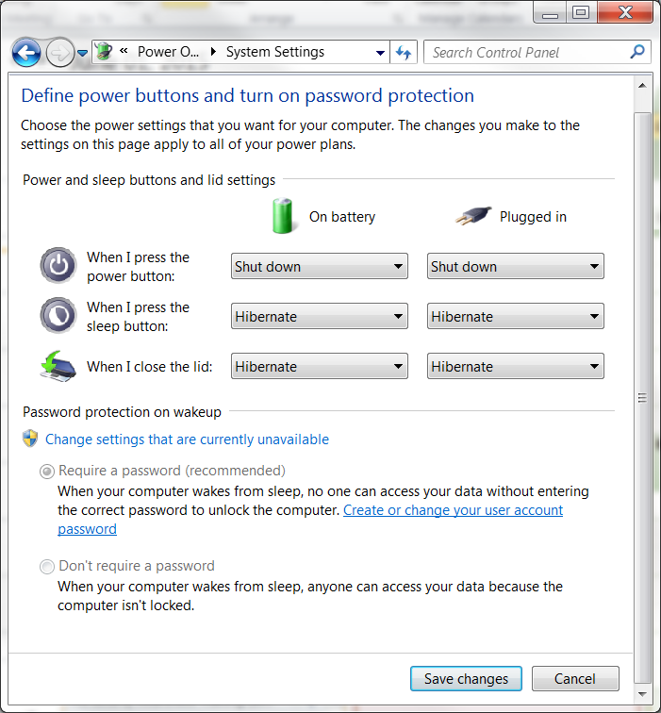
- Click Save changes.

Windows 8.1 & RT 8.1:
This option was designed for laptops and might not be available for all PCs (PCs with InstantGo don't have the hibernate option). Hibernate uses less power than sleep and when you start up the PC again, you’re back to where you left off (though not as fast as sleep). Use hibernation when you know that you won't use your laptop or tablet for an extended period and won't have an opportunity to charge the battery during that time. First check to see if this option is available on your PC and if it is, turn it on.
Hibernate your PC:
Open Power Options by swiping in from the right edge of the screen, tapping Search (or if you're using a mouse, pointing to the upper-right corner of the screen, moving the mouse pointer down, and then clicking Search), entering Power options in the search box, and tapping or clicking Power options.
Tap or click Choose what the power button does and under Shutdown settings, select Hibernate (if it's available).
Now you'll see hibernate in these two places:
- In the Power menu in the Settings charm.
- In the Shut-down menu.
To get here, move the mouse to the lower left-hand corner of the screen and right-click or press Start button, or on your keyboard, press the Windows logo key ()+X.

Closing the Lid:
- Open Power Options by clicking the Start button , clicking Control Panel, clicking System and Maintenance, and then clicking Power Options.
- On the Select a power plan page, click Choose what closing the lid does.
- On the Define power buttons and turn on password protection page, next to “When I close the lid”, choose hibernate, both for when it is running on battery and when it is plugged in.

Tip:
  - Hibernate mode will allow you to save battery power and quickly resume working. When you wake your mobile PC, Windows restores your work session within seconds.
- Click Save changes.
To hibernate due to inactivity:
In the event that you forgot to hibernate your drive after a long period you could set the machine so that it automatically goes into hibernate mode after a set number of minutes. This ensures that should the machine be stolen then at least the drive would hibernate automatically and it also serves as a back up to the screen lock function.
- Go to Control Panel \ All Control Panel Items \ Power Options \ Edit Plan Settings: then choose the “Change Advanced Power Settings”.
- Under the category for “Sleep” change the settings to match those seen in the example below, then click “Apply”.
