How to connect to UofL’s VPN so that you can access HIDRA

In order to increase the web security in relation to accessing HIDRA, we had to change some settings in the UofL’s firewall. This means that any office/users that are not directly using UofL’s network (or the ulsecure wireless access) will need to connect to the UofL’s VPN first before accessing HIDRA.

You first need to determine if you have VPN access already or not. If you’re unsure, you can check it by logging into ULINK. Under Information Technology section in the middle of the window, click on Computer Accounts, as shown below - 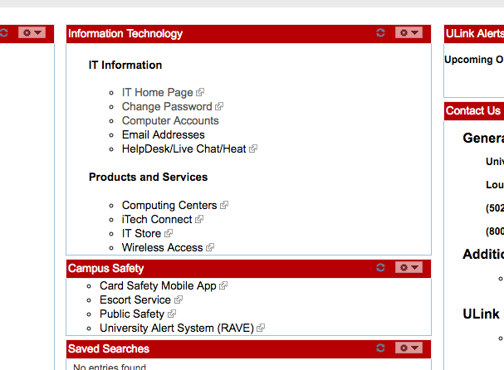

If you already have VPN access, you should see a line in the Current Accounts area that’s labeled VPN 1: or VPN 1: Campus. If not, then you should see this line in the ‘Requestable Accounts’ area. If the VPN 1 is in the requestable area, click on the “Open” checkbox on that line, and then click the “Save” button in the lower left. This will send off the request to UoL’s helpdesk, which you should have a response very soon.

If you already have VPN access, you’ll need to install a software called “GlobalProtect”. Open up a web browser to https://vpn.louisville.edu/ It will ask you to login, use the same Ulink credentials. You should now see three clickable links on the page. Click on the 2nd line, labeled 64 bit.
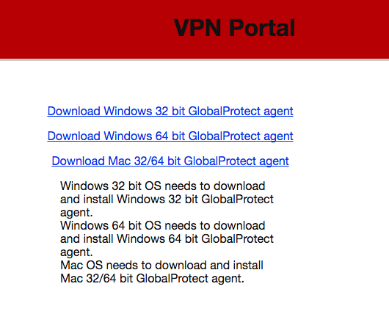
This should start downloading the software. Once the download is complete, run it and install on your computer, using the default options. If it asks you to allow this app to make changes to your device, select Yes.

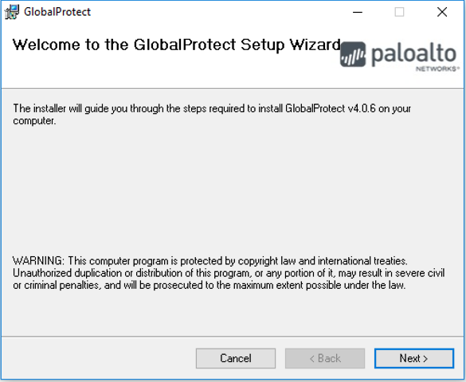

Once installed, run the GlobalProtect program. On the home tab, enter vpn.louisville.edu. in the portal line. If it asks for your username and password at that time, then enter your ULINK credentials. Otherwise it’ll ask for your credentials after you click on the Connect button. 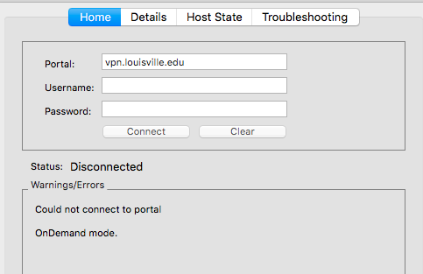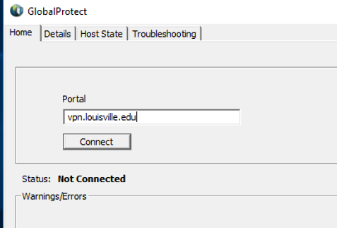

Once the status changes to ‘Connected’ you’ll then be able to connect to HIDRA in the normal way.

