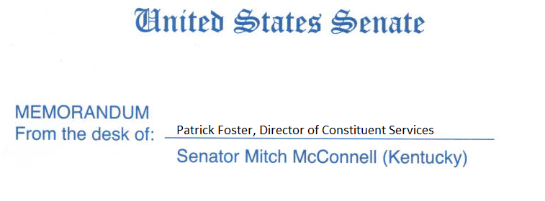
Senator McConnell has a paid internship opportunity available in his Louisville, KY office. Interns will be provided a hands on experience in a fast-paced office that will provide them with a working knowledge of how the federal government operates.
Duties include:
*Assisting office staff in drafting letters to constituents and federal agencies
*Organizing and maintaining constituent casework files
*Gathering and disseminating news clips from the Commonwealth of Kentucky
*Opening and distributing office mail
*Answering phones and recording constituent messages for the Senator
*Assisting Senator McConnell’s State Director, Director of Constituent Services, Office Manager, and Casework Staff with various assigned duties and projects
* Various clerical and office duties as assigned
Additional Information:
*Must be highly motivated and knowledgeable of current legislation and non-legislative issues
*Must be able to work a minimum of 15 hours per week
*Professional office attire
Please send your resume to the Director of Constituent Services, Mr. Patrick T. Foster, at Patrick_Foster@McConnell.Senate.gov. He can also be reached at (502) 582-6304 if you have additional questions about the internship.

