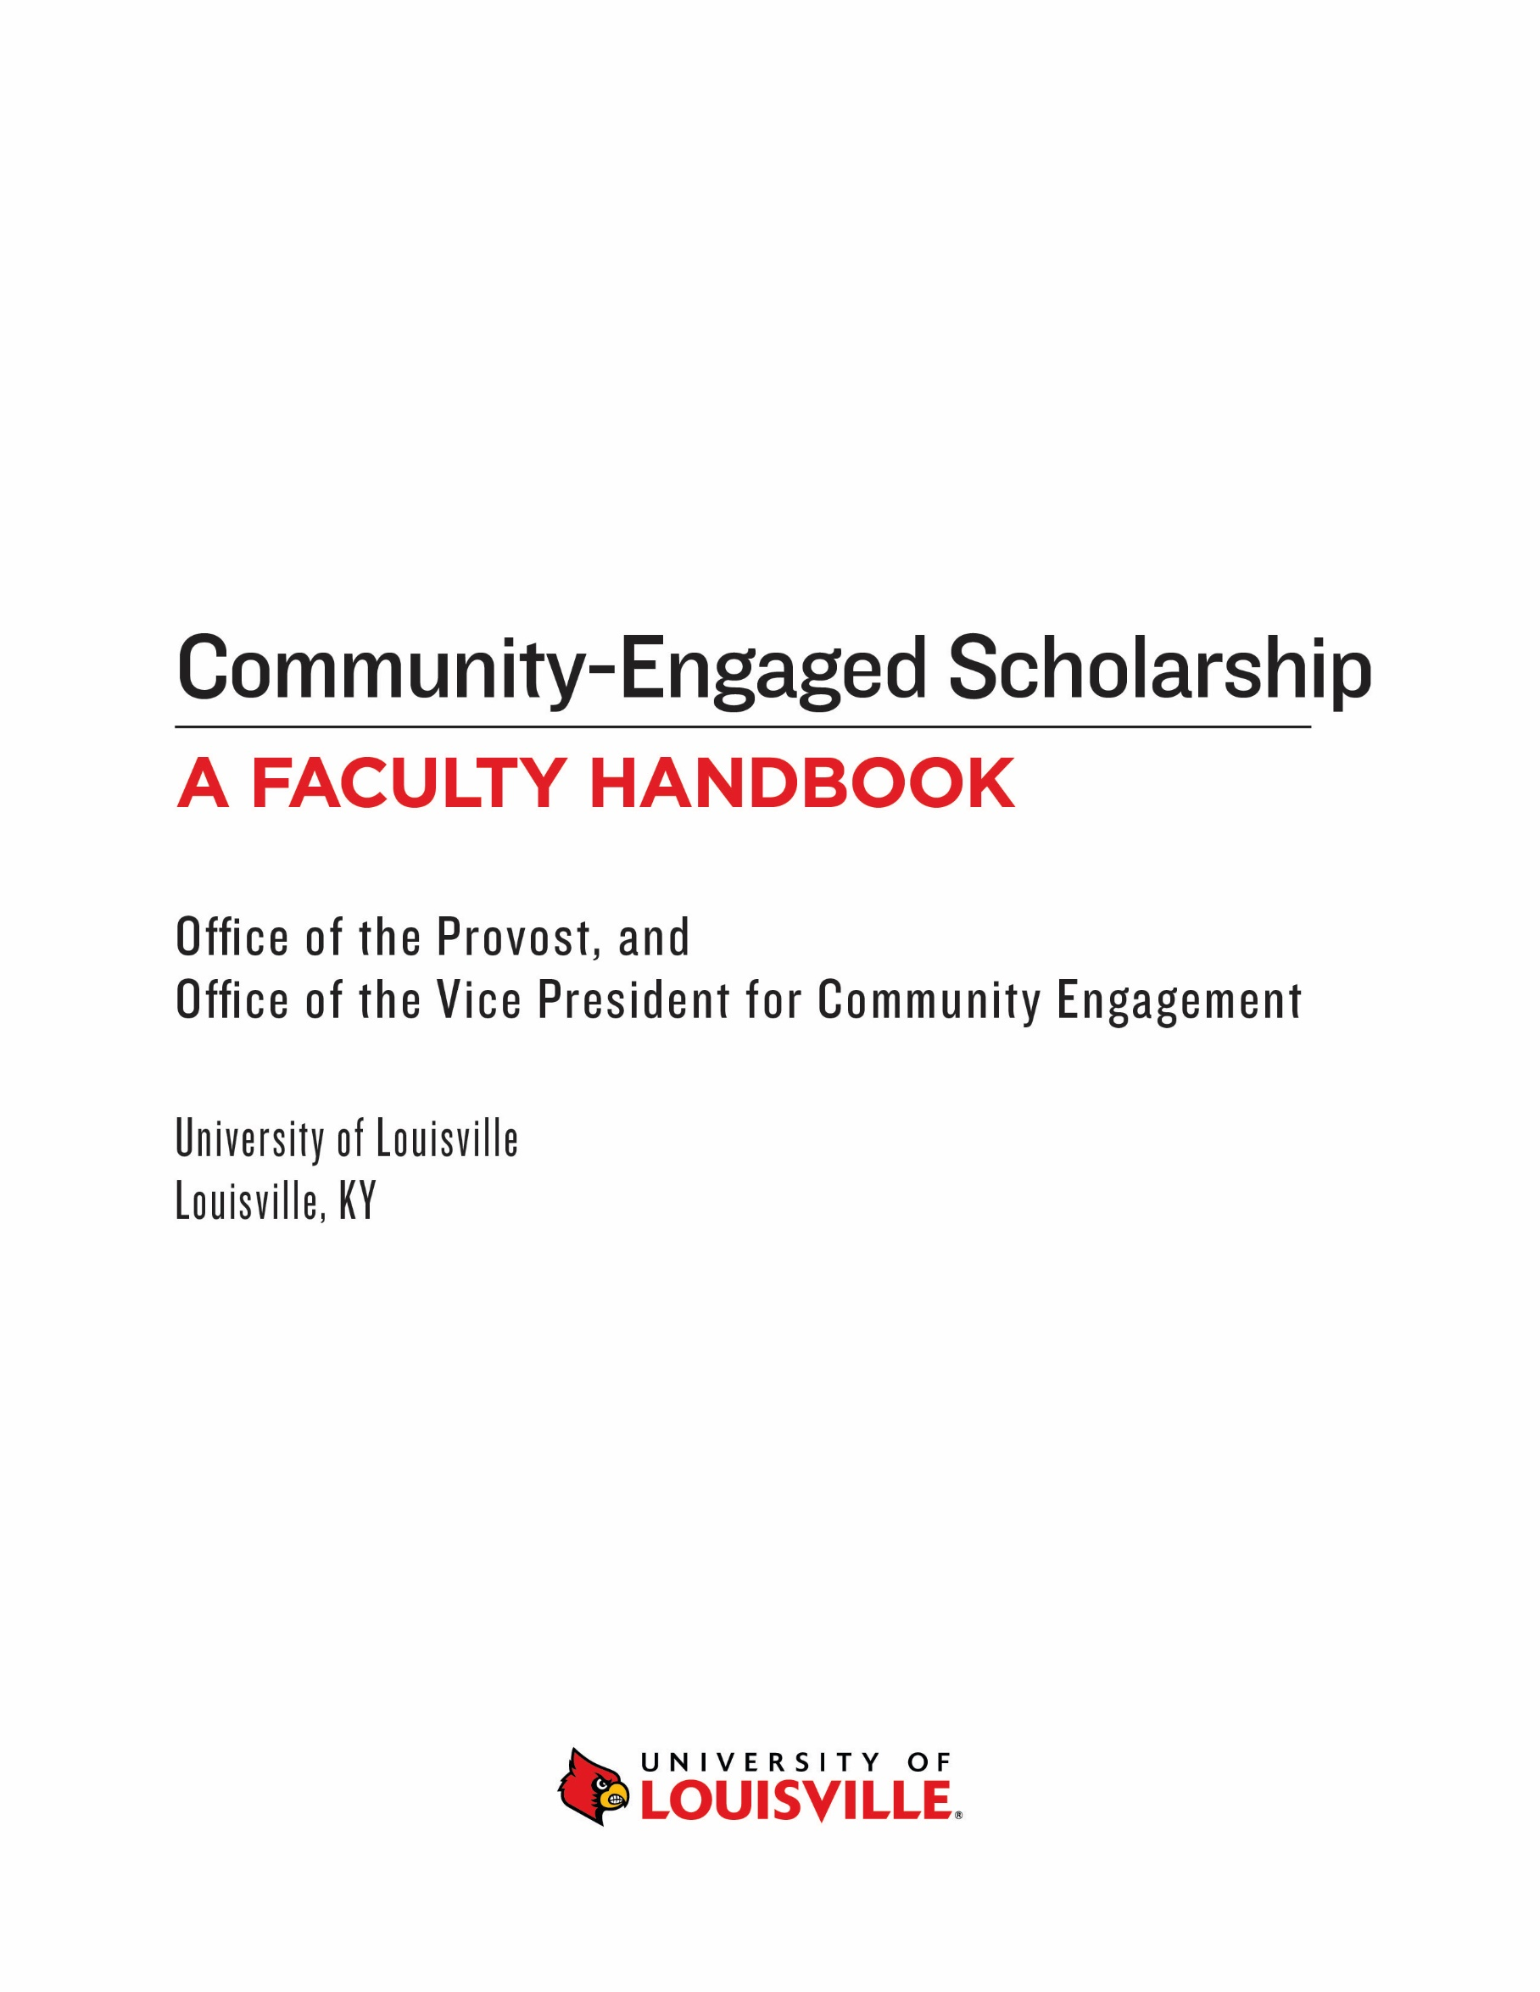

Contributors

Harrie Buecker Clinical Assistant Professor & Liaison for District and School
Partnerships, College of Education & Human Development

Fannie Cox Outreach and Reference Librarian, University Libraries

Henry R. Cunningham Director of Community Engagement, Office of Community Engagement
Adjunct Professor, College of Arts & Sciences

Tracy Eells Vice Provost for Faculty Affairs
Professor, School of Medicine

John Gibson, Director, Commonwealth Center for the Humanities and Society
Professor of Philosophy, College of Arts & Sciences

Vicki Hines-Martin Acting Assistant Dean, School of Nursing Office of Community Engagement and Diversity Inclusion
Professor, School of Nursing

Baron Kelly Professor of Theatre Arts, College of Arts & Sciences

Kaila Story Associate Professor of Women's, Gender, & Sexuality Studies
College of Arts & Sciences

Theresa Rajack-Talley Associate Dean for International, Diversity, and Community Engagement Programs
Professor of Pan-African Studies, College of Arts and Sciences

Enid Trucios-Haynes Professor, School of Law
Chair, Faculty Senate (2016-18)
Director, Muhammed Ali Institute for Peace & Justice

Reviewer
Muriel Harris Associate Professor, School of Public Health and Information Sciences

Endorsed By
The Faculty Liaisons to Community Engagement,
Representing all academic units

Table of Contents

From the Provost 4

Frequently Asked Questions 5

Introduction 6

Section 1: Glossary of Terms 7
Community-Engaged Scholarship
Community-Engaged Teaching
Community-Based Learning
Community-Engaged Service
Community-Engaged Research

Section 2: Traditional Versus Community-Engaged Scholarship 10

Section 3: Community-Engaged Scholarship & P & T Decisions 14
What Kind of Activities May be Documented
Evidence to Consider in Developing CE Portfolio/Dossier

Section 4: Proper Documentation of Community-Engaged Activities 17

Section 5: Reviewing and Evaluating Community-Engaged Work 20
Criteria for Considering Activity Scholarly
Peer Review
Policy Papers and Their Influence of Public Policy

Section 6: Impact of Community-Engaged Research & Scholarship 26

Resources 28

From the Provost

As Kentucky's metropolitan research university, the University of Louisville has a commitment to collaborate with diverse communities locally, statewide, nationally and internationally to address pressing community needs and issues. This commitment is evident in the University’s mission statement to “serve its community through: ……providing engaged service and outreach that improve the quality of life for local and global communities,” and it is manifested through mutually beneficial community-engaged research, teaching, and service.
This Faculty Handbook on Engaged Scholarship attempts to help faculty understand community engagement and engaged scholarship. It is a resource for faculty who are already engaged in this work and for those interested in using community engagement as a method for teaching and conducting research. The suggestions and recommendations offered in this handbook, while helpful, do not replace the criteria for faculty review and documentation in unit and departmental personnel documents. Colleges and schools and many academic departments have different perspectives on what constitutes engaged scholarship so faculty should read their department and unit policies and consult with their Chairs and Deans before embarking on community engaged work. Unit policies and procedures should be consulted and adhered to at all times.
Faculty across the University should find the Faculty Handbook on Engaged Scholarship a valuable and educational resource. It should be helpful to faculty in documenting and reviewing community-engaged work as we fulfil our commitment to collaborate with our community in mutually beneficial ways.

Beth A. Boehn, Ph.D.
Executive Vice President and University Provost

Frequently Asked Questions
- Does the Handbook on Engaged Scholarship replace the Redbook and unit criteria for scholarship and creative activity?

No, the Redbook is the governing document for promotion and tenure and units and departments are responsible for any changes to their personnel policies. The Faculty Handbook on Engaged Scholarship is designed to provide suggestions and recommendations to document and review products derived from community-engaged scholarship. It does not replace the Redbook or Unit policy. Faculty should consult with their units to determine what is required for promotion and tenure.
- Is this handbook the final product?
The Faculty Handbook on Engaged Scholarship is a living document and will be updated as necessary.
- What is the purpose of the Faculty Handbook on Engaged Scholarship?
The purpose of the Faculty Handbook on Engaged Scholarship is to inform/educate faculty about community engagement and engaged scholarship, provide suggestions to faculty on how to document scholarly products derived from their community-engaged work, and to assist reviewers with suggestions on reviewing and evaluating this work.
- How will individual faculty and others learn about the contents of the handbook and how to use it?
There will be scheduled professional development sessions and the Faculty Handbook on Engaged Scholarship will be posted on the Office of Community Engagement website. Individual consultations may be scheduled with the Office of Community Engagement.
- Is engaged-scholarship less rigorous than traditional scholarship?
Many accomplished community-engaged scholars assert that their work is as rigorous and impactful as traditional scholarship. For example, engaged-scholarship may be grounded in theory, be methodologically rigorous, and undergoes peer-review. However, the products of community-engaged work, measures of impact and the type of peer review may differ from that of traditional scholarship. Faculty should consult with their Chairs and Deans. The Redbook, approved unit documents, and any departments documents approved as provided in article 4.6 of the Redbook shall establish procedures and the only criteria for appointments, tenure, promotion, career reviews and annual reviews.
- Does this handbook apply to all faculty?
The Faculty Handbook on Engaged Scholarship applies to faculty who are engaging with the community for teaching and research purposes and generating scholarly products from this work.
Introduction

Community engagement as a method for teaching and conducting research is somewhat new in academia, particularly in the non-professional schools. Disciplines such as education, dentistry, medicine, nursing, and social work have long engaged with the community in teaching their students and conducting research to understand the underlying issues that impact those they serve. Boyer’s (1996) call to action led many institutions of higher learning to enhance town-gown relationships and led faculty from other disciplines to become involved in community engagement.
Community engagement is more than just service. It is a method for teaching and conducting research while providing a service to the community. The nature of community-engaged scholarship requires faculty to collaborate with community partners in jointly addressing issues. These collaborations may lead to scholarly products, such as policy papers, brochures, websites, reports, exhibits, performances, and training, to be used by community partners. These products are different from journal articles, books, and book chapters that traditionally are accepted by academia, despite having resulted from research. However, it may be possible to use the same data from engaged research to produce refereed publications.
The purpose of this handbook is to educate faculty on community engagement and community-engaged scholarship. The faculty handbook is not a complete guide to community-engaged teaching, academics, research, and services sectors of the university, including those related to engaged-scholarship and teaching. Rather, it is intended as a reference guide for orientation purposes. This is not intended to create nor does it constitute an expressed or implied contract between the University of Louisville and any of its employees. It does not replace criteria for tenure, promotion, annual review, or post tenure review as outlined in the Redbook or approved unit or Departmental personnel documents.

Section 1
Glossary of Terms Related to Community Engagement and Engaged Scholarship

- Community-Engaged Scholarship (sometimes referred to as the Scholarship of Engagement) is a form of scholarship that directly benefits the community and is consistent with university and unit missions. It is scholarship that derives from teaching, research, creative activity and service to generate, transmit, and apply knowledge in mutually beneficial ways.

- Community-Engaged Teaching is embedded with a focus of inquiry typically grounded by the instructor’s expertise. Theoretical knowledge is at the core of the curriculum. It is important that community-engaged teaching and learning is at the heart of an engaged university, and the following criteria outline how these efforts can be most effective:

- An intentional integration of project and academic content is linked to a high level of synergy with community engagement and learning experiences. There should be close alignment of the goals for learning as well as community engagement. The focus of the content should inform students about various dimensions of their community project. This community engagement should allow opportunities to learn course content at deeper levels. Such learning is known as “high impact practices,” which significantly enhances students’ learning experiences.

- Learning is significantly enhanced through reflection upon the overall community–engaged experience. Writing is an effective way to address reflection, and this may include directed writings or personal journals (e.g. double-entry, key-phrase, and dialogue). Research papers, case studies, and online discussions are other tools for reflection activities.

- These activities should align with the principles of community engagement established by the Carnegie Foundation (www.carnegiefoundation.org) and include collaborative opportunities for students, faculty, and members of the community. Feedback for the activities may be made through formative or summative evaluations.

- Community-Based Learning (CBL) or “service learning” refers to a pedagogy that explicitly engages students in studying and reflecting on community issues in order to increase students' understanding and application of academic content. CBL courses should include learning outcomes concerning application of the concepts and skills of an academic discipline to issues in the community. CBL courses may integrate a broad range of teaching and learning strategies and structures.

- Community-Engaged Service refers to any activity that promotes opportunities for the university to connect with external communities, agencies, businesses, and schools. It is the use of one’s expertise to address a specific, community-identified issue. While it is not a requirement that such service be connected to teaching and research, it is beneficial to the individual to connect the service to their teaching and/or research. Examples of community-engaged service include:

- Providing technical assistance
- Expert testimony
- Legal advice
- Policy analysis
- Training/Consulting
- Disciplinary-related advisory boards and other service to community organizations
- Diagnostic and clinical services (psychology, education, social work, health care, others)
- Patient care (dentistry, medicine, nursing)
- Community-Engaged Research or Engaged Scholarship generally refers to scholarly work that typically requires a high level of proficiency in a related discipline. The results often have a significant public impact in some way. At the heart of the work is collaboration among faculty, students, and community partners to address community concerns and build academic scholarship. These partnerships may lead to publications, partnerships, programs, and other new opportunities.
- Community-Based Research
The focus of community-based research is to identify and study a problem or issue within a community. Researchers design and implement the study with input from the community members and data related to the issue. The findings should be beneficial to the community through identification of underlying issues or causation, followed by suggested interventions for positively impacting the identified focus of the study.

- Community-Based Participatory Research
Community-Based Participatory Research (CBPR) involves conducting a study collaboratively with community partners rather than on them. In other words, CBPR is academically-relevant, community-focused research that partners with the community equitably to conduct research. The partners contribute their expertise and share responsibility and ownership of the results to enhance understanding and to integrate knowledge gained into action for change to solve concrete problems, making a positive difference in people’s lives and directly impacting social problems.
There is typically a common interest or problem at the heart of the research, so that the data would be mutually beneficial to community and university partners. The process of conducting the research involves an inclusive dialogue related to questions, data collection, hypotheses, the design, and the research process itself. The aim is empowerment of the community in facilitating the identified social change.

References & Further Reading
Campus Compact. (2015). Research University Engaged Scholarship Toolkit. Retrieved from https://compact.org/initiatives/trucen/research-university-engaged-scholarship-toolkit/.

Community-Campus Partnership for Health (2007). Community-Engaged Scholarship Toolkit.
Retrieved from https://www.ccphealth.org/wp-content/uploads/2017/10/HE_toolkit.pdf

Colbeck, C. L., & Michael, P. W. (2006). The public scholarship: Reintegrating Boyer’s four
domains. New Direction for Institutional Research, 129, 7-19.

Daly, K. (2011). Template for the development of assessment criteria for community engaged
scholarship. Retrieved from https://depts.washington.edu/ccph/pdf_files/UGuelph-Template.pdf.

Doberneck, D.M., Glass, C.R., & Schweitzer, J. H. (2010). From rhetoric to reality: A typology
of publicly engaged scholarship. Journal of Higher Education, Outreach and Engagement, 14(5), 5-35.

Janke, E. M., & Clayton, H. P. (2012). Excellence in community engaged scholarship:
Advancing the discourse at UNOG, University of North Carolina Greensboro TRUCEN (The Research University Civic Engagement Network) report. New Times Demand New Scholarship II, 6-12.

The URBAN Scholar-Activist Network. (2015). Updated guidelines for peer-reviewing community based research. Retrieved from. http://urbanresearchnetwork.org/updated-guidelines-for-peer-reviewing-community-based-research.

Center for Experiential Learning. (n.d.). The Scholarship of Engagement. Retrieved from
https://www.luc.edu/experiential/engaged_scholars.shtml.

University of Louisville Community Engagement Steering Committee. (2011). Community
Engagement Glossary of Terms [PDF file]. Retrieved from
https://louisville.edu/communityengagement/CommunityEngagementGlossary2.7.11.pdf.

Section 2
Comparison of traditional scholarship with community-engaged scholarship

When the institutional mission relies on continued connections between the local and regional community, the institution must be willing to acknowledge new discourses that do not adhere to traditional models. Redefining teaching, research/creative activity, and service is necessary, particularly as it pertains to community engagement as scholarship in tenure and promotion cases. This section compares traditional and community-engaged scholarship. The term community-engaged scholarship (sometimes also referred to as the scholarship of engagement), refers to teaching, research/creative activities, and service undertaken by faculty members in collaboration with community members (and often students). It embodies the characteristics of both community engagement (e.g. reciprocal partnerships, public purposes) and scholarship (e.g. demonstrating current knowledge of the field/discipline, inviting peer collaboration and review, being open to critique, presenting in a form that others can build on, involving inquiry).
Both traditional and community-engaged scholars are active producers of knowledge whose research is guided by standards of academic and methodological rigor. Community-engaged scholarship is aligned with traditional scholarship with respect to its guiding commitment to the discovery, dissemination, and preservation of knowledge. If engaged scholarship incorporates teaching and service, it cannot be collapsed into either category; engaged scholarship is distinguished from purely instructional and service activities by virtue of its essential commitment to generating knowledge in and for the community it serves. While the boundaries between traditional and engaged-scholarship are porous, different goals and standards of success often animate each:
- Community-engaged scholarship regards the products of its research as public goods that are intended to contribute directly and concretely to the intellectual health of the community in which the research is conducted. While engaged scholars may share the results of their projects in standard academic venues (conferences, scholarly publications, etc.), the goal is typically to produce research that responds foremost to the needs of a specified (non-academic) community and that is intended to be shared publicly in that community.
- Community-engaged scholars do not regard community members primarily as potential subjects of, or audiences for, their research (for instance, as sample populations for statistical studies or target groups for public lectures); they frame community members as partners in the production of knowledge and participants in the process of discovery. Community partners play a role in articulating the problems to be solved, executing research, sharing findings, and assessing impact. This enfranchisement of community members in the basic elements of research activity is one of the defining features of community-engaged scholarship and what distinguishes it most clearly from traditional scholarship: it effectively regards community members as both beneficiaries of and stakeholders in the production of knowledge. Accordingly, community partners assume some of the responsibility typically assigned peer reviewers in traditional scholarship: they play a role in assessing the success and significance of community-engaged scholarship.
- Community-engaged scholarship is fundamentally transdisciplinary, collaborative, and translational. It draws on diverse disciplinary methods and theories, conducts its research cooperatively, and strives to close the gap between theory and practice by exploring how academic findings can result in material solutions to community-specified problems. While traditional forms of scholarship may share in some of these goals (for instance, the medical sciences), community-engaged scholarship is distinguished by its additional commitment to (1) and (2) above.

How does engaged scholarship meet the rigor of traditional scholarship?
Traditional and community-engaged scholarship draw upon the same foundation of theoretical knowledge and research methodology that earns academics their claim to scholarly expertise. The work of each is informed by and, in turn, demonstrates this expertise. Moreover, the work of each can be documented, shared, and assessed by other scholars, though the submitted materials, standards of evaluation, and guiding notions of rigor must be appropriate to the nature and goals of each kind of scholarship. In general, community-engaged scholarship demonstrates academic expertise and rigor through its translational success—that is, by effectively utilizing the scholarly methodologies, technologies, and resources appropriate for a given project. To this extent, the translational demands of engaged scholarship introduce a distinctive notion of scholarly rigor, one that foregrounds expertise in determining the academic resources to be marshalled in the service of solving a community-based problem and the competencies demonstrated therein..

The table below, adapted from Furco (2005), compares traditional academic scholarship with engaged scholarship.
Traditional Scholarship | Engaged Scholarship
Breaks new ground in the discipline | Breaks new ground in the discipline and has direct application to broader public issues
Answers significant questions in the discipline | Answers significant questions in the discipline, which must be relevant to public or community issues
Is based on a solid theoretical basis | Based on solid theoretical and practical basis
Applies appropriate investigative methods | Applies appropriate investigative methods
Disseminated to appropriate audiences (academia) | Disseminated to appropriate audiences (academic and other)
Makes significant advances in knowledge and understanding of the discipline and may address public issues | Makes significant advances in knowledge and understanding of discipline and public issues
Is reviewed and validated by qualified peers in the discipline | Is reviewed by and validated by qualified peers in the discipline and informed members of the community
The following table compares traditional research with community-engaged research and community-based participatory research (CBPR).
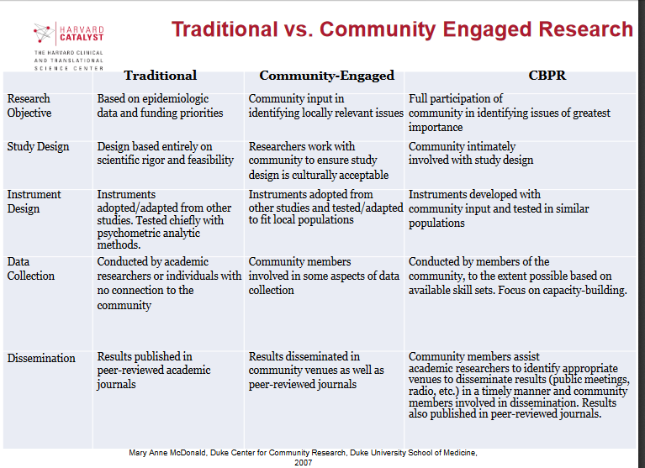

References & Further Reading

Boyer, Ernest L. (1997). Scholarship Reconsidered: Priorities of the Professoriate. San
Francisco: Jossey-Bass.

Bowen, S. J., & Graham, I. D. (2012). From knowledge translation to engaged scholarship:
Promoting research relevance and utilization. Archives of Physical Medicine and Rehabilitation, 94(1), S3-S8.

Campus Compact. (2015). Research University Engaged Scholarship Toolkit. Retrieved from
https://compact.org/initiatives/trucen/research-university-engaged-scholarship-toolkit/.

Diamond, R. M. (2002, Summer). Defining scholarship for the twenty-first century. New
Directions for Teaching and Learning, 90,73-79. New York: Wiley Periodicals.

Driscoll, A., & Sandmann, L. (2001). From maverick to mainstream: The scholarship of engagement.
Journal of Higher Education Outreach and Engagement, 20(1), 83-94.

Furco, A. (2005). A comparison of traditional scholarship and the scholarship of engagement. In
Anderson, J., & Douglass, J.A. et al, Promoting civic engagement at the University of California: Recommendations from the strategy group on civic and academic engagement (1-16). Berkeley, CA: Center for Studies in Higher Education

Glassick, C., Huber, M., & Maeroff, G. (1997). Scholarship Assessed: Evaluation of the
Professoriate. San Francisco: Jossey-Bass.

Hyman, D., Gurgevich, E., Alter, T., Ayers, J., Cash, E., Fahnline, D., . . . Wright, H. (2001-2).
Beyond Boyer: The UniSCOPE model of scholarship for the 21st Century. Journal of
Higher Education Outreach and Engagement, 7(1&2), 41-65.

Hacker, K., & Taylor, J. G. (2011). OHRP Research community forum protecting human
subjects in research: Blending regulatory requirements and best practices Community-Engaged Research (CEnR) and the Institutional Review Board: Principles, challenges, and opportunities. Presentation, Boston, MA.

McDonald, M.A. (2007). Traditional vs Community Engaged Research. Duke Center for
Community Research, Duke University School of Medicine.

Working Group on Evaluating Public History Scholarship. (2010). Working group issues: Tenure, promotion, and the publicly engaged academic historian report. American Historical Association. Retrieved from https://www.historians.org/publications-and-directories/perspectives-on-history/september-2010/working-group-issues-tenure-promotion-and-the-publicly-engaged-academic-historian-report.

Section 3
Documenting Community-Engaged Scholarship

When engaged scholars prepare a portfolio/dossier for review, they will need prior assurance that it will count and will need to include all of the necessary evidence that can be evaluated and measured by extramural reviewers, the scholar’s home department(s), and the university’s review committee, dean, and provost. Engaged scholars need to show a mutually-beneficial partnership between the community and the University. It is important to present a strong case on how each work product is scholarly in nature and meets such guidelines. To ensure that it will be recognized, faculty members should seek approval prior to beginning community-engaged work and including the work in their review portfolio. Junior faculty in particular, should not rely on one type of scholarly work to support a successful review, especially since community-engaged scholarship can take longer to cultivate partnerships and presents other challenges.

This section provides information about what kinds of activities and documentation could be appropriate in academic units that support community-engaged scholarship. More information on promotions and tenure guidelines of the University can be found in the Redbook and the unit and department promotion and tenure documents (approved by the Board of Trustees).

What kind of activities may be documented?
Community-engaged scholarship can provide documentation from the following areas: Teaching, Research/Creative Activity, and Service.

Community-Engaged Teaching includes, but is not limited to, the following:
- Developing and delivering instruction to communities and other constituencies through a community partnership between a community organization, institution and/or program.
- Developing and delivering off-campus teaching activities such as study-abroad courses and experiences or immersions, international instruction and distance education courses.
- Developing and delivering community-based instruction, such as community-based learning (or service learning) experiences, on-site courses, clinical experiences, professional internships, and collaborative programs.
- Developing and delivering noncredit classes and programs to members of the community
- Developing scholarly resources for the general public, such as bulletins, pamphlets, textbooks, software (apps), podcasts, and web pages.

Community-Engaged Research/Creative Activity includes, but is not limited to, the following:
- Publishing papers in referred journals or presenting at academic conferences.
- Writing policy or position papers, reports, and other documents for policymakers, which demonstrate faculty expertise and further community needs.
- Disseminating research through various public programs, forums, and events.
- Creating exhibits in educational and/or cultural institutions.
- Developing innovative solutions that address social, economic, or environmental challenges (e.g. inventions, patents, products, services, clinical procedures and practices).
- Conducting and reporting program evaluation research or public policy analyses for other institutions and agencies.
- Conducting and disseminating directed or contracted research.
- Developing apps, podcasts, websites, brochures, exhibits, or performances for community members.

Community-Engaged Service includes, but is not limited to, the following:
- Writing position papers and/or op-eds for the general public, resulting from the community partnership.
- Consulting and providing technical assistance, expert testimony, and/or services to public and private organizations, based on the scholar’s area of expertise.
- Collaborating with schools, businesses, advocacy groups, community groups, and civic agencies to develop policies that will effect change within the larger community.
- Providing leadership in or making significant contributions to economic and community development activities.
- Patient, clinical, and diagnostic services offered by faculty members and graduate/professional students.

Evidence to Consider in Developing a Community Engagement Portfolio/Dossier
The table below provides examples of how one might document for outcomes in teaching, research/creative activity, and service for the purposes for inclusion in a portfolio/dossier for promotion and review.

Teaching Documentation | Research & Creative Activity Documentation | Service Documentation
In an Arts course, evidence of partnership with a community organization for a community-based learning course or project; evidence of how students become familiar with new ways of framing social problems. | Illustrations of exhibits, performances, public forums, and original work created for the community; creation of original work including interdisciplinary research. | Evidence of how project was collaboratively identified with community partners and utilizes faculty member's expertise; evidence of how project was co-developed to address relevant social issue or problem; evidence of impact and/or contribution to the community.
Evidence of enhanced access to materials, resources, organization of materials, and facilitation of critical thinking and reflection content for the students who worked within the community setting. | Report of research conducted or report of directed research focused on community priorities and community involvement. | Documents/reports resulting from an activity/service provided; number of people served and benefitting from the project and scholar’s expertise.
Course syllabi that shaped the community project, student theses, student internship projects (such as a political philosophy project on the nature of solidarity). | Evidence of publications and conference participation based on project. | Various promotional and public relations materials in the service of the events organized with community partners.
Student creative works, project works, or field work reports that reflect collaboration with a community partner. | Grant proposals and/or external funding received to support community-engaged research. | Letters of acknowledgement from community/partners.
Textbooks and/or other educational materials created by the instructor for non-credit course taught to community members. | Patent applications and/or adoption of scholarly products if community partners are involved or if it impacts community populations/groups. | Changes in public policy or institutional processes.
Evidence of graduate/professional student participation in courses in mental health assessment and program evaluation. | Interprofessional practice & program evaluation of services offered in a counseling/mental health clinic. | Evidence of counseling services provided by graduate/professional students at a mental health clinic.
Evidence of graduate students involved in research as part of an oral history course. | Evidence of research on historic sites and communities. | Documentation of research and reports available to community.

Section 4
Defining Characteristics of Community-engaged Activities

Although engaged scholarship, research, teaching and service has been discussed in academia since the 1990s, there continues to be a lack of clarity regarding what it is and how to demonstrate the products of this engaged work. This section of the handbook will provide some guidance about how one may document engaged activities.
A plan for documenting community-engaged activities should be a part of the development phase of any effort in which community collaboration is identified as integral to the conduct of the teaching, research/creative activity, and service. This planning should include an understanding of the eight quality characteristics of community-engaged scholarship that underlie the evaluation of those activities.
The Community Campus Partnership for Health (2007) identifies the following eight characteristics as foundations for community-engaged activities that reflect high-level academic scholarship.
- Clear Academic and Community Change Goals
- Adequate Preparation in Content Area and Grounding in the Community
- Appropriate Methods: Rigor and Community Engagement
- Significant Results: Impact on the Field and the Community
- Effective presentation/dissemination to academic and community audiences
- Reflective Critique: Lessons Learned to Improve the Scholarship and Community Engagement
- Leadership and Personal Contribution
- Consistently Ethical Behavior: Socially-Responsible Conduct

Although these characteristics were developed with a focus on health partnerships, they utilized the work of Diamond and Adam (1993), which focused on academics across disciplines and can be easily adapted to any discipline. Any activity that incorporates community engagement as a strategy must be able to document specifics about how these characteristics are reflected in the conduct and outcomes of their community-engaged work.
The following examples are provided to illustrate the documentation approach that may be used as part of annual review and promotion and tenure documentation.
Characteristic | Areas for Discussion in Documentation
Clear Academic and Community Change Goals | Goals for teaching, research, practice and service and how collaboration with community advanced those in a unique way (in the academy & community).
Adequate Preparation in Content Area and Grounding in the Community | Time and effort invested in developing community partnerships; relating knowledge of extant literature in the field that supports the need for community partnerships.
Appropriate Methods: Rigor and Community Engagement | Impact on designs, methods/strategies, curriculum approaches; how involving community partners enhanced understanding of concepts.
Significant Results: Impact on the Field and the Community | What knowledge was created or applied and what impact it has had or may likely have in the future (“significant results” broadly defined as “what changed?”).
Effective Presentation/Dissemination to Academic and Community Audiences | Publications and presentations in scholarly and community venues; co- authoring with community partners.
Reflective Critique: Lessons Learned to Improve the Scholarship and Community Engagement | Critical reflections on the work, the community partnerships, the issues and challenges that arose and how they were able to address these (for example, issues of power, resources, capacity, racism, etc.); reflections on what worked/did not work and ways to improve in the future.
Leadership and Personal Contribution | Impact within the discipline and/or community engagement arena related to their work; leadership roles in relation to the identified project.
Consistently Ethical Behavior: Socially-Responsible Conduct | Process for cultivating the conduct of exemplary practice, sound research techniques, and appropriate engaged pedagogies that result in meaningful and beneficial contributions to communities; process for cultivating respect for social and cultural norms of communities.

The following template offers scholars a way to track engaged-research activities for promotion and tenure purposes:
Planned Activity Area | Role of Community/ partnership | Academic Outcomes | Community Outcomes | Documentation of products
Teaching
Research/ Scholarship/ Creative Activity
Practice
Service

Engaged scholars may be able to use this information to identify possible items to employ as part of documentation and review. For details on specific examples that can be used and a faculty dossier exemplar, please see: https://ccph.memberclicks.net/assets/Documents/CESToolkit/ces_rpt_package.pdf

References & Further Reading

Diamond , R. M., & Adams B. A. (1993). Recognizing faculty work: Reward systems for the
Year 2000. In Diamond & Adams (Eds), New Directions in Higher Education. San Francisco: Jossey-Bass.

Driscoll, A., & Sandmann, L. (2001). From maverick to mainstream: The scholarship of engagement. Journal of Higher Education Outreach and Engagement, 20(1)83-94.

Ellison, J. & Eatman, T. (2008). Scholarship in public: Knowledge creation and tenure policy in the engaged university. Imagining America. Retrieved from http://imaginingamerica.org/wp-content/uploads/2015/07/ScholarshipinPublicKnowledge.pdf.

Foster, K. M. (2012). Taking a stand: Community-engaged scholarship on the tenure track.
Journal of Community Engagement and Scholarship, 3(2), 20-30.

Franz, N. K. (2011). Tips for constructing a promotion and tenure dossier that documents engaged scholarship endeavors. Journal of Higher Education Outreach and Engagement,
15(3), 15-29.

Jordan, C. M., Wong, L.A., & Jungnickel, P.W. (2009). The community-engaged scholarship review promotion and tenure package: A guide for faculty and committee members.
Metropolitan Universities, 20(2), 66-86.

Jordan, C. (Ed). (2007). Community-Engaged Scholarship Review, Promotion & Tenure
Package. Peer Review Workgroup, Community-Engaged Scholarship for Health
Collaborative, Community-Campus Partnerships for Health.

O'Meara, K., Eatman, T., & Petersen, S. (2015). Advancing engaged scholarship in promotion and tenure: A roadmap and call for reform. Association of American Colleges & Universities. 101(3).

University-wide evaluation guidelines for promotions and tenure. University of North Carolina at
Greensboro. http://provost.uncg.edu/documents/personnel/evaluationPT.pdf

The URBAN Scholar-Activist Network. (2015). Updated guidelines for peer-reviewing community based research. Retrieved from. http://urbanresearchnetwork.org/updated-guidelines-for-peer-reviewing-community-based-research.

Section 5
Reviewing and Evaluating Community-Engaged Work

This section provides examples from other institutions and organizations of criteria for reviewing and evaluating community-engaged scholarship. You may find this information useful in characterizing your community-engaged work. These criteria are not in the University of Louisville Redbook and may not be recognized in UofL academic units.

Michigan State University Points of Distinction (Doberneck and Fitzgerald, p.5)

Scholarship – To what extent is the effort consistent with the methods and goals of the field and shaped by knowledge and insight that is current or appropriate to the topic? To what extent does the effort generate, apply, and utilize knowledge?

Significance – To what extent does the effort address issues that are important to the scholarly community, specific constituents, and the public?

Impact – To what extent does the effort benefit or affect fields of scholarly inquiry, external issues, communities, or individuals? To what extent does the effort inform and foster further activity in instruction, research and creative activities, or service?

Context – To what extent is the effort consistent with University Mission Statement, unit criteria for evaluating community-engaged scholarship, issues within the scholarly community, the constituents’ needs, and available resources?

The National Review Board
The National Review Board for the Scholarship of Engagement developed the following criteria to assess and evaluate community-engaged scholarship or the scholarship of engagement. The criteria are similar to what is used by Michigan State University and other institutions.

Goals/Questions
- Does the scholar state the basic purpose of the work and its value for public good?
- Is there an "academic fit" with the scholar's role, departmental and university mission?
- Does the scholar define objectives that are realistic and achievable?
- Does the scholar identify intellectual and significant questions in the discipline and in the community?
Context of theory, literature, "best practices"
- Does the scholar show an understanding of relevant existing scholarship?
- Does the scholar bring the necessary skills to the collaboration?
- Does the scholar make significant contributions to the work?
- Is the work intellectually compelling?
Methods
- Does the scholar use methods appropriate to the goals, questions and context of the work?
- Does the scholar describe rationale for election of methods in relation to context and issue?
- Does the scholar apply effectively the methods selected?
- Does the scholar modify procedures in response to changing circumstances?
Results
- Does the scholar achieve the goals?
- Does the scholar's work add consequentially to the discipline and to the community?
- Does the scholar's work open additional areas for further exploration and collaboration?
- Does the scholar's work achieve impact or change? Are those outcomes evaluated and by whom?
- Does the scholar's work make a contribution consistent with the purpose and target of the work over a period of time?
Communication/Dissemination
- Does the scholar use suitable styles and effective organization to present the work?
- Does the scholar communicate/disseminate to appropriate academic and public audiences consistent with the mission of the institution?
- Does the scholar use appropriate forums for communicating work to the intended audience?
- Does the scholar present information with clarity and integrity?
Reflective Critique
- Does the scholar critically evaluate the work?
- What are the sources of evidence informing the critique?
- Does the scholar bring an appropriate breadth of evidence to the critique?
- In what way has the community perspective informed the critique?
- Does the scholar use evaluation to learn from the work and to direct future work?
- Is the scholar involved in a local, state and national dialogue related to the work?
Diamond (2002) summarizes ways in which to evaluate engaged scholarship for promotion and tenure, including Table 1 below, which provides his recommended structure (p. 78):

Table 1. Criteria for Considering an Activity as Scholarly
1. The activity or work requires a high level of discipline-related expertise.
2. The activity or work is conducted in a scholarly manner with
• clear goals
• adequate preparation
• appropriate methodology
3. The activity or work and its results are appropriately and effectively documented and disseminated.
This reporting should include a reflective critique that addresses the significance of the work, the
process that was used, and what was learned.
4. The activity or work has significance beyond the individual context. It
• breaks new ground or is innovative
• can be replicated or elaborated
5. The activity or work, both process and product or result, is reviewed and judged to be meritorious and
significant by a panel of one’s peers.

It will be the responsibility of the academic unit to determine if the activity or work itself falls within the priorities of the department, school or college, discipline, and institution.

The chart below—developed by contributors to this handbook—serves as a guide to developing products that meet the needs of both university and community partners.

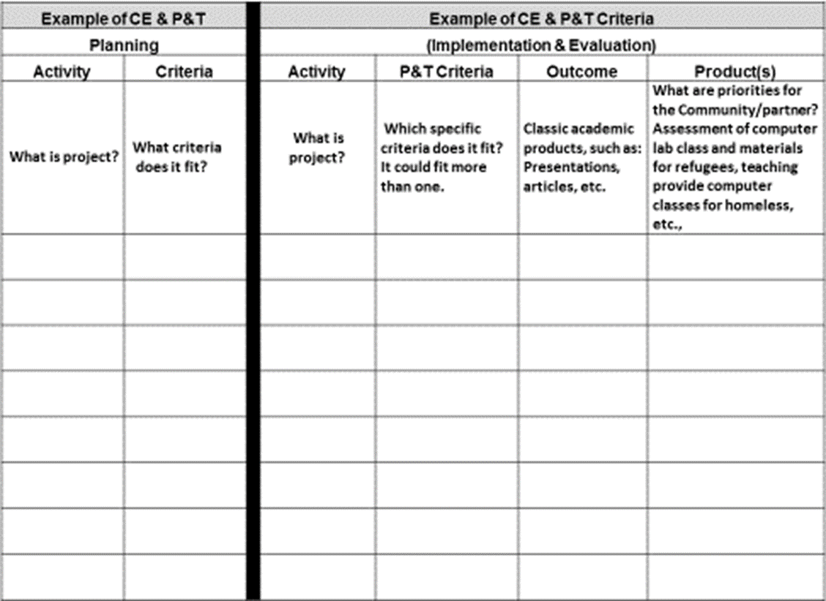
Source: Hines-Martin, V. and Cunningham, H. R. (2016) Using Community-Engaged Work in Support of Promotion and Tenure. University of Louisville.

Peer Review
As mentioned earlier, by adding “reciprocity” to traditional scholarship—or in this case traditional peer-review—to the campus-community partnership, the flow of knowledge is multidirectional, and new forms of scholastic products emerge that document the needs of both sides of the partnership. These collaborative takeaways do not necessarily fit the traditional form of scholarship, so the peer evaluator must be an expert who is knowledgeable about the quality of the work and has the ability to think beyond traditional research while performing the peer review (adapted from Janke & Clayton, 2012).

Policy Papers and Their Influence on Public Policy
Policy papers or white papers are communication tools that identify a public problem and clearly states a conclusion about this problem based on primary research. These are products that often result from community-engaged work, for the benefit of community partners. Technical papers are usually written by an expert in a field of study, an academician. However, as academic scholars collaborate with public communities, research- and policy- driven relationships develop.

Research-policy relationships are not new. Since the 1970s, scholars from both the U.S. and the U.K. have developed theories and models on the relationship between academicians and policymakers. Figure 1 on the next page (Boswell and Smith, p. 2) illustrates the possible “direction of influence” of research-policy relations. In number three, circular overlapping arrows are meant to convey a “mutually-beneficial” relationship between research and policy (e.g. social issues, social policy, governance, etc.).

Related to policy papers produced during engaged research are technical reports, which may similarly shape policies and programs. There are different types of technical reports produced from community-engaged research, varying based on the objectives or utilization of the research findings. In all cases, stakeholder needs, the research purpose, and target audience should be considered when communicating results. Technical reports should not only identify what, when, how, and to what extent information should be shared but should also take into account how information might be received and used.

For example, community-engaged research can have an evaluative focus. In this case, researchers can collaborate with Community Program managers/teams to identify appropriate evaluation products and processes, looking for how to streamline processes, reduce costs, improve efficiency, and so on. They can focus on impact assessment, in which findings can be used to increase the understanding of risks and opportunities and the viability of programs/projects or sectors.

In many instances, findings from community-engaged research can influence management strategies, policies and business plans. These include environmental, social, and economic recommendations, as well as issues surrounding good governance. A successful community-engaged research project will adopt the participatory action approach in which communities and stakeholders are equally empowered by the research process and the information generated.

Research-Policy Relations

1. Research Policy

2. Research Policy/politics

3. Research Policy

4. Research Policy

Fig. 1 Research-policy relations

The key is to recognize ways that engaged research reciprocally combines scholarly expertise with public needs. As Ellison and Eatman (2008) state, “Publicly engaged academic work is scholarly or creative activity integral to a faculty member’s academic area. It encompasses different forms of making knowledge about, for, and with diverse publics and communities. Through a coherent, purposeful sequence of activities, it contributes to the public good and yields artifacts of public and intellectual value” (p. iv).

References and Further Reading

Boswell, C., & Smith, K. (2017). Rethinking policy ‘impact’: Four models of research-policy relations. Palgrave Communications, 3(44), 1-10.

Colbeck, C. L., & Michael, P. W. (2006). The public scholarship: Reintegrating Boyer's four domains. New directions for institutional research, 2006(129), 7-19.

Clearinghouse and National Review Board for the Scholarship of Engagement. (2002). Evaluation criteria for the scholarship of engagement. Retrieved from http://unh.edu/engaged-scholars/pdf/review-board-criteria.pdf

Diamond, R. M. (2002). Defining scholarship for the twenty‐first century. New Directions for Teaching and Learning, 2002(90), 73-80. Retrieved from https://doi.org/10.1002/tl.57.

Ellison, J., & Eatman, T. K. (2008). Scholarship in public: Knowledge creation and tenure policy in the engaged university. Syracuse, NY: Imagining America.

Janke, E. M., & Clayton, H. P. (2012). Excellence in community engagement & community-engaged scholarship: Advancing the discourse at UNCG. University of North Carolina Greensboro.

Jordan, C. M., Wong, K. A., Jungnickel, P. W., Joosten, Y. A., Leugers, R. C., & Shields, S. L. (2009). Metropolitan Universities, 20(2), 66-86.
Michigan State University, (2009). Points of Distinction: A Guidebook for Planning and Evaluating Quality Outreach.

O'Meara, K., Eatman, T., & Petersen, S. (2015). Advancing engaged scholarship in promotion and tenure: A roadmap and call for reform. Liberal Education, 101(3).

Saltmarsh, J., Giles, D. J., Ward, E., & Buglione, S. M. (2009). Rewarding community-engaged
scholarship. New Directions For Higher Education, (147), 25-35.

Scott, J. (2007). Engaging academia in community research: Overcoming obstacles and providing incentives, Center for Urban and Environmental Solutions (CUES), Florida Atlantic University. Retrieved from http://consensus.fsu.edu/bog-fcrc/pdfs2/Engaging_Academic_in_Community_Research_FAU.doc

Weerts, D. J., and Sandmann, L. R. (2008) Building a two-way street: Challenges and
opportunities for community engagement at research universities.” Review of Higher
Education, 32(1), 73–106.

Weiss, C. (1979). The many meanings of research utilization. Public Administrative Review, 39, 426–431

Section 6
The Impact of Community-Engaged Research and Scholarship

This handbook focuses on developing, describing, documenting, and reviewing community engaged scholarship. The key is to develop a strategy at the beginning of the research design on how data from the community-engaged projects can be prepared for refereed publications. At the same time, community-engaged research and scholarship have other benefits that extend beyond the walls of academia. They reflect the social responsibility of an institution to address the needs of the communities and societies in which they are embedded. The non-referred technical reports that are generated as shown in the previous section can have different functions, including evaluation, impact assessment, institutional analyses, risk management, policy recommendation, and community empowerment, among others.
This section of the handbook highlights how evaluators and scholars might conceive of the impact community-engaged research and scholarship in more complex ways to support a more effective promotion and tenure process. Community-engaged scholarship has many levels of impact, all of which include elements of transformative change. Tremblay (2017) suggests that there are three main levels: (i) micro or individual; (ii) meso or community; and (iii) macro or institutional.
The Micro or Individual Level
Community-engaged scholarship can result in changed behavior, skills, attitudes, knowledge, or understandings for both the researcher and research participants. Consequently, more community-based researchers are adopting reciprocity, reflexivity, and epistemological inclusiveness in their research methodology. This allows for greater participation, increased likelihood of accurate representation, and empowerment of research subjects.
This work can result in refereed publications (e.g. journal articles, books and monographs, co-authored or co-edited articles or books, and conference papers). In addition, community engagement can lead to successful jointly-prepared funding proposals and grants. The impact of such work can be documented through personnel, letters from community partners, media coverage of your work, and other sources.
The Meso or Community Level
At the meso or community level, engaged research can result in constructive and positive changes to a community project through collaboration and the sharing of ideas and indigenous knowledge. This includes addressing disparities and enhancing diversity and inclusiveness, as well as a more targeted identification of the social, political, cultural, and economic issues that are important to change in systemic outcomes.

Engaging the community also results in increased relevance of the research in meeting the policy needs of the community. Scholars can influence policy through publication of policy reports and/or briefs, as well as from advising/consulting with government and non- government bodies. According to Viswanathan (2004), community-engaged research and scholarship places a high priority on converting findings into new practices and policies that are beneficial to the community.
Additionally, communities benefit from faculty non-referred publications that are informative and educational (such as handbooks, newsletters, local/national newspapers, multi-media products, etc.) and from invited presentations, workshops, commissioned works, artistic and/or digital performances, exhibits, videos and films, etc. Overall, community-engaged research and scholarship can improve the quality of life and economic vitality of a community in sustainable fashions.
The Macro or Systemic Level
Macro-level impact of community-engaged research and scholarship usually takes years. These outcomes include sustainable changes in long-term policies, structures, and/or regional, national and international agendas. It also involves changing some of the traditional methodologies of research used in knowledge generation, interpretation, and validation. This often takes place through increased adoption and acceptance of the participatory action research approach, spending more time in the community, sharing power, and changing the hierarchical structure of academic and non-academic structures.

Resources on Community Engagement & Engaged Scholarship

- American Association of Colleges and Universities: https://www.aacu.org/leap/hips
- Association of Public and Land Grant Universities https://www.aplu.org/projects-and-initiatives/economic-development-and-community-engagement/
- Campus Compact: https://compact.org/
- Carnegie Foundation’s Classification for Community Engagement https://www.brown.edu/swearer/carnegie
- Community Campus Partnership for Health: https://www.ccphealth.org/resources/
- Coalition of Urban and Metropolitan Universities: http://www.cumuonline.org/
- Engagement Scholarship Consortium: https://engagementscholarship.org/
- Imagining America: https://imaginingamerica.org/
- International Research on Service Learning and Community Engagement (IRSLCE): http://www.researchslce.org/
- University of Louisville Office of Community Engagement: www.louisville.edu/communityengagement

