**Plays Gud**

**Senior Digeridoo Recital**

*with*

Ivory Keys, piano

A Student of Dr. Doesn’t Sound Bad

Friyay, June 32, 2049

Birdstock Concert Hall

7:31 p.m.

**PROGRAM**

Sonata Prima per Trombetta Sola, Op. 4 Giovanni B. Viviani

I. Andante (1638-1693)

II. Allegro

III. Presto

IV. Allegro

V. Adagio

Piano Concerto No. 21 in C Major, K. 467 Wolfgang Amadeus Mozart

(1756-1791)

*Intermission*

Concerto for Saxophone & Orchestra, Op. 109 Aleksandr Glasunov

I. Allegro moderato (1865-1936)

II. Andante sostenuto

III. Allegro

Fantasie for Violin & Piano (1933) Olivier Messiaen

(1908-1992)

“Come all ye songsters” from The Fairy Queen, Z.629 Henry Purcell

(1659-1695)

Footprints (1966) Wayne Shorter

(b. 1933)

arr. Terrance Blanchard

Miles Davis, trumpet  
Tommy Dorsey, trombone  
Eric Clapton, guitar  
Dave Brubeck, piano  
Buddy Rich, drums

*This recital is in partial fulfilment of the requirements for the Bachelor of Music degree.*

**Performances at the School of Music**

The School of Music welcomes you to a performance from our talented musicians.

As a part of the University of Louisville, we strive to be a great place for musicians of all ages to learn and grow. Our School offers numerous opportunities to share talents, including this performance. We encourage all of our students, faculty and visitors to express their creativity throughout their time at the University of Louisville and are excited for you to share in this experience.

Find Us On The Web!

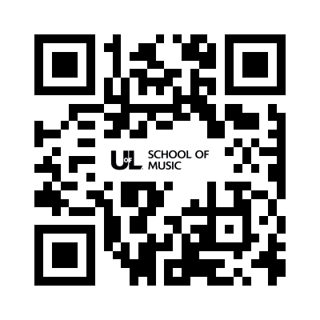



@uoflmusic

**How to make a difference in a student’s life**

The University of Louisville School of Music is committed to becoming a preeminent school of music in the Midwest and the first choice for music students in Kentucky.   
Your support of the School of Music helps keep the university affordable for our students and provides them with opportunities for learning and discovery. Your support helps provide the flexibility to meet emerging needs and challenges that cannot be funded by state and tuition support alone. Your gift changes lives.

Help us continue to change lives today!

**give.louisville.edu/music**

or scan the QR code below

If you have questions about how you can   
help support the School of Music please contact our   
Director of Development,

**Mark Kaczmarczyk, M.M**.

m.kacz@louisville.edu

502.852.7108.