MEMO
TO: All Department Triptych Staff
FROM: Beth Williams, Director of Faculty Affairs and Advancement
DATE: September 14, 2018
RE: Instructions on balloting faculty for promotion, appointment and tenure actions

Many departments have asked which executive faculty are eligible to vote for which actions and how to create an anonymous balloting system. The goal of the following instructions is to answer those questions. The Office of Faculty Affairs and Advancement recommends using Survey Monkey for balloting your faculty. The program we used to create these instructions was the Advantage plan (Approx. $23/month). We find it easy to use and it provides anonymous voting. If your department chooses to use another program, its balloting system MUST BE anonymous as required by the PAT document. (Page 21, Appendix B, Section III. A. 2.).

Who are eligible to vote for which actions?
Note: You will find the following information also listed in detail in the SOM PAT document, page 21:
Award of Tenure: All tenured executive faculty, no matter the rank
Promotion to advanced rank (Associate Professor or Professor): All tenured, probationary and term executive faculty at or above the rank that the candidate is being promoted to.
Promotion to Assistant Professor, term, tenured or probationary: All executive faculty of the department.
PCR: All tenured, probationary and term executive faculty at or above the rank of the individual being reviewed.
All new appointments no matter the status or rank: All executive faculty of the department
Track change for term to probationary: All executive faculty of the department

Promotion and award of tenure actions are sometimes processed together (i.e. Promotion to Associate Professor and award of tenure). When balloting these actions they need to be balloted separately because all executive faculty are not always eligible to vote on all actions. One action would be for promotion and one action would be for award of tenure.

Example: An associate professor, probationary (tenure track), is going up for promotion to Professor and award of tenure. All professors are eligible to vote for the promotion to Professor (no matter the voting professor’s track: tenured, probationary, or term). However, only tenured individuals can vote for the action of award of tenure. (The award of tenure vote should include associate professors that are tenured.)
In Survey Monkey, if these two actions are on the ballot separately then you will be able to apply a filter on the rank and status, filtering out the individuals that don’t fit the eligibility requirements to vote. The following instructions are for the Advanced Survey Monkey program with two-answer filtering capabilities.
Survey Monkey Instructions:
After beginning the survey by naming and choosing the type:
- The first question will be the rank of the faculty that are being balloted (necessary for filtering when analyzing votes). Offer multiple choice answers, as seen below:
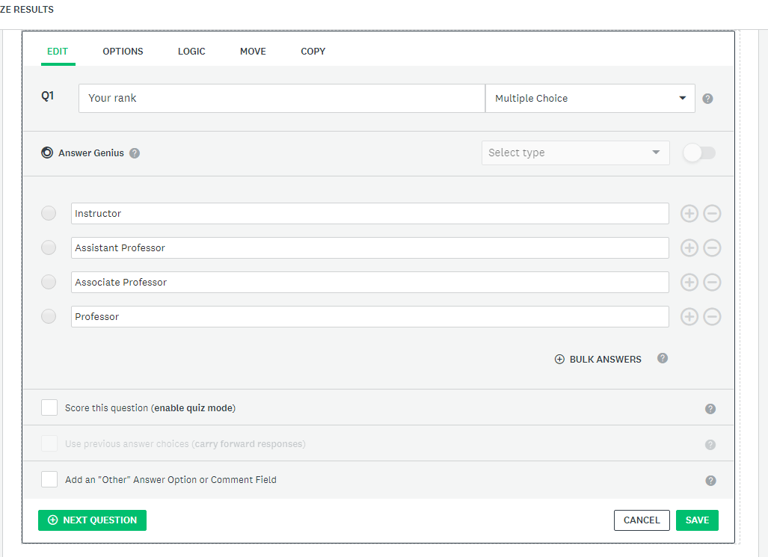
- After you create the question and multiple choice answers, click the options tab as seen below and make the question require an answer by checking the box next to “Require an Answer to This Question”.
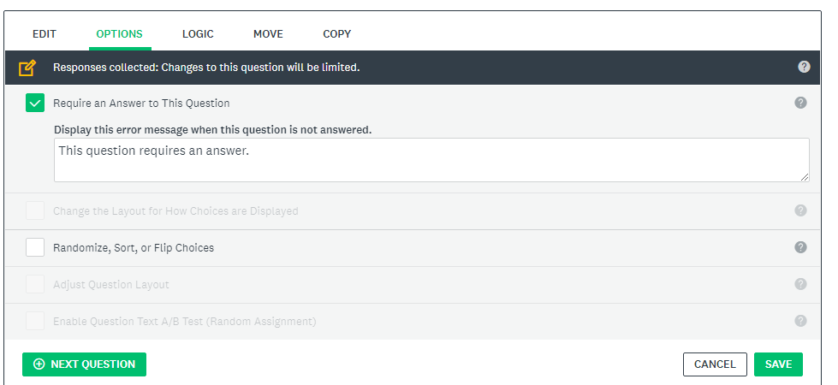
- After completing step 2, click on the “next question” button.

- The second question will ask for the track of the faculty that are being balloted. (necessary for filtering when analyzing votes)
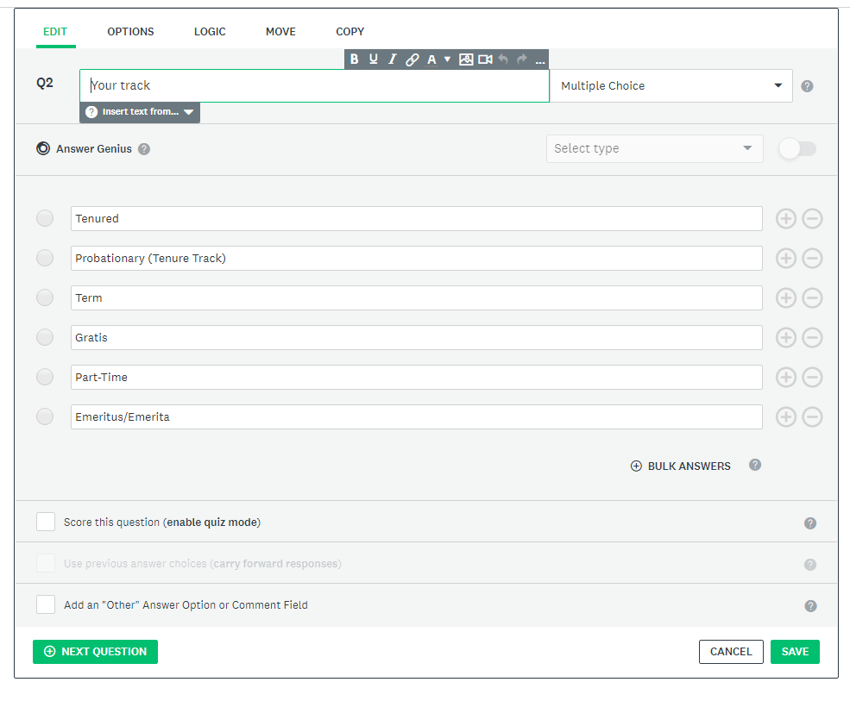

*If you have any Emeritus/Emerita faculty that have opted to remain executive faculty, this ballot should also be sent to them. If your department has gratis faculty members that have been chosen by the department to serve as executive faculty they should be invited to vote on these ballots.

- After you create the questions and multiple choice answers as previously described, go to the options tab and make the question require an answer by checking the box next to “Require an Answer to This Question”.
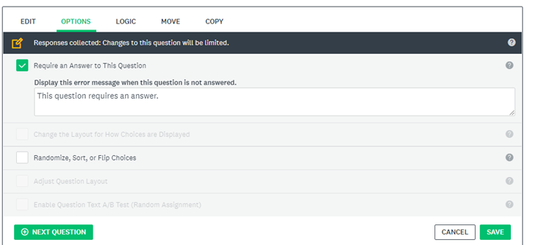

- Click “next question”. Your survey so far will look like the example below with the “*” next to the questions that require an answer by the faculty member when completing the ballot. If they don’t have an “*” beside them, then click on the question and refer to step 2 of these instructions.
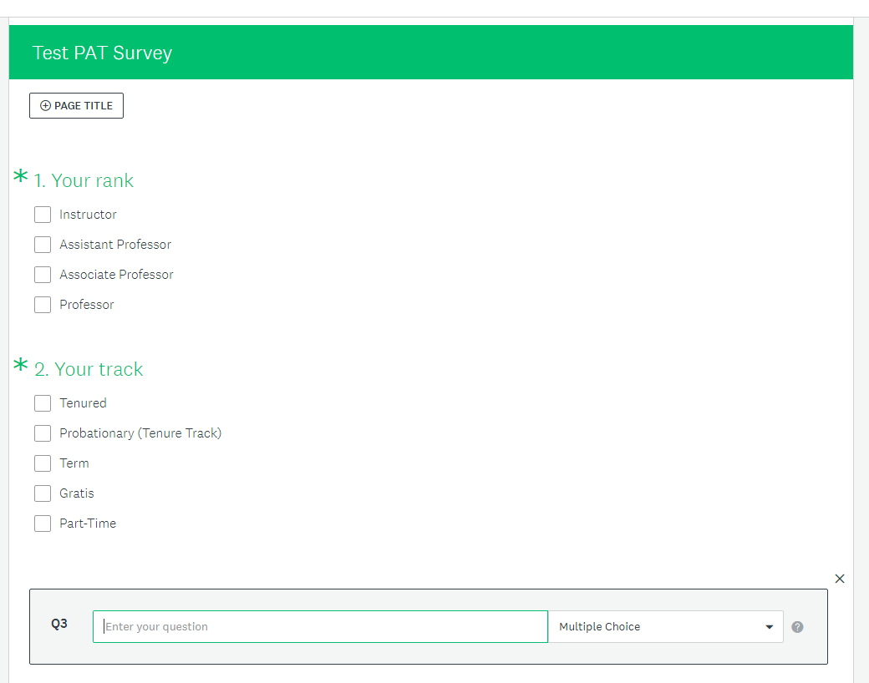

- The third question will begin the actions requiring the executive faculty to vote. See below and note that all actions are balloted separately as discussed on page 1. The questions are the action being balloted and the responses are the multiple choice option answers of “Approve”, “Deny”, or “Abstain”.
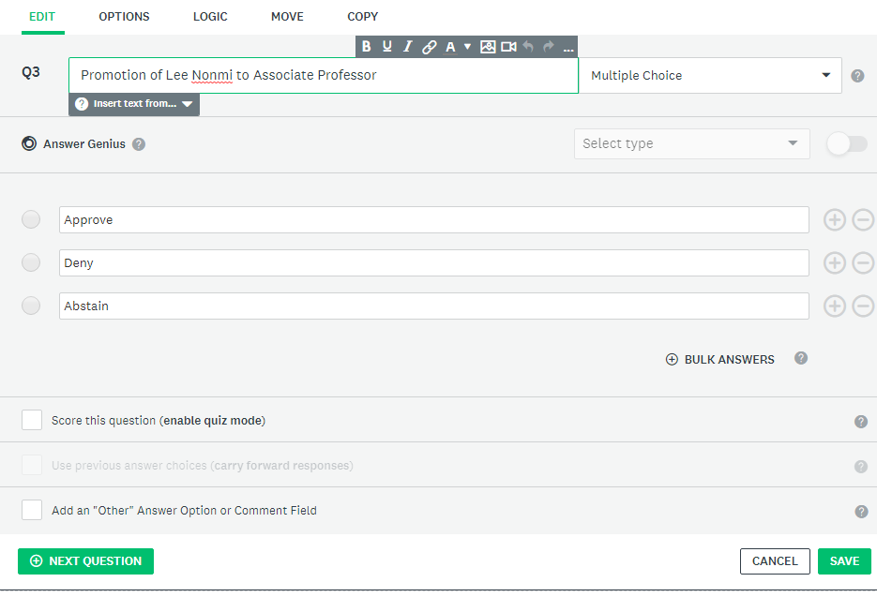
*Answers are not required in this section so nothing needs to be changed in the “Options” tab

- Click next question and add all actions that you are balloting for by repeating step 7.

- Once you have added all actions for the ballot click “Next” in the top right of the screen.
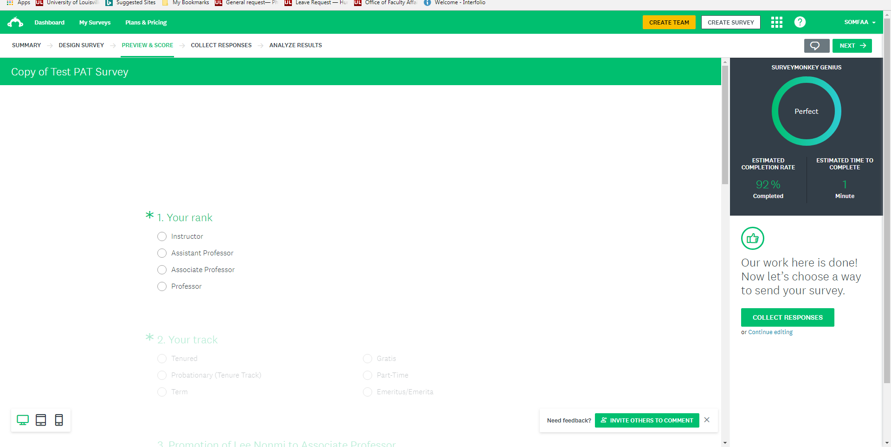

- Click “Collect Responses” in the right middle of your screen.
- Next you will be asked “How would you like to collect your responses to your survey”. Choose the option “Get Web Link” to send to your faculty
- When setting up the Web Link make sure the following are chosen below the web link:
  - Multiple responses “off”
  - Response Editing “On, until survey complete”
  - Anonymous responses “on”
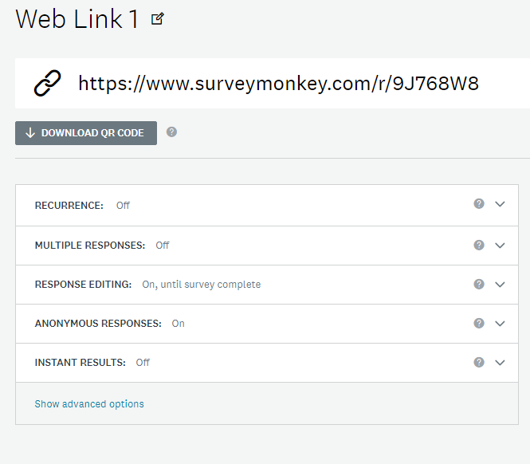
- Click on “Show advanced options”
  - Click “cutoff date and time” and then select “on, close this collector on a specified date and time”
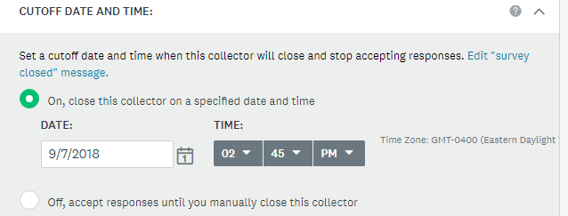

  - Set the date and time to close the survey (the survey must be available for at least one week, per SOM PAT document)

  - Click on blue link: ‘Edit “survey closed” message’ and insert the message you would like to send when someone tries to vote after the ballot is closed.

- After completing the above steps, click “copy” next to the web link at the top of the page. This will copy the link to put into your email to the executive faculty asking them to vote
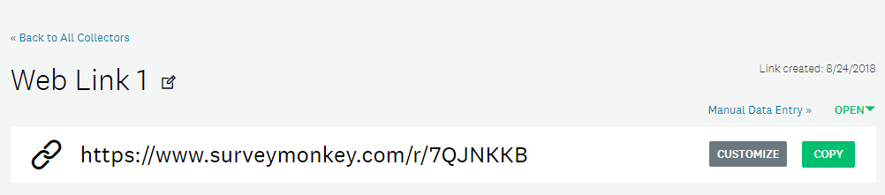

- Create an email to request the executive faculty vote and paste the link in the body of the email.
  - Please note that the email should be sent to all executive faculty including any gratis, part-time, and emeritus/emerita executive faculty. You will be able to filter all of the votes that are eligible after the ballot is closed and when analyzing the data.

- Once the survey is closed go to “My Surveys” in the top left of the screen and choose the survey to see the results
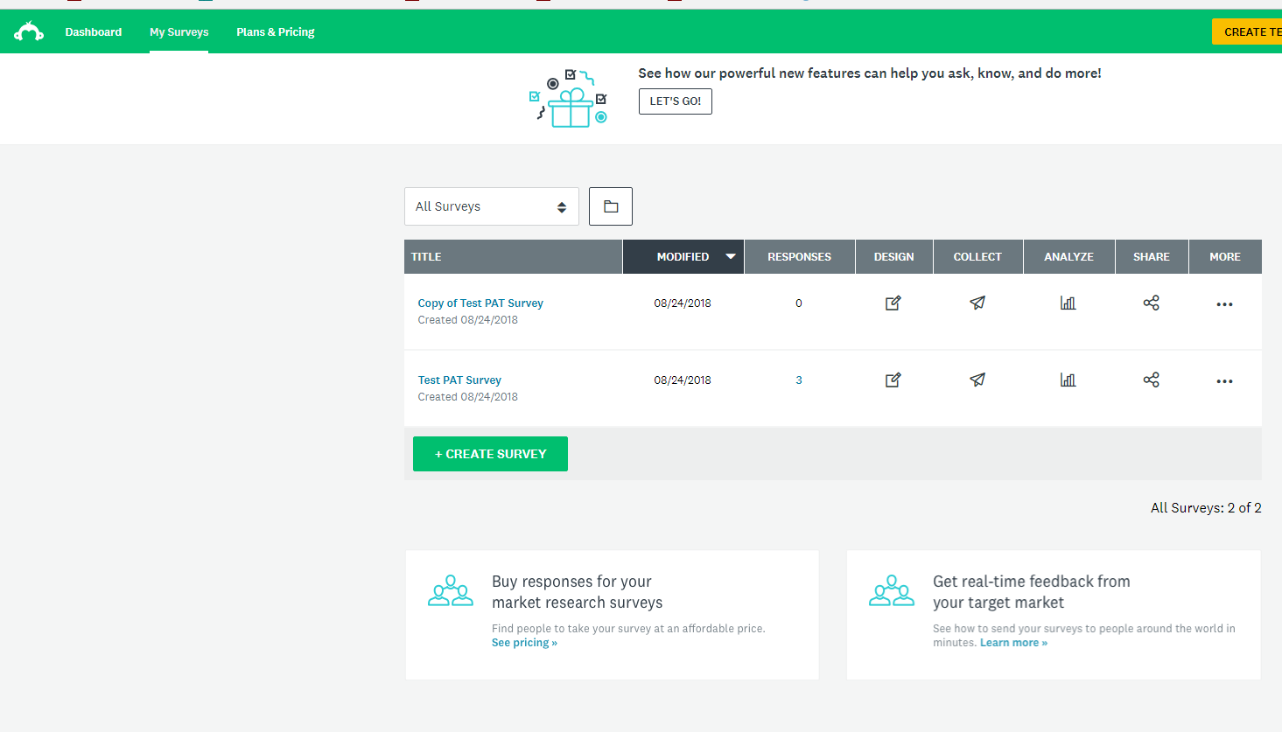

- You will see a summary screen. From this screen you can review the individual actions and the votes by clicking on “Analyze Results”.

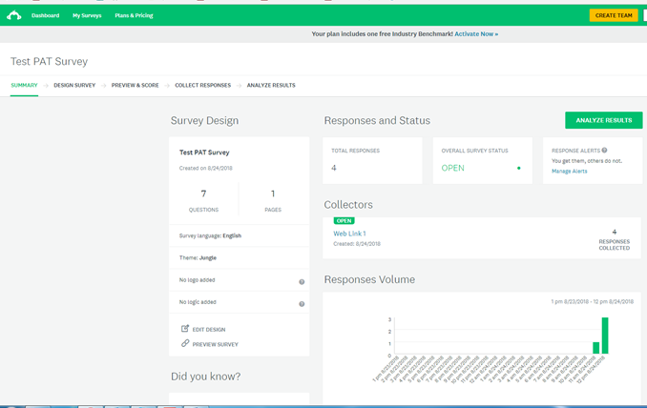

- You can scroll through the results summary and add filters to make sure you are only counting the executive faculty that are eligible to vote for each action by using the +FILTER in the top left corner:
  - Filter by question and answer.
  - For example, if you would like to see how Associate Professors and above voted on an advanced rank appointment, choose “Q1: Your rank” and check “Associate Professor” and “Professor” and click “Apply”.
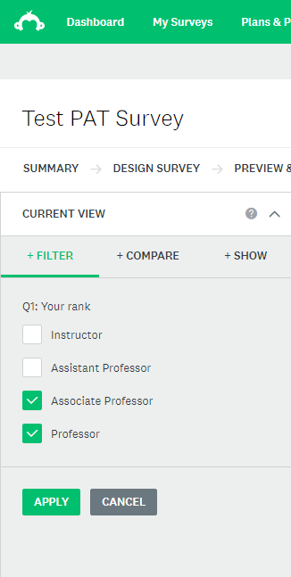

- Next, scroll down to the advanced rank promotions to see the results for the Associate Professors and Professors votes.
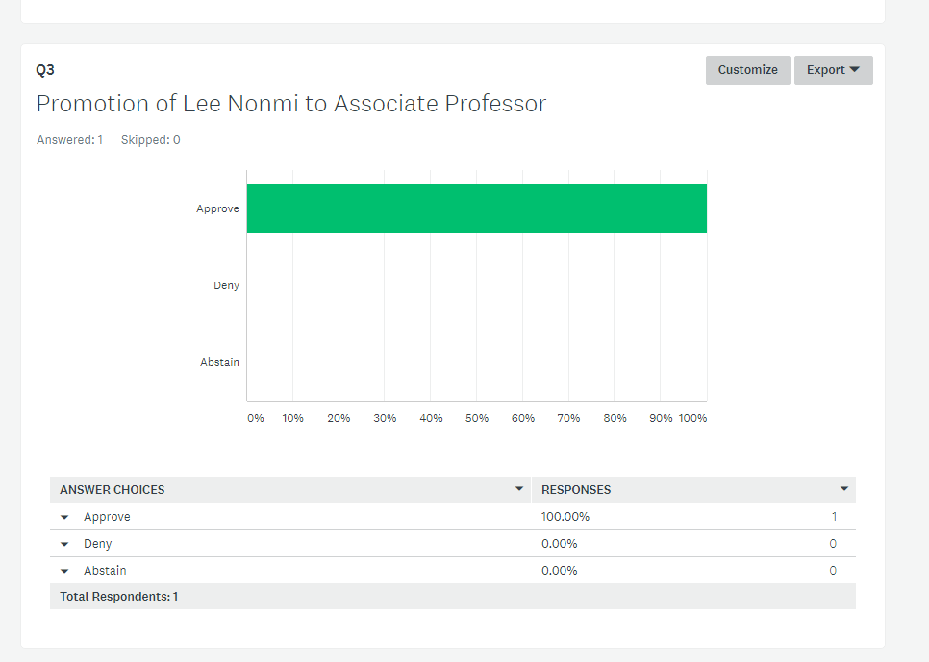

- You can add other filters using this same process. If you want to remove these filters, click on the option dots next to each filter.
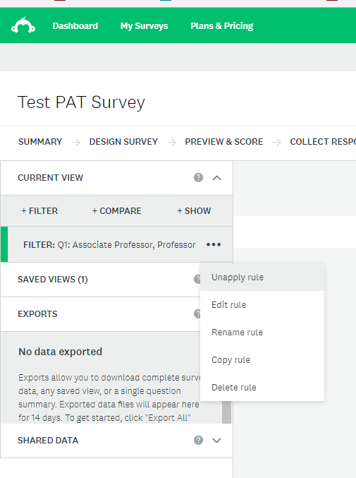
** For examples about when to use these filters, please see the first page under the heading “Who is eligible to vote for which actions?”
**For more information on how to use Survey Monkey, including how to filter and analyze your reports see the Survey Monkey Help Center.

