Department Anonymous Ballot Guide
This document is to help departments understand and provide suggestions on creating an electronic balloting system to meet the requirements of the required secret ballot. The Office of Faculty Affairs and Advancement recommends using Microsoft Forms. We find it easy to use and it provides anonymous voting. If your department chooses to use another program, its balloting system MUST BE anonymous as required by the personnel document. (Appendix B, Section III. A. 2.).

SECTION I: Who are eligible to vote for which actions?
Below are the different executive faculty groups eligible to vote on the listed actions. A member of the Executive Faculty in the School of Medicine holds a full-time, academic appointment in the University of Louisville with a primary appointment in the School of Medicine; or may be a part-time, emeritus or gratis General Faculty who has been elected to the Executive Faculty. You will find the following information also listed in detail in the SOM Personnel Document:
Award of Tenure: All tenured executive faculty, no matter the rank
Promotion to advanced rank (Associate Professor or Professor): All tenured, probationary and term executive faculty at or above the rank that the candidate is being promoted to.
Promotion to Assistant Professor, term, tenured or probationary: All executive faculty of the department.
PCR: All tenured, probationary and term executive faculty at or above the rank of the individual being reviewed.
All new appointments no matter the status or rank (including term to tenure track change): All executive faculty of the department

Promotion and award of tenure actions are sometimes processed together (i.e. Promotion to Associate Professor and award of tenure). When balloting these actions they need to be balloted separately because all executive faculty are not always eligible to vote on all actions. One action would be for promotion and one action would be for award of tenure.
Example: An associate professor, probationary (tenure track), is going up for promotion to Professor and award of tenure. All professors are eligible to vote for the promotion to Professor (no matter the voting professor’s track: tenured, probationary, or term). However, only tenured individuals can vote for the action of award of tenure. (The award of tenure vote should include associate professors that are tenured.)
If these two actions are on the ballot separately then you will be able to apply a filter on the rank and track, filtering out the individuals that don’t fit the eligibility requirements to vote. The following instructions are for Microsoft Forms.

SECTION II: Microsoft Forms Instructions
After beginning the survey by naming and choosing the type:
- The first question will be the rank of the faculty that are being balloted (necessary for filtering when analyzing votes). Offer multiple choice answers, as seen below:
- Click Add and then choose “Choice”
- Include these ranks and toggle to required as seen below.
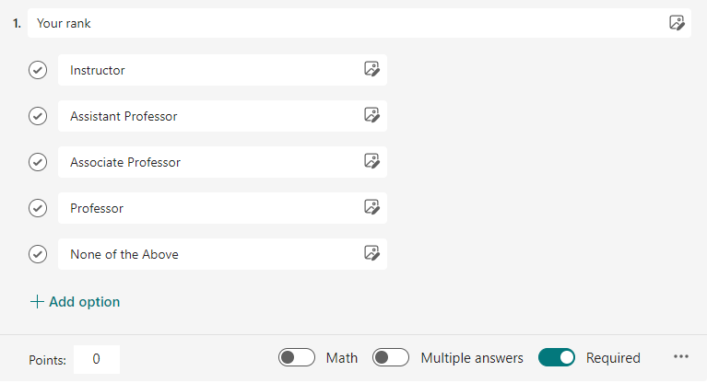

- Click Add new and then choose “Choice”

- Create the next question to allow for filtering on track type to identify for tenure actions (only tenured faculty can vote on these actions). Ensure that the required toggle is on.
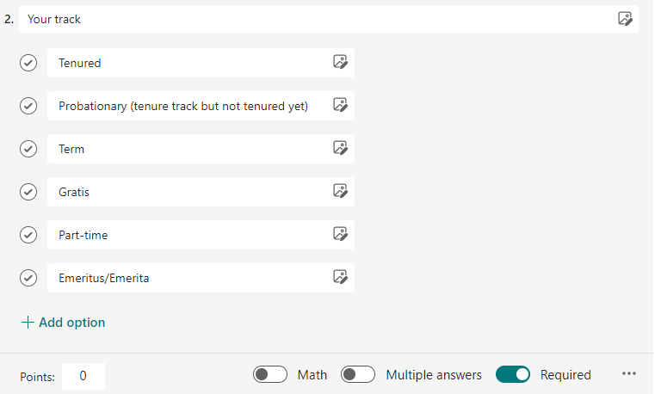

- The third question will begin the actions requiring the executive faculty to vote. You will click Add new and Choice for each question added to the ballot. All actions are balloted separately as discussed in this guide. The response options should be “Yes”, “No”, or “Abstain”. See below suggestions on ballot questions. Answers should be required in this section because we are allowing for the three options including abstain.
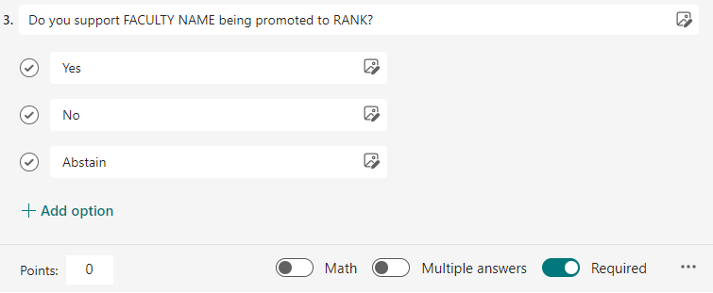
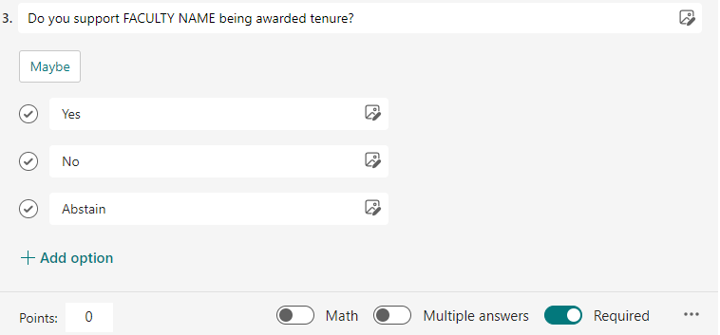

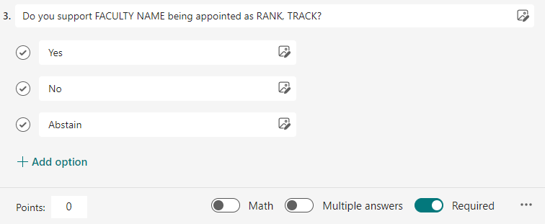

- Click add new and add all actions that you are balloting for by repeating step 6.
- Once you have added all actions for the ballot you are ready to assign how to collect responses, start and end dates.

- Click “Collect responses” (usually in the top right corner). To assign only your executive faculty, you should click “Specific people in University of Louisville can respond”. For the vote to remain anonymous uncheck “Record name”. To ensure that each faculty can only vote once you will check “one response per person”. In the section where it says “enter a name, group, or email address” you will add each of your executive faculty (defined in Section I of this guide).
  - Please note: once you have received the results of the ballot you can filter on the track and rank to acquire eligible faculty votes.
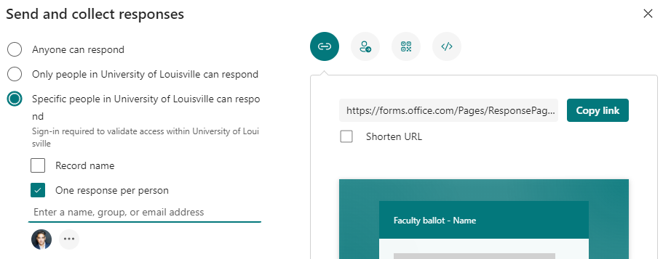

  - If you’ve added someone by mistake and need to delete them you can click on the ellipsis next to the listed faculty (See above red arrow). Once you are in the next screen you can click on the trash can next to the name and it will remove their ability sign into the ballot.
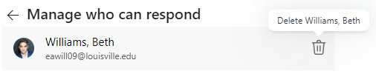

- Once you’ve added all the executive faculty you will need to set the start and end dates of the ballot. You will set the start and end dates by going to the ellipses in the right corner and click settings.
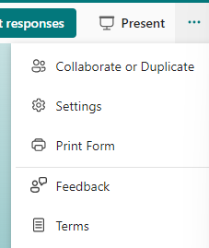

- Navigate to “Options for responses” and check the boxes next to the start and end date to set the open and close dates and times. This will automatically set when the faculty can complete the ballot. Please be aware that the ballot must stay open for a minimum of a week.
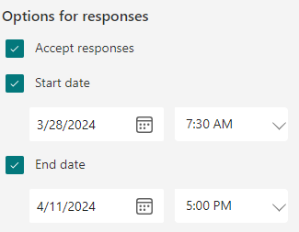

- Once you are ready to send the ballot email you can copy the ballot link to add in the email. You do this by clicking on “Collect responses” and then copy link.
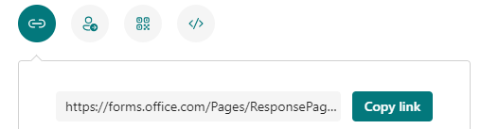
- Create an email to request the executive faculty vote and paste the link in the body of the email.
  - Please note that the email should be sent to all executive faculty including any gratis, part-time, and emeritus/emerita executive faculty. This email should include all necessary information (CV, letters, other relevant materials).

- Once the ballot is closed you will be able to review the results and download the excel report to complete the ballot form for faculty actions.

