Faculty Hire Workflow
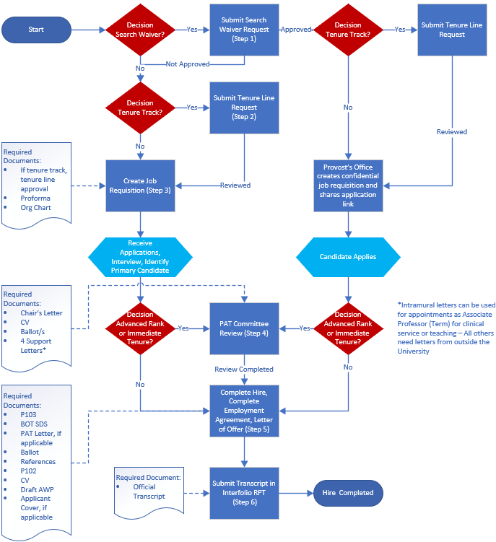
Workflow Guide
- Decision: search waiver?
  - Yes: Follow the Search Waiver request process. If approved the Provost’s office will create a confidential job requisition and share the link for application
  - No: Go to step 2
- Decision: tenure track?
  - Yes: Submit the tenure line request through this website
  - No: Go to step 3, unless search waiver is approved. Then skip to step 4.
- Workday: Follow Create Job Requisition QRG
  - Make sure to choose the correct track line. If the tenure line request, was requested and not approved you will need to choose term.
  - On the Profile: if the position is tenure track, use “regular” and if the position is term track, use “regular term”
  - Attach:
    - Tenure line request approval, tenure track position only
    - Proforma
    - Org chart
- Decision: Will hire be offered at advanced rank or immediate tenure?
  - Yes: If the appointment is at advanced rank (Associate Professor or Professor) or with immediate tenure, the CV must be reviewed by Office of Faculty Affairs before any offer is made verbally or written. Send the CV electronically to the Faculty Affairs Committee program manager. In the email correspondence with the CV, please include major responsibilities, work assignment, leadership roles and expectations the department/faculty member has for rank and track. The department will be notified of appropriate rank and track. The Vice Dean for Faculty Affairs will obtain pre-approval of immediate tenure from the Provost’s Office. The School of Medicine PAT committee will need to review the following items before the approval to use the letter of offer will be processed. The following items are to be sent via Interfolio. Submit the following documents in Interfolio Advanced Rank Appointment/Immediate Tenure Pre-Approval template 3 months in advanced of hire date for term or probationary appointments and 5 months prior for immediate tenure appointment:
      - Letter of recommendation from Chair to Dean including major responsibilities, work assignment and leadership roles
      - At least 4 letters of recommendation – Intramural letters can be used if appointments Associate Professor (Term) for clinical service or teaching – all others need letters from outside the University
      - Curriculum Vitae
      - Ballot form - one for rank and one for tenure (if applicable)
    - Once reviewed go to step 5, the Letter of Offer (LOO) will need to follow the approval/review of the PAT committee
  - No: Go to step 5

- Workday: Follow Recruit to Hire QRG
  - When you are creating the employment agreement in Workday you will need to attach the following items:
    - P103
    - BOT Supplemental Data Sheet
    - PAT committee letter for advanced rank (Associate Professor and Professor) and immediate tenure appointment
    - Ballot
    - LOR or summary of reference checks
    - P102, for immediate tenure appointment only
    - CV
    - Applicant Cover Letter, if available
    - Draft Annual work plan (signatures not required)
  - LOO generated and sent for approval
    - Important Note: the information entered when creating the employment agreement needs to be accurate because the information you input in this step will be entered on the letter of offer and locked from editing.
    - If tenure track, use tenure review schedule for LOO under Contract/Letter Templates on our Forms page
- Interfolio RPT: Transcripts will need to be submitted through the Interfolio template titled Transcript Submission to Faculty Affairs at least 6 weeks prior to the hire effective date. The School holding the official transcript for the highest degree will need to forward the official transcript directly to the UofL department contact.

