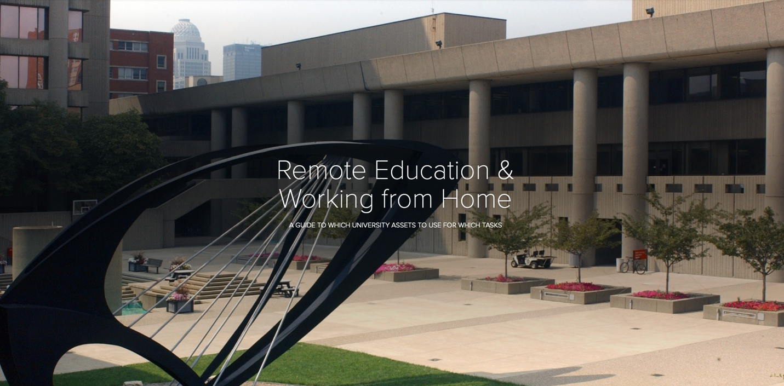

Administrative, Departmental, or Just Getting a Team Together:
We recommend the use of Microsoft Teams for administrative audio or video conferencing, document sharing and collaboration. This tool is free to all University faculty and staff and can be used for collaboration even with folks outside the University. Here is a page to help you get started:
Microsoft Teams video training

Online Instruction MD Program:
If you are in the MD curriculum, the Undergraduate Medical Education team, including the Academic Technology Office, will likely be reaching out to you and guiding you through this process. However, familiarizing yourself with the tools at your disposal is a great idea. The Academic Technology Office has a website with Faculty training resources available HERE. Specifically, you may want to review the training for:
- Panopto for lecture capture, whether for asynchronous learning modules or live web streamed presentations with student feedback discussion board, quizzing and polling.
- SoftChalk for the creation of online learning modules, possibly including Panopto videos as well
- iClicker for use in live quizzing or for formative feedback

For some specific instances, we have set up BlueJeans Rooms to emulate our physical rooms for Standardized Patient Encounters and certain small group interactions. If you need assistance getting set up or using BlueJeans, here are a number of tutorials that should get you up to speed: BlueJeans tutorials

Student Instructions for Online test taking:
Respondus Lockdown Browser with Monitor:
Watch this brief Video:
https://web.respondus.com/lockdownbrowser-student-video/

To log in to BlackBoard go to: Blackboard.louisville.edu
Login using your ULink username and password

Follow these instructions (Be sure to follow the Mac version):
http://louisville.edu/delphi/-/files/blackboard/student-ldb-install.pdf
The Webcam is built into your MacBook Pro. If you have the camera covered, remove the cover/piece of tape/sticker. This is a requirement for the test.

Click on the ‘Assignments’ link in the left navigation panel to find your test.

Message from Dr. Holthouser regarding online exams:
I am communicating clearly with you in this message that any student issues with recording or collecting exam questions, collaborating with others or notes on your exam, or other academic dishonesty that takes advantage of this public health crisis for the student’s academic gain or the benefit of other students or years will be fully prosecuted. This is a closed book examination, to be completed without notes or help, and you should act accordingly.

For Large Events up to 200 Participants with Limited Interactivity:
BlueJeans Events can host up to 200 ‘attendees’ with designated presenters, moderated, to allow attendees to ‘raise their hand’ and be recognized for speaking and video. This tool also has built in polling and Q/A capabilities. Contact us at atosupport.louisville.edu to plan this type of event.

For non-MD Courses:

Delphi Center Training in the Use of University Online Educational Resources:
In our continuing effort to provide training and support to faculty moving classes online, the Delphi Center has created two new training opportunities to address more specific needs.
- Blackboard Collaborate Ultra - This web conferencing tool can be used to meet synchronously (at the same time) with your students. Sessions start Friday morning and run all next week -- even Saturday!
- Panopto – You can use this tool to record audio and/or video lectures. Your students can also use it for recording presentations. Sessions start Friday and run to Tuesday.
The use of these tools can make the transition to online much easier. Please reserve your spot soon by clicking on the links above, and don’t forget about our other trainings designed to get you started:
1. Online Module you can complete at your own pace (available now)
2. In-Person Classroom Trainings to be held in the TILL Classroom in Ekstrom Library
3. Live Virtual Trainings to be held via Blackboard Collaborate from any location
If you have any questions about moving your class online, please call or email Aimee Greene at aimee.greene@louisville.edu or 852-4482.

Additional Resources:
University of Louisville Information Technology Services “Working Remotely” website

For questions or help with any of the above, please contact atosupport@louisville.edu not any of our staff individually. Emails to this address go to the whole ATO team, so if one of us should not be available, you will still get a timely response. We have the ability to ‘drive’ your computer remotely (upon you granting permission) so feel free to contact us from wherever you are, even from home.

