Community newsletter template:
Did you know that Kentucky has one of the highest rates of antibiotic prescribing in the country?
Antibiotics are important, life-saving drugs. Unfortunately, any time antibiotics are used they can cause side effects and antibiotic resistance. It’s important for everyone’s health to use antibiotics ONLY when needed.

What is antibiotic resistance?
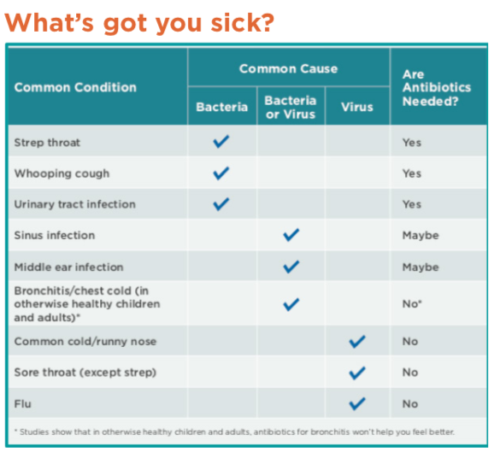
Antibiotic resistance is one of the scariest threats to public health. Resistance is when bacteria are no longer killed by antibiotics. The more antibiotic resistance, the harder it is to treat even common infections. Antibiotic use is one of the main causes of resistance, so it’s important to use antibiotics only when needed.

When are antibiotics needed?
Antibiotics are needed for infections caused by bacteria, such as pneumonia, urinary tract infections, and ear infections. Antibiotic are NOT helpful against infections caused by viruses, like the common cold, bronchitis, or the flu.

Taking antibiotics when they’re not needed can lead to unwanted adverse effects (eg. diarrhea) and antibiotic resistance.

What can you do to encourage appropriate antibiotic use?
- Talk to your doctor about when antibiotics are needed
- Don’t request antibiotics when they’re not needed
- Ask your doctor for symptomatic treatment recommendations for viral infections
- When you do receive an antibiotic, always take it as directed: do not share your prescription or “save some for later.”

For more information, visit: KAA website
Follow us on Social Media:
These materials were developed by health professional researchers from the University of Louisville, Department of Pediatrics, Child and Adolescent Health Research Design and Support Unit (CAHRDS). This project was supported by the following: Kentucky Cabinet for Health and Family Services: Department for Medicaid Services under the contract titled “Improving Care Quality for Children Receiving Kentucky Medicaid”, Norton Children’s Hospital, and the University of Louisville: School of Medicine, Department of Pediatrics; School of Public Health and Information Sciences.

