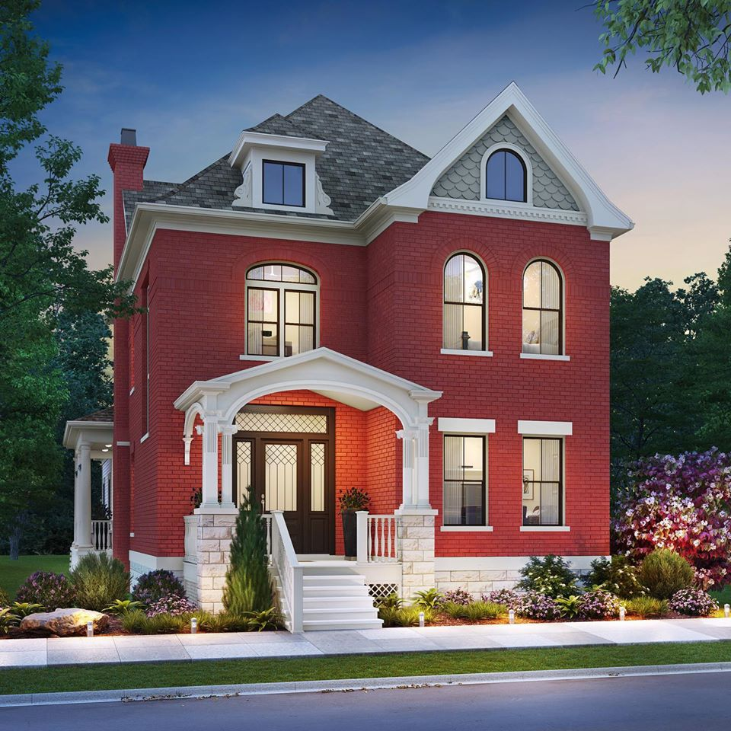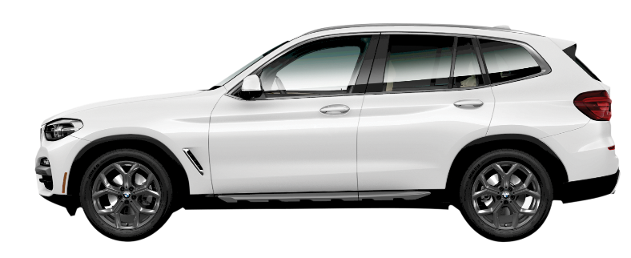

Quick Facts
Grand prize drawing for a new house in Norton Commons valued at more than $750,000
First prize drawing for a 2021 BMW X3 from BMW of Louisville plus $10,000 cash

- Ticket Cost: $100, tickets on sale July 1!
- Only 12,000 tickets will be sold!
- The home is located in Norton Commons, 6120 Mistflower Circle, Prospect, KY 40059
- Built by Ramage Company
- 3 bedroom, 3 bathroom, 1 half bathroom and nearly 3,200 square feet of living space
- How to get tickets
    - Visit HomeAndBMWRaffle.com
    - Call 629-8060
    - Visit our Open Houses *
      - Oct. 3 to Nov. 14, Saturdays and Sundays, Noon to 6 p.m., and Nov. 21, Noon to 3 p.m.
      - When you visit an open house sign up FREE to win a great prize.
- Drawing to be held at the Snow Ball, Nov. 21, 2020
- This is our 10th raffle house.
- All Proceeds benefit Norton Children’s Hospital Foundation
*Open house tours of the Norton Children’s Raffle house are subject to CDC guidelines as of October. The personal safety and well-being of our patients, families, staff, visitors, donors, volunteers and community is central to the mission of the Norton Children’s Hospital Foundation.

