Bard Minnesota Kit Instructions
By Neil Crittenden ~ Updated 11/2015

Materials you will need:
-1 Bard Minnesota Tube (In white Boxes in the Endoscopy Supply Closet)
-Football Helmets (4 Sizes small through X-large, in the Endoscopy Supply Closet)
-Sphygmomanometer Pressure Gauge (check to ensure is working properly by verifying that the needle responses to different pressures applied to a balloon with the pressure gauge in series). If uncertain if the pressure gauge is working, see if the nurses can use an arterial line pressure kit on a bedside electronic monitor or cut off a new Sphygmomanometer Pressure Gauge from a new blood pressure cuff check out to the patient)
-Four (4) hemostats
-Scissors
-Tape
-Two (2) 60 mL (each) Luer-Lock Tip Syringe (309653) (only 1 will be used, but an extra should be available)
-Six (6) Baxter Large Bore Stopcock with rotating male Luer Lock Adapter (2C6204) (only 5 will be used, but an extra should be available)
-Two (2) CardinalHealth Medi-Vac Tubing Connectors (double “Christmas Tree”)
*The material above should be in the red Minnesota Tube Kit Toolbox in the supply closet at all times. The materials below should be available anywhere.
-Container for Water and Ice
-Water Based Lubricant (KY-Jelly)
-Two (2) blue tip suction tubing and (for the gastric and esophageal aspiration tubes)
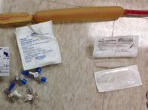
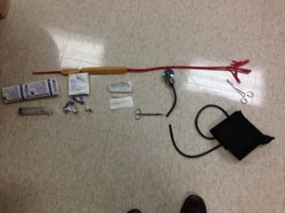
Pictures 1 & 2, Overview and close-ups of items needed

Preparation:
1. Remove and discard the white plastic plugs the Minnesota tube. You may need to use a hemostat to separate the rubber from the plastic plugs
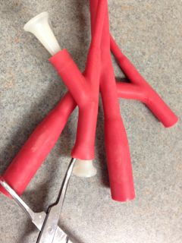
2. Remove and discard the blue plastic ends to the stopcocks. They cannot hold pressure reliably and should not be used

3. Attached the middle port of a stopcock to each of the 2 gastric balloon tubing ports and each of the 2 esophageal balloon tubing ports. 4 of the stopcocks will be used in this process. You may need hemostats to stretch open the rubber tubing to insert the stopcock.
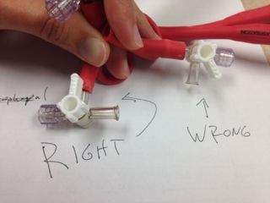

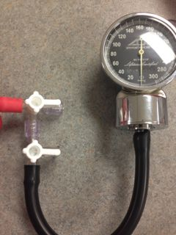
4. If one is not already attached, attach the middle or end port of one stopcock the tubing of a Sphygmomanometer Pressure Gauge.

5. Attach one double “Christmas Tree” tubing connector adapter to the esophagus aspiration tube and stomach aspiration tube.

Testing:
1. Familiarize yourself with the different balloons and how the stopcocks work. Turn all of the stopcocks so that the Off Switch is pointing towards the tubing effectively closing the tubing to the outside air.

2. Connect the 60 mL Luer-Lock Syringe to one of the stomach balloon stopcocks and suction out all of the air from the stomach balloon and then turn the dial to off again sealing it from the outside air. Do the same thing for the esophageal balloon.
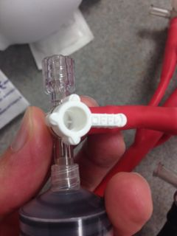

3. Practice connecting the 60 mL Luer-Lock Syringe to either stomach balloon stopcock drawing up 50 mL of air through the open side of a stopcock, turning the stopcock switch so that off faces the open port (not the syringe or the balloon port), and then fill the 50 mL of air into the balloon. Next, turn the stopcock switch back to off on the balloon, draw up 50 more mL of air through the open port of the stopcock and then turn the off switch back to the open port and fill the balloon with 50 more mL of air and then turn the off-switch back to the “close” position for the gastric balloon tubing sealing 100 mL of air in the stomach balloon.

3. Attach the stopcock on the Sphygmomanometer Pressure Gauge to the second stomach balloon rubber tubing stopcock. Open the pressure have the off switch of the pressure gauge towards the stomach balloon’s stopcock which will “zero out” the pressure reading on the pressure gauge. Prior to each reading of the pressure gauge, you need to “zero out” the pressure in the tubing to the pressure gauge or you will subsequently build up air pressure in the pressure gauge tubing and get falsely high readings.

4. After the pressure gauge is zeroed out, turn its stopcock off switch to the outside air and it is open to the stomach balloon stopcock. Next open the stomach balloon stopcock so that the off switch is to the outside air. Air pressure in the sphygmomanometer pressure gauge should now be reading what the pressure is with 100 cc of air in the stomach balloon. Turn the stomach balloon stopcock switch back to off on the balloon.
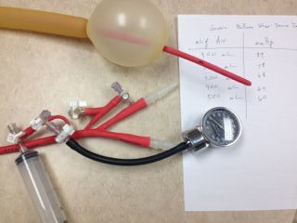

5. Repeat the filling process of the stomach balloon filling an additional 100 cc of air each time into the stomach balloon and create a table of how many mL of air correspond to how much air pressure is read. Note that since the balloon grows in size (the volume is not fixed) the volume of air insufflated into the balloon is not going to be directly proportional to the pressure). When we tested the demo model, this was the readings of pressure we got at different volumes. If you are in a hurry, measure the pressure at 100 mL and 500 mL and see how it corresponds with our table.

Stomach Balloon Volume of Air (mL) | Stomach Balloon Pressure (mmHg)
100 mL | 84 mmHg
200 mL | 78 mmHg
300 mL | 68 mmHg
400 mL | 64 mmHg
500 mL | 60 mmHg

Learn how the stopcocks work and think before opening them. Inadvertently opening a balloon stopcock can quickly deflate a balloon.

6. The goal for the stomach balloon will be to have 500 cc of air in it anchoring it below the GE junction in the stomach and compressing on the entry of the varices at the GE junction. If it slides up into the esophagus the balloons volume will be constricted and the air pressure will suddenly rise and cause potential esophageal pressure necrosis. After eventually placing it in the patient and verifying location with an x-ray (example on the last page), measure what the gastric balloon pressure is inside the patient. Hopefully the pressure will be similar to that of the table. Check it several times a day. If the pressure rises to >20 mmHg, check an X-ray for tube migration.
The goal for the esophageal balloon is if the gastric balloon is unable to stop the bleeding, then to maintain a pressure of 30-40 mmHg to cause gentle pressure on the bleeding esophageal varices and tapenade them off. With this in mind, practice adjusting the esophageal balloon to a goal pressure in the next step.

7. Close all of the stomach balloon stopcocks and attached the pressure gauge stopcock to an esophageal balloon stopcock and attach the syringe to the other stopcock.

8. Inflate about 100 mL of air into the esophageal balloon and turn off the switch to the balloon.

9. Zero out the pressure gauge, and then measure the pressure of the esophageal balloon. If the pressure is above 40 mm Hg, leak out some air from the other stopcock until it comes down to 40 mmHg. If the pressure is below 40 mmHg, insufflate more air into the esophageal balloon.

10. Close off the pressure gauge stopcock and remove the gauge, and insufflate more air into the esophageal balloon in preparation for testing for leaks.

11. With both balloons filled and all the stopcocks off, submerge the balloon into a bath of water and check for leaks.

12. If no leaks, then remove all of the air from the gastric and esophageal balloons using the syringe and close all of the stopcocks. Place the tube in ice water to stiffen the tube.

Placement:
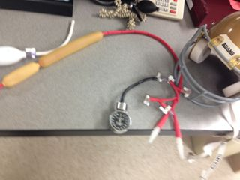
1. Intubate the patient.

2. Lubricate the Minnesota tube and introduce through the mouth, beyond the 50 cm mark.

3. If fluoroscopy is available, document the position of the balloon in the stomach (ideally the procedure should be done under fluoroscopy guidance, but in an emergency it can be done without it).

4. If fluoroscopy is not available, insufflate the stomach balloon with 100, 200, 300, 400 and 500 mL of air, watching for the balloon pressure not to exceed corresponding “baseline” pressure for each volume by more the 15 mmHg.

5. Place helmet and secure to patient’s head.

6. Pull Minnesota tube to “snug” tension and tape to helmet frame.

7. Connect “gastric aspiration” to medium suction (60-100 mmHg)

8. Connect “esophageal aspiration” to high suction (120-150 mmHg)

9. Obtain a KUB to document position of gastric and esophageal balloon.

10. If esophageal varices continue to bleed as evidenced by blood continuing to come out the esophageal aspiration, you should inflate the esophageal balloon to 40 mmHg. Deflate for at least 5 minutes every 6 hours to reassess if bleeding has stopped and to limit the likelihood of esophageal necrosis.

11. Continue routine care for variceal bleeding including antibiotics, octreotide, correcting coagulopathy and arranging urgent TIPSS.

12. Keep scissors all the time at bedside to cut tube in case of tube migration. If tube migrates and causes difficult to breath, cut the tube for rapid deflation, and then remove it.

13. Perform periodic gastric and esophageal lavage with lukewarm water to assess for continuous bleeding.

14. Obtain daily KUB to assess for stomach balloon migration.

Assessment of a patient transferred with a Minnesota Tube:

1. Obtain a STAT KUB to asses for gastric balloon location.

2. Assess the manner in which the tubes are being locked (hemostats, clamps, stopcocks?)

3. Consider clamping off all of the tubes and replacing with stopcocks.

4. With stopcocks attached, attempt to measure the pressure in the gastric and esophageal tubes without letting air out. If the esophageal balloon is not inflated and the patient is continue to bleed as evidenced by blood coming from the esophageal aspiration tube, then insufflate the esophageal balloon as described above in testing step 9 and Placement Step 10.

5. Continue routine care as described in placement step 4-14.

Troubleshooting:
The Gastric balloon must be in the stomach.

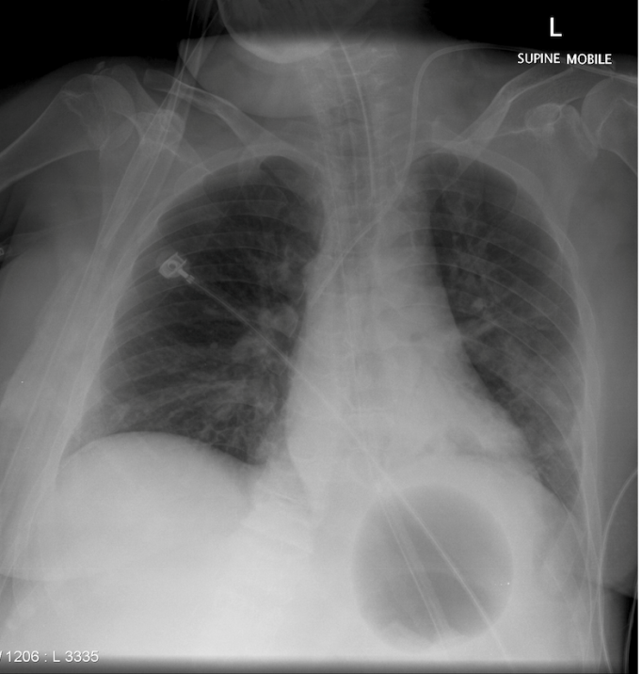
Figure 1: Correct position of gastric balloon in the stomach

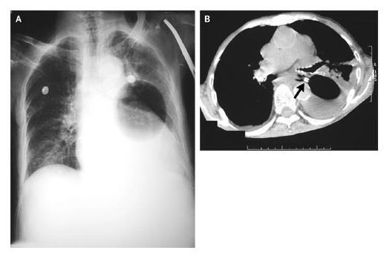
Figure 2:Malpositioned gastric balloon (Panel A). Computed tomography of the chest showed that the tube had penetrated the esophageal wall (arrow, Panel B), with the gastric balloon visible in the left pleural cavity.

