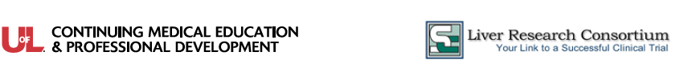
2020 Emerging Therapies for PBC, NASH and ESLD Seminar Series

Conference  Location | Washington, DC Area – June 13, 2020
  Embassy Suites by Hilton Alexandria Old Town  1900 Diagonal Road  Alexandria, Virginia, 22314 | Phone: (703)-684-5900  https://www.hilton.com/en/hotels/wasotes-embassy-suites-alexandria-old-town
Parking at the Conference | A discounted parking rate of $10 is available for all participants.  Once you enter the self-parking area, bring the parking ticket to the Seminar Registration Desk
Driving Directions | - Take 14th Street Bridge to 395 South.  - Exit King Street East. Follow King Street approximately 3 miles.  - You will pass the George Washington Masonic Temple, go under the train overpass and take right onto Diagonal Road  - The hotel will be on the left
Seminar Agenda and Syllabus Information | Registration and breakfast begin at 7:30 a.m. in the Virginia Ballroom. Please check signage for any last-minute room changes.  The Emerging Therapies seminar is a paperless program. The course syllabus and related materials will be made available on a digital app that can be accessed by a smart phone, tablet device or personal computer. Instructions to download the App will be provided to participants in advance of the seminar. Wi-Fi will be available without charge.
7:30 am | Registration, Continental Breakfast & View Exhibits
8:00 am | Opening Comments and Pre-Test
8:20 am | End Stage Liver Disease: Treatment, Managing Complications and Transplant  - Staging, workup, and diagnosis of cirrhosis  - Medical care of the patient with end stage liver disease  Liver Transplantation  - Listing criteria, MELD scores, Exceptions and the transplant process  Case Study 1 – Cirrhosis and Encephalopathy
9:25 am | Hepatocellular Carcinoma (HCC)  - Screening diagnostic serum assays and imaging tests  - Diagnosis without histology  - Treatment and management options: Ablation, TACE and Surgery
10:00 am | Break & View Exhibits
10:15 am | Hepatocellular Carcinoma: New Systemic Treatment Options  - Current FDA-Approved Therapies  - New chemotherapy regimens in development and testing  - Immunotherapy as the new MoA for HCC  Case Study 2 – Diagnosis and Treatment of Hepatocellular Carcinoma
11:00 am | Primary Sclerosing Cholangitis (PSC) and Primary Biliary Cholangitis  - Epidemiology of PSC and Ursodiol and Antibiotic Treatments  - Predicting outcomes and Improving Survival in PSC patients  - Causes and Markers of PBC  - Ursodeoxycholic Acid (UDCA) and Obeticholic Acid
11:40 am | Hepatology Update I – Viral Hepatitis  - The reemergence of Hepatitis A, Autoimmune Hepatitis and Transplanting HCV+ organs
12:15 pm | Luncheon Presentation
12:55pm | Dessert and View Exhibits
1:10pm | Hepatology Update II Emerging Topics in Liver Disease  - Alcoholic Liver Disease, Liver disease and Pregnancy, Hepatorenal sysndrome
1:40 pm | NAFLD, LAL-D and NASH  - Epidemiology, Demographics and Diagnosis  - Treatment options for thrombocytopenia; including alternatives to platelet transfusion.  - Treatment of patients with Lysosomal Acid Lipase Deficiency (LAL-D) causing adult Fatty Liver Disease
2:15 pm | Break & View Exhibits
2:30 pm | NASH Treatments in Practice and in Development  - Current therapies for NASH  - Life style changes as a therapy  - Drugs in clinical development for NASH  Case Study 3 - NASH Diagnosis and Treatment
3:30 pm | Post-test and Wrap-Up
Attendance Policies | Attendee Cancellation, Substitution, Refund  The course tuition is refundable, minus a $20 processing fee, if your cancellation is received in writing no later than seven days prior to the conference. Attendee substitutions are allowed, but notification must be made in writing seven days prior to the conference. After that date, no refunds, credits, or substitutions will be granted. No refunds or credits will be given to those who “no show.”  Recording and Photography  The University of Louisville reserves exclusive rights to record (audio and video) and/or photograph conference proceedings for use in marketing materials, future presentations and other purposes.  Guest Attendance  All conference activities (including educational sessions, meal functions, exhibit hall participation and others) are exclusively reserved for seminar participants. Non-registered guests (including children, family members, colleagues and others.) are not permitted in the seminar areas.  Conference Modification or Cancellation  The University of Louisville and SC Liver Research Consortium reserve the right to modify the course’s schedule, faculty or content if necessary. They also reserve the right to cancel this seminar, and in the unlikely event, a full refund of the registration fee will be provided. We are unable to refund any travel costs (flight, hotel, etc.) in the case of a seminar cancellation.
CME Information | Physicians (MD/DO) - The University of Louisville Office of Continuing Medical Education & Professional Development designates this live activity for a maximum of 6.0 AMA PRA Category 1 Credit(s)™. Physicians should claim only the credit commensurate with the extent of their participation in the activity.  Nurses - This program has been approved by the Kentucky Board of Nursing for 7.3 continuing education credits through University of Louisville Hospital, provider number 4-0068-7-20-1150. The Kentucky Board of Nursing approval of an individual nursing education provide does not constitute endorsement of program content.  Nurse Practitioners and Physician Assistants - AANP and AAPA accept Category I credit from AMA PRA Category 1 Credit(s)™ organizations accredited by ACCME.

Your Seminar Faculty | 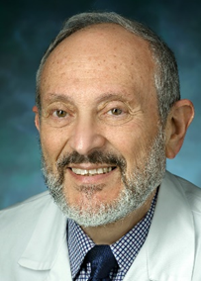  COLEMAN SMITH, MD  Dr. Smith received his medical degree from the University of Sydney, Australia and subsequently completed his internal medicine and gastroenterology training at that institution. He went on to spent three years at the University of Queensland in Australia where he completed a research doctoral thesis. He subsequently continued his research and clinical training in Denmark, at USC and Stanford University.  He moved to Minneapolis, Minnesota in 1985 where he joined the faculty of the University of Minnesota and remained there until he moved to Georgetown University in Washington, DC in 2015. He is currently a transplant hepatologist is at the Medstar Georgetown Transplant Institute and a professor of medicine at Georgetown University School of Medicine.  He is very actively involved in the American Association for the Study of Liver Diseases and has served on a number of committees including on the executive committee of the Clinical Practice Special Interest Group. He was the founding chairman of the Mid West branch of the American Liver Foundation and is currently a member of the National Medical Advisory Board of the American Liver Foundation.  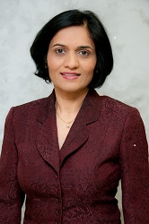  KIRTI SHETTY, MD, FACG  Dr. Kirti Shetty is currently Professor of Medicine at the University of Maryland School of Medicine and Adjunct Professor of Medicine and Surgery at Georgetown University. She serves as the Director of Hepatology at the University of Maryland.  Her clinical interests include viral hepatitis, nonalcoholic fatty liver disease, liver cancer and liver transplantation outcomes. Dr. Shetty’s research focuses on mechanisms of hepatocarcinogenesis in cirrhosis. Her ongoing translational research collaborations explore biomarkers for hepatocellular carcinoma and chemopreventive approaches in patients with cirrhosis.  Dr. Shetty has authored numerous publications in prestigious journals and has both contributed to and edited textbooks in liver disease. She attained her medical degree at Christian Medical College in Vellore, India.  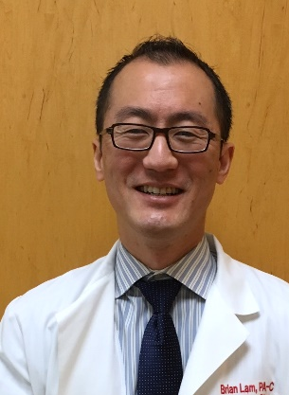  BRIAN LAM, MSHS, PA-C  As a physician assistant and research investigator in Northern Virginia, Brian Lam has enjoyed the privilege of working in hepatology for over a decade. From translational research to clinical trials and routine clinical care, he has been privileged to work with an exceptional team at Inova Health System’s Beatty Liver and Obesity Research Program and Center for Liver Disease.  Brian also has particular interests in non-alcoholic steatohepatitis and cholestatic liver diseases; he serves as an investigator in multicenter clinical trials and in Inova’s research projects in these areas. Brian looks forward to the advances in hepatology to come in the upcoming years.

