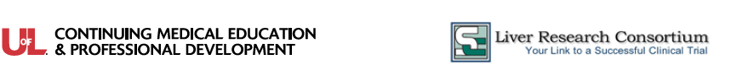
2020 Emerging Therapies for PBC, NASH, ESLD and HCC Seminar Series

Conference  Location | New Orleans, LA – June 20, 2020
  Hyatt Centric French Quarter  800 Iberville St  New Orleans, LA | Phone: (504) 586-0800  https://www.hyatt.com/en-US/hotel/louisiana/hyatt-centric-french-quarter-new-orleans/msyrf
Parking at the Conference | Reduced parking for all participants is available for $12.  Once you enter the self-parking area, bring the parking ticket to the Seminar Registration Desk
Driving Directions | Drive from I-10 E to New Orleans. Take exit 232 from I-10 E  - Continue on US-61 S. Take Tulane Ave to Iberville St  - Merge onto US-61 S/Airline Hwy  - Continue onto Tulane Ave  - Turn right onto Loyola Ave  - Turn left onto Gravier St  - Turn left onto O'Keefe Ave  - Continue onto Roosevelt Way and Continue onto Burgundy St  - Turn right onto Iberville St. The hotel is on the right
Seminar Agenda and Syllabus Information | Registration and breakfast begin at 7:30 a.m. in the Orleans Room. Please check signage for any last minute room changes.  The Emerging Therapies seminar is a paperless program. The course syllabus and related materials will be made available on a digital app that can be accessed by a smart phone, tablet device or personal computer. Instructions to download the App will be provided to participants in advance of the seminar. WiFi will be available without charge.
7:30 am | Registration, Continental Breakfast & View Exhibits
8:00 am | Opening Comments and Pre-Test
8:20 am | End Stage Liver Disease: Treatment, Managing Complications and Transplant  - Staging, workup, and diagnosis of cirrhosis  - Medical care of the patient with end stage liver disease  Liver Transplantation  - Listing criteria, MELD scores, Exceptions and the transplant process  Case Study 1 – Cirrhosis and Encephalopathy
9:25 am | Hepatocellular Carcinoma (HCC)  - Screening diagnostic serum assays and imaging tests  - Diagnosis without histology  - Treatment and management options: Ablation, TACE and Surgery
10:00 am | Break & View Exhibits
10:15 am | Hepatocellular Carcinoma: New Systemic Treatment Options  - Current FDA-Approved Therapies  - New chemotherapy regimens in development and testing  - Immunotherapy as the new MoA for HCC  Case Study 2 – Diagnosis and Treatment of Hepatocellular Carcinoma
11:00 am | Primary Sclerosing Cholangitis (PSC) and Primary Biliary Cholangitis  - Epidemiology of PSC and Ursodiol and Antibiotic Treatments  - Predicting outcomes and Improving Survival in PSC patients  - Causes and Markers of PBC  - Ursodeoxycholic Acid (UDCA) and Obeticholic Acid
11:40 am | Hepatology Update I – Viral Hepatitis  - The reemergence of Hepatitis A, Autoimmune Hepatitis and Transplanting HCV+ organs
12:15 pm | Luncheon Presentation
12:55pm | Dessert and View Exhibits
1:10pm | Hepatology Update II Emerging Topics in Liver Disease  - Alcoholic Liver Disease, Liver disease and Pregnancy, Hepatorenal syndrome
1:40 pm | NAFLD, LAL-D and NASH  - Epidemiology, Demographics and Diagnosis  - Treatment options for thrombocytopenia; including alternatives to platelet transfusion.  - Treatment of patients with Lysosomal Acid Lipase Deficiency (LAL-D) causing adult Fatty Liver Disease
2:15 pm | Break & View Exhibits
2:30 pm | NASH Treatments in Practice and in Development  - Current therapies for NASH  - Life style changes as a therapy  - Drugs in clinical development for NASH  Case Study 3 - NASH Diagnosis and Treatment
3:30 pm | Post-test and Wrap-Up
Attendance Policies | Attendee Cancellation, Substitution, Refund  The course tuition is refundable, minus a $20 processing fee, if your cancellation is received in writing no later than seven days prior to the conference. Attendee substitutions are allowed, but notification must be made in writing seven days prior to the conference. After that date, no refunds, credits, or substitutions will be granted. No refunds or credits will be given to those who “no show.”  Recording and Photography  The University of Louisville reserves exclusive rights to record (audio and video) and/or photograph conference proceedings for use in marketing materials, future presentations and other purposes.  Guest Attendance  All conference activities (including educational sessions, meal functions, exhibit hall participation and others) are exclusively reserved for seminar participants. Non-registered guests (including children, family members, colleagues and others.) are not permitted in the seminar areas.  Conference Modification or Cancellation  The University of Louisville and SC Liver Research Consortium reserve the right to modify the course’s schedule, faculty or content if necessary. They also reserve the right to cancel this seminar, and in the unlikely event, a full refund of the registration fee will be provided. We are unable to refund any travel costs (flight, hotel, etc.) in the case of a seminar cancellation.
CME Information | Physicians (MD/DO) - The University of Louisville Office of Continuing Medical Education & Professional Development designates this live activity for a maximum of 6.0 AMA PRA Category 1 Credit(s)™. Physicians should claim only the credit commensurate with the extent of their participation in the activity.  Nurses - This program has been approved by the Kentucky Board of Nursing for 7.3 continuing education credits through University of Louisville Hospital, provider number 4-0068-7-20-1150. The Kentucky Board of Nursing approval of an individual nursing education provider does not constitute endorsement of program content.  Nurse Practitioners and Physician Assistants - AANP and AAPA accept Category I credit from AMA PRA Category 1 Credit(s)™ organizations accredited by ACCME.
Your Seminar Faculty | 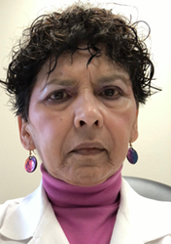  SHOBHA JOSHI, MD  Dr. Joshi received her medical degree from the University of Bombay, India. After completing her Internal Medicine training at the Sinai Hospital of Baltimore and LSU Affiliated Program, she did her clinical and research Gastroenterology fellowship at Tulane University and the University of Pittsburgh.  She was an Associate Professor of Medicine at St. Louis University School of Medicine, where in addition to doing basic research, she took care of liver transplant patients and general hepatology patients.  In December 2008, Dr. Joshi joined Ochsner Clinic Foundation as Director of Hepatology Research and Transplant Hepatologist where she has I incorporated the TeleECHO model to guide and educate providers on liver disease management, so they can manage their own patients for their hepatitis C or detection of Hepatocellular carcinoma  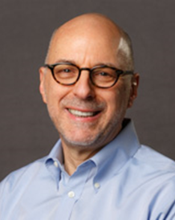  FREDRIC REGENSTEIN, MD  Fredric Regenstein, MD is the Medical Director of Liver Transplantation and a Professor of Clinical Medicine, Tulane University School of Medicine, New Orleans, Louisiana.  Dr. Regenstein received his MD degree from the Washington University School of Medicine. He completed his Internship and Residency in Medicine at Barnes Hospital, St. Louis, Missouri, and his Fellowship in Gastroenterology at Washington University School of Medicine.  Dr. Regenstein has more than 30 years of hepatology experience. His clinical and research interests include viral hepatitis, liver transplantation, and innovative therapies for hepatocellular carcinoma, cholestatic liver disease and nonalcoholic steatohepatitis. Dr. Regenstein is a Fellow of the American College of Gastroenterology and a member of the American Gastroenterological Association, AASLD, EASL, AST and the International Liver Transplant Society.  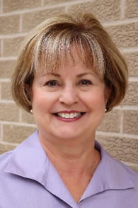  CYNTHIA BENZ DNP APRN  Cynthia Benz DNP APRN was certified as a Clinical Nurse Specialist in 1981. In her role as a CNS she has focused on the care of the chronically ill patient, with the last 18 years in Hepatology. She graduated with honors from Louisiana State University School of Medicine In New Orleans.  She is currently employed at the Southeast Louisiana Veterans Health Care System in GI/Hepatology. Additionally, Dr. Benz precepts graduate students from the University of South Alabama.

