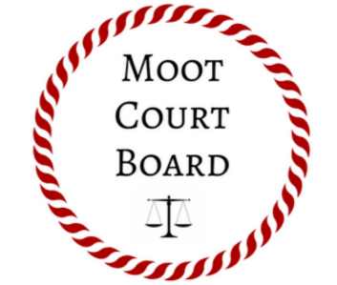
2021-2022 Moot Court Team Application

Please rank the following moot court teams 1-8 (#1 being your most preferred team).
Labor and Employment Law Team: _____
Workers’ Compensation Law Team: _____
National Appellate Team: _____
Arbitration Team: _____
Civil Rights and Liberties Team: _____
Client Counseling Team: _____
National Mock Trial Team: _____
Intrastate Mock Trial Team: _____
For your top two teams, please describe why you would be a good “fit” for the team.

Why are you interested in moot court/mock trial?

Any final thoughts you would like to share?

Please attach a writing sample (preferably an appellate brief) and any moot court score sheets along with this application*

