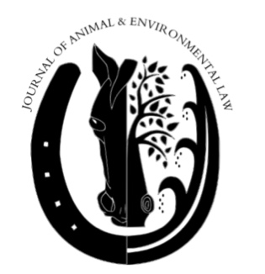
JOURNAL OF ANIMAL AND ENVIRONMENTAL LAW (JAEL)
Information Sheet and Interest Statement

On behalf of JAEL, thank you for your interest in becoming a member. Please review the following instructions to ensure you have a completed application for our review:

- Please attach a completed information sheet and interest statement (see below).
- Please attach a copy of your current resume that includes your GPA.
- Please attach a copy of a writing sample (10 pages).
- Make sure that your application is all in one PDF document. Please do not submit multiple documents.

Please submit your application materials as attachments via email to JAEL’s Executive Editor, Matt Shahroudi at Matthew.Shahroudi@louisville.edu no later than 5:00 PM on Friday, May 14th. You will receive an email confirming receipt of your application materials. We will not review applications submitted past the deadline.

Please note that if you are extended an offer for membership, you will be expected to attend an orientation prior to the first day of Fall 2021 classes. Do note that all information provided in your application materials must adhere to the Honor Code. In submitting your application materials, you agree that all information provided is in compliance with the Honor Code.

In evaluating applicants, JAEL takes a holistic approach. The extenuating circumstances of the past year have had varying impacts on many students, and we know that your GPA is not always determinative of how much you can contribute to legal scholarship. While grades may be considered in some circumstances, we will evaluate the totality of your application in making a determination on whether to extend membership. All students in good standing with the university, and who possess a solid writing background, are invited to apply.

Good luck! Thank you again for your interest in applying for JAEL membership. Should you have any questions about the application process or membership duties, please contact JAEL’s Editor-in-Chief, Brian Fields at Brian.Fields@louisvill.edu, JAEL’s Executive Editor, Matt Shahroudi at Matthew.Shahroudi@louisvill.edu, or JAEL’s Associate Editor, Henna Khan at Henna.Khan@louisville.edu.

Name: ________________________________________________________________

Year for 2021-2022 (highlight one): 2L 3L 4L

Other Division for 2020-2021 (highlight one): Full-time Part-time

Primary email address: __________________________________________________

Secondary email address: ________________________________________________

Lawyering Skills professor: ______________________________________________

Grade received in Lawyering skills Fall semester ___________ Spring semester__________

Phone Number:________________________________________________________

Are you interested in Animal or Environmental Law? (circle one, or both, if applicable):

Animal only Environmental only Both

-------------------------------------------------------------------------------------------------------------------

INTEREST STATEMENT
-------------------------------------------------------------------------------------------------------------------

In 350 words or less, please explain why you are interested in becoming a member of JAEL and what issues within Animal or Environmental Law that you are particularly interested in.

