2017 STUDENT BAR FOUNDATION
FELLOWSHIP APPLICATION INSTRUCTIONS

Dear Applicant,

On behalf of the Student Bar Foundation, thank you for your interest in public interest work. Your ambitions will allow you to serve under-represented communities while gaining your own professional experiences. We work hard to provide financial assistance to students like you, and do not take this honor lightly.

The attached fellowship application is quite straightforward. It is designed to allow you to paint a complete picture of your position, and the assistance you need to make it a reality. To qualify for a Student Bar Foundation Fellowship, you must already have a position secured. It is therefore incumbent on you to arrange for supervised legal work with a legal services organization, or other organization providing law-related public interest work. Please contact me, or reach out to the Office of Professional Development, if you are interested in public service work this summer but have not yet secured a placement.

Funding will vary based on need, but no fellowship will be less than $250. We encourage you to apply for funding even if you have secured other financial assistance. We exist to make public service work more accessible for fellow students, and recognize the varying levels of need amongst our student body related to life outside of law school, particularly where your placement is geographically.

Fellows will work with The Student Bar Foundation and The Office of Professional Development to receive their funding upon selection. Fellows pledge to attend an All Fellows Meeting in late August 2017, to donate at least ten hours of time to the Student Bar Foundation fundraising over the school year, and to assist at the Spring 2018 Silent Auction.

The Fellowship application is due Monday May 15th, 2017 at 5:00 p.m.

Please submit your application via jamorg02@louisville.edu, or hard copy to my mailbox on the basement. Fellowship awards will be determined in a timely manner. The Student Bar Foundation reserves the right to request additional information to better understand an applicant’s placement. Every effort will be made to notify all applicants of their awards by Friday May 19, 2017 at 5:00 p.m.

Please contact me with questions, and thank you for your interest in public service work.

Thank you,
Jessica Morgan
2016-2017 Chair, Student Bar Foundation
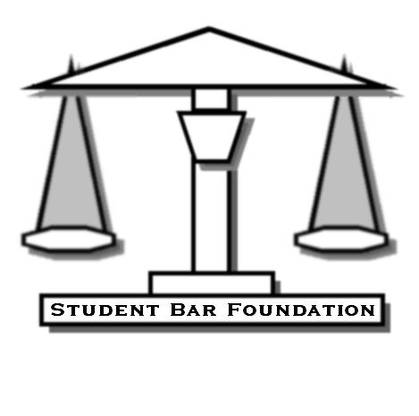

OUR MISSION
The Brandeis School of Law Student Bar Foundation is a student lead fundraising body providing fellowships to law students serving in local, state, and national public service organizations. Our goals include:

- Delivery of legal services to underrepresented communities
- Law-related public education
- Improvement of the judiciary, the legal profession, and access to the justice system

As lawyers, law students, and citizens, we are asked to contribute to our communities through public service, as described in Model Rule of Professional Conduct 6.1.

The Student Bar Foundation strives to support these values among the Brandeis School of Law student body, by fundraising and providing fellowships to students wishing to serve their communities through summer public service.

2017 STUDENT BAR FOUNDATION

FELLOWSHIP APPLICATION

APPLICATIONS MUST BE SENT VIA EMAIL (jamorg02@lousisville.edu) OR PLACED IN JESSICA MORGAN’S MAILBOX BY 5PM ON MONDAY, MAY 15th.

NAME:

ADDRESS:

PHONE:

EMAIL:

YEAR IN LAW SCHOOL:

Name of Summer 2017 Placement:

Hours of work per week and in total over summer:

Supervisor name and contact information:

Underrepresented communities served:

Please attach 1) a Resume, 2) a Statement of Interest, and 3) an Estimated Summer 2017 Budget to this application in three separate documents. Please complete the certification form on the following page.

Your Statement of Interest should one single spaced page describing your placement, your commitment to public service, and how your work connects with our mission. Your estimated budget must include living expenses, other expenses like transportation, as well all outside funding you are projected to receive.

2017 STUDENT BAR FOUNDATION

CERTIFICATION FORM

I certify that all information provided in this application and in my attached documents is complete, and correct to the best of my knowledge.

Signature of Applicant_______________________________

Date__________________

I pledge that if I am funded, I will attend the All Fellows Meeting in late August, will volunteer at least ten hours to the Student Bar Foundation’s 2018 fundraising, and will assist at the Spring 2018 Silent Auction.

Signature of Applicant_______________________________

Date__________________

