Survival Tips For Online Learning



**15 seconds each arm**

**For your arms and shoulders:** Grab one elbow and pull towards your shoulder. Switch sides.

* Set an alarm to take stretch breaks away from your computer screen at least once every 2 hours
* Stand up and walk around the room while listening to lectures to stretch your legs and back
* Get outside to get some fresh air for 10-30 minutes mid-day and toward the end of the work day
* Get some exercise, whether you participate in a virtual workout class or go outside for a walk/run, do so 4-6 days/ week for 30-60 minutes
* Do the following stretches frequently during the day while at your computer/ work station

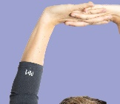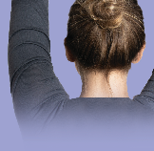

**15 seconds**

**For your arms and shoulders:**

Interlace ﬁngertips, ﬂip palms to face upwards

and straighten arms above your head.



For your wrists: Flatten palms against wall. Switch directions and point fingertips down. 10 seconds each position

For your wrists: Rotate from left to right 10-15 times each direction