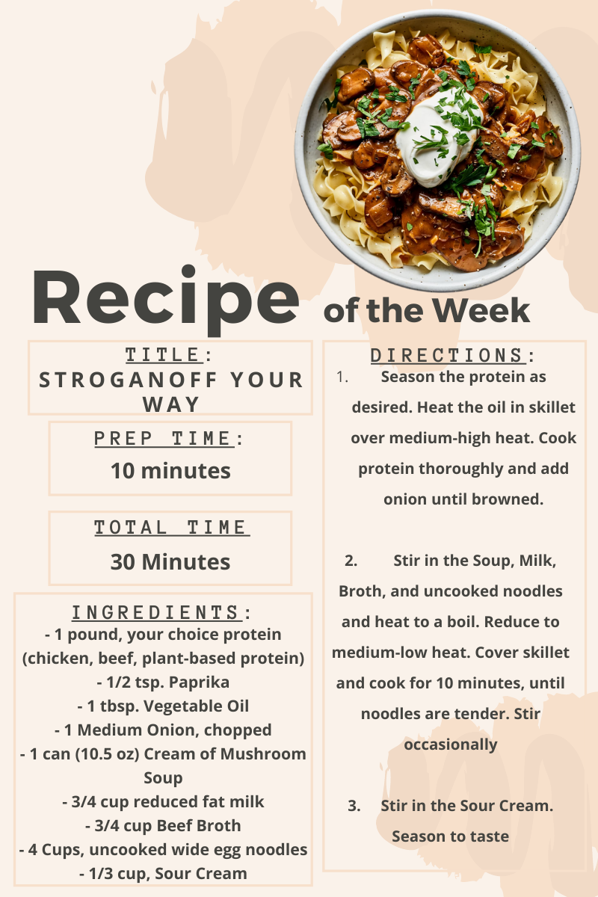  Simple Meal Ideas:  Stroganoff Your Way | Nutrition was once overlooked when it came to living a healthier lifestyle. We know how impactful our dietary choices and habits are to our wellbeing, but making positive changes can sometimes be overwhelming. It is important to remember a diet isn’t what new fad we choose to eat in line with on any given day—it is what we habitually eat. One way to take some stress out of the dietary conversation is to make simple meals that don’t require too much time or guesswork. Check out this simple recipe! A delicious meal you can make your own, ready to eat in 30 minutes.

