Diversity, Ethics, and Personalized Medicine Research
By: Dr. Kyle Brothers
There was a time when the aim of every ambitious biomedical researcher was to discover a “silver bullet.” If only we could find the right treatment, this logic went, we could cure everyone with a disease. While this approach did result in a few remarkable success stories, it became apparent over time that the best we could hope for were treatments that helped most patients.
Over the past 15 years, however, suspicion has grown that the reason no single treatment works for every patient is that we are attempting to use one-size-fits-all interventions to treat dissimilar patients with subtly dissimilar diseases. This suspicion has evolved into a whole field of research focused on dividing diseases and patient populations into smaller and smaller subgroups. Because these subgroups will contain patients with more similar individual characteristics and more similar pathophysiology, it is hoped that they will also respond more similarly to treatments. This new field – usually referred to as “personalized medicine” – focuses on discovering the biological markers that healthcare providers may one day use to separate out patients who will respond to a specific treatment. The majority of research in this area currently focuses on genetic variants to identify these patient subgroups.
In this short article I want to draw attention to a few ethical challenges having to do with race that are relevant to personalized medicine. It may not seem obvious that there is a link between personalized medicine and issues related to diversity, but in fact the connection is extremely important. There are a number of issues that I could raise. But for this short piece, I’ll focus on the way that genetic association studies, the types of research studies that are needed for personalized medicine, usually have to be performed in only one racial group at a time. This has raised problems for making sure that personalized medicine can benefit patients from all racial and ethnic groups, and draws attention to the importance of performing biomedical research in subjects from diverse backgrounds.

Genetic Association Studies and Race
Before healthcare providers can use a genetic variant to predict whether a patient will respond to a specific treatment, genetics researchers must first discover which genetic variants are more common in patients who respond to a treatment. They do this using a type of study called a “genetic association study.”
This type of study is demonstrated in Figure 1.
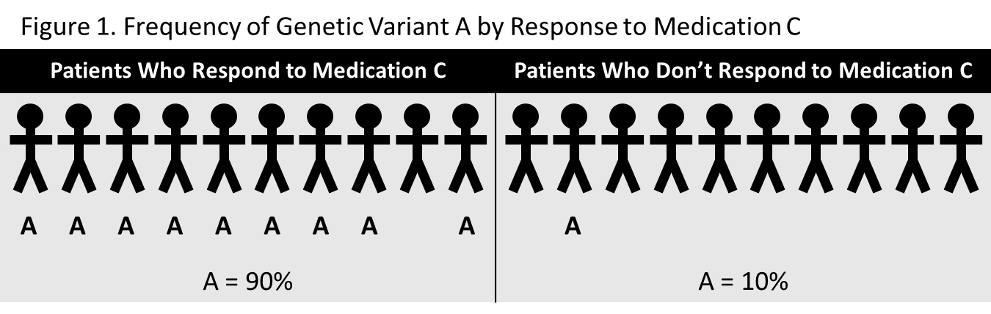

Researchers compared how frequently genetic variant A occurred in a group of patients who had received benefit from Medication C. They compared this to the frequency of genetic variant A in patients who did not respond to Medication C. From this, they were able to see that having genetic variant A seems to greatly increase the chances that a patient will respond to the medication. If they are able to replicate this finding in additional studies, doctors might one day test patients for genetic variant A before decided whether to prescribe Medication C.
While this may sound straightforward in principle, there is often a “catch.” Not all genetic differences affect our risk for developing a condition or responding to a treatment. In fact, our genomes differ at thousands of different locations. Some of these differences influence our risk for developing a disease, some influence things like how tall we will be, and some have absolutely no measurable effect on us – they are “neutral”. Even though we are all different in this way, two persons with ancestors from the same continent (such as Africa or Europe) share many of the same variants. Some of these are important for health, others are neutral.
Imagine what would happen, then, if researchers used a genetic association study to look for a genetic variant that is associated with a disease or a medication response that is especially common in one racial group. We can take Type 2 diabetes as an example, since this condition is somewhat more common in black patients than it is in white patients of the same age. Figure 2A shows how a genetic association study using a diverse set of patients with diabetes might turn out. In this study, it appears that genetic variant B is associated with risk for developing diabetes, since it is twice as common in patients with diabetes compared with patients who do not have diabetes.
But there is a catch! Because diabetes is more common in black patients, it turns out that black patients ended up being overrepresented in the sample of patients who have diabetes. Figure 2B breaks down the frequency of genetic variant B by race. It turns out that this genetic variant is much more common in black patients than it is in white patients, but these frequencies have nothing to do with risk for developing diabetes. We might infer that genetic variant B emerged in ancestral populations in Africa, and is therefore only found in patients who have ancestors from Africa. But it is perfectly possible that this variation is neutral – it has absolutely no effect on diabetes risk or other characteristics that people might develop.

Separate but Equal?
We can see from the example in Figure 2 that genetic ancestry can be a confounder for genetic association studies. In fact, this phenomenon is so important that genetics researchers usually have to separate out research subjects according to their genetic ancestry. For researchers in the United States, this means that scientists interested in finding genetic associations for diabetes or for a response to a medication need to perform a study once in patients with African ancestry and again in patients with European ancestry.
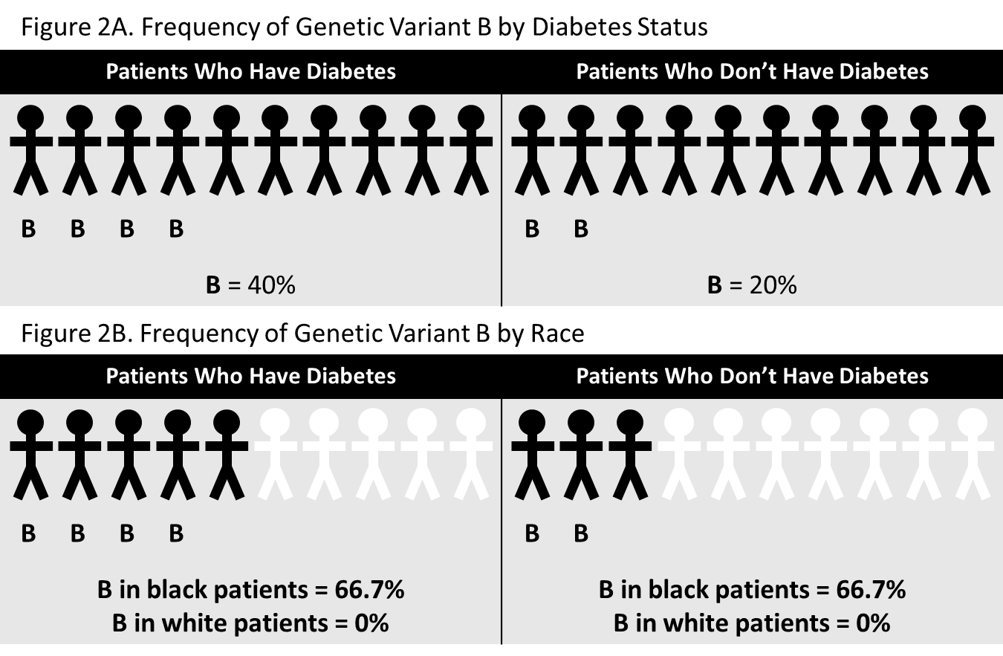

This approach would be largely unproblematic were it not for a number of “real-world” limitations that make it difficult for researchers to perform every genetic association study in every genetic ancestry group. There are greater numbers of persons in the US whose genetic ancestry is primarily from Europe compared with other genetic ancestry groups. And in certain areas, including a few where many genetics researchers work, this majority is particularly large.
The disparity in population sizes creates problems, since large sample sizes are needed for these types of studies. The examples I provided in Figures 1 and 2 involved only twenty research subjects each. But in real genetic association studies researchers may need to recruit 100, 1000, or even 2000 research subjects in order to identify a genetic association. And a large percentage of these participants must have a particular disease of interest. Because of this and a number of other factors, genetic association studies in the US have been performed disproportionately with patients from the largest ancestry group – those with European ancestry. In fact, a group of researchers reported in 2010 that between 50 and 60% of all genetic association studies performed with National Institutes of Health (NIH) funding in the previous 5 years involved persons of European ancestry only.
My concern about this matter is perhaps all too obvious. If it is true that personalized medicine is going to lead to better medical care, then disparities between the groups that are being studied could lead to disparities in the benefit minority groups receive from this research. Research findings generated from studies that involved only patients of European ancestry are not as relevant for patients from different ancestry groups. If researchers tend to discover primarily those variants that are important for patient of European ancestry, then patients with African ancestry, or Native American ancestry, or Asian ancestry may not reap the same benefits of this research.

