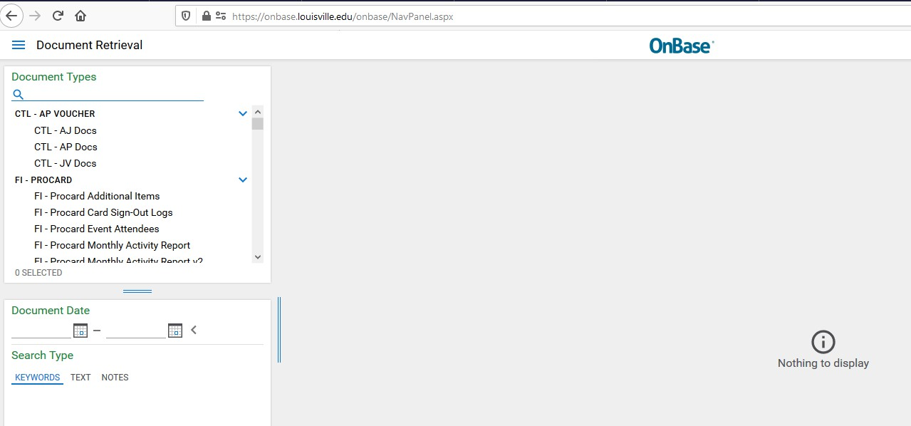
Uploading Performance Appraisals to OnBase
2021
Designated users from each department/unit can upload performance appraisals to OnBase. If a designated user needs access, please contact Human Resources at hrbpsvcs@louisville.edu and a ticket will be submitted for the designee to gain access. Follow the steps below to upload and retrieve performance appraisals on the web version of OnBase.

Upload Performance Appraisals to OnBase – Web Version:

- Go to https://onbase.louisville.edu and log in using UofL userID and password.
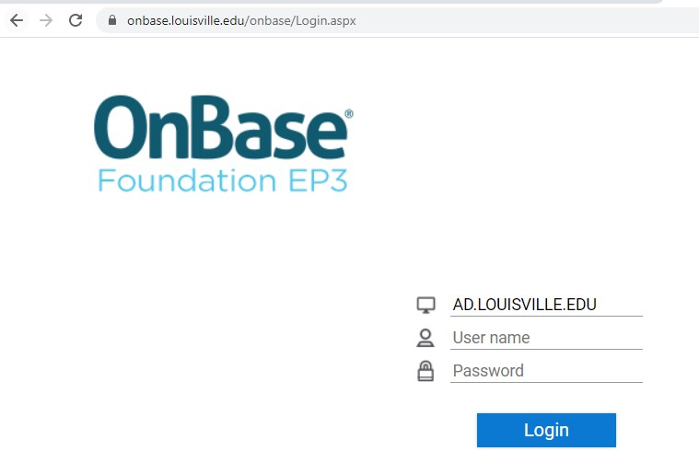
- Click on the Menu icon then Document Retrieval.

- Click on Import Document from menu.
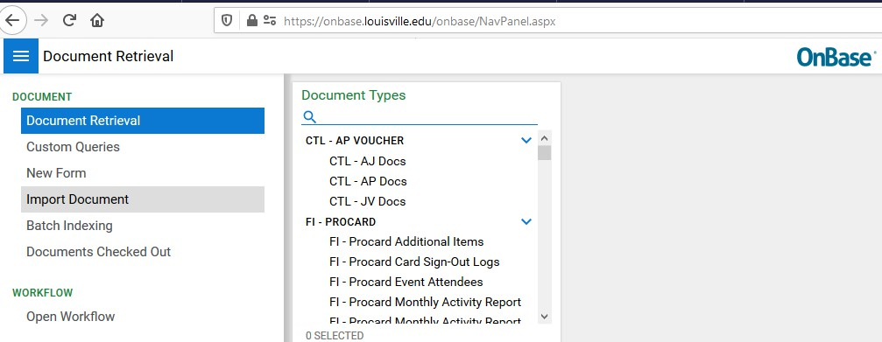

- Click on Document Type Groups and select HR-Performance. Make sure the following fields in the Import Settings are populated with the following:
  - Document Type: HR – Performance Appraisal
  - File Type: PDF (.???)

Note: If you do not see this group, you do not have access to upload the appraisals for your Supervisory Organization and you should contact hrbpsvcs@louisville.edu for access.
- Enter in data for the following required fields: Employee ID, (HR) PA Year, (HR) PA Score, (HR)Type of Review and (HR) Completion Date. Note: the abbreviation PA stands for Performance Appraisal. 2023 should be entered in the (HR) PA Year field.
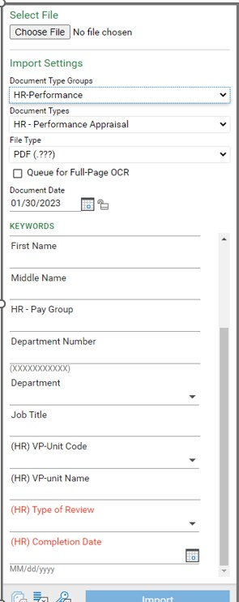
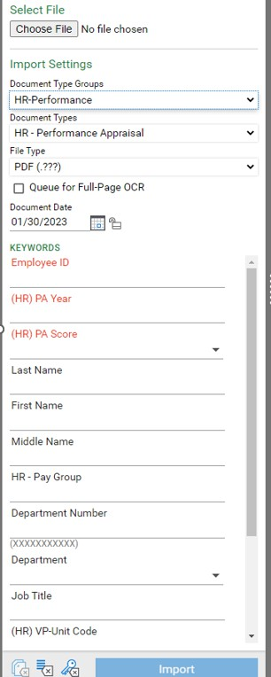
- Information should pull directly from system to populate the rest of the fields, if it doesn’t, please enter the department number.

- Go to the top of the menu and click Browse under Select File and import/upload the appraisal for the employee you have specified.
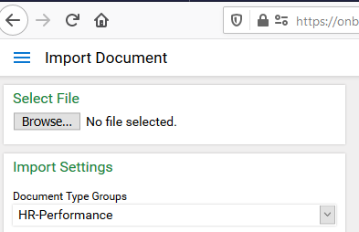

- Your document will populate in the window and then select Import at the bottom of the page.
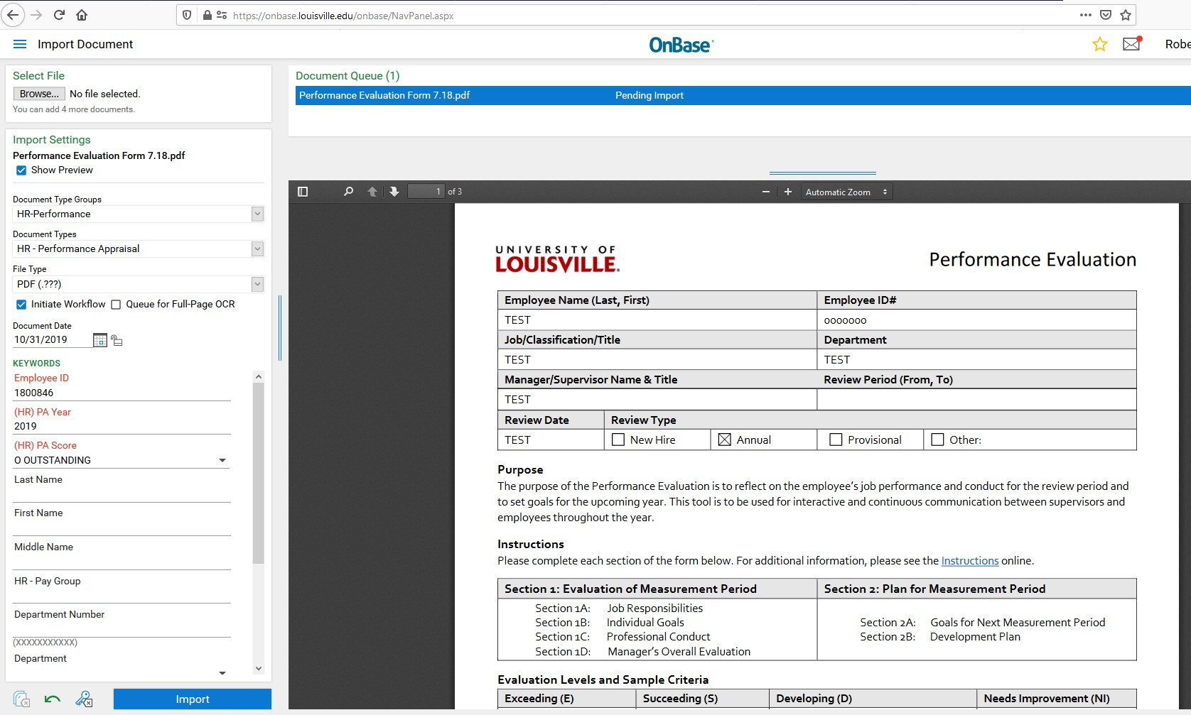

- Once uploaded, you’ll receive a message that it was Imported Successfully.
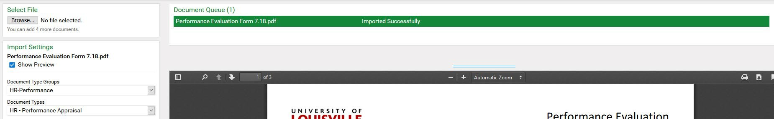

- To Retrieve/View the uploaded document, click on the menu icon at the top left and select

Document Retrieval.

- Under Document Types, scroll to find HR-Performance or type in HR-Performance and select HR – Performance Appraisal.
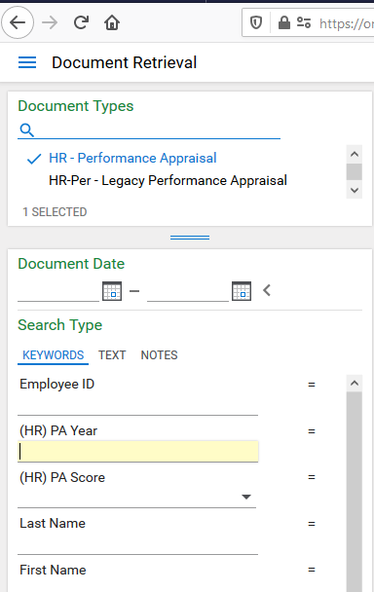

- Enter the criteria you wish to retrieve (e.g., employee ID number, name, etc…)

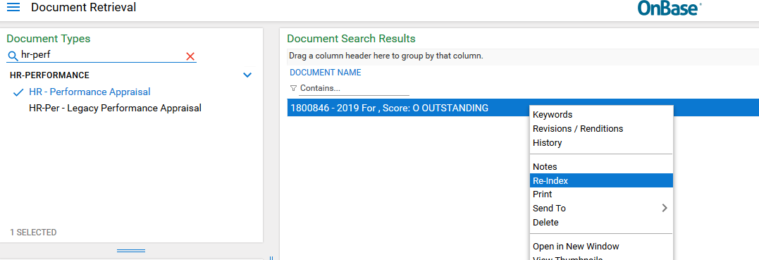
- If updates need to be made to the document, right click on the document, make the updates and click Re-Index.

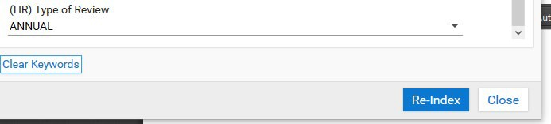

- If you need to delete a duplication, please contact Human Resources at hrbpsvcs@louisville.edu with the employee’s name and employee ID number, and what information will need to be updated.

- If you have technical questions regarding the uploading of Performance Appraisals to OnBase, please contact the ITS Help desk at helpdesk@louisville.edu.

