Uploading Performance Appraisals to OnBase

Designated users from each department/unit can upload performance appraisals to OnBase. If a designated user needs access, please contact Human Resources at hrbpsvcs@louisville.edu and a ticket will be submitted for the designee to gain access. Follow the steps below to upload and retrieve performance appraisals on the Unity Client.
If you do not currently have OnBase, you will need to install the Unity Client, which requires Microsoft Edge or Internet Explorer 11 and above. https://onbase.louisville.edu/InstallUnity/UnityClientPROD.application - When downloading it may it may require Tier 1/tech support from your area if you do not have the permission to download. If you aren’t sure if you have OnBase, type Hyland Unity in your Windows search bar at the bottom left of your computer. If the OnBase icon does not appear, you will need to install the application or use the web version. The web version of OnBase: https://onbase.louisville.edu may require certain installation prerequisites.

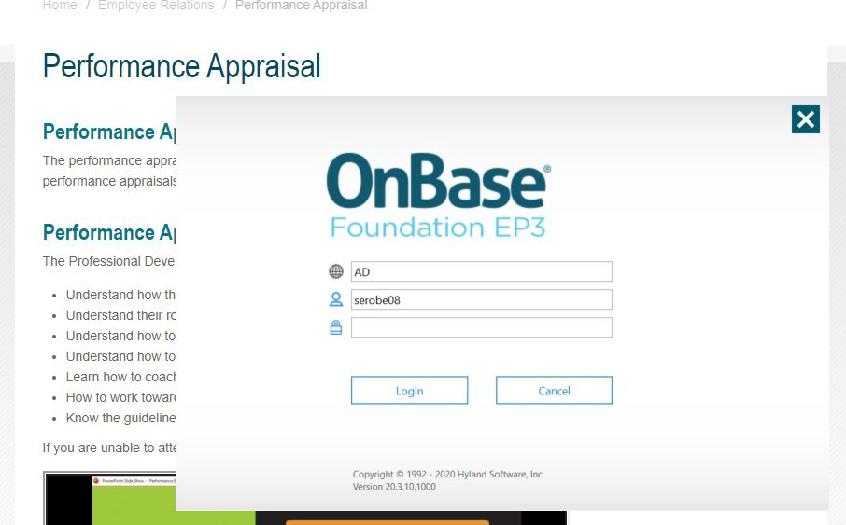
Upload Performance Appraisals to OnBase – Unity Client:
- Once you have installed the OnBase Unity Client, you will need to log in using your UofL user ID and password. You must also be using the AD domain to get into OnBase, if you are using a different domain, this will unfortunately not work, so please make sure you are logged into an appropriate workstation.

- From the Home tab click on the Import icon, this will open a new tab to import the documents.
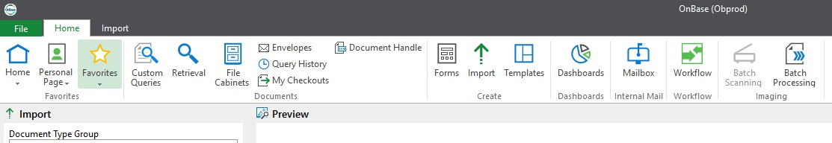

- Select from the drop-down arrows:

  - Document Type Group - select HR-Performance

Document Type – select HR – Performance Appraisal
  - The File Type will auto-populate to PDF, but you can change this to Image File Format if using an OnBase scanner. See below for suggestions on File Type as this pertains to where the PAs are retrieved and then uploaded.

    - Browse – document will be a pdf, as it was previously scanned using a scanner or copier not linked to OnBase and saved on your computer. Select PDF for File Type.
    - Acquire – document will be scanned directly into OnBase with a scanner linked to OnBase, select Image File Format for File Type.
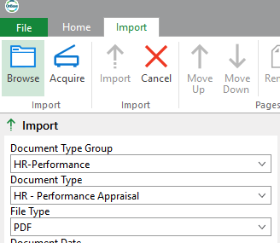
    - If unsure as to what the file type is, look at the extension of the document to be uploaded (i.e. .pdf, .jpeg, etc.).

All sections to be completed

- Once the Document Type and File Type sections are completed, five required Keywords will appear: Employee ID, (HR) PA Year, (HR) PA Score, (HR) Type of Review and (HR) Completion Date. Please enter in the data for these fields as appropriate.
  - The abbreviation PA stands for Performance Appraisal.
  - The fields not highlighted in red will auto-populate after the Employee ID has been entered.
  - 2023 should be entered in the (HR) PA Year field.
  - The (HR) PA Score will have a dropdown menu, please select the appropriate score.
  - The (HR) Type of Review will have a dropdown menu, please select the appropriate type: Annual, Mid-Year, Provisional or New Employee Expectations
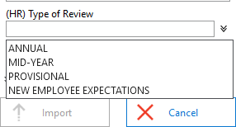
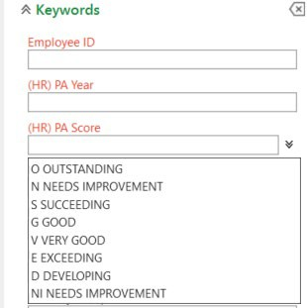
  - The (HR) Completion Date use the pop-up calendar provided to enter date of when PA was reviewed and completed with employee

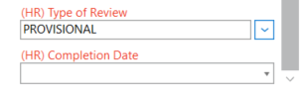

- Once all fields are completed, you may click on Browse or Acquire referenced in #3.
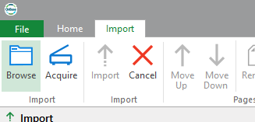
- Retrieve the document where you initially saved the performance appraisal on your computer; the document name does not matter as it will automatically change when uploaded.
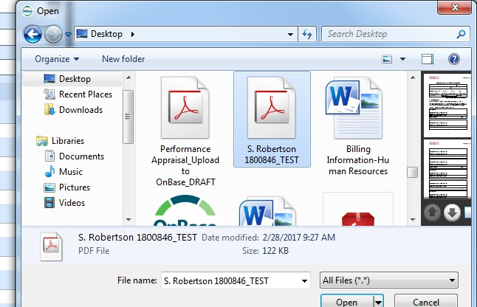

- Select Import.
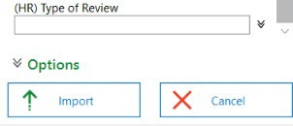

- If not all Keywords are typed in when you select Import, an error box will appear. Please select
OK and complete the missing field(s) and select Import again.
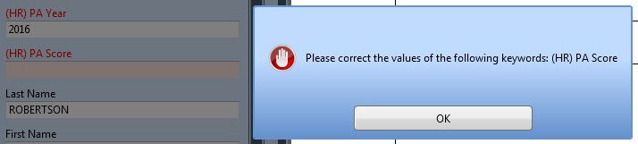

- The uploaded performance appraisal will be previewed in the window and once completed will be displayed into a new window. A notification will appear on the right bottom corner when your document has been uploaded successfully.

Employee ID – YEAR for Last Name,First Name Score:
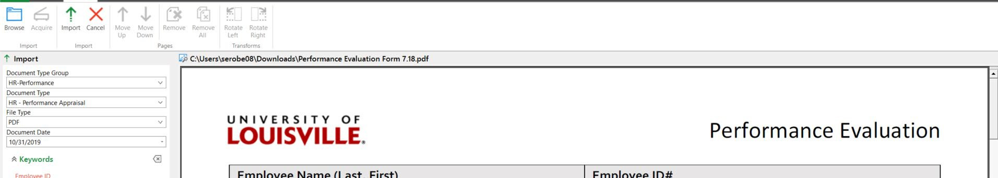


- The employee’s performance appraisal is now in OnBase and you can proceed to upload the next performance appraisal.

View Scanned Performance Appraisals in OnBase:
- To view your scanned performance appraisals, please go to Retrieval under the Home tab, select
HR-Performance from the drop-down menu and click on HR – Performance Appraisal.

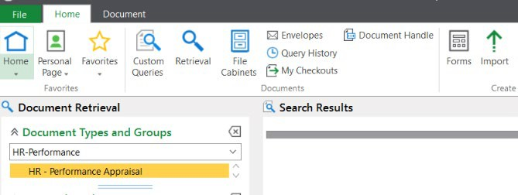

2021

2021
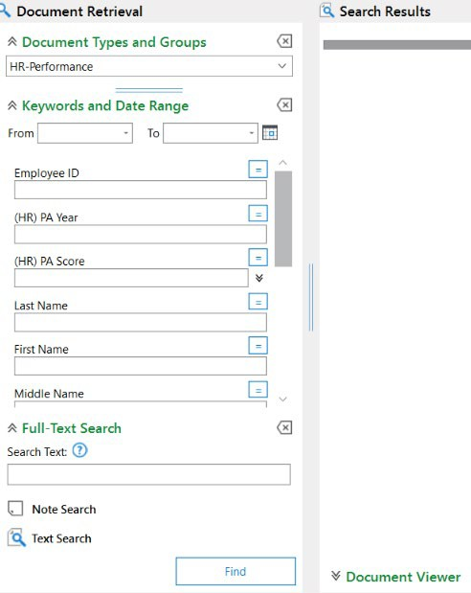
- Enter any keywords that you wish to search; employee ID, Year, Last Name, etc. Press enter on your keyboard or select Find located at the bottom.

Enter other Keywords to narrow search

- If you have pulled your list from above and realize that the score was entered incorrectly, the wrong document uploaded, or duplicated PA entry, please right click on the document and select Re-Index.
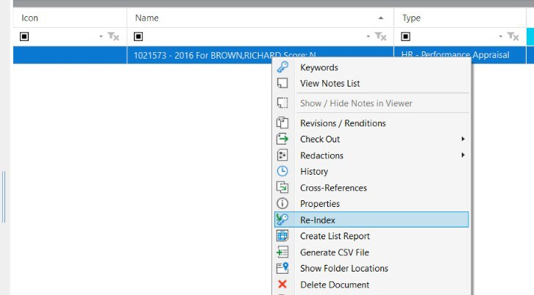

- You can update the mandatory Keyword fields, then click on Re-Index at the bottom, for any errors.

If you need to delete a duplication, please contact Human Resources at hrbpsvcs@louisville.edu with the employee name and employee ID number, and what information will need to be updated.
If you have technical questions regarding the uploading of Performance Appraisals to OnBase,please contact the ITS Help desk at helpdesk@louisville.edu.

