LITERATURE SEARCHING: SOME STRATEGIES

Literature Review Guide: louisville.libguides.com/litreview
Getting things we don’t have at UofL, or getting a digital copy when we have the hard copy only in the stacks. . .
InterLibrary Loan (ILL): A service available to the students, staff, and faculty at UofL. ILL specializes in obtaining study and research materials needed by members of the UofL community that are not owned by the Libraries. We do this by borrowing items or requesting photocopies of items located at other libraries around the world. We can obtain nearly anything that has been published, including books, journals, video and audio recordings, and microforms.
While we strive to obtain materials as quickly as possible, delivery time depends on the scarcity of the item and the institution lending the item. Ekstrom pays up to $20.00 towards obtaining an item. For items above $20.00, the patron will be asked to pay the difference.
Document Delivery: Request that library-owned print articles or book chapters less than 50 pages in length, and within copyright fair use, be scanned for electronic delivery.
I have my literature; now what do I do with it?
Literature Review Matrix: Identifying key themes in your literature. http://www.literaturereviewhq.com/how-to-find-your-theme-with-a-literature-review-matrix/
Source Grid: Using a table in Word or Excel to organize your literature and identify key themes and patterns (similar to the literature review matrix). See reverse side for more information.
EndNote Software: http://louisville.libguides.com/endnote With EndNote you can....
- Format citations automatically in a preferred citation style (e.g., APA 6th, MLA)
- Export and organize citations and abstracts from databases (e.g., EBSCO, PubMed)
- Write your paper in Word and create citations and bibliographies while you write.
UofL has a site license to EndNote and EndNote Web, allowing anyone at UofL to download the software for free. EndNote is not the only software with this capability. If you prefer non-commercial software, check out Zotero (http://www.zotero.org/) and Mendeley (http://www.mendeley.com/).
UofL Writing Center: http://louisville.edu/writingcenter/ Get individual assistance with drafting, revising, and thinking through your literature review.
Example Source Grid (Switzer & Perdue, 2011)
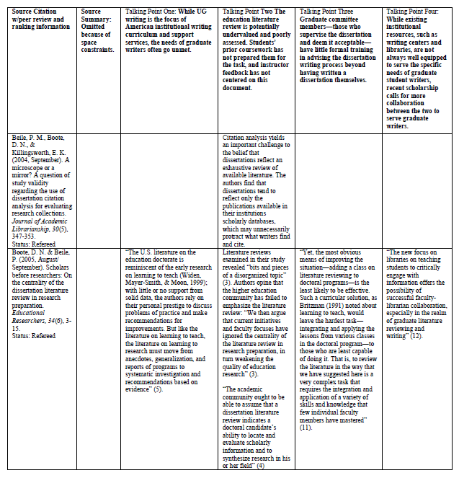

Switzer, A., & Perdue, S. W. (2011). Dissertation 101: a research and writing intervention for education graduate students. Education Libraries, 34(1), 4-13.

