GSC Summit
Saturday, January 22nd, 2022
10:00 am
Virtual

10:00-10:05 Introduction
10:05-10:20 Icebreaker
10:20-10:35 Reintroduction to GSC
10:35-10:50 Research and Travel Grants
10:50-11:15 Fall Semester Reflection
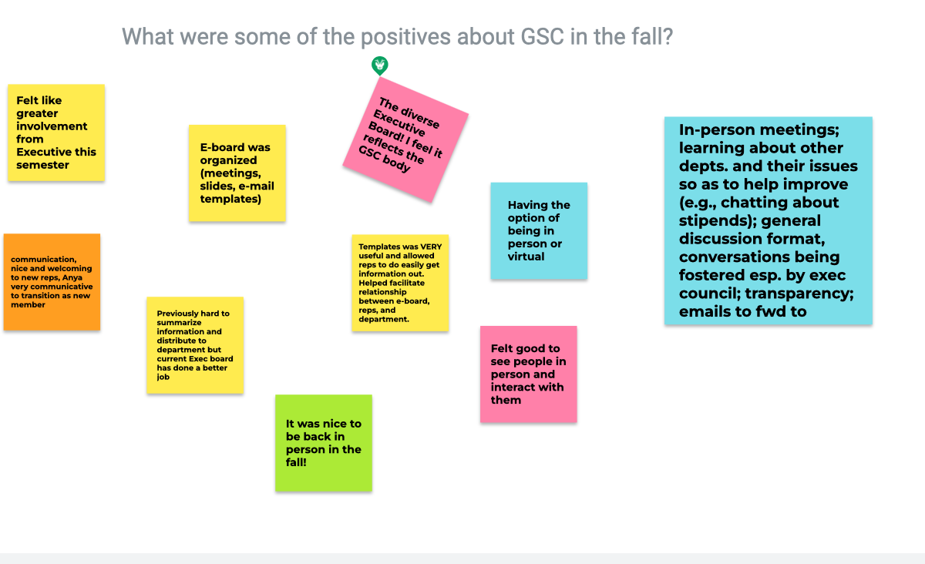
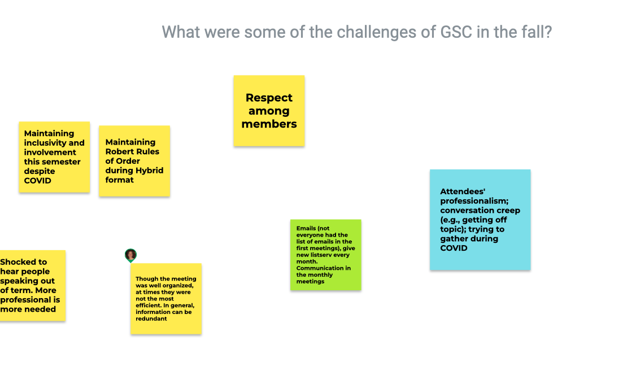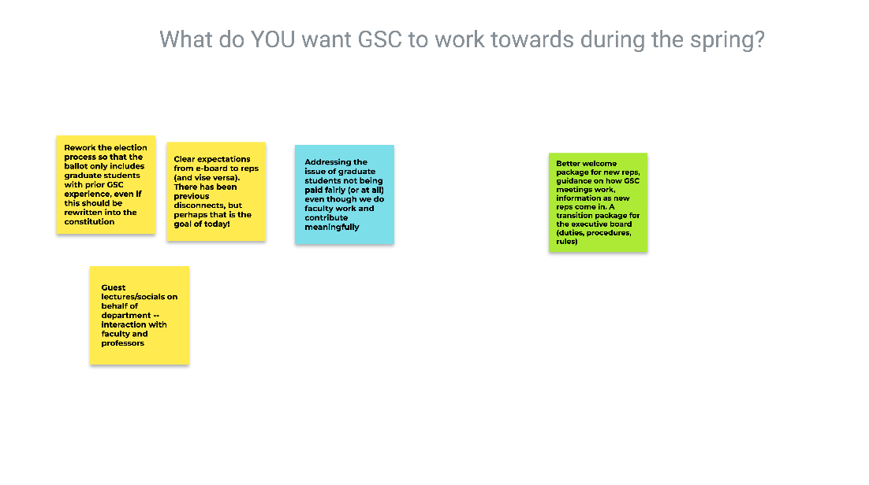
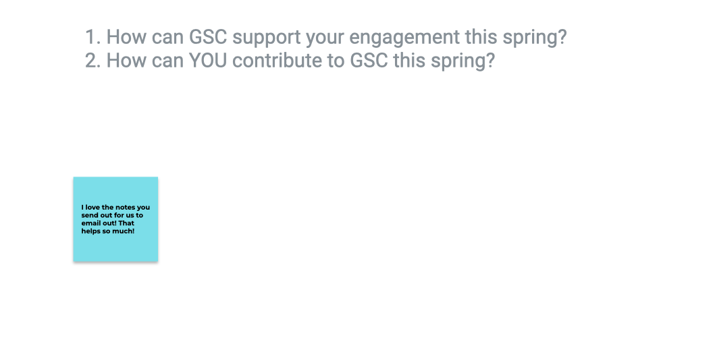

11:15-12:00 Q & A with the Deans
Stipend problems
- Study with biostats student has been completed on doctoral students (not masters because many competitors do not fund masters student); study was conducted with UofL benchmark schools
- Doctoral student stipends are at a deficit between 500-4k dollars = 2.16 million for students (compared to 14 million deficits in faculty/staff)
- Deans are working on a potential payment that should begin July 1st and catch up those that are furthest away from their mean (and then increase everyone)
HEERF/BLOCK grants
- Another one will be disbursed this semester (200-1k); prioritized people who have not yet received it
- Money will be sent to DGs first so they can send out to students who are need (however, “need” isn’t required); get your requests in EARLY
12:00-12:30 Lunch
12:30-2:00 First Meeting of the Semester

Officer Reports
- President – Anya Trell, gscpres@louisville.edu
- Join the GroupMe!
- Vice President – Tomi Ogungbenle, oluwatomisin.ogungbenle@louisville.edu
- Elections are coming up
- Director of Outreach – Camella-Rosa Nasr, camellarosa.nasr@louisville.edu
- Interested in photography? Reach out to Cami for GSC instagram
- Director of Professional Development – Nancy Ngo, nancy.ngo@louisville.edu
- The 15th Annual Graduate Student Regional Research Conference is on March 24-25, 2022! If you are interested in attending/participating in poster/oral presentations on research, the link to submit your abstract is now live! The deadline for abstract submissions is February 25th, 2022 at 11:59pm EST. For more information, follow this link!
- Director of Finance – Parker McGuffey, parker.mcguffey@louisville.edu
- Spring Research Grants applications will be due by February 9th, 2022, with a late 2nd round by March 26th, 2022. If all funds are allocated in the 1st round, there will not be a 2nd round.
- Director of Graduate Travel – Idoia Meaza, gsctravl@louisville.edu
- Spring Travel Grants opened January 17th! There will now be TWO awards per fiscal year (travels from July 1, 2021 through May 30, 2022).
- Senator Proxy – Beverly Granger, beverly.granger@louisville.edu
- No report
- Senator Proxy – Jacob Miller, jacob.miller.4@louisville.edu
- No report

New Business
- November Meeting Minutes Approval
- Minutes approved
- Attendance Approval
- Attendance approved
- Constitution Changes
- Article II, section I: changes approved
- Article III, section II: changes approved
- Article IV, section I: changes approved
- Article IV, section III: changes approved
- Article IV, section IV: changes approved
- Article IV, section V: changes approved
- Article IV, section VIII: changes approved
- Article V, section IV: changes approved
- Article VI, section II: changes approved
- Article VI, section IV: changes approved
- Article VII, section II: changes approved
- Article VII, section III c: changes approved
- Article VIII, section III a: changes approved
- Article XII, section 1 b: changes approved
- Article XII, section 1 c: changes approved
- Article XIII, section 1 a: changes approved
- Article XIII, section 1 b: changes approved
- Article XIII, section 1 c: changes approved
- Article XIV, section 1 ai: still needs revision, voting has been moved to postponement
- Article XIV, section 1 b: waiting on SGA president before voting approval
- Article XIV, section 1 ci: changes approved
- Article XIV, section 2: changes approved
Bylaw Changes:
- 301.1: changes approved
- 301.5: changes approved
Announcements
- MAGS held their first e-board meeting and are looking for other officers (President, VP, and secretary are already occupied). Can go to engage to find out more information
- MAGS will also have a logo re-design contest (hopefully completed by the summer to get swag going)
- MAGS next meeting is next Thursday
- Feb 2nd 11-1am: finding our new university president (interested in voicing concerns about our new president and what you expect to see from UofL regarding our new leadership.
Adjourn

