Graduate Non-Degree Hours Restriction procedure

This procedure will be used for any students who are admitted to a graduate program in non-degree status (excluding certificate & other designated programs approved by SIGS).

- Students admitted in non-degree status will be permitted per the Graduate Catalog to accumulate no more than 15 hours of graduate credit before being prevented to register for further courses. Graduate Admissions Holds will be placed on any non-degree students who have met or exceeded the 15 hour threshold.
- Graduate Admissions Holds will be placed approximately one week prior to the beginning of registration on any students who have met or exceeded the 15 credit hour limit. The holds are reflected as follows:

Service Indicator Code: GA – Graduate Admissions Hold
Service Indicator Reason Code: HRLMT - Non-Degree Credit Hour Limit

- Individuals will be designated by their unit as having the authority to remove the Graduate Admissions Hold for credit hour limits if they wish to allow the student to continue to register for courses in non-degree status.
- To lift the hold, follow the instructions below. Again, only those individuals designated by their unit will be able to lift the Graduate Admission Holds.
- Navigation: Main Menu > Campus Community > Service Indicators >Person > Manage Service Indicators
- Click on the service indicator code that you wish to release.
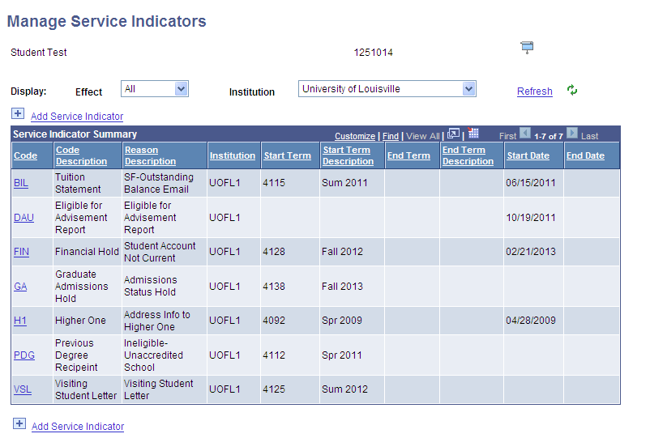
- Click the yellow ‘Release’ button
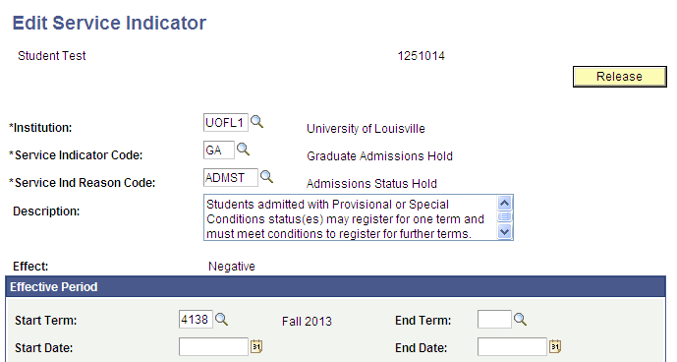

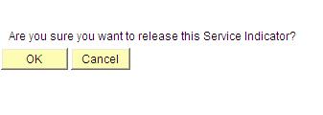
- Click ‘OK’, if you do indeed wish to release this service indicator

- If the student is granted permission by the department to continue to register for more than 15 hours of credit in non-degree status, the Graduate Admissions Hold will be placed upon their account every term and will need to be removed every term.

