Graduate Admission Status Change Procedure

This procedure will be used for any students who are admitted to a graduate program with any status other than GS – Good Standing. This will apply to those admitted as PROV – Provisional, SPCO – Special Conditions, and PSPC – Provisional/Special Conditions.
- Once a student satisfies their provisions and/or conditions, the department will need to change their status to good standing using the Admission Status Change form. Individuals will be designated by their unit as having the authority to complete the admission status change form. The form can be found at:
http://louisville.edu/graduate/forms/admission-status-change
- Graduate Admissions Holds will be placed approximately one week prior to the beginning of registration on all current students whose status has not been changed to good standing. The holds are reflected as follows:
Service Indicator Code: GA – Graduate Admissions Hold
Service Indicator Reason Code: ADMST - Admissions Status Hold
- To lift the hold, follow the instructions below. Again, only those individuals designated by their unit will be able to lift the Graduate Admission Holds.
- Navigation: Main Menu > Campus Community > Service Indicators >Person > Manage Service Indicators
- Click on the service indicator code that you wish to release.
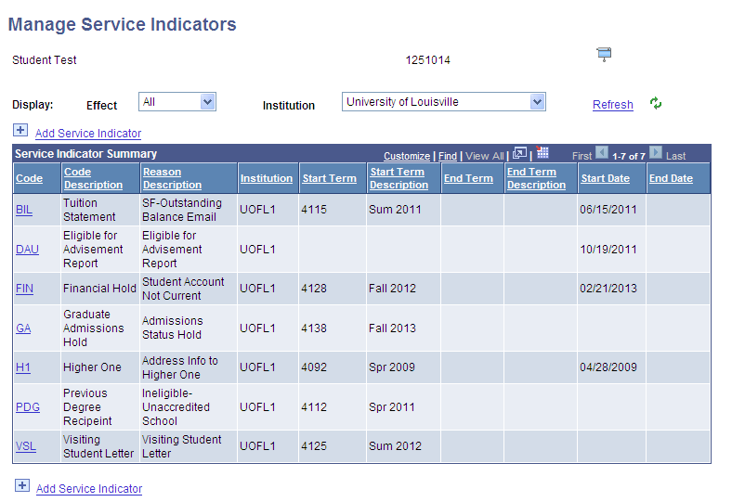
- Click the yellow ‘Release’ button
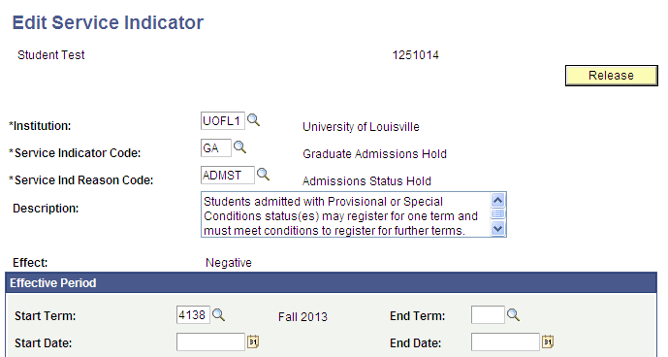

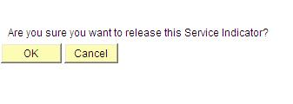
- Click ‘OK’, if you do indeed wish to release this service indicator
- Lifting the hold only and not completing the Admission Status Change form will result in the hold being placed on the student again as the student will still be considered not in Good Standing.

- Returning students who were admitted in PROV/SPCO/PSPC status who wish to re-enroll will be evaluated to determine if their conditions were met. Upon submitting a request to re-enroll form to the registrar’s office, the registrar’s office will forward for review by SIGS. If the student is not eligible to be changed to good standing, a Graduate Admissions Hold will be placed on the student account prior to the processing of the re-enrollment form.

