Orientation and Resource Fair

Fall 2015
Thursday, August 20, 2015
8:45 am - 2 pm
Ekstrom Library, Chao Auditorium (lower level)

Spring 2016
Tuesday, January 5, 2016
9:30 am - 2 pm
Ekstrom Library, Chao Auditorium (lower level)

ISSS Contact Information

Sharolyn Pepper Associate Director pepper@louisville.edu
502.852.0300

Barbara Jones
International Student and Scholar Coordinator
barbara.jones@louisville.edu
502.852.0294

Thomas Beard
International Student Coordinator thomas.beard@louisville.edu
502.852.8698

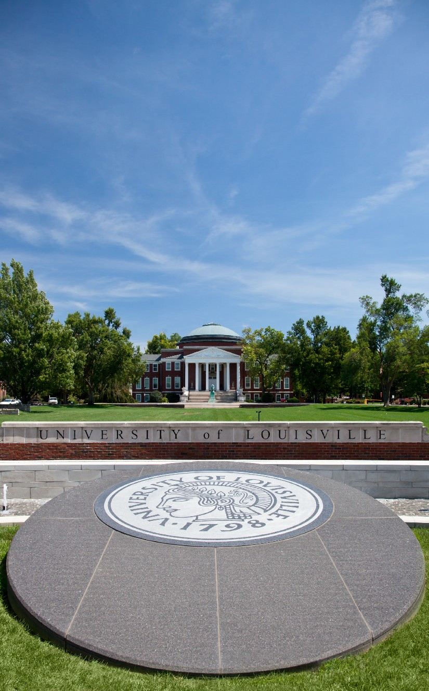

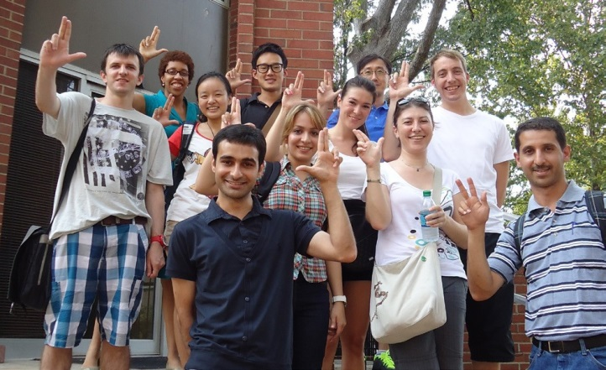
ISSS Services

• Provide information to individuals and departments seeking to invite a non-immigrant student or scholar to campus

• Issue immigration documents and pre-arrival materials for students, scholars and their dependents

• Conduct arrival Orientation and Resource Fair

• Provide immigration advising and benefit processing along with social security, driver’s license, housing opportunities and banking needs

• Offer 20 $500 scholarship opportunities and emergency funds - application online at ISSS website
12/2015
Beverly Cooper Senior Program Assistant blcoop01@louisville.edu
502.852.6604

Belknap Office Hours
International Center
8:30am - 4:30pm

HSC Office Hours
HSC Instructional Building, Room 120
10am-4pm – Tuesday only
502.852.7124

International Student and Scholar Services

International Center
P: 502.852.6604
F: 502.852.7216 intcent@louisville.edu

louisville.edu/internationalcenter/isss facebook.com/UofL.ISSS

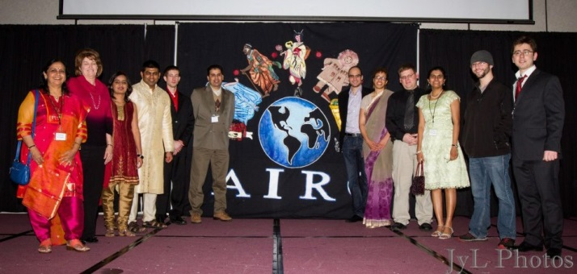
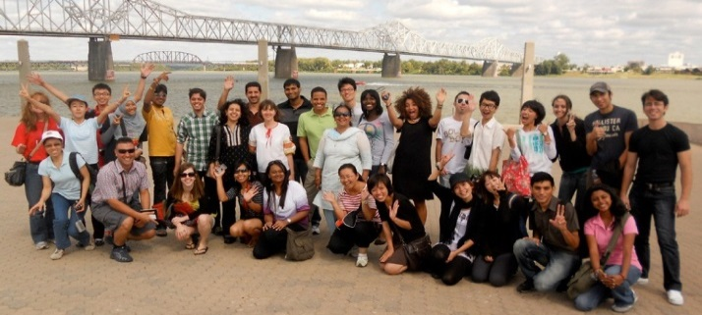
Student & Scholars by the Numbers – Fall 2015

Africa……………………………………………………….69

Egypt…………………………………………………………………………………………24
Ghana……………………………………………………………………..…….9
Cameroon………………………………………………………………………………………..8

Asia………………………………………………………..524

China……………………………………………………………………………………………………………………………………………………..237
India……………………………………………………………….........147
South.Korea……………………………………………………………………………29

Australia………………………………………8

Caribbean Islands…………………………..8

Central America…………………………………………………………………………………………23

Panama. . . . . . . . . . . . . . . . . . . . . . . . . . 19

Europe……………………………………………………97

Germany . . . . . . . . . . . . . . . . . . . . . . . . . . 17
United.Kingdom . . . . . . . . . . . . . . . . . . . .14
France. . . . . . . . . . . . . . . . . . . . . . . . . . . . 14

Middle East……………………………………………122

Iran. . . . . . . . . . . . . . . . . . . . . . . . . . . . . . 53
Saudi.Arabia. . . . . . . . . . . . . . . . . . . . . . . . .50

New Zealand…………………………………………….3

North America………………………………………………………………………………………..34

Canada. . . . . . . . . . . . . . . . . . . . . . . . . . . .25
Mexico. . . . . . . . . . . . . . . . . . . . . . . . . . . . . . . . ..9

Russia………………………………………………………..12

South America…………………………………………..54

Brazil. . . . . . . . . . . . . . . . . . . . . . . . . . . …………19
Colombia. . . . . . . . . . . . . . . . . . . . . . . . . …….10

Total…………………………………………………954

*Numbers in red boxes indicate total in each area.
*Numbers below red boxes indicate total from top three represented countries at the university.
Programming

2015-2016
Free Meet and Greet Luncheons
Thursday, September 17, 2015 Noon @ Red Barn
Co-Sponsored by: American International Relations Club
AIRC Office elections to be held at this luncheon

Thursday, October 15, 2015 Noon @ Red Barn
Co-Sponsored by: Dean of Students Office

Tuesday, November 17, 2015 12:30 pm
@ Health Sciences Campus, Nursing Building, HK2006
Co-Sponsored by: Office of Graduate & Postdoctoral Studies

Thursday, November 19, 2015 Noon @ Red Barn
Co-Sponsored by: PEACC Program,
Campus Health Promotion & College of Business, MBA Office

Thursday, January 14, 2016 Noon @ Red Barn
Co-Sponsored by: Women’s Center & Baptist Campus Ministry

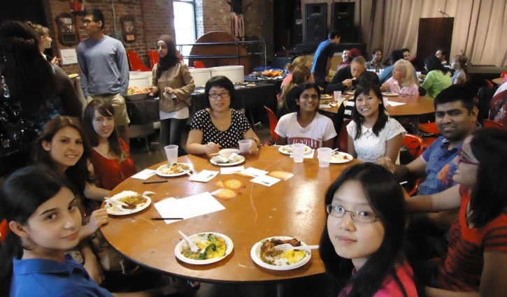

Tuesday, February 16, 2016 12:30 pm
@ Health Sciences Campus Nursing Building, HK2006
Co-Sponsored by: Office of Graduate & Postdoctoral Studies

Thursday, February 25, 2016 Noon @ Red Barn
Co-Sponsored by: Church Women United

Thursday, March 24, 2016 Noon @ Red Barn
Co-Sponsored by: Sister Cities of Louisville

Thursday, April 14, 2016 Noon
@ Student Services Annex, Health Promotions Activity Room
(Across from the Post Office)
Co-Sponsored by: Campus Health Promotion & PEACC

International Center Welcome Party
Friday, August 28, 5-7pm
@Red Barn on the Belknap Campus

International Education Week
November 16-20, 2015

Welcome Reception Students & Scholars
November 19, 5:00-7:00, Alumni Club

American International Relations Club Banquet
February 13, 2016

Immigration Workshops
Optional Practical Training (OPT)
Ekstrom Library Room W104, 4:15-5:15
Wednesday, September 23, 2015
Wednesday, February 17, 2016

Health Sciences Campus HK2023, 11:00-Noon
Wednesday, September 16, 2015
Wednesday, February 3, 2016

H1B Employment & Legal Permanent Resident (LPR)
Ekstrom Library Room W104, 5:30-7:00
Wednesday, October 21, 2015
Wednesday, February 17, 2016

Health Sciences Campus HK2023, Noon-1:00
Wednesday, September 16, 2015
Wednesday February 3, 2016

Library Workshop (Ekstrom W104)
August 28, 12:30-1:30

Career Workshop (Ekstrom W104)
October 28, 2:00-3:00

Visit the International Center ISSS website for more information and collaborative events.

