**Connect the Dots Challenge**

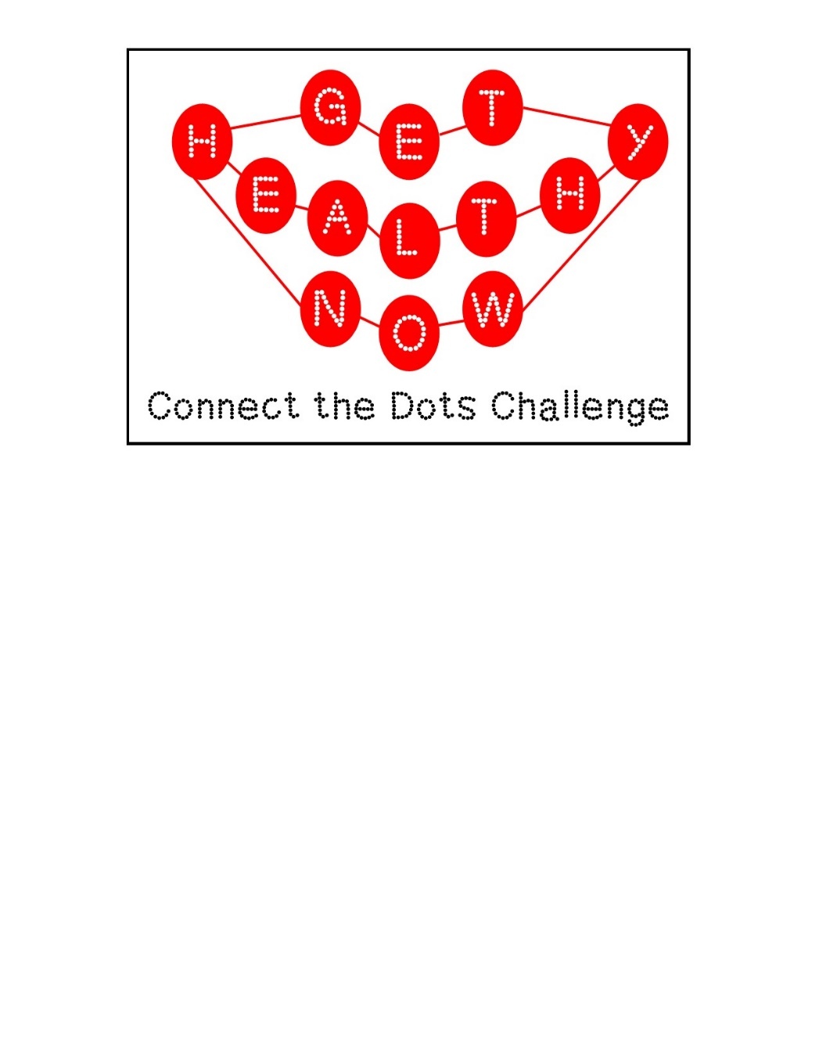

Get ready to connect your health, fitness, & leisure with Get Healthy Now’s newest wellness challenge: Connect the Dots. Join the GHN Connect the Dots Challenge to reconnect with your health, fitness, & relationships through various wellness opportunities. Each member can track their participation at GHN Wellness Center events with a “Bingo” inspired board & enter to win a prize when they connect five. Keeping reading to find out more...

Dates: January 7 – February 11, 2015

How do I get connected?

* Earn a mark on the game board by participating in the activities on the game board.
* Bingo theme: Get five across, down, or diagonally to be entered for a PRIZE!
* Multiple winners will receive prizes, and the Grand Prize is a Fit Bit!

How to Register for the Challenge:

1. The Challenge is open to UofL employees, retiree, and their spouses/QA.
2. Registration is now open! Pick up your game board online (PDF) or at the GHN Front Desk.
3. Questions? Contact GHN via [email](mailto:ghn@louisville.edu?subject=Fall%20Into%20Wellness%20Question) or 852-7755

The Challenge Starts January 7th:

1. Complete the Registration process (above).
2. Get ready to begin on January 7, 2015. The challenge ends February 11th, allowing one full month for you to connect the dots by attending different GHN events!
3. Participants will be issued a game board to track and mark what GHN events & activities they have participated in. These boards are available in the Wellness Center or by fax.
4. After connecting 5 dots across, diagonally, or down, return the completed game board to GHN via email, fax (852-6654), or in person.  Completed boards received by the end of the challenge deadline will be entered into a prize drawing.  Prize drawings will take place on Friday, February 13th.
5. Encourage your colleagues, supervisors, friends on campus, and your spouse/QA to sign up, too! Not only will you reconnect with GHN, but also with friends, family, & colleagues!

FAQ's  
  
Q: Can I join the Challenge after January 7th?  
A: Yes! You can join at any point before the February 11th deadline.

Q: Can I complete more than one row on the game board (i.e. 5 across and 5 down)?  
A: Yes! GHN wants you to get as connected as possible during this challenge. If you complete more than one row, such as 5 down and 5 diagonally, then you will be entered twice for a prize. If you complete three rows, then you will be entered three times, etc.