Connect the Dots Challenge
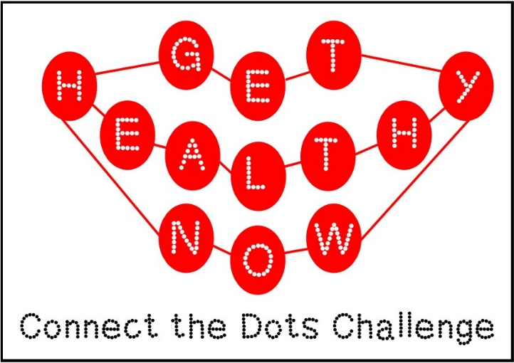

Get ready to connect your health, fitness, & leisure with Get Healthy Now’s newest wellness challenge: Connect the Dots. Join the GHN Connect the Dots Challenge to reconnect with your health, fitness, & relationships through various wellness opportunities. Each member can track their participation at GHN Wellness Center events with a “Bingo” inspired board & enter to win a prize when they connect five. Keeping reading to find out more...

Dates: January 7 – February 11, 2015

How do I get connected?
- Earn a mark on the game board by participating in the activities on the game board.
- Bingo theme: Get five across, down, or diagonally to be entered for a PRIZE!
- Multiple winners will receive prizes, and the Grand Prize is a Fit Bit!

How to Register for the Challenge:
- The Challenge is open to UofL employees, retiree, and their spouses/QA.
- Registration is now open! Pick up your game board online (PDF) or at the GHN Front Desk.
- Questions? Contact GHN via email or 852-7755

The Challenge Starts January 7th:
- Complete the Registration process (above).
- Get ready to begin on January 7, 2015. The challenge ends February 11th, allowing one full month for you to connect the dots by attending different GHN events!
- Participants will be issued a game board to track and mark what GHN events & activities they have participated in. These boards are available in the Wellness Center or by fax.
- After connecting 5 dots across, diagonally, or down, return the completed game board to GHN via email, fax (852-6654), or in person. Completed boards received by the end of the challenge deadline will be entered into a prize drawing. Prize drawings will take place on Friday, February 13th.
- Encourage your colleagues, supervisors, friends on campus, and your spouse/QA to sign up, too! Not only will you reconnect with GHN, but also with friends, family, & colleagues!

FAQ's
Q: Can I join the Challenge after January 7th?
A: Yes! You can join at any point before the February 11th deadline.

Q: Can I complete more than one row on the game board (i.e. 5 across and 5 down)?
A: Yes! GHN wants you to get as connected as possible during this challenge. If you complete more than one row, such as 5 down and 5 diagonally, then you will be entered twice for a prize. If you complete three rows, then you will be entered three times, etc.

