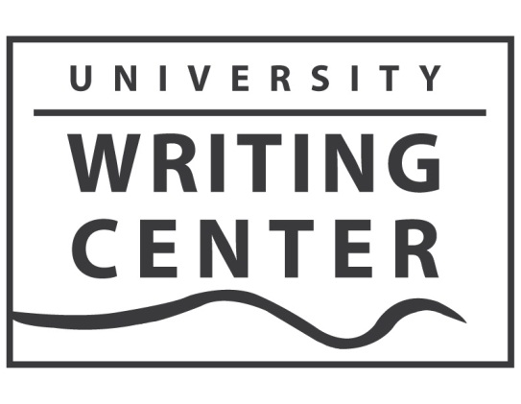

August 14, 2018

To: Glynis Ridley, Chair
Department of English

From: Bronwyn T. Williams,
Director, University Writing Center

Re: Writing Center Report AY 2017-2018

The University Writing Center had a successful year in 2017-18. Credit for the accomplishments in the Writing Center is shared by the director, Associate Director Cassandra Book, Program Assistant Robin Blackett, Assistant Directors Layne Gordon, Jessica Newman, Christopher Stuck, and Caitlin Ray, as well as the dedicated and talented staff of consultants.

Achievements

1. Writing Center Consultations: The Writing Center had a successful year of consultations.
Visits for the 2017-18 Academic Year in Brief:

Fall 2017 – Belknap 2164 Visits
Health Sciences 51 Visits
Virtual 327 Visits
Total 2542 Visits

Spring 2018 – Belknap 1827 Visits
Health Sciences 40 Visits
Virtual 381 Visits
Total 2248 Visits

Summer 2017 – Belknap 220 Visits
Health Sciences 29 Visits
Virtual 134 Visits
Total 383 Visits

Total for 2016-17 5173 Visits

Our usage rate for available appointments increased from 67 percent in 2016-17 to 71 percent in 2018. That the total number of visits for the year declined by 76 visits in 2017-18 can be attributed to the fact that had fewer staff and fewer available hours this past year.
2. Exit Survey Results: Our exit survey indicated a high level of satisfaction with the Writing Center, by both quantitative and qualitative measures. Highlights of the survey are:

- In answer to the statement: “My Writing Center consultation addressed my concerns about my writing project,” more than 98% of respondents selected “Strongly Agree” (85%) or “Agree” (13%).

- In answer to the statement: “What I learned during my Writing Center consultation will help me with future writing projects,” more than 93% of respondents selected “Strongly Agree” (74%) or “Agree” (19%).

- In answer to the statement: “I plan to use the Writing Center again,” more than 96% of respondents selected “Strongly Agree” (81%) or “Agree” (15%).

- In answer to the statement: “The Writing Center staff were welcoming and helpful,” more than 97% of respondents selected “Strongly Agree” (83%) or “Agree” (14%).

The qualitative responses on the survey were overwhelmingly positive as well. A small group of suggestions requested longer consulting sessions. We feel the length of sessions is currently the most conducive to effective tutoring.

3. Presentations and Workshops: During the academic year, University Writing Center staff conducted 45 in-class workshops on writing issues, serving more than 900 students and 108 presentations about our services. We also conducted workshops about effective writing for Residence Life, TRIO, the Cultural Center, SIGS, and other campus organizations.

4. Community Literacy Projects: We continued our collaborations with Family Scholar House and the Western Branch of the Louisville Public Library. We provide workshops, tutoring, and other writing-focused activities and events with both organizations. We also collaborated with Dr. Andrea Olinger’s course on Literacy Tutoring to sponsor student volunteers and interns with both organizations. Our work was recognized this year with the College of Arts & Sciences Community Engagement Award for 2017-18.

5. Events: We sponsored or participated in writing-focused events including an Axton Creative Writing Reading, the White Squirrel Literary Magazine launch, Kick Back in the Stacks, a faculty roundtable discussion on issues of diversity and writing, a Halloween Open Mic Night, International Mother Language Day, and the Celebration of Student Writing.

6. Writing Groups: We continued to facilitate the Graduate Student and Faculty Writing Group; Creative Writing Group; and LGBTQ Writing Group.

7. Dissertation Writing Retreat: The spring Dissertation Writing Retreat during May was again a success. In the May retreat, funded by SIGS, 14 Ph.D. students representing five different colleges and nine different disciplines spent a week in the Writing Center working on their dissertations. The exit surveys and discussions with the students indicated that the retreat was overwhelmingly successful. We had eight students on our waitlist for the retreat. We also piloted a smaller, mini-retreat in January.

8. Graduate Student Writing Workshop Series: The Writing Center, in collaboration with SIGS, conducted a series of writing workshops for graduate students on both the Belknap and Health Sciences Campuses. The workshops, some of which were repeated each semester, covered issues including Reading and Responding to Graduate Level Scholarship, Writing for Publication, and Writing a Literature Review. The workshops will take place again in 2018-19.

9. Writing Center Blog and Social Media: The Writing Center Blog, to which all members of the staff contribute posts during the year, was viewed more than 14,000 times in 2017-18. In addition, many of the posts have drawn interest from readers outside the UofL community.

10. Writing Center Scholarship: During the 2017-18 academic year University Writing Center staff (not including the director) had four scholarly and creative publications. In addition, Cassandra Book, the associate director, received a grant from the Southeastern Writing Centers Association to conduct a usability study on our Virtual Writing Center. Writing Center staff also had 10 conference presentations at conferences including the Community Writing Conference, the International Writing Centers Association Conference, the Conference on College Composition and Communication, the Southeast Writing Centers Conference, and the Louisville Conference on Literature and Culture,

11. Learning Commons: The Writing Center continued to meet with other student support organizations located in Ekstrom Library to coordinate Learning Commons' activities. The offices involved are the Digital Media Suite, Media Resources, the REACH Computer Resource Center, the Reference & Information Literacy Department, and the Writing Center.

12. Student Artists on Display: We continued with our rotating display of student art.

13. New Website Video Resources. – We created new video workshops on writing issues such as APA and MLA Citation Styles and Using Sources Effectively in Writing.

