What’s New in Kentucky: An Overview of
the Kentucky Advisory Council on Autism
Spectrum Disorder

Heidi Cooley-Cook

Family Field Training Coordinator

Kentucky Autism Training Center
Amy Cooper-Puckett Director for the Office of Autism Commission for Children with Special
Health Care Needs

What’s New in Kentucky: An Overview of the
Kentucky Advisory Council on ASD

Overview:
• History of the Kentucky Advisory Council on ASD
• What is The Office of Autism
• Director - Amy Cooper-Puckett

L O U I S V I L L E . E D U

What’s New in Kentucky: An Overview of the
Kentucky Advisory Council on ASD

Overview:
• History of the Kentucky Advisory Council on ASD
• What is The Office of Autism
• Director - Amy Cooper-Puckett

L O U I S V I L L E . E D U

What’s New in Kentucky: An Overview of the
Kentucky Advisory Council on ASD

The Office of Autism at the Commission for Children with Special
Health Care Needs was established to:

1. Create a centralized location to coordinate statewide and regional efforts to enhance the quality of life and independence to individuals with ASD and to support their families and caregivers
2. Improve coordination of autism resources within the system of care supporting children and adults with autism and help make those resources available to families and self-advocates

3. Be the center of a communication network sharing autism-related information among state agencies
4. Provide administrative support to the Advisory Council on ASD to unify and promote initiatives aimed at improving Kentucky’s system of care

L O U I S V I L L E . E D U

What’s New in Kentucky: An Overview of the
Kentucky Advisory Council on ASD

Overview:
• History of the Kentucky Advisory Council on ASD
• What is The Office of Autism
• Director - Amy Cooper-Puckett

L O U I S V I L L E . E D U

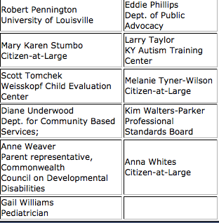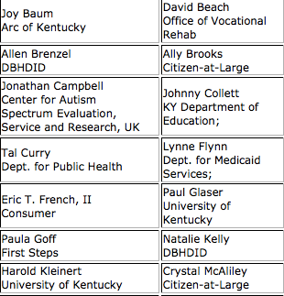What’s New in Kentucky: An Overview of the
Kentucky Advisory Council on ASD

Kentucky Advisory Council on ASD
• Who are the members

L O U I S V I L L E . E D U

What’s New in Kentucky: An Overview of the
Kentucky Advisory Council on ASD

Kentucky Advisory Council on ASD
• Subcommittees
• How can I get involved?
• Upcoming events:
• 2015 ASD Parent Summit

L O U I S V I L L E . E D U

The commlulon for OMfdren wh SpecialHealth care Needs· ffiof' Autism
2015 ASD PARENT SUMMIT: ADVOCACY THROUGH PARTNERSHIPS
FRIDAY MAY 8 & SATURDAY MAY 9
FOR PARENTS, CAREGIVERS, PROFESSIONALS, AND SELF-ADVOCATES FROM ACROSS T.HE COMMONWEALTH OF KENTUCKY
-B-AR-RE-N-RIV-E-R S-T•A-TE-R-ES-O-RT-PA-R-K
1149 STATE PARK ROAD LUCAS, KY 42156

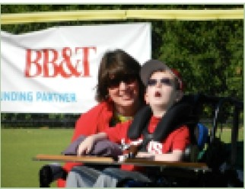Keynote Presentation:Saturday May g,tt. 9:00 • lO:OOam CST United We Stand'!The lmportanr.e· of'Co11aboratlve Advocacy Presen12d by:Marylee Uhder.vood

er itsin tb"duHoom < <"lit tile Cllpitol, 111ortins r results in gn:llta" S!UIClCeSS.. For peep.,with lisebilities, tile wofld bm truly m""''...:l bealllsoo individr:n•l• 1111d fami&es b........d tngether to
advoc.atr for 8'"" 'riglrts 1111.d supports. This s=sion n lproW...,
an ·cnoerview of what can be done 1111d how•

.Warytft-llnrl-oodis t!lot EkiKllrMr Oitrecmroftn.Cam.ma. w8GI'tll Gounril • • •
a"DfiwltJ ...raroisDD.wn'H. As thll ,_,<1J a c.11il:1t wit!! cti54biritilu.
.waryt.ot -Ulll dl'alangti and i!>Iasm9' til at fDmililn nc .- Sll•is
a _gfll<l>latot aJ 'Io Uninmtya{r:ontrtay. ScJJooiofSoria l Won.and tr..
Univomitv at Hartl! cam.rina.School anow.

friday,Jtky 8
4<00-6:15RegjstratioD
5:00-6:15Dinner
6:15-6:30 W!!!lcom1!
6-..30-7:30 R.owu:kabl1!S
7:30-8:00Nem-orting
I'
l
I

lb.e roundtabk!s on Friday ewg will forus on l"eSOllro!S and Dl!-twmtingy,-1tfl gi'Ollp<S acd individJuls from across Kenmcky.Satunlay.following MaryLee's empowering ntatioc.Summitalt1!Ddees wiD sele3 brealout si!Srions to att1!Dd. Topks include: Mediui.d. bwvior, Offit:e ofVocal:iocal Reba:bifitati.oc.
mppo:rtl!!d employment.IEP, pareiit alfvoeacy,and
partnering with fOLll' chfld s doftllr.

On-lOtte Regjstration will be .available - Registration fee is $15 per JIEl'WD andindudl!-5 allsessions.md meals. Please bring esart C\lSb (no dlecks or credit cards will be accepted). Lodgi.ugat tbl!! State Resort Park is sold out. bu:t there art! several botl!ls nl!!3l'b}1

Quenions!!'Contact:
Heidi Cooley-COOk
t t: dl.cooleycaoktflou'lsVUie.edu saz.ssz.otOI MD:Ie Miller

Saturday, Jtky 9
7:00-9:00 Bl"'!-iliast
8:00-9:00 Registration
9:00-10:00 Keynote
1015-11:30 Sess1ac 1
11:45-12:45 Lundt
1:00-2:15SI!-SliDlJ 2
2:30-3:45 SI!-Ssion 3
3:45-4:00 Evafu.rtiom

LOUISVILLE.EDU

What’s New in Kentucky: An Overview of the
Kentucky Advisory Council on ASD

Amy Cooper-Puckett
Director for the Office of Autism
Commission for Children with Special Health Care Needs
(859) 252-3170 x 3003
http://chfs.ky.gov/ccshcn/autism.htm

Heidi Cooley-Cook
Family Field Training Coordinator
Kentucky Autism Training Center
(502) 852-6401
Heidi.cooleycook@louisville.edu

Kentucky Autism Training Center:
Telephone: (502) 852-2467 or
800-334-8635 ext. 852-4631 Fax: (502) 852-7148
E-mail: katc @ louisville.edu
https://louisville.edu/education/kyautismtraining

L O U I S V I L L E . E D U

