Supporting Individual with Autism In the General Education Setting

Laura Ferguson, M.Ed., BCBA

LOUISVILLE Kentucky Autism Training Center
UNIVERSITY OF

Autism characteristics in the educational

setting

Strategies for the general education setting

UNIVERSITY OF
LOUISVILLE.
KENTUCKY AUTISM .
TRAINING CENTER

What is Autism?

Autism is a complex developmental disability that has a neurological basis that causes impairments in social interactions, communication, and the presence of unusual behaviors and interests.

A. Persistent deficits in social communication and social interaction across multiple contexts, not accounted for by general developmental delays, and manifest by all 3 of the following:
• Deficits in social-emotional reciprocity
• Deficits in nonverbal communicative behaviors used for
social interaction
• Deficits in developing, maintaining, and understanding relationships

Difficulty in SOCIAL INTERACTION in the classroom

• Turn taking

• Interrupting adult and peer non-verbal cues

• Using symbolic play skills to pretend
• Partner work;
cooperative group work

• Effectively navigating social situations (discussed later)

B. Restricted, repetitive patterns of behavior, interests, or activities as manifested by at least 2 of the following:

• Stereotyped or repetitive motor movements, use of objects, or speech

• Insistence on sameness, inflexible adherence to routines, or ritualized patterns of verbal or nonverbal behavior

• Highly restricted, fixated interests that are abnormal in intensity or focus

• Hyper-or hypo-reactivity to sensory input or unusual interest in sensory aspects of the environment

Difficulty in COMMUNICATION in the classroom

• Staying on-topic

• Interrupting, blurting out, and always telling the truth
• Partner work;
cooperative group work

• Engaging beyond the surface during non- individual activities

Difficulty in RRS BEHAVIORS in the classroom

• Staying on-task

• Seeing the big picture during academic activities
• Turning peers off by
“odd” behaviors

• Meltdowns with schedule changes

• Listening without dominating the
conversation with own interest

Characteristics in the Classroom

What characteristics cause our students to have
difficulties in school?

• Working Memory
• Executive Functioning
• Low Self-Esteem
• Not able to self monitor
• Lack of emotional regulation at times
• Lack of ability to read social cues/understand
– Expands beyond peer interaction—
• answering questions, waiting, turn taking, raising hand, flexibility

UNIVERSITY OF
LOUISVILLE Kentucky Autism Training Center

ork

UNIVERSITY OF
LOUISVILLE.
KENTUCKY AUTISM .
TRAINING CENTER

Antecedent Interventions

• Setting clear behavioral expectations
 Consider the individualized needs of learners when delivering expectations

• Placing specific demands
 Example: “Hang your coat on the hook next to the door”
vs. “Hang your coat over there”

• Manipulating the learning environment
 Pairing the learning environment with reinforcement
 Providing visual supports in environment
 Purposefully setting schedule structure

• Manipulating the learning environment (cont.)

 Location of instruction (is the table an aversive?)

 Providing preferred items in instructional area prior to demands

 Decreasing/altering the task demand

• Priming

• Behavior Momentum

• Offering choice
 Reinforcers
 Materials
 Order of instructional tasks
 Partners/Peers
 Locations

Let’s Explore (Positive) Reinforcement!!

Positive Reinforcement

Something provided contingent on demonstration of a target behavior that increases the likelihood that the target behavior will occur again.

Example:
When student raises hand, to be called on, without talking,
the teacher provides him with behavior specific praise (“Nice
job raising your hand” OR “You raised your hand so quietly”)
and a small piece of candy. Next large group student quietly
raises his hand again.

UNIVERSITY OF
LOUISVILLE Simple Strategies that Work

Myles, Adreon, and Gitlitz (2006)
UNIVERSITY OF
LOUISVILLE.
KENTUCKY AUTISM 5
TRAINING CENTER

Simple Strategies that Work

Ask them about their concerns.
Ask for solutions
Ask what can make the day better for them
Ask about reinforcers

Myles, Adreon, and Gitlitz (2006) 16

UNIVERSITY OF
LOUISVILLE Simple Strategies that Work

Think about

Myles, Adreon, and Gitlitz (2006)
UNIVERSITY OF
LOUISVILLE.
KENTUCKY AUTISM . 7
TRAINING CENTER

“Twice as much time, half as much done”

Students will need more time to:

▪ Complete assignments

▪ Gather materials

▪ Orient themselves during transitions

Strategy: MODIFY REQUIREMENTS

• Reduce the number of problems on a page by circling items on the page or masking the items the student doesn’t need to complete

• Change short-answer questions to true/false or multiple choice
• Provide a five-, four-, three-, two-, one transition
reminder

• Provide early or late release from classes to ensure successful transitions between classes

Strategy: AVOID RUSHING

• Time constraints add anxiety which can mean student freezes or could begin to meltdown

• Increased anxiety also means that difficulty with comprehension is magnified

Anxiety = no longer in “working” mode

UNIVERSITY OF
LOUISVILLE Simple Strategies that Work

UNIVERSITY OF
LOUISVILLE.
KENTUCKY AUTISM .
TRAINING CENTER

Students with Autism have a lack of
organizational and planning skills so don’t
always navigate through their day successfully—

• Don’t understand routines

• Struggle with handling change

• Has difficulty with predicting what happens next

What does this mean for the classroom?
▪ Routines or rules have to be formally taught

(Examples: how to ask for help, how to ask permission to sharpen a pencil, how to ask to go to the bathroom, how and when to turn in homework, how to line up for lunch, recess, etc.)

This will:
✓ decrease anxiety
✓ increase attention
✓ increase work output

I Will Remember To:.

Put my hand up

work quei tly

,{)..Remain seated

ea -. : -. -
DaiiJ!: Go·al ReQort:
00;1!1: Nome:
f£:!1
,_.!4110 IlK-
1'-•IQ- LJ,rl;h
l IOII!KtiJ
V401;1J!.•IQ- IIII
(Ww,.

UNIVERSITY OF
LOUISVILLE.
KENTUCKY AUTISM TRAINING CENTER

Ask yourself if you were:
-writin answers
-watchin the teacher
-ll Y!.ng attention

If you answered yes to any of these questions put a check in the YES column. If the answer is noput a check in the N 0
col umn

 | YES | NO
1
2
3
4
5

UNIVERSITY OF
LOUISVILLE.
KENTUCKY AUTISM TRAINING CENTER

Get the Task I folder out of" file box
Open Spqthght on I 1Jc;rpcy book to page 60
Read page 60
Return book to f"older
Put f"oldcr tn the file box
Cornputer f"or .S mtnutes.

Get the Task 2 Colder out oCthe file. Complete worksheet I . Return worksheet to Colder.
Put Colder in the file box. ---
Computer for S minutes.

Get the Task 3 folder out of the file. Write narne
==
Return narne page to folder
Put folder tn the file box
Computer for S minutes •
•

Task4
•
J
2
3
4
s

Get the Task 4 folder out of the file Complete worksbeet 2 stde I and sad Return worksheet 2 to folder
•
Put folder m the file box
Computer for S mmutes

After you have finished your rald•na tasks you may read sdently

UNIVERSITY OF
LOUISVILLE.
KENTUCKY AUTISM ----­ TRAINING CENTER£''

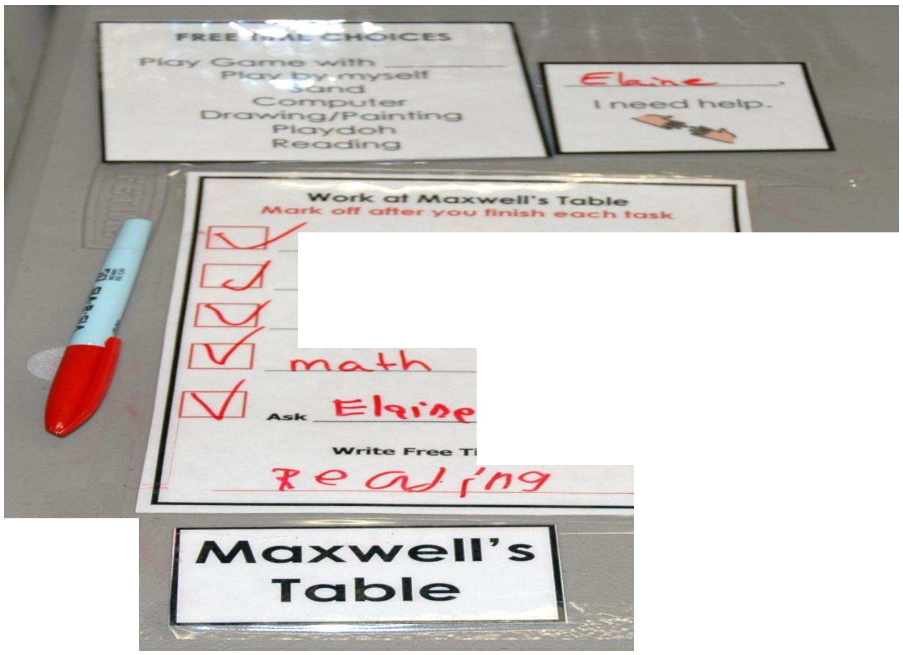

reCJt...d ,;

oC':) ,e

£-;ve.

Write F.-- ""Time C:h lc::eo

Science Clas.s Rules

· P ace aU of your belongi'ngs under your desk or on the cabinet" shelf behind you
· Raise your hand 1if you ne,ed the
1-eacher s assistance.

· You may qu et"ly get' up and sharpe.n penc iI when needed.

Visuals can be placed
on top of activity
materials, within
academic tasks, and
a variety of other
ways to
communicate “no”

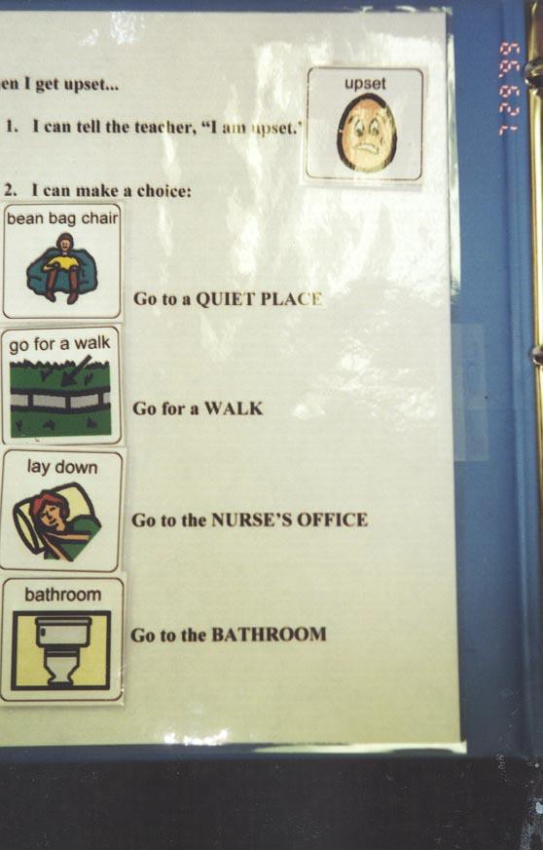

Self-management
Emotional
Regulation

STRATEGY: PREPARE FOR CHANGE

▪ Avoid sudden changes

▪ If can’t, tell the student about the change as
soon as possible

✓ Use “Change Card”

✓ Use verbal cues

✓ Use social stories

STRATEGY: INCORPORATE
STUDENT PREFERENCES
▪ What does the student enjoy?

STRATEGY: PROVIDE CHOICES

▪ Give choice to do math group work or independent worksheet

The Gingerbread man wants you to raise your
hand before speaking.

UNIVERSITY OF
LOUISVILLE Simple Strategies that Work

know when

UNIVERSITY OF
LOUISVILLE.
KENTUCKY AUTISM .
TRAINING CENTER

In many cases, if the student is not

directly told | what will | happen | next,
they cannot | predict.

So…..

STRATEGY: USE VISUAL SUPPORTS

✓Visual schedules

✓Lists of materials needed

✓Lists of activities to complete

UNIVERS I TY OF
LOUISVILLE. Types of Visual Supports

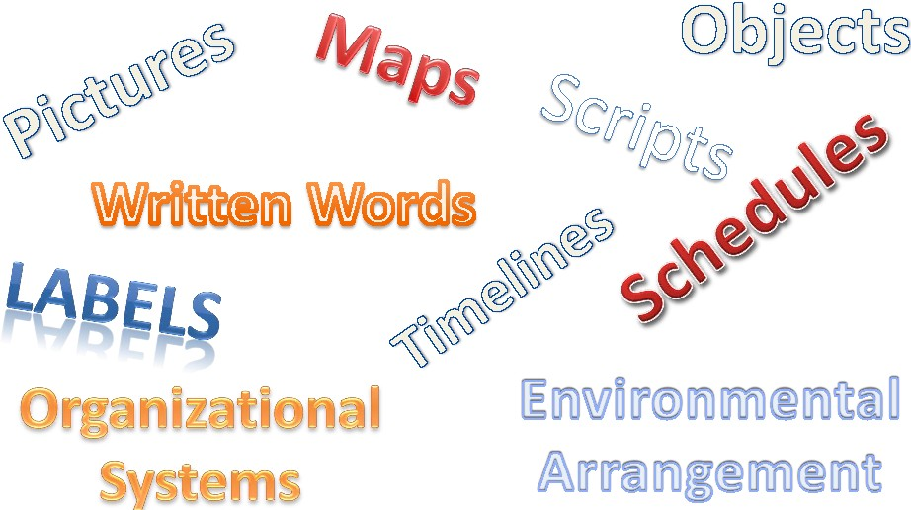

UNI VERS I TY Of LOUISVILLE. l<ttm!CKY AUTISM -2<··
TRAINING CENTER ;! :E}

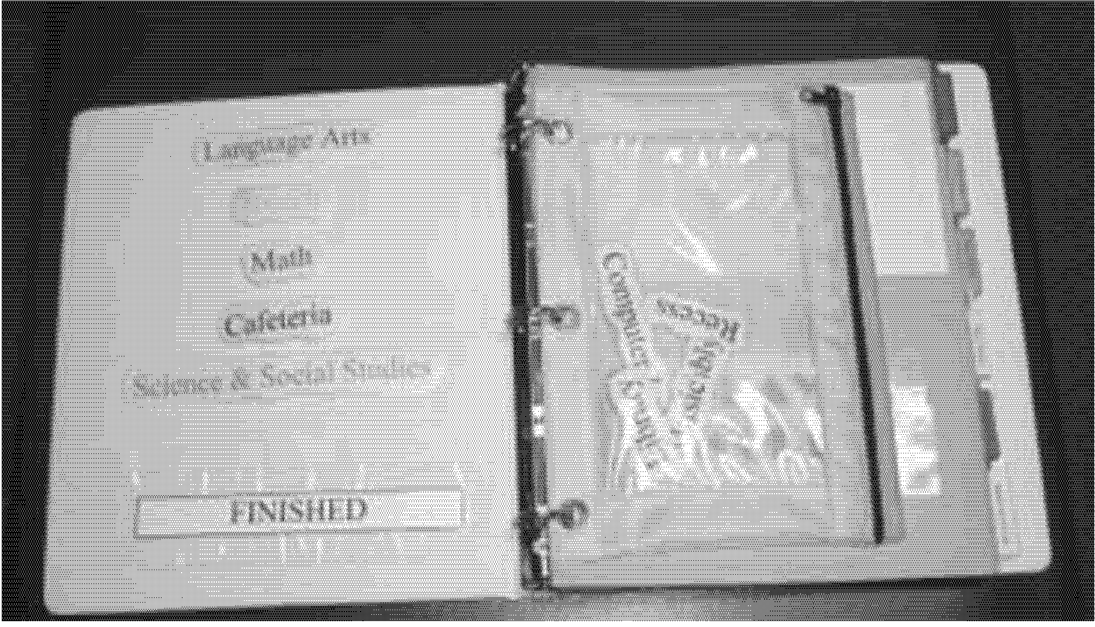

A good option for an older student- very age appropriate

and facilitates independence

Individual Daily
Schedule

To Do Schedule –
Mini/Activity Schedule

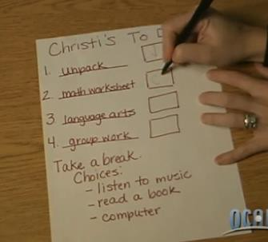

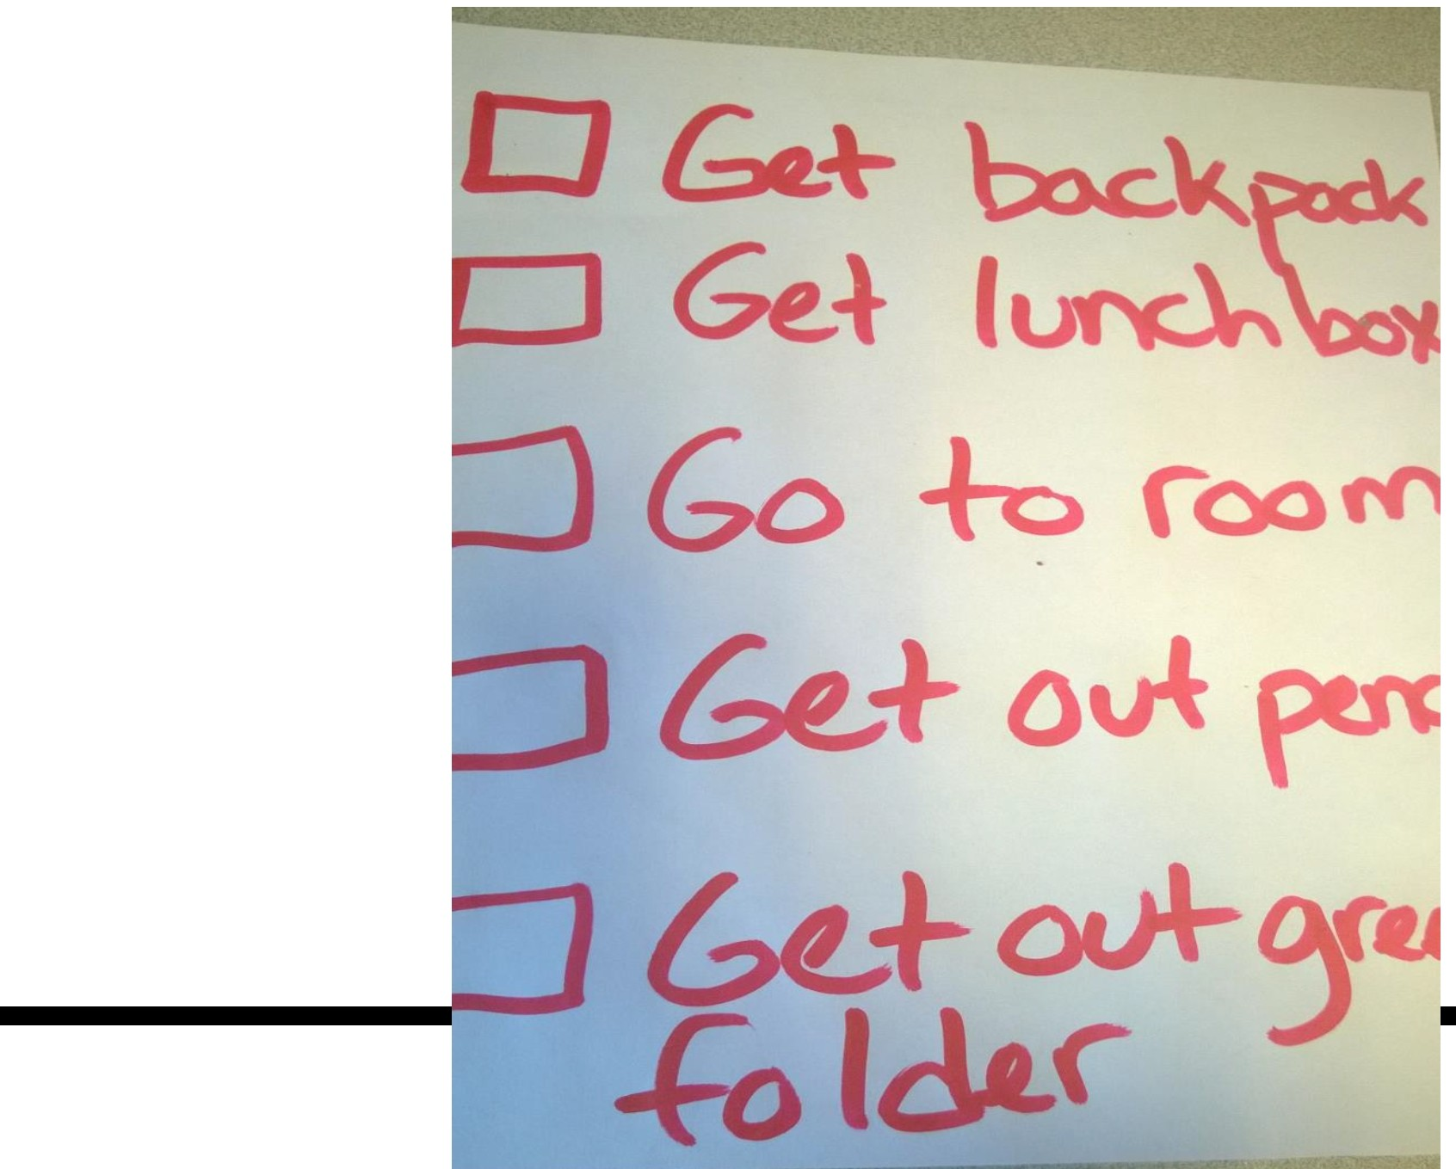 LOUISVILLE® Kentucky Autism Training Center
UNIVERSITY OF

UNIVERSITY OF
LOUISVILLE.
KENTUCKY AUTISM TRAINING CENTER

Kentucky Autism Training Center

Fire Alarm Steps

If I hear the alarm I…..

Grab my headphones or cover my ears
Follow directions
Follow the students outside
Stay with class till the alarm stops
Go back into the school

UNIVERSITY OF
LOUISVILLE Simple Strategies that Work

UNIVERSITY OF
LOUISVILLE.
KENTUCKY AUTISM .
TRAINING CENTER

▪ Students with Autism have significant difficulties with social and communication skills

(A lot of people forget because of good verbal skills.)

▪ Social communication means effective use and understanding of communication in social contexts

(nonverbal behaviors such as eye gaze, facial expression, body language, gestures, tone of voice)

STRATEGY: WATCH FOR LITERALNESS

✓ Avoid metaphors, idioms, and sarcasm

✓ Can be misread as noncompliance

Examples of good practice:
▪ Use student’s name prior to giving a direction or asking a
question
▪ Tap gently on student’s desk prior to giving a direction
▪ Provide student with questions in advance
▪ Combine verbal instructions with pictures, gestures, demonstrations, and written instructions
▪ Have students demonstrate understanding by paraphrasing

★ Do not rely on Yes/No questions to indicate comprehension!

UNIVERSITY OF
LOUISVILLE Simple Strategies that Work

UNIVERSITY OF
LOUISVILLE.
KENTUCKY AUTISM .
TRAINING CENTER

STRATEGY: FOSTER UNDERSTANDING

▪ Give specific praise often so students can see himself as a valued individual

▪ Find opportunities through out the day
to tell students what they did “right”

▪ Compliment attempts, even if they fail.

Remember that….

✓ Students with Autism live in a world that is unpredictable, puzzling, and stressful.

✓You are not only responsible for teaching content, but independence—no pressure!

✓ These are relatively easy-to-use strategies and considerations, but require thought and practice until they become more automatic.

Thank you so much for attending!!

Questions??

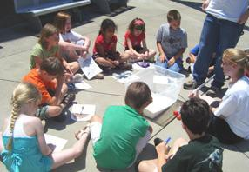Questions?

Laura Ferguson Laura.ferguson@louisville.edu (502) 852-6403

Center contact info:

Telephone: (502) 852-4631
Fax: (502) 852-7148 E- mail:
katc @ louisville.eu https://louisville.edu/e ducation/kyautismtrai ning

