**Teaching and Learning for Secondary Physical Education**

**HSS 606**

**(Six Credits)**

**Instructor**: Dr. Stefanie Wooten-Burnett

**Office Hours**: Tuesdays: 10:00 - 1:00 am or **by appointment**

**Phone**: 502-852-2615

**E-mail address**: stefanie.wooten@louisville.edu

**Course Description**

Philosophy, objectives, curriculum and methods of teaching physical education to secondary students. Must be taken prior to student teaching.

**Purpose of Course**

The purpose of HSS 606 is to assist students to become effective secondary physical education teachers. A primary function of HSS 606 is to analyze, plan for, and implement several different instructional models to recognize that one teaching style “does not fit all”. To accomplish this objective students are expected to show proficiency in knowledge of content, planning units of instruction, selecting appropriate content, constructing performance objectives, implementing lessons in a variety of teaching environments and assessing student learning through various forms of authentic assessment.

**Required Texts**

Rink, J. (2010). Teaching for learning in physical education (6th ed.). New York: McGraw-Hill.

Metzler, M. (2011). Instructional models for physical education (2nd ed.). Scottsdale, AZ:

Holcomb Hathaway.

Darst, P. W., & Pangrazi, R. P. (2006). Dynamic physical education for secondary school students (5th ed.). San Francisco, CA: Pearson.

**LiveText:**

All students enrolled in College of Education and Human Development (CEHD) programs are required to have a LiveText account. LiveText will be utilized for submitting a Hallmark Assessment Task (HAT) in every course in addition to other requirements by program (i.e., portfolios). If you do not already have a LiveText account, you will be required to purchase one for use during the courses in which you are currently enrolled.

A LiveText student membership may be purchased at [*www.livetext.com*](https://ch1prd0310.outlook.com/owa/redir.aspx?C=5jH61XLV5kO_Gl-zZ9UrnSs_8DAYdtAINSAYouQwanyZVV6i_ORXdZ75HzVeGhL_uaMOaocMld8.&URL=http%3a%2f%2fwww.livetext.com) or from the University bookstore. Information about LiveText and how to purchase an account are available at [https://louisville.edu/education/livetext](https://ch1prd0310.outlook.com/owa/redir.aspx?C=5jH61XLV5kO_Gl-zZ9UrnSs_8DAYdtAINSAYouQwanyZVV6i_ORXdZ75HzVeGhL_uaMOaocMld8.&URL=https%3a%2f%2flouisville.edu%2feducation%2flivetext).

**Student Learning Outcomes**

**Professional Standards Met by HSS 606**

HSS 606 addresses Kentucky Teacher Standards and National Association of Sport and Physical Education (NASPE) Initial Physical Education Teacher Standards. The course focuses most directly on KTS Standard 1 and NASPE Standard 1 (Demonstrates Knowledge of Content), KTS Standard 2 and NASPE Standard 3 (Designs/Plans Instruction), KTS Standard 3 and NASPE Standard 4 (Maintains a Learning Climate), KTS Standard 4 and NASPE Standard 3 (Implements/Manages Instruction), KTS Standard 5 and NASPE Standard 5 (Teacher Assess Learning Results), KTS Standard 6 and NASPE Standard 3 (Technology), KTS Standard 7 and NASPE Standard 5 (Teacher Reflects on Teaching), KTS Standard 8and Standard NASPE 6 (Teacher Collaborates with Colleagues/Parents/Others, KTS Standard 9 and NASPE Standard 6 (Reflection/Professional Growth), KTS Standard 10 and NASPE Standard 6 (Leadership), and NASPE Standard 2 (Skills Fitness Based Competence).

***KTS Standard 1 and NASPE Standard 1 (Demonstrates Applied Content Knowledge*** is assessed through written assignments (skill analyses, daily lessons, and unit plans) candidates’ presentations, including the accuracy of feedback, in peer and field-based teaching experiences.

***KTS Standard 2 and NASPE Standard 3 (Designs and Plans Instruction)*** is assessed through written assignments (e.g., daily lesson and unit plans) that emphasize the design of developmentally appropriate learning experiences that are inclusive of diverse learners and consider contextual variables.

***KTS Standard 3 and NASPE Standard 4 (Creates and Maintains a Learning Climate)*** is assessed through the candidate’s interactions with students which focus on setting high expectations for student learning and behavior, positive and congruent feedback, designing learning tasks that facilitate personal growth and positive interactions among students, etc.

***KTS Standard 4 and NASPE Standard 3 (Implements and Manages Instruction)*** is assessed during peer and field-based teaching experiences where students are expected to implement effective instruction strategies that result in student learning. These strategies should be based on understanding secondary students’ developmental level, the learning environment and nature of the task.

***KTS Standard 5 and NASPE Standard 5 (Assesses and Communicates Learning Results)*** is assessed by how well teacher candidates use of a variety of formative and summative assessment instruments during the instructional process to assess their impact on secondary students’ learning.

***KTS Standard 6 and NASPE Standard 3 (Technology)*** is assessed through the use of LiveText, and incorporating technology resources into lesson and unit plans. Teacher candidates will also focus on student use of technology.

***KTS Standard 7 and NASPE Standard 5 (Reflection)*** is assessed through reflections on teaching and learning on lesson plans, unit plans and post-observation conferences and coding sheets.

***KTS Standard 8 and NASPE Standard 6*** is assessed through assignments that require teacher candidates to collaborate on lesson and unit plans, team teach lessons with classmates and cooperating teachers, including coding classmates’ teaching behaviors, and when appropriate, communicate with parents/guardians, and participate in projects such as field days, health fairs, etc.

***KTS Standard 9 and NASPE Standard* 6** is assessed through how effectively teacher candidates identify their impact on student learning and professional growth during post-observation conferences, and progress toward developing the professional growth plan.

***KTS Standard 10 and NASPE Standard 6*** is assessed through assignments in seminars, assuming relevant leadership roles during the field-based unit and their presentations at a professional conference.

***NASPE Standard 2*** is assessed through regular participation in motor skill performance for a variety of physical activities.

**Additional Standards**

Success of reading and writing may be dependent on a solid background in oral language skills. Both oral and written language can be explored in the same manner. That is, by using literacy skills in a variety of holistic literacy experiences, students can develop deeper understandings of what the students already know about and can do with oral and written communication. Oral language is an interactive and social process, and experiences within physical education are a natural way for students to experience language in a meaningful way. Physical education classrooms create an environment that is conducive to this type of holistic learning. It can reduce stress, increase interest, and set the stage for intrinsically valuable listening and learning experiences. Using movement as a stimulus can effect one's emotions and retain and recall information with more ease. The similarities between literacy acquisition and movement development are many. It is important for adolescent readers to experience many connections between literacy in language and physical education for students of all backgrounds and ages. HSS 606 will explore these similarities and connections aligned with the following Content

Literacy standard:

***Standard 1: Foundational Knowledge:*** Candidates understand the theoretical and evidence-based foundations of reading and writing processes and instruction. Through a written assessment, teacher candidates will be asked to locate and read scholarly articles outlining the importance and effective ways to incorporate reading and writing into the physical education classroom.

**Statement of meeting the Kentucky Common Core Standards**

Student work related to academic content for K-12 students is based on the Kentucky Core Academic Standards:

<http://education.ky.gov/curriculum/docs/pages/kentucky-core-academic-standards---new.aspx>

**Course Objectives**

1. Effectively implement several different instructional models to facilitate student learning

through differentiated instruction during a school-based teaching assignment.

2. Work collaboratively with classmates and K- 12 teachers to refine/improve skills in systematic

observation and reflection so that students can analyze and improve their instructional skills.

3. Design and implement engaging lesson and unit plans that facilitate student learning in

multiple areas (i.e., skill acquisition, physical fitness, literacy, etc.). Planning will include the Teacher Performance Assessment system’s Instructional Sequence and should address issues that relate to students’ developmental stages and diversity and include age appropriate activities.

4. Design and implement a variety of assessment instruments and use them to document their

impact on student learning.

5. Create and maintain a positive learning environment that includes high expectations for students, supportive classroom management techniques, precise feedback, and affirms student dignity while teaching a school-based instructional sequence.

6. Continue to develop reflective teaching skills during the implementation of a school-based instructional sequence. The reflective skills should relate to facilitating student learning and improving one’s instructional skills and be the basis for the ongoing development of a professional growth plan.

7. Continue to develop and refine a professional philosophy and vision as a physical education teacher.

**The content of the course is framed by the following questions:**

* What should my goals as a physical educator be?
* How should I respond to student diversity and issues that pertain to age appropriate instruction?
* How can I establish a positive learning climate for all students?
* How can I continue to improve my instructional skills?
* What should I do to continue to grow professionally and personally?
* How should I assess and evaluate my students in ways that are meaningful and engaging and that truly assess student learning?
* How can I assess my impact on student leaning, using formative and summative assessments?
* How can I collaborate with parents/guardians and communities to improve the physical and mental well-being of my students?
* How do I design and implement instruction and assess whether my instruction positively accounted for student learning?

**Conceptual Framework Summary**

**Shaping Tomorrow: Ideas to Action**

The conceptual framework, *Shaping Tomorrow: Ideas to Action,* embodies a unified rationale for our diverse programs that includes three constructs: Inquiry, Action, and Advocacy. Under the construct of ***Inquiry,*** and through active engagement and skilled training in methods of rigorous ***Research***, candidates develop the knowledge, skills, and dispositions to become ***Critical Thinkers***. Scholarship, informed practice through inquiry and reflection, is performed not in isolation but in communion with others, both within the university and in the world (Shulman, 2004). Under the construct of ***Action,*** and through continual ***Practice***, candidates develop the knowledge, skills, and dispositions to become ***Problem Solvers*** in the community. They are encouraged to apply knowledge and change practice to solve real world problems. Under the construct of ***Advocacy,*** and through dedicated, committed ***Service*** to their peers, university, community, and world, candidates develop the knowledge, skills, and dispositions to become ***Professional*** ***Leaders***. Our candidates are empowered to participate fully in the life of the metropolitan community in which we live, to practice social justice, and to seek equity of educational access for all the constituents.

|  |  |  |  |
| --- | --- | --- | --- |
| *Conceptual Framework Constructs* | Inquiry | Action | Advocacy |
| *Constructs as Learned and Applied* | Research | Practice | Service |
| *Constructs Reflected in Candidates* | Critical Thinkers | Problem Solvers | Professional Leaders |
| *Unit Dispositions Reflected in Candidates* | Exhibits a disposition to inform practice through inquiry and reflection | Exhibits a disposition to improve practice through information, knowledge, and understanding | Exhibits a disposition to affirm principles of social justice and equity and a commitment to making a difference |

**Relationship of HSS 606 to the Conceptual Framework**

HSS 606 directly addresses all components of the CEHD conceptual framework. It is the final class that candidates complete before they student teach. As such, there is a systematic emphasis on applying and reaffirming the best practices for instruction and assessment as well as disciplinary concepts that have been developed through classroom and reading assignments in prior classes (**Inquiry, Research**). Candidates are required to apply what they’ve learned previously to a school-based fieldwork assignment and reflect on their effectiveness for facilitating student learning (**Critical Thinking**).

Teacher candidates are engaged in **Action/Practice** when they design and teach a two week instructional sequence at a secondary school under the supervision of university faculty members and a K-12 teacher. Candidates are expected to design the unit or instructional sequence and address the issues of diversity, student differences in growth and development as well as variation in teaching/learning environments (**Problem Solvers**) as they implement the instructional unit. This is a challenging task but will be invaluable for preparing them for the time they will assume increasing responsibility for instruction in the near future.

Teacher candidates are also expected to demonstrate the University’s long-standing commitment to **Service and Advocacy**. This commitment may be demonstrated in multiple ways including participation in professional conferences, health fairs, field days, community projects, interactions with parents/guardians, etc. that contribute to the ongoing improvement of K-12 students’ physical and social well-being.

Throughout HSS 606 candidates are expected to demonstrate positive dispositions toward their students, classmates, and supervisors that reflect commitments to informed practice, principles of equity and social justice and a willingness to enhance student learning and well-being in multiple ways. Candidates’ dispositions are systematically addressed at the beginning and conclusion of HSS 606.

**Course Content**

**PART I –Foundations for Model-Based Instruction in Physical Education**

1. Aligning KTS and NASPE Standards, Curriculum and Instruction with Model-Based Instruction
   1. The evolution of instruction in physical education: From methods to models
   2. No “one best way” to teach
   3. Instructional models: Tools for teaching and learning
2. Describing Instructional Models for Physical Education
   1. Instructional models as blueprints for teaching
   2. Advantages of using instructional models
   3. Selecting an instructional model
3. Integration of Planning Strategies with Instructional Models
   1. Use of unit plans and lesson plans (HATS)
   2. Impact of instruction on student learning
4. Knowledge Base for Instructional Models
   1. Knowledge base for teaching physical education
   2. Developing expert physical education teachers
5. Teaching Strategies for Model-Based Instruction
   1. Managerial strategies
   2. Instructional strategies
   3. Effective teaching skills for model-based instruction
6. Assessing Student Learning in Model-Based Instruction
   1. Norm and criterion referenced assessments
   2. Formative and summative assessments
   3. Alternative/Authentic assessments
   4. Making assessment practical

**PART II – Instructional Models for Teaching Physical Education**

For each instructional model there will be an overview, alignment with standards,

foundations, teaching and learning features, implementation and unit and lesson plan examples.

Rink (2010) also provides a brief synopsis of several models (Chapter 8).

1. Direct Instruction
2. Personalized System for Instruction (if time permits)
3. Cooperative Learning
4. Sport Education
5. Peer Instruction
6. Inquiry Teaching (Guided Discovery)
7. Tactical Games
8. Teaching Personal and Social Responsibility
9. Others (Stations, Self-Instruction)

**Course Requirements**

Course requirements are listed below and are described in greater detail on separate pages.

1. **Written Assignments**: Written work will be assigned on a regular basis. Examples of assignments include:
   1. Horizontal Alignment and Unit Framework Assignment

b. Writing performance objectives and instructional goals for physical education, designing task analyses and assessments, linking assessments to objectives, etc.

c. Diversity Assignment: Students will read and reflect upon various diversity issues pertaining to K-12 education and physical education.

d. Literacy: Students will read, reflect, and implement age appropriate ways to incorporate literacy in the physical education classroom. Students will incorporate those methods in their unit and lesson plans.

***(KTS Standard 1 and NASPE Standard 1 (Demonstrates Applied Content Knowledge) and Literacy Standards 1 and 6***

1. **Peer Teaching Activities**: Students will teach specific individual and team sports skills to the class and will design and teach a sequence of activities that demonstrate one’s knowledge of content development.

***(KTS Standard 3 and NASPE Standard 4 (Creates and Maintains a Learning Climate)***

1. **Quizzes:** Four quizzes will be completed by the end of the semester that cover learned content.

***(KTS Standard 1 and NASPE Standard 1 (Demonstrates Applied Content Knowledge)***

1. **Class Participation**: Class participation includes such factors as the quality of your answers and solutions to problems, enthusiasm, support of classmates, etc.

**\*\*\*Hallmarks\*\*\***

1. **Lesson Plans**: Each student will design several lesson plans that fit a modified format of the KTIP lesson plan template. The lesson plan will include components of objectives, assessments, task analysis and content development. Lesson plans for each assignment must be given to the instructor one class prior to teaching.

**Standards: *KTS Standard 3 and NASPE Standard 4, KTS Standard 2 and NASPE Standard 6, KTS Standard 4 and NASPE Standard 6, and KTS Standard 7 and NASPE Standard 8.***

**2. Unit Plan: Unit Plan Teaching/Implementation of a Five-Day Unit in a Secondary School**

Students are required to demonstrate specific teaching skills that we know, through empirical evidence from research, contribute to effective teaching. These skills are reflected in the NASPE/SHAPE and Kentucky Teacher Standards (KTS). Students are required to complete a unit plan. The focus of the unit plan depends on what topic is taught at the secondary school. The unit plan must be submitted on LiveText.

**Standards: *KTS Standard 3 and NASPE Standard 4 and KTS Standard 2, NASPE Standard 6, KTS Standard 8 and NASPE Standard 6, KTS Standard 7 and NASPE Standard 5.)***

Teacher candidates are preparing to become professional teachers. Therefore, expectations for professional behavior will be stated, reinforced and evaluated. This evaluation will include a progress report to assess your professional behavior, dispositions for teaching and progress toward the Kentucky Teacher Standards.

If you are unable to attend class on the day you are to give a class presentation, you must notify the instructor at least one week before the presentation so the class schedule can be revised. In addition, you are expected to be punctual to all classes. All assignments are due at the beginning of class. ***No credit will be given for assignments handed in late.***

**Criteria Included for Evaluation and Determination of Grades**

*Written Assignments*

Horizontal Alignment/Unit Framework: 25 pts.

Professional Journal Assignment 1 (Diversity): 10 pts.

Professional Journal Assignment 2 (Physical Education): 10 pts.

Professional Journal Assignment 3 (Literacy Skills in the Physical Education): 10 pts.

PGP – Submission 1: 10 pts.

PGP – Submission 2: 10 pts.

Daily Lesson Plans: 50 pts.

Reflection of Teaching: 10 pts.

*Peer Teaching and Skill Presentations*

Skill Presentation (1): 20 pts.

Skill Presentation (2): 20 pts.

*Quizzes*

Pop Quizzes (4): 20 pts. Total (5 pts. Each)

*LiveText Assignments*

Unit Plan: 50 pts.

Lesson Plans: 50 pts. Total (25 pts. Each)

*Class Participation*

Please talk….: 25 pts.

**Total: 320 pts.**

**\*\*\*The instructor reserves the right to add any written assignments. Students will be notified of any additions.\*\*\***

**Grading Scale (%)**

A+ = > 98% B+ = 88% and >

A = 94-97% B = 84 -87%

A- = 90-93% B- = 80-83%

C+ = 78% and > D+ = 68% and >

C = 74-77% D = 64-67%

C- = 70-73% D- = 60-63% F = < 60%

**Policy on Instructional Modifications**

Students with disabilities, who need reasonable modifications to complete assignments successfully and otherwise satisfy course criteria, are encouraged to meet with the instructor as early in the course as possible to identify and plan specific accommodations. Students will be asked to supply a letter from the Disability Resource Center to assist in planning modifications.

**CEHD Diversity Statement**

Diversity is a shared vision for our efforts in preparing teachers, administrators, school counselors and other professionals. Students will be encouraged to investigate and gain a current perspective of diversity issues (race, ethnicity, language, religion, culture, SES, gender, sexual identity, disability, ability, age, national origin, geographic location, etc.) related to their chosen fields. Students will also have the opportunity to examine critically how diversity issues apply to and affect philosophical positions, sociological issues, and current events in a variety of areas. Students will examine their belief systems and be encouraged to reexamine and develop more grounded beliefs and practices regarding diversity.

**Title IX/Clery Act Notification**

Sexual misconduct (sexual harassment, sexual assault, and any other nonconsensual behavior of a sexual nature) and sex discrimination violate University policies. Students experiencing such behavior may obtain confidential support from the PEACC Program 852-2663, Counseling Center 852-6585 and Campus Health Services 852-6479. To report sexual misconduct or sex discrimination, contact the Dean of Students (852-5787) or University of Louisville Police (852-6111).

Disclosure to University faculty or instructors of sexual misconduct, domestic violence, dating violence, or sex discrimination occurring on campus, in a University-sponsored program, or involving a campus visitor or University student or employee (whether current or former) is not confidential under Title IX. Faculty and instructors must forward such reports, including names and circumstances, to the University’s Title IX officer.

For more information, see the Sexual Misconduct Resource Guide

(<http://louisville.edu/hr/employeerelations/sexual-misconduct-brochure>).

**Technology Expectations**

Assignments are to be word-processed. Continuing and regular use of university e-mail is required. Assignments that document secondary students’ use of technology are required on lesson and unit plans.

All students enrolled in College of Education and Human Development (CEHD) programs are required to have a LiveText account. LiveText will be utilized for submitting a Hallmark Assessment Task (HAT) in every course in addition to other requirements by program (i.e., portfolios). If you do not already have a LiveText account, you will be required to purchase one for use during the courses in which you are currently enrolled.

A LiveText student membership may be purchased at [www.livetext.com](http://www.livetext.com) or from the University bookstore. Information about LiveText and how to purchase an account are available at <https://louisville.edu/education/livetext>.

**Plagiarism Statement**

Representing the words or ideas of someone else as one’s own in any academic exercise.

An academic unit that determines that a student is guilty of academic dishonesty may impose any academic punishment on the student that it sees fit, including suspension or expulsion from the academic unit.

**Academic Integrity and Dishonesty**

All contributions and assessments in this course, including any field placement requirements, will demonstrate academic integrity which means that submitted work is of high quality, is original, and represents a single submission, unless otherwise noted through explicit and appropriate citations.

“Academic dishonesty is prohibited at the University of Louisville…Academic dishonesty includes, but is not limited to, the following:

* Cheating
* Fabrication
* Falsification
* Multiple Submission [the same assignment should not be submitted for more than one course]
* Plagiarism
* Complicity in Academic Dishonesty”  (UofL Student Code of Conduct)

<http://louisville.edu/undergraduatecatalog/versions/2014-2015-catalog.pdf#pagemode=bookmarks&toolbar=true>

**Bibliography**

Buck, M.M., Lund, J.L., Harrison, J.M., Cook, C. B. (2007). Instructional strategies for  
secondary school physical education (6th ed.). Boston: McGraw-Hill.

Darst, P. W., & Pangrazi, R. P. (2009). Dynamic physical education for secondary students

(6th ed.). San Francisco: Benjamin Cummings.

Dougherty, N. J. (ed.). (2002). Physical activity and sport for secondary school student (5th ed.).

Reston, VA: NASPE Publications.

Fronske, H. (2005).Teaching cues for sport skills for secondary school students (3rd ed.). San Francisco: Pearson – Benjamin Cummings.

Griffey, D. C., & Housner, L.D. (2007). Designing effective instructional tasks for physical education and sports. Champaign, IL: Human Kinetics.

Lund, J. L., & Kirk, M. F. ((2002). Performance-based assessment for middle and high school physical education. Champaign, IL: Human Kinetics.

Lund, J. L., & Tannehill, D. (2005). Standards-based physical education curriculum development. Boston: Jones and Bartlett.

Mohnsen, B.S. (2003). Teaching middle school physical education (2nd ed.). Champaign, IL: Human Kinetics.

Mosston, M., & Ashworth, S. (2002). Teaching physical education (5th ed.). New York: MacMillan.

National Association for Sport and Physical Education. (2004). National standards for physical education: A guide to content and assessment (2nd ed.). St. Louis: Mosby.

National Association for Sport and Physical Education. (2000). Appropriate practices for elementary school physical education. Reston, VA: Author.

National Association for Sport and Physical Education. (2001). Appropriate practices for   
middle school physical education. Reston, VA: Author.

National Association for Sport and Physical Education. (2004). National standards for physical education: A guide to content and assessment (2nd ed.). St. Louis: Mosby.

Pangrazi, R. P,.& Beigle, A. (2010). Dynamic Physical Education for elementary school

students. (16thed.). San Francisco: Benjamin Cummings.

Schemp, P.G. (2003). Teaching sport and physical activity. Champaign, IL: Human Kinetics.

Siedentop, D., & Tannehill, D. (2000). Developing teaching skills in physical education (4th ed.). Mountain View, CA: Mayfield.

**Literacy Citation**

Buell, C., & Whittaker, A. (2001). Enhancing content literacy in physical education. *Journal of Physical Education, Recreation & Dance*, *72*(6), 32-37.

Ming, K. (2012). 10 Content-Area Literacy Strategies for Art, Mathematics, Music, and Physical Education. *The Clearing House: A Journal of Educational Strategies, Issues and Ideas*, *85*(6), 213-220.

**Hallmark Assessment**

**HSS 606 Unit Plan Hallmark - 2012**

**Introduction**

Each student will develop a unit plan for his/her secondary physical education methods course. This is an authentic assessment and your group's opportunity to demonstrate progress toward reaching some of the most important KY Teacher Standards (Content Knowledge, Designs/Plan Instruction, Reflection, Assesses and Communicates Learning Results, and Technology) and the National Association for Sport and Physical Education

(NASPE) Standards (Scientific and Theoretical Knowledge, Planning and Implementation, Impact on Student Learning). The unit plan should be shared with your secondary method course instructor and other classmates. The unit plan should also be submitted as part of your HSS 606 course requirements. You should use the information in the unit as the basis for what you teach and how you will assess students during your five (5) day unit.

All parts of the unit plan must be word-processed, conform to the following format, and be submitted on LiveText. Make sure you save all work since you could use it during your student teaching or KTIP. When designing the unit plan, use your class notes, texts, websites, and other references as well as materials in the library to guide your work. In addition, your secondary supervising teacher and professors at the University will have information that you can incorporate into the unit.   
  
The outline below describes only the MINIMUM information that must be included in your unit plan. In your unit plan, you have the freedom to supplement the unit plan with an additional activities or assignments that reflect your creative or innovative talents. A few examples are handouts that you've provided to your students, actions that you will take to enhance the learning environment (posters and awards), other authentic assessments, creative homework assignments, or letters home to the parents. You should strive for quality and practicality and include resources that you can use in your daily lesson plans. This will give you choices for accommodating diverse learners you will encounter in the future and for differentiating instruction.  
  
Your unit plan is an opportunity for you to develop something important for your current and future teaching. The information that makes up your unit plan will be used as evidence of the Kentucky Teacher and NASPE Standards.

**Most importantly, be creative. Your individuality, enthusiasm, and teaching style should be embedded in your unit plan.**

**Standards**

|  |  |
| --- | --- |
| **KY-KTS-08 Correlated Sets** | |
| KY-KTS-08.1 | THE TEACHER DEMONSTRATES APPLIED CONTENT KNOWLEDGE: The teacher demonstrates a current and sufficient academic knowledge of certified content areas to develop student knowledge and performance in those areas. |
| KY-KTS-08.2 | THE TEACHER DESIGNS AND PLANS INSTRUCTION: The teacher designs/plans instruction that develops student abilities to use communication skills, apply core concepts, become self-sufficient individuals, become responsible team members, think and solve problems, and integrate knowledge. |
| KY-KTS-08.3 | THE TEACHER CREATES AND MAINTAINS LEARNING CLIMATE: The teacher creates a learning climate that supports the development of student abilities to use communication skills, apply core concepts, become self-sufficient individuals, become responsible team members, think and solve problems, and integrate knowledge. |
| KY-KTS-08.4 | THE TEACHER IMPLEMENTS AND MANAGES INSTRUCTION: The teacher introduces/implements/manages instruction that develops student abilities to use communication skills, apply core concepts, become self-sufficient individuals, become responsible team members, think and solve problems, and integrate knowledge. |
| KY-KTS-08.5 | THE TEACHER ASSESSES AND COMMUNICATES LEARNING RESULTS: The teacher assesses learning and communicates results to students and others with respect to student abilities to use communication skills, apply core concepts, become self-sufficient individuals, become responsible team members, think and solve problems, and integrate knowledge. |
| KY-KTS-08.6 | THE TEACHER DEMONSTRATES THE IMPLEMENTATION OF TECHNOLOGY: The teacher uses technology to support instruction; access and manipulate data; enhance professional growth and productivity; communicate and collaborate with colleagues, parents, and the community; and conduct research. |
| KY-KTS-08.7 | REFLECTS ON AND EVALUATES TEACHING AND LEARNING: The teacher reflects on and evaluates specific teaching/learning situations and/or programs. |
| **NASPE-PETE-2008 Correlated Sets** | |
| NASPE-PETE-2008.1 | Scientific and Theoretical Knowledge: Physical education teacher candidates know and apply discipline-specific scientific and theoretical concepts critical to the development of physically educated individuals. |
| NASPE-PETE-2008.3 | Planning and Implementation: Physical education teacher candidates plan and implement developmentally appropriate learning experiences aligned with local, state, and national standards to address the diverse needs of all students. |
| NASPE-PETE-2008.4 | Instructional Delivery and Management: Physical education teacher candidates use effective communication and pedagogical skills and strategies to enhance student engagement and learning. |
| NASPE-PETE-2008.5 | Impact on Student Learning: Physical education teacher candidates utilize assessments and reflection to foster student learning and inform instructional decisions. |

**Instructional Unit/Unit Plan Goals/Outcomes/Designing Instructional Strategies**

**Instructional Unit/Unit Plan Goals/Outcomes**

**Cover Page**

The cover page includes the name of your unit, your name and supervisors name and school.

1. **Key Concepts/Big Idea:** Identify concepts (essential questions) and skills you plan to develop in this unit. Look at the KY Core Content for assessment Standards.

2. **Statement of Outcomes for the Unit:** There should be between one and three unit outcomes for each of the three educational domains (psychomotor, affective, and cognitive). These are goals/outcomes are general and state what students will know or do at the conclusion of the unit.

3**. NASPE and Program of Studies to be Addressed**: Briefly identify the NASPE Content Standard(s), KY Goals/Academic Expectancies, and Programs of Studies your unit addresses. Give a detailed description of how your instruction will connect with the above standards.  
  
4. **Learning Content and Implications**: Identify two or three implications and/or a rationale for teaching the unit.

5. **Levels and Categories of Student Performance Expected**: Identify the levels or categories of performance you will expect from your students as a result of instruction in this unit of study. Indicate the different types of learning you expect from your students. (Bloom's Taxonomy, assessment types, DOK levels, etc.)  
  
6. **Use of Technology for Instruction**: Describe how you will implement technology to assist and enhance instruction and/or assessment of your unit.

**Task Analysis**

 Use a diagram to develop an instructional task analysis. The diagram should include major skills (psychomotor), cognitive information (cognitive), and behavior performance (affective) tasks that you plan to teach and their relationship to each other. Be sure to base the information taught on your instructional context.

**Block Plan**

List the major skills, concept and activities taught for each of the five (5) day in a calendar format.  
  
  
*Example Format*

|  |  |  |  |  |  |
| --- | --- | --- | --- | --- | --- |
|  | Day 1 | Day 2 | Day 3 | Day 4 | Day 5 |
| Fitness  Activity | List the fitness activity or instant activity. | List the fitness activity or instant activity. | List the fitness activity or instant activity. | List the fitness activity or instant activity. | List the fitness activity or instant activity. |
| Skill | List the skill for the sport you are discussing. | List the skill for the sport you are discussing. | List the skill for the sport you are discussing. | List the skill for the sport you are discussing. | List the skill for the sport you are discussing. |
| Practice | List the practice activity you will do for the sport. | List the practice activity you will do for the sport. | List the practice activity you will do for the sport. | List the practice activity you will do for the sport. | List the practice activity you will do for the sport. |
| Lead-up/Modified  Game | List the name of the modified game you will use to practice the skill. | List the name of the modified game you will use to practice the skill. | List the name of the modified game you will use to practice the skill. | List the name of the modified game you will use to practice the skill. | List the name of the modified game you will use to practice the skill. |
| Review and Assessment | List the skill you will review and the assessment you used. | List the skill you will review and the assessment you used. | List the skill you will review and the assessment you used. | List the skill you will review and the assessment you used. | List the skill you will review and the assessment you used. |

**Performance Objectives**

**Performance Objectives**  
 State three (3) performance objectives (one for product and one for process) for **each** day outlined in your block plan. You must have a psychomotor, cognitive and affective performance objective. Be certain that each performance objective accurately assesses the skill or concept being taught.

**Skill Presentation, Progression, and Process Assessment**

1. List the critical elements (cues/refining task) for each major skill you teach.  
  
*Content Development Sequence(s)*  
1. Develop a task progression/content elopement sequence (extending, refining, and application) for **EACH MAJOR PSYCHOMOTOR SKILL YOU TEACH**.

**Lead-Up/Modified Games**

Lead-up/modified games should integrate several different skills and strategies. In addition to skill development, lead-up games develop outcomes such as teamwork, communication, patience and respect. Design **one (1)** lead-up/modified game for **each day** listed on your block plan.

**Provide the following information for each lead-up game.**

1. The name of the game.

2. The objective(s) of the game.

3. The skills being developed by the game.

4. Description of the lead-up/modified game.

**Culminating Event**

The unit should end with a culminating event such as a series of games/tournaments. Provide the following information when designing your units culminating event.  
  
1. Explain the rule, modifications, and policies that you will implement to make your event developmentally appropriate and relevant to your teaching situation. Remember, the rule modifications to achieve such outcomes as maximizing participation, increasing OTR, or practicing the skills you emphasized during instruction. These outcomes will be possible by playing in an official game.  
  
2. Explain how the event will be organized. For example, state the methods for selecting teams and captains, whether the teams remain the same each day, game length, how winners are decided (points, time, etc.) **Be creative**.

**Assessments**

*Pre-test and Post-test*  
1. Develop one (1) pre-test **and** one (1) post-test that will assess the students’ knowledge. The information on the two tests should cover the cognitive and psychomotor domains.  
  
*Rating Scales*  
1.   Develop a rating scale for **each** major psychomotor skill you teach. Design the checklists so teachers and students can evaluate the critical elements of the major skills during peer and self-assessments (same as previous section).  
2.   Design **two (2)** rating scales that can be used to assess the students’ affective behaviors.  
  
*Skills Test*  
1. Design a skill test that is outcome or product based for **two (2)** of the major skills taught.  
  
*Written Test*  
1.  Design a written test to assess the unit’s content.  
  
*Student Assignments*  
1.  Design a **homework assignment** or **in-class assignment** that is an authentic assessment. Provide a detailed description of the assignment. Also, for this assignment develops a detailed **rubric** that will help you grade the assignment.  
2. Design a technology assignment that students will complete either during or outside of class.

3. Develop three (3) assignments, one for each educational domain, that fosters content literacy. Reference the samples located in previous course readings.   
  
*Formative Assessments*  
1. Develop **ten (10)** peer, teacher and self-assessments you will be using during the unit. These include the checklists and rating scales above in addition to exit slips, pre and post-tests, etc.  
  
*Assessment Plan*  
After you have completed your performance objectives and assessments, complete the assessment plan organizer. Pick five **(5)** performance objectives from each educational domain (cognitive, psychomotor and affective). Match the assessment you designed with the performance objective you wrote and fill in the other information.  
  
*Assessment Plan Organizer*

|  |  |  |  |  |
| --- | --- | --- | --- | --- |
|  | Objective  Number | Type of Assessment | Description of  Assessment | Depth of  Knowledge  Level |
| Cognitive P.O. |  |  |  |  |
| Cognitive P.O. |  |  |  |  |
| Cognitive P.O. |  |  |  |  |
| Cognitive P.O. |  |  |  |  |
| Cognitive P.O. |  |  |  |  |
| Psychomotor P.O. |  |  |  |  |
| Psychomotor P.O. |  |  |  |  |
| Psychomotor P.O. |  |  |  |  |
| Psychomotor P.O. |  |  |  |  |
| Psychomotor P.O. |  |  |  |  |
| Affective P.O. |  |  |  |  |
| Affective P.O. |  |  |  |  |
| Affective P.O. |  |  |  |  |
| Affective P.O. |  |  |  |  |
| Affective P.O. |  |  |  |  |

**References**Develop a reference list that contains the sources that you’ve used in your lesson as well as those you might use in the future. Your textbooks can be included in this list.  
  
In addition, list at least two websites that your students could access to learn more about the activity you are teaching.

**Unit Plan Reflection**

Assess how effective you were in reaching your unit outcomes. Wherever practical refer to your assessment results to support your conclusions.

Comment on any parts of your unit plan that were particularly effective or ineffective. Try to specifically explain why this was the case. How would you improve the unit if you retaught it?

**Rubric**

|  |  |  |  |
| --- | --- | --- | --- |
| Rubric | | | |
|  | **Target (3 pts)** | **Acceptable (2 pts)** | **Unacceptable (1 pt)** |
| **Unit Plan Goals and Outcomes (1, 10%) KY-KTS-08.1 NASPE.INI.1** | **Target is evidenced by:**   *1. The unit plan goals include all three educational domains and a clear description of student outcomes.  2. NASPE and KY-POS connect with lesson focuses. 3. Two or three implications and/or a rationale for teaching the unit is identified. An overview of available technology that could be used to enhance your instruction and student learning is included.  4. Levels of performance expected from the students as a result of instruction in this unit of study are provided.  5. An age appropriate description for use of technology is included.  6. The cover page lists all unit and student information. (Ex: name of student and supervising teacher and unit.)* | **Acceptable is evidenced by:** *1. The unit plan goals include some educational domains and an adequate description of student outcomes.  2. NASPE and KY POS sometimes attempt to connect with lesson focuses.. 3. Only one implications and/or a rationale for teaching the unit is identified. A vague overview of available technology that could be used to enhance your instruction and student learning is included.  4. Levels of performance expected from the students as a result of instruction in this unit of study are provided but vague.  5. An age appropriate description for use of technology is not included.  6. The cover page lists some unit and student information. (Ex: name of student and supervising teacher and unit.)* | **Unacceptable is evidenced by:** *1. The unit plan goals include no educational domains and an unclear and incorrect description of student outcomes.  2. NASPE and KY POS rarely connect with lesson focuses. 3. Only one implications and/or a rationale for teaching the unit is identified. An overview of available technology that could be used to enhance your instruction and student learning is not included.  4. Levels of performance expected from the students as a result of instruction in this unit of study is not provided. 5. An age appropriate description for use of technology are not included.  6. The cover page lists minimal unit and student information. (Ex: name of student and supervising teacher and unit.)* |
| **Task Analysis (1, 10%) KY-KTS-08.1 KY-KTS-08.2 NASPE.INI.1 NASPE.INI.6** | **Target is evidenced by:**  *1. The diagram precisely illustrates the main skills, cognitive information, and behavior performances that are being taught and their relationship to each other.  2. The task analysis also has a clear connection with the instructional context.* | **Acceptable is evidenced by:**  *1. The diagram tries to illustrate the main skills, cognitive information, and behavior performances that are being taught and their relationship to each other.  2. The task analysis has an occasional connection with the instructional context.* | **Unacceptable is evidenced by:**  *1. The diagram minimally illustrates the main skills, cognitive information, and behavior performances that are being taught and their relationship to each other.  2. The task analysis has a unclear and incorrect connection with the instructional context.* |
| **Block Plan (1, 10%) KY-KTS-08.2 KY-KTS-08.3 KY-KTS-08.4 NASPE.INI.4 NASPE.INI.6** | **Target is evidenced by:**   *1. The block plan has a comprehensive plan for the 10 day unit.  2. Major skills, concepts, and activities that are being taught are presented in a logical order and enhance the learning experience.* | **Acceptable is evidenced by:** *1.The block plan has an acceptable plan for the 10 day unit.  2. Major skills, concepts, and activities that are being taught are presented in a somewhat logical order that may enhance the learning experience.* | **Unacceptable is evidenced by:**  *1. The block plan has a vague plan for the 10 day unit.  2. Major skills, concepts, and activities that are being taught are presented in random order that does not enhance the learning experience.* |
| **Performance Objectives (1, 10%) KY-KTS-08.1 KY-KTS-08.2 KY-KTS-08.5 NASPE.INI.1 NASPE.INI.6 NASPE.INI.7** | **Target is evidenced by:**  *1. Performance objectives for each major skill accurately assess the skills that are taught.  2. Product and process objectives assess each major skill and can be precisely assessed.* | **Acceptable is evidenced by:**  *1. Performance objectives for each major skill occasionally assess the skills that are being taught.  2. Product and process objectives are included for major skill and assess each skill.* | **Unacceptable is evidenced by:**  *1. Performance objectives for each major skill fail to assess the skill that is taught.  2. Product and process objects are not included for each major skill.* |
| **Skill Presentation, Progression, and Process Assessment (1, 10%) KY-KTS-08.1 KY-KTS-08.2 NASPE.INI.1 NASPE.INI.6** | **Target is evidenced by:**   *1. The refinement, extension, and application of all major skills are clearly illustrated in a logical manner.  2. Rating scales assess the learning activity and can be used by the teacher and/or student.* | **Acceptable is evidenced by:**   *1. The refinement, extension, and application of all major skills are generally illustrated in a logical manner.  2. Rating scales sometime assess the learning activity and can be used by the teacher and/or student.* | **Unacceptable is evidenced by:**  *1. The refinement, extension, and application of major skills are minimally illustrated in a logical manner.  2. Rating scales do not assess the learning activity and can be used by the teacher and/or student.* |
| **Lead-up/Modified Games (1, 10%) KY-KTS-08.1 KY-KTS-08.2 NASPE.INI.1 NASPE.INI.6** | **Target is evidenced by:**  *1. Lead-up games chosen integrate learned skills and strategies that aid in the mastery of the sport. A detailed description of the lead-up game is included.  2. The lead-up game chosen enhances teamwork and communication skills among the students.* | **Acceptable is evidenced by:** *1. Lead-up games chosen sometimes integrate learned skills and strategies that aid in the mastery of the sport. A brief description of the lead-up game is included.  2. The lead-up game chosen somewhat promotes teamwork and communication skills among the students.* | **Unacceptable performance is evidenced by:** *1. Lead-up games chosen do not integrate learned skills and strategies that aid in the mastery of the sport. A description of the lead-up game is not included.  2. The lead-up game chosen does not enhance teamwork and communication skills among the students.* |
| **Culminating Event (1, 10%) KY-KTS-08.1 KY-KTS-08.2 NASPE.INI.1 NASPE.INI.6** | **Target performance is evidenced by:**  *1. Rules, modifications, and policies are developmentally appropriate and make a connection with teaching situation.  2. Modifications enable maximum playing time and full development of learned skills.  3. A detailed description of how the game is played and is organized is provided.* | **Acceptable performance is evidenced by:**  *1. Rules, modifications, and policies are somewhat developmentally appropriate and sometimes make a connection with the teaching situation.  2. Modifications enable limited playing time and some development of the learned skills.  3. A brief description of how the game is played and organized is provided.* | **Unacceptable performance is evidenced by:**  *1. Rules, modifications, and policies are not developmentally appropriate and do not make a connection with the teaching situation.  2. Modifications result in minimum playing time and minimal development of learned skills.  3. An unclear and incomplete description of how the game is played and how it is organized is listed.* |
| **Assessments (1, 10%) KY-KTS-08.5 KY-KTS-08.6 NASPE.INI.7 NASPE.INI.9** | **Target performance is evidenced by:**  *1. All rating scales evaluate the critical elements of the major skills. Checklists assess the learning activity and can be used by the teacher and/or student.  2. The skills tests and written tests incorporate product and process outcomes and assess the unit's goals and outcomes.  3. An assessment is provided that assesses affective behaviors that relate to the learned skills.  4. The student homework and/or in-class assignment is a detailed authentic assessment that relates to the unit and aids in the mastery of the skill.  5. Peer, teacher and self-assessments relate to the unit and aid in the mastery of the skills learned.  6. The technology assignment relates to the unit and in the mastery of the skills learned. 7. The pre and post-tests evaluates the students cognitive and psychomotor abilities and is age appropriate.  8. The assessment plan is clear and the performance objectives clearly match the assessments designed.* | **Acceptable performance is evidenced by:**  *1. The rating scales evaluates some of the critical elements of the major skills. Checklists demonstrates the learning activity and may be used by the teacher and/or student.  2. The skills tests and written tests occasionally incorporate product and process outcomes and occasionally assess the unit's goals and outcomes.  3. An assessment is provided that assesses some affective behaviors but does not relate to the learned skills.  4. The student homework or in-class assignment is a somewhat detailed authentic assessment that relates to the unit and aids in the mastery of the skill.  5. Peer, teacher and self-assessments somewhat relate to the unit and aid in the mastery of the skills learned.  6. The technology assignment somewhat relates to the unit and in the mastery of the skills learned.  7. The pre and post-tests somewhat evaluates the students cognitive and psychomotor abilities and is somewhat age appropriate. 8. The assessment plan is somewhat clear and the performance objectives match the assessments designed.* | **Unacceptable performance is evidenced by:**  *1. Few rating scales that are created evaluate the critical elements of the major skills. Checklists do not provide any connection to the learning activity and cannot be used by the teacher and/or student. 2. The skills tests and written tests do not incorporate product and process outcomes and do not assess the unit's goals and outcomes.  3. Assessment fails to assess affective behaviors that relate the learned skills.  4. The student homework or in-class assignment is not a detailed authentic assessment or is unrelated to mastering the skill.  5. Peer, teacher and self-assessments do not relate to the unit or aid in the mastery of the skills learned.  6. The technology assignment does not relates to the unit or in the mastery of the skills learned. 7. The pre and post-tests do not evaluate the students cognitive and psychomotor abilities and is not age appropriate. 8. The assessment plan is not clear and the performance objectives do not match the assessments designed.* |
| **References (1, 10%)** | **Target performance is evidenced by:**  *1. A thorough and detailed list of resources used to complete the unit is included. (Ex: Websites and professional literature)  2. References are appropriate for students' experience with activities.* | **Acceptable performance is evidenced by:**  *1. A general list of resources used to complete the unit is included. (Ex: Websites and professional literature)  2. Some or most references are appropriate for students' experience with activities.* | **Unacceptable performance is evidenced by:**  *1. A non-specific list of resources used to complete the unit is included. (Ex: Websites and professional literature)  2. References are either omitted or are inappropriate for students' experience with activities.* |
| **Unit Plan Reflection (1, 10%) KY-KTS-08.7 NASPE.INI.8** | **Target performance is evidenced by:**  *1. Specific unit outcomes are cited. The reasons for reaching or not reaching them are generally justified based on assessment data.  2. Effective and ineffective unit components are specifically identified and the reasons for their effectiveness are clearly stated. The plan for improvement is supported with logical reasoning and linked to enhancing student learning.* | **Acceptable performance is evidenced by:**  *1.Specific unit outcomes are cited but the rationale for achieving them is vague and rarely linked to assessment data. 2. Effective and ineffective unit components are identified but the explanation for their effectiveness is unclear. The plan for improvement is vague and marginally linked to student learning.* | **Unacceptable performance is evidenced by:**  *1. Unit outcomes are either not identified, or if cited, there is no reference to assessment data. 2. No explanation for effective/ineffective components is provided or is based solely on reinforcing candidate’s comfort level. Plan for improvement is absent or based on maintaining candidate’s comfort level.* |

Description: https://c1.livetext.com/assets/lt-logo-20.gifCreated with LiveText - livetext.com

|  |  |  |  |  |
| --- | --- | --- | --- | --- |
|  | **Exemplary** | **Target** | **Developing** | **Insufficient Evidence** |
| Standard 1: Foundational Knowledge  Candidates understand the theoretical and evidence-based foundations of reading and writing processes and instruction. | * Demonstrate a depth of knowledge in theories and research of the reading and writing processes of the content area(s) * Identify and explain both the specific reading and writing expectations of content area(s) as described in national and state standards and how they are effectively interwoven in instruction | * Recognize major in theories and research of the reading and writing processes of the content area(s) * Identify and explain the specific reading and writing expectations of content area(s) as described in national and state standards | * Demonstrate limited knowledge of major theories and research of the reading and writing processes of the content area(s) * Identify and explain general reading and writing expectations of content area(s) as described in national and state standards | * Demonstrate little to no knowledge of major theories and research of the reading and writing processes of the content area(s) * Identify and/or inaccurately explain reading and writing expectations of content area(s) as described in national and state standards with |
| Standard 3: Assessment and Evaluation  Candidates use a variety of assessment tools and practices to plan and evaluate effective reading and writing instruction. | * Select or develop assessment tools to analyze effectiveness of reading and writing instruction demonstrating understanding of effective integration of reading and writing assessment | * Select or develop assessment tools to analyze effectiveness of reading and writing instruction | * Select or develop assessment tools to provide limited analysis of effectiveness of reading and writing instruction | * Select or develop assessment tools to provide little or no analysis of effectiveness of reading and writing instruction |
| Standard 6: Professional Learning and Leadership  Candidates recognize the importance of, demonstrate, and facilitate professional learning and leadership as a career-long effort and responsibility. | * Identify specific, relevant questions and goals about literacy and the learning of content and plan comprehensive strategies for finding answers to questions | * Identify specific questions and goals about literacy and the learning of content and plan strategies for finding answers to questions | * Identify general questions and goals about literacy and the learning of content and plan limited strategies for finding answers to questions | * Identify general questions and goals about literacy and the learning of content and plan ineffective strategies for finding answers to questions |

Literacy Standards met by HSS 606: Standard 1, 3, and 5 (This rubric is attached within the Unit Plan.)

**HSS 606 Lesson Plan Hallmark**

[hide properties](https://c1.livetext.com/doc/6278700?print=1)

Description:

This lesson plan format will be used for both elementary and seconadary placement during the fall semester. Inorder to receive a satisfactory grade, all areas of the lesson plan must be completed correctly.

Document Type:

Assessment

# KTIP PGES Lesson Plan Format

by UL CEHD Version 2 (Aug 14, 2015 10:44 AM)

|  |
| --- |
|  |

## Guidelines for the 4 Lesson Templates

### Guidelines for Identifying the Source of Evidence

Please see the Word document attached below for the Guidelines for Identifying the Source of Evidence.

**Attachments** [[https://www.livetext.com/assets/icons/file/txt.gif](https://www.livetext.com/folder/11276971/Cm3FhFZR_2015_Guidelines_for_Review.rtf) 2015_Guidelines_for_Review.rtf](https://www.livetext.com/folder/11276971/Cm3FhFZR_2015_Guidelines_for_Review.rtf)

## Context

### Instructions for Posting Each Template in LiveText

Download the word version of this template (see below).

Complete it.

Save as an .rtf file.

Then copy all and paste the completed template into the cell below.

See "Guidelines" for specific instructions on how to complete the template.

### Context Template

**2015 UofL Official Lesson Plan Template**

**Source of Evidence: Context**

This Source of Evidence should be written before your lesson plan and used to inform your lesson planning. It will be assessed using the Kentucky Teaching Standards # 8 U of L Rubric or rubric(s) from other professional standards for your certification area. Each question below is also mapped to the Teacher Professional Growth and Effectiveness System (PGES) Components for your reference.

**1.Content (PGES 1A)**

*Identify the enduring skills, concepts, and processes that your students should master by the end of the year*.

1. **2. Students (PGES 1B)**

*Identify your students’ abilities regarding the identified enduring skills, concepts, and processes for your class.*

*Identify your students’ backgrounds, special needs, cultural differences, interests, and language proficiency.*

1. **3. Resources (PGES 1D)**

*Resources:*

*Collaboration Partners:*

## Lesson Plan

### Instructions for Posting Each Template in LiveText

Download the word version of this template (see below).

Complete it.

Save as an .rtf file.

Then copy all and paste the completed template into the cell below.

See "Guidelines" for specific instructions on how to complete the template.

### Lesson Plan Template

**2015 UofL Official Lesson Plan Template**

**Source of Evidence: Lesson Plan**

Lesson plan **must** be submitted to the observer at least two (2) days prior to the scheduled observation to allow for review and feedback. This template will be assessed using the Kentucky Teaching Standards # 1, #3, #4, #5 U of L Rubrics or rubrics from other professional standards for your certification area. Each question below is also mapped to the Teacher Professional Growth and Effectiveness System (PGES) Components for your reference.

**\*\*\*\*\*\*\*\*\*\*\*\*\*\*\*\*\*\*\*\*\*\*\***

**Name**:

**Date of Observation**:

**Data on Students**:

Ages/Grades of Students:

Number of Students in Class:

Number of Students having IEP:

Number of Gifted Students:

Number of English Language Learners (ELLs):

**Lesson Title:**

**1. Learning Target(s)/Objectives (PGES 1C)** *List the lesson learning target(s)/objective(s) [connect each target/objective to the appropriate state curriculum/content area standards]*

**2. Pre-assessment (PGES 1F)** *Describe the pre-assessment(s) you used (or could use) to establish students’ baseline knowledge and skills for this lesson.*

**3. Formative Assessment (PGES 1F).** *Describe and include (paste below or attach) the formative assessment(s) to be used to measure student progress during this lesson.*

**4. Resources (PGES 1D).** *Identify the resources including appropriate technology needed for the lesson.*

**5. Lesson Procedures** **(PGES 1E)**. *Describe the sequence in which the differentiated strategies/activities and/or assessments will be used to engage your students and facilitate attainment of the lesson objective(s) and promote higher order thinking.*

*MISE thought that #5 read better in the Guidelines and we should use that wording in the template too (I concur — otherwise folks will be confused)*

*Guidelines language instead:*

*Describe the sequence of strategies/activities and assessments you will use to engage students and accomplish your learning targets/objectives. Within this sequence be sure to: (a) describe the differentiated strategies/activities and/or assessments designed to meet the needs and strengths of your students and (b)identify the questions you will use to promote higher order thinking and understanding and encourage discussion.*

**6. Watch For------- (PGES 2 and 3).** *Identify specific indicators from KTS Standards 3 and 4 (or other professional standards) that you would like specifically observed during this lesson.*

## Observation of Teaching

### Attach Formal Observation Form Here

## Post-Observation Reflection

### Instructions for Posting Each Template in LiveText

Download the word version of this template (see below).

Complete it.

Save as an .rtf file.

Then copy all and paste the completed template into the cell below.

See "Guidelines" for specific instructions on how to complete the template.

### Post-Observation Template

**2015 UofL Official Lesson Plan Template**

**Source of Evidence: Post-Lesson Reflection**

This Source of Evidence asks you to reflect on the impact of the decisions you made in planning, implementing, and assessing a lesson. It must be completed within 2 days after each observed lesson and may be used after any lesson. Responses must be based on your formative assessment data from the lesson. This template will be assessed using the Kentucky Teaching Standard #7 U of L Rubric or rubrics from other professional standards for your certification area. Each question below is also mapped to the Teacher Professional Growth and Effectiveness System (PGES) Components for your reference.

**Name:**

**Lesson Title:**

**1. Use the formative assessment data for each lesson objective/learning target to sort the students’ performance into three categories (Below, Meets, and Exceeds):**

**Objective / Learning Target 1**

_____ # of students Below _____ # of students Meet _____ # of students Exceeds

**Objective / Learning Target 2**

_____ # of students Below _____ # of students Meet _____ # of students Exceeds

[Insert additional Targets as needed]

Include a copy of the formative assessment with the criteria or rubric used to determine the students’ performance on each of the lesson’s learning targets/objectives.

**2. Based on the formative assessment data, how successful was the lesson? Did the students achieve the learning target(s)? What will you do for those students who did not achieve the learning target criteria? For those students who exceeded the criteria? (PGES 4A)**

**3. In addition to the student work witnessed by the observer, identify any other student work samples, evidence or artifacts that assisted you in making your determination regarding student achievement. (PGES 4A)**

**4. To what extent did classroom procedures, student conduct, and/or physical space contribute to or hinder student learning? (PGES 4A)**

**5. Did you depart from your plan? If so, how and why? (PGES 3E)**

**6. If you had the opportunity to teach this lesson again to the same group of students, what would you do differently, and why? (PGES 4A)**

**7. What do you see as the next step(s) in your professional growth for addressing the needs you have identified through personal reflection? (PGES 4A)**

https://www.livetext.com/assets/lt-logo-20.png    Created with LiveText - livetext.com

**Rubric**

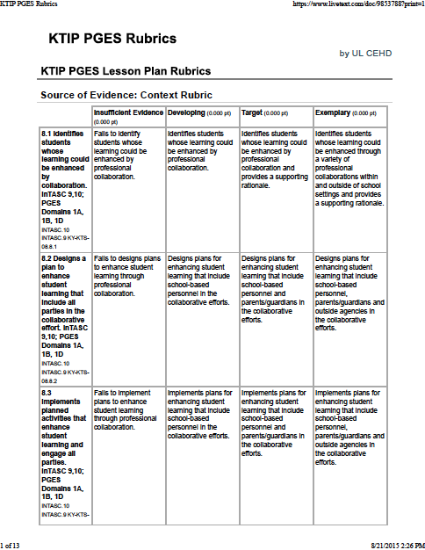

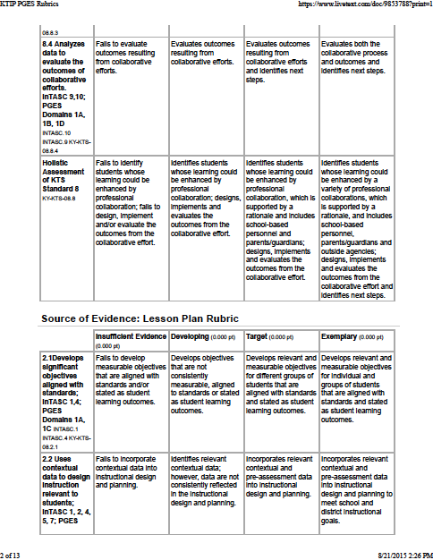

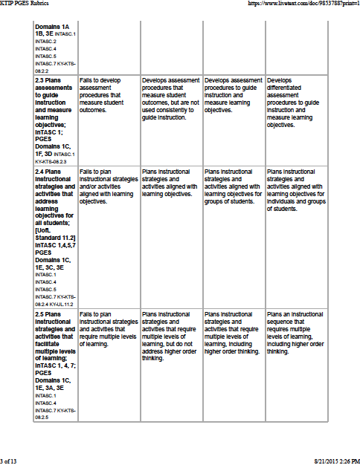

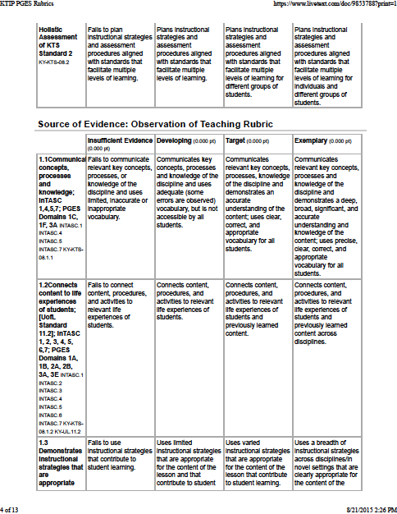

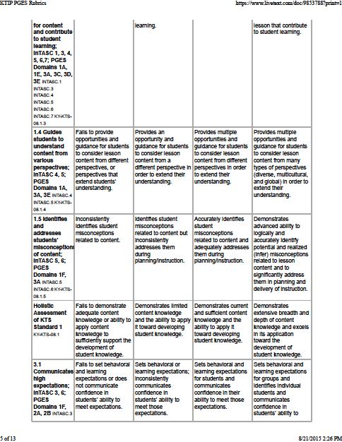

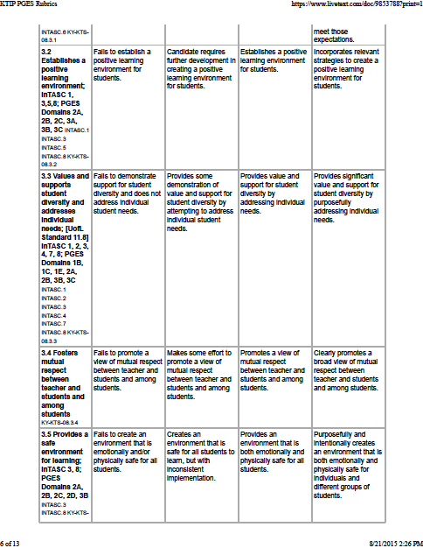

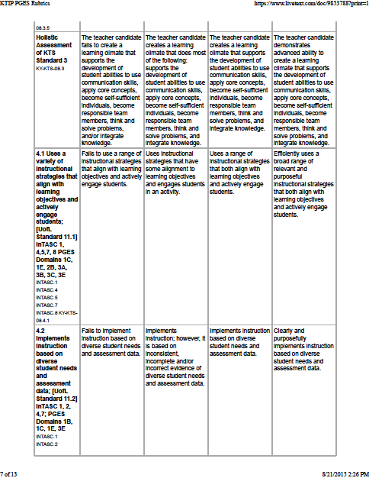

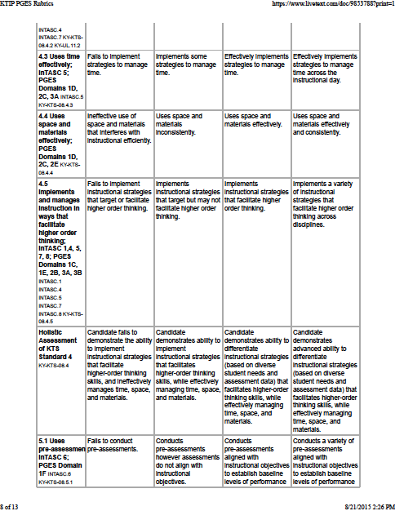

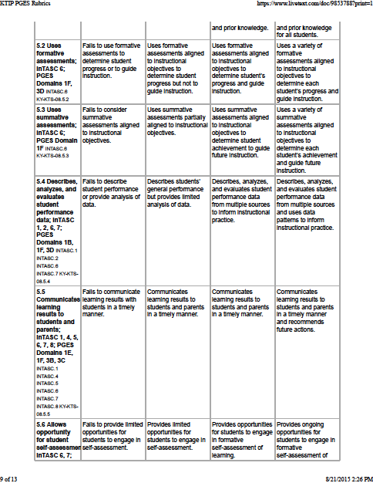

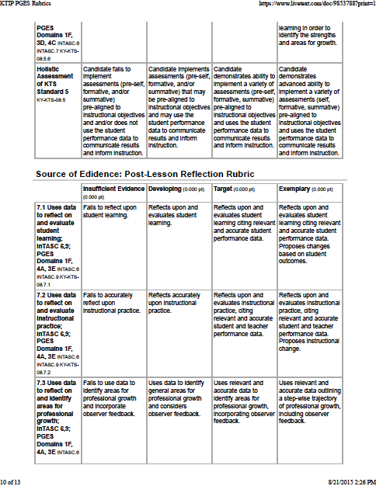

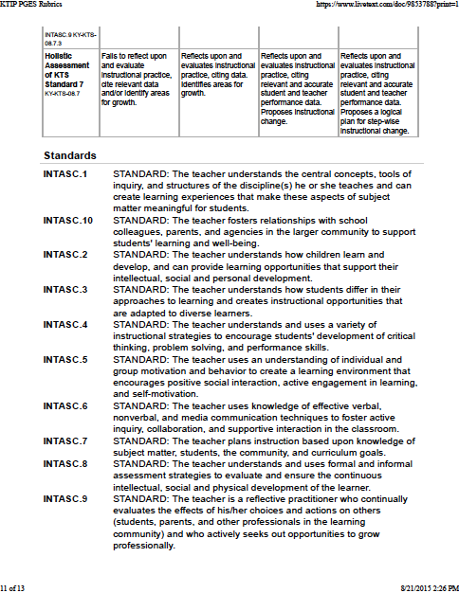

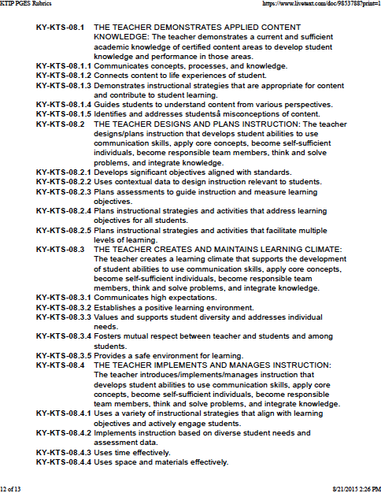

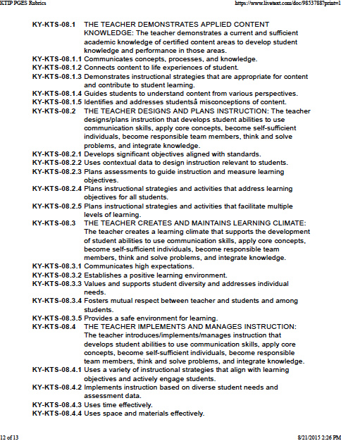

Syllabus prepared by Stefanie Wooten Burnett August, 2015.