CAEP Annual Reporting Measure 1: Impact of P-12 learning & development

The EPP has been working with the Kentucky Center for Statistics (KYSTATS) and the Education Professional Standards Board (EPSB) and the University of Kentucky to collect and disseminate data related to completer impact on P-12 students. In 2020, the preliminary report indicated the following Median Growth Percentile data.

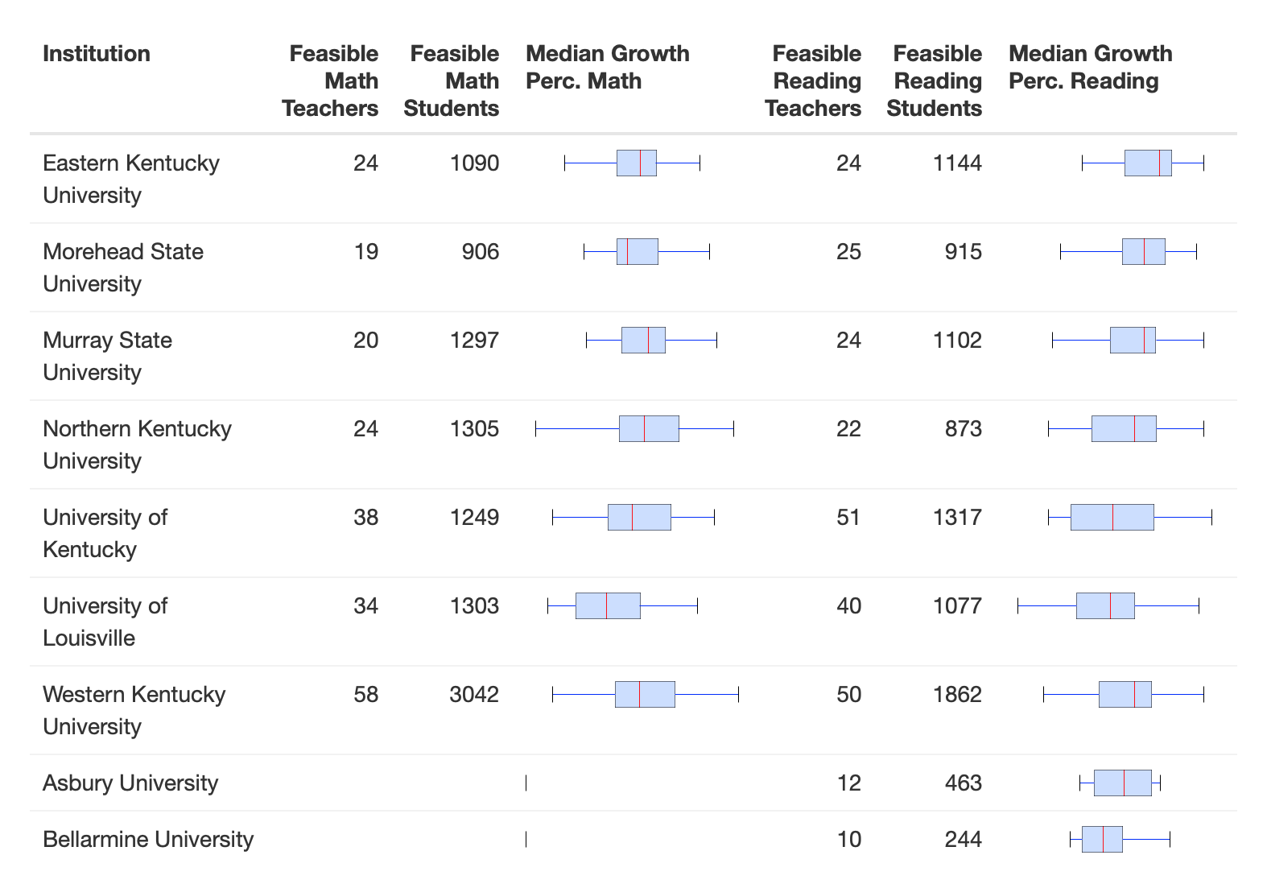

The final report is being worked on by the group. The description of the items included in the report are listed below.

Investigating New Teacher Impact
Over the last few years, revised CAEP standards have driven multiple reports designed to assist in meeting accreditation standards. CAEP ‘Standard 4: Program Impact’ has continued to present challenges.
This data is devised to explore the limitations and available information when using the broadest consistent cohort available with regular standardized testing. This cohort consists of beginning teachers who completed a traditional route initial undergraduate certification program with sufficient eligible students for subject specific median student growth percentile calculation. Students and teachers are defined by being in the public K-12 school during the 2019 academic year (AY) and meeting eligibility requirements.
Teachers eligible for attribution to the EPP must meet several criteria:
- The individual must have completed a traditional route initial undergraduate certification program. [source: EPSB (EPSB_EducatorCollegePrm)]
  - This criteria captures the largest subgroup of initial certificate completers who can be expected to be reasonably consistent in experience.
  - The minimum year of successful initial certification program completion was determined for each individual. If all completions within that year were attributed to the same postsecondary institution, the individual was eligible for inclusion as a teacher attributable to that particular institution.
- The individual must not be re-enrolled in a Kentucky postsecondary institution in pursuit of a graduate degree in education prior to or concurrent with the specified AY (2019). [Source: CPE (KPEDS_Enrollments)]
  - This information is based on enrollments from the Council on Postsecondary Education with and individual seeking a graduate degree in a major falling under the two-digit NAICS of ‘13’.
- The individual must be recorded as the primary teacher of record for a course considered eligible for attribution of math or reading student growth percentiles. [Source: KDE (IC_courses)]
  - A course was considered eligible if the state course code was consistent with the course codes used for state level teacher growth score calculation under the retired Professional Growth and Evaluation System (PGES) model.
  - A teacher was deemed the primary teacher of record based on the primary teacher identifier in Infinite Campus Course Records.
- The individual must be a beginning teacher (based on primary teacher of record) in the Public K-12 system during the specified AY. [Source: EPSB (EducatorCollegePrm); KDE (MUNIS)]
  - Years taught in a K-12 classroom were determined based on the number of AYs in which a teacher appeared in the ‘MUNIS Person PSD’ system, with any job class code, from the minimum year of successful initial certification program completion to the specified year (inclusive of the specified year). Individuals were included if they were in their first, second, or third recorded year since first initial certification program completion.
- The individual must have at least 10 students who meet eligibility requirements in a given subject area enrolled in a course eligible for attribution during the specified AY.
  - KPREP scores are not comparable across subject matter, grade level, or academic years and must be assessed separately.
Students eligible for attribution must meet the following criteria:
- The student must have a valid KPREP score on the standard form of the test for the given subject matter and AY. [Source: KDE (IC_Assessments, IC_AnnualPerson)]
  - The standard and alternative forms are scored on different metrics. Restriction to the non-alternative form of the test for the same AY allows scores to be appropriately compared.
- The student must have a valid KPREP score on the standard form of the test for the given subject matter in the previous AY. [Source: KDE (IC_Assessments, IC_AnnualPerson)]
  - This restricts students to 4th through 8th grade students.
  - This also restricts students to mathematics and reading subject matter
  - Prior year scores are used when matching students to a similar comparison student. Comparison students are based on prior KPREP scale score similarity, prior FRL status, prior SPED status, prior grade, ethnicity, and race (general).
- The student must have only one primary teacher for any given subject matter in the specified AY, based on course codes eligible for attribution. [Source: KDE (IC_Courses, IC_AnnualPerson)]
  - If a student takes two courses, within the same subject, eligible for attribution with the same teacher, the student is still eligible. Only if more than one teacher is eligible for attribution is the student excluded from the analysis.
Institutions are eligible for reporting if they meet the following criteria:
- The institution has at least 10 beginning teachers eligible for MSGP calculation during the 2019 AY.
  - Eligible teachers are based on meeting the teacher eligibility criteria listed above and having at least 10 students who meet the previously described student eligibility requirements.
  - Eligibility requirements must be met by subject as MSGP is calculated separately for reading and mathematics.
Institutions are eligible for t-test calculations if they have at least 30 beginning teachers eligible for MSGP calculation during the 2019 AY.

