You can now use Panopto with Microsoft Teams! With the Panopto application in Teams, you can access your Panopto content, upload meeting recordings to Panopto, and more.

Follow these steps to add the Panopto applications to your Microsoft Teams client.

Log into your Teams desktop client. On the left-hand side of the screen, click Apps.

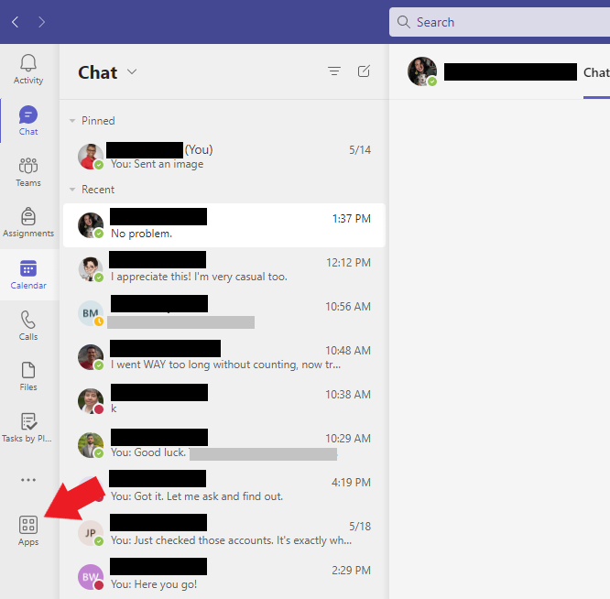

Find Panopto under Popular in your org. Alternatively, search for Panopto in the Search bar on the left side of the screen. After selecting Panopto, a new window will appear.

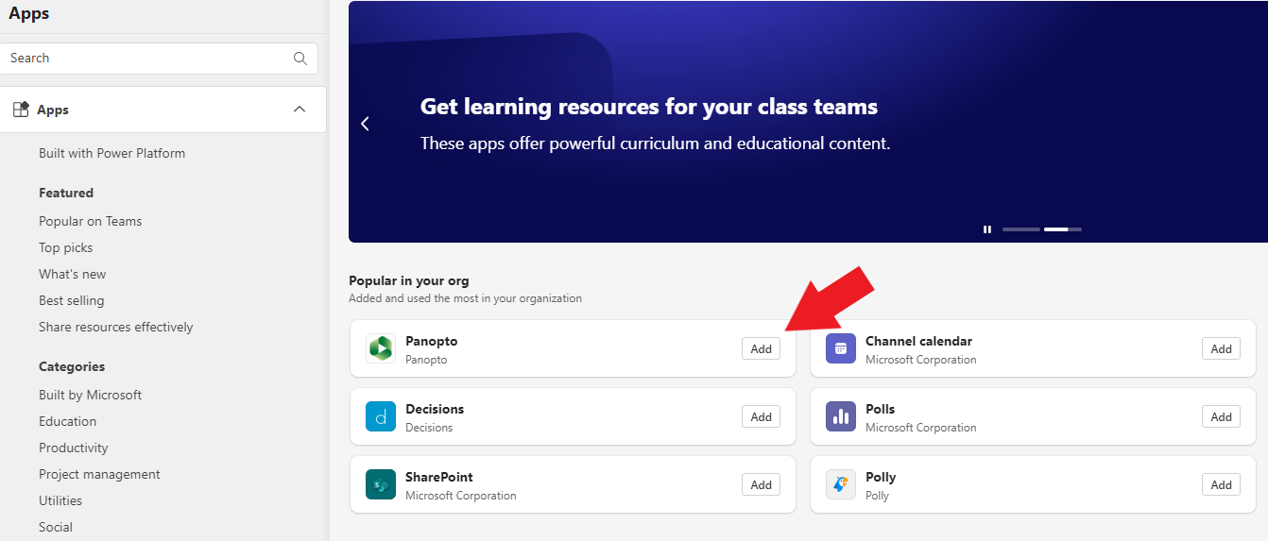

In the new window, click Add. The window will close.

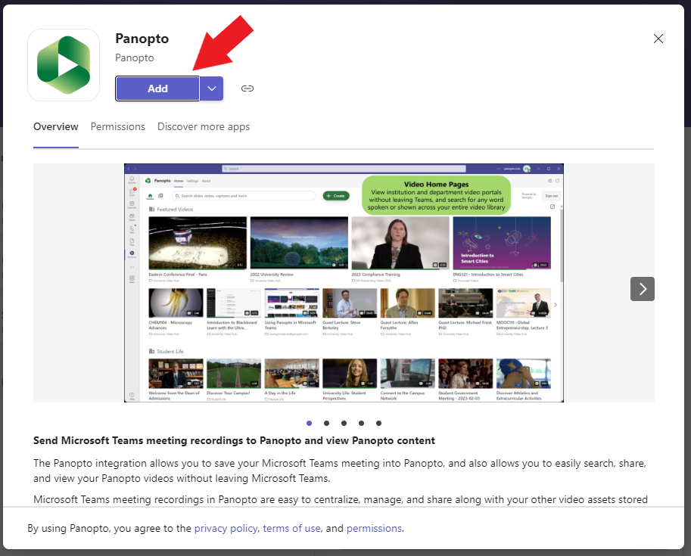

After the window closes, you will be prompted to sign into Panopto. On the first step, select blackboard.louisville.edu from the dropdown menu. Then, click Sign in. A new window will appear.

In the new window, sign in using your University email (userID@louisville.edu) and password.

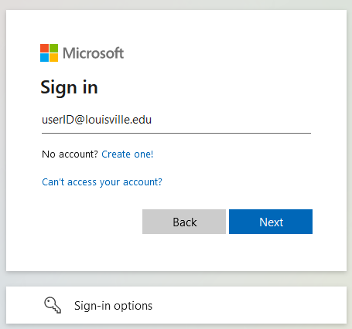

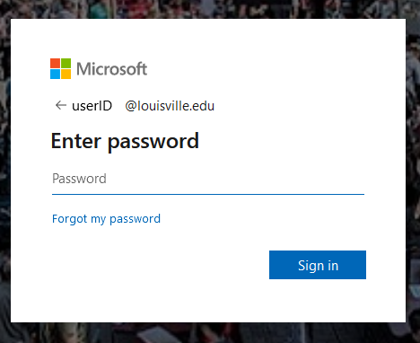

After signing in, the window will close. Your Panopto account will display in your Teams client.

