Standard Operating Procedure (SOP)
REPRODUCTIVE TOXICANTS
CASRN: View specific chemical SDS
DANGER
View specific chemical SDS for complete hazard details.
Suspected of damaging the unborn child;
May damage fertility.
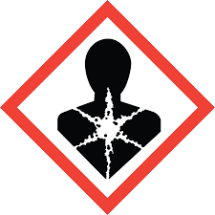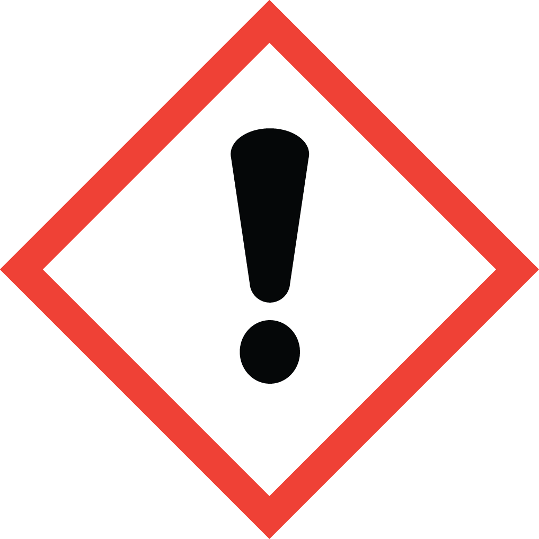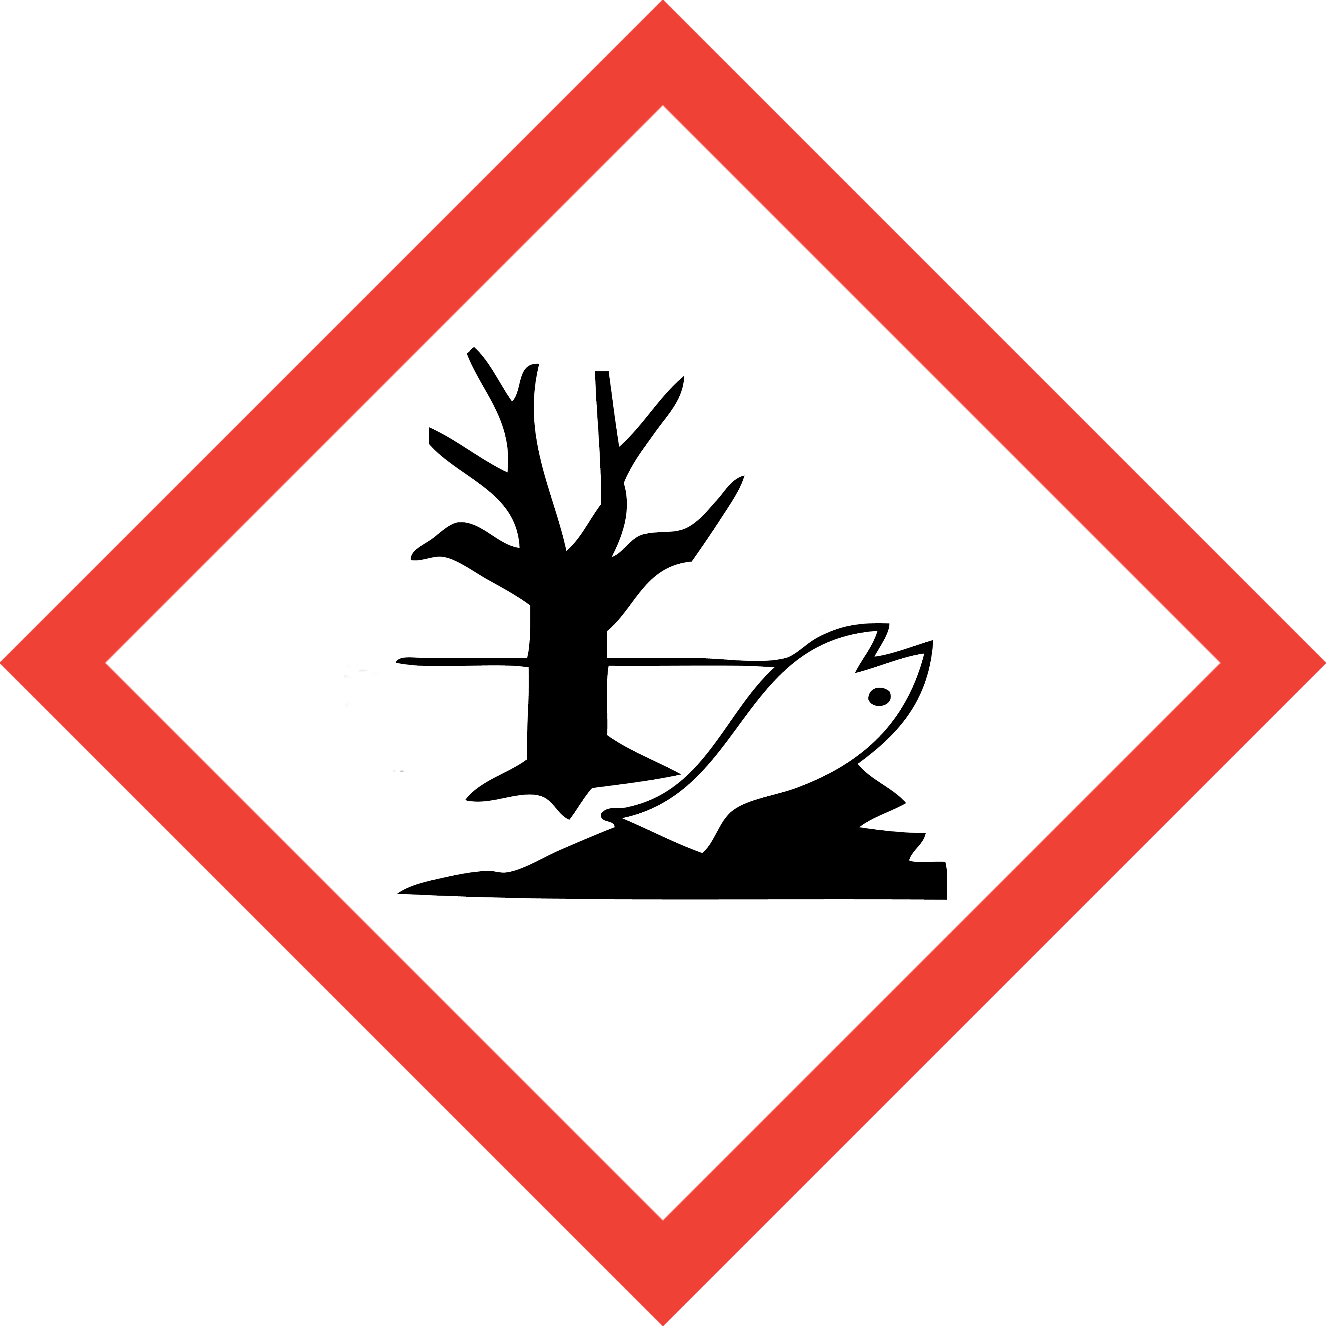
This is an SOP template and is not complete until:
1) Lab specific information is entered into Section 1
2) Lab specific protocol/procedure is added to Section 8 and,
3) Section 9, SOP has been signed and dated by the PI and relevant lab personnel.

Upload PI approved and signed SOP into SciShield PI Lab Web Page, Documents Section.
Print a copy and insert into your Laboratory Chemical Hygiene Plan.
Section 1 – Lab-Specific Information
Building/Room(s) covered by this SOP:
Department
Principal Investigator
Principal Investigator Phone
Date SOP written, approved by PI
Lab Manager
Lab Phone
Emergency Contact & Phone Number

Lab Specific REPRODUCTIVE TOXICANT(s) covered by this SOP:
PI shall purchase REPRODUCTIVE TOXICANT chemical in smallest container size needed.
All lab personnel authorized to use and work with any reproductive toxicant must read each specific REPRODUCTIVE TOXICANT(s) chemical or product Safety Data Sheet (SDS) prior to use.
List all REPRODUCTIVE TOXICANT(s) below, add additional rows as needed.
CHEMICAL NAME | CAS NUMBER | TARGET ORGAN(s) | Additional Specific hazard info (i.e. OSHA PEL, personal decontamination/clean up instructions)

Section 2 – Potential Hazards/Toxicity
REPRODUCTIVE TOXICANTS listed lab-specific chemical(s) current manufacturer-specific Safety Data Sheet (SDS) must be available and reviewed by lab personnel prior to use.
- Reproductive hazards are substances or agents that may affect the reproductive health of women or men or the ability of couples to have healthy children.
- Hazards may be chemical, physical or biological. Examples of reproductive hazards are lead (chemical), radiation (physical) and certain viruses (biological).
- Workers may be exposed to reproductive hazards by breathing them in (inhalation), by contact with skin (dermal) and by swallowing them (ingestion).
- Potential health effects include infertility, miscarriage, birth defects and developmental disorders in children.
- GHS Classification for Reproductive Toxicity Category 1A, 1B, or 2 (SDS Section 2.1)
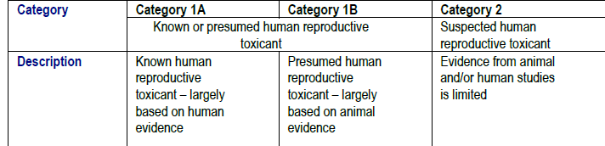
REPRODUCTIVE TOXICANTS covered under this SOP are defined as chemical solid and liquid materials:
REPRODUCTIVE TOXICANT compressed gas cannot be included under this SOP. Contact DEHS at 852-6670 for separate required SOP assistance.

Section 3 – Engineering Controls and Personal Protective Equipment (PPE)
- Engineering Controls: Use of REPRODUCTIVE TOXICANTS must be conducted in a properly functioning chemical fume hood. Chemical fume hoods must be approved and certified annually by DEHS and have a face velocity between 80 – 120 feet per minute (fpm).
- Hygiene Measures: Avoid contact with skin, eyes, and clothing. Wash hands before breaks and immediately after handling the product.
- Hand Protection: Nitrile gloves. Gloves must be inspected prior to each use. Use proper glove removal technique (without touching outer surface of the gloves) to avoid skin contact with REPRODUCTIVE TOXICANTS on the contaminated gloves. Dispose of gloves after use into medical waste box labeled for incineration. Wash hands thoroughly with warm water and soap.
- Eye Protection: ANSI-approved properly fitting safety glasses or chemical splash goggles are required.
- Skin and Body Protection: A chemical resistant lab coat shall be worn at a minimum. The lab coat must be appropriately sized for the individual and securely closed to its full length. Personnel must also wear full length pants, or equivalent, socks, and close-toed and closed-heeled shoes.
- Respiratory Protection: REPRODUCTIVE TOXICANTS should not be opened or administered outside of a chemical fume hood; therefore, respiratory protection should not be required. If work with REPRODUCTIVE TOXICANT cannot be conducted within a chemical fume hood, or other ventilated enclosure, contact DEHS at 852-6670 for a safety assessment.
Section 4 – First Aid Procedures
  - Personnel exposure should be reported to PI immediately. For assistance contact UofL Campus Health at 502-852-2402 or preferred physician for medical advice regarding possible long-term health effects and potential recommendation for medical monitoring. PI shall also report any exposure incident to DEHS at 502-852-6670.
If inhaled: Call 502-852-6111 if victim is unconscious or not breathing. Move to fresh air. If the person is not breathing, give artificial respiration. Avoid mouth to mouth contact.
In case of skin contact: Call 502-852-6111 or consult physician. Immediately (within seconds) flush affected area for at least 15 minutes. Remove contaminated clothing and shoes. Place clean blanket around victim.
In case of eye contact: Call 502-852-6111 or consult physician. First check the victim for contact lenses and remove if present. Flush eyes with water for 15 minutes then transport patient immediately to hospital.
If swallowed: Call 502-852-6111 or consult physician. Do not induce vomiting. Rinse mouth with water. Never give anything by mouth to unconscious person.
Section 5 – Special Handling and Storage Requirements
- REPRODUCTIVE TOXICANTS and working solutions containing REPRODUCTIVE TOXICANTS must be clearly labeled to describe contents and hazards.
- When in use, there shall be an established, designated area for REPRODUCTIVE TOXICANTS (i.e. tape of area of bench where REPRODUCTIVE TOXICANTS will be used, post signage, etc ).
- When not in use, REPRODUCTIVE TOXICANTS and working solutions must be securely stored.
- Access and use of REPRODUCTIVE TOXICANTS must be restricted to PI-authorized lab personnel who are current on DEHS Lab Safety and Hazardous Waste training and have read, understand, and been trained on this SOP as well as any other lab-specific procedure involving use of this chemical.
- A current copy of the REPRODUCTIVE TOXICANTS Safety Data sheet (SDS) must be available at all times to personnel working in the laboratory.
- Do not work with REPRODUCTIVE TOXICANTS alone. Lab buddy system is highly recommended.

Section 6 –Spill and Accident Procedures; Decontamination
  - Report any spills of REPRODUCTIVE TOXICANTS to DEHS immediately. If there is an imminent threat to building occupants, pull the nearest fire alarm station to evacuate the building and call 502-852-6111. If personnel have become exposed and need medical assistance, call 502-852-6111.
Clean up all spills immediately. ensure others are aware of the release of REPRODUCTIVE TOXICANTS outside of the chemical fume hood or other ventilated enclosure.
- Avoid breathing vapors and contact with skin and eyes. Wear protective clothing, rubber gloves and safety glasses.
  - Wipe up and absorb small quantities with vermiculite or other absorbent material. Place spilled clean up materials in lab chemical solid waste container or ziplock bag marked as “Hazardous waste REPRODUCTIVE TOXICANT Specific name – REPRODUCTIVE TOXICANT “ and submit for DEHS chemical waste pick up. Spill clean up contaminated PPE, such as gloves, can be place these in bag with spill clean-up waste.
  - Decontaminate any surfaces that may have contacted REPRODUCTIVE TOXICANTS with detergent, such as Alconox, soap and water, or other manufacturer prescribed method.

Section 7 – Waste Disposal Procedures
Label, Proper Disposition and/or Waste Submission

- REPRODUCTIVE TOXICANTS is prohibited from sink disposal or discard into trash.
- Collect REPRODUCTIVE TOXICANTS containing liquid waste in a container not to exceed 1 gal. Waste collection container must have a closeable lid (i.e. screw top cap) and marked as “Hazardous waste REPRODUCTIVE TOXICANT Specific name –REPRODUCTIVE TOXICANT “ and submit for DEHS chemical waste pick up via Chematix.
- REPRODUCTIVE TOXICANTS contaminated sharps (syringe, needle, pipette tips, glass slides) shall be disposed in a puncture resistant sharps container and discarded into medical waste box to be destroyed by incineration (Stericycle Yellow QR code label) .
- Unwanted or expired containers of REPRODUCTIVE TOXICANTS must be submitted for DEHS chemical waste pick up via Chematix.
- If you have never used Chematix, contact DEHS at 852-6670 or chematix@louisville.edu for further assistance and training.
- For existing users of Chematix, Quick Reference Guides and Videos are available at https://louisville.edu/dehs/waste-disposal

Store Waste
- Store properly labeled hazardous waste closed containers in a designated location within the lab.
- Best management practice (BMP) is to store hazardous waste containers in secondary containment (i.e. polyethylene tray, do not use Styrofoam).
- Waste must be under control of the person generating the waste and stored at or near the process generating the waste (i.e. kept in the same lab or assigned pod).

Section 8 – Description of Lab-Specific Procedures
List working principle (lab SOP) for each REPRODUCTIVE TOXICANT listed in section 1
NOTE: Any deviation from this SOP requires approval from Principal Investigator.
REPRODUCTIVE TOXICANT Chemical Name:
REPRODUCTIVE TOXICANT CAS Number:

Section 9 – Documentation of Training (signature and training date of all users is required)
Principal Investigator SOP Approval
Print name ____________________________________ Signature______________________________
Approval Date: ___________________
MM/DD/YYYY
Prior to conducting any work with REPRODUCTIVE TOXICANTS listed in Section 1 of this SOP the Principal Investigator must ensure that all laboratory personnel receive training on the content of this SOP and have read and understand this SOP and are aware of chemical specific hazard(s) and how to minimize their risk of exposure to themselves and others.
I have read and understand the content of this SOP:
Name | Signature | Date

