Standard Operating Procedure (SOP)
CARCINOGENS & MUTAGENS
CASRN: View EACH specific chemical SDS
DANGER
View specific chemical SDS for complete hazard details.
Toxic if inhaled, swallowed or in contact with skin; may cause cancer; may cause genetic effects, and/or
suspected of causing genetic defects.
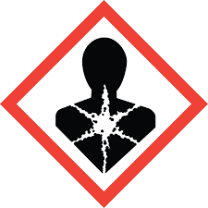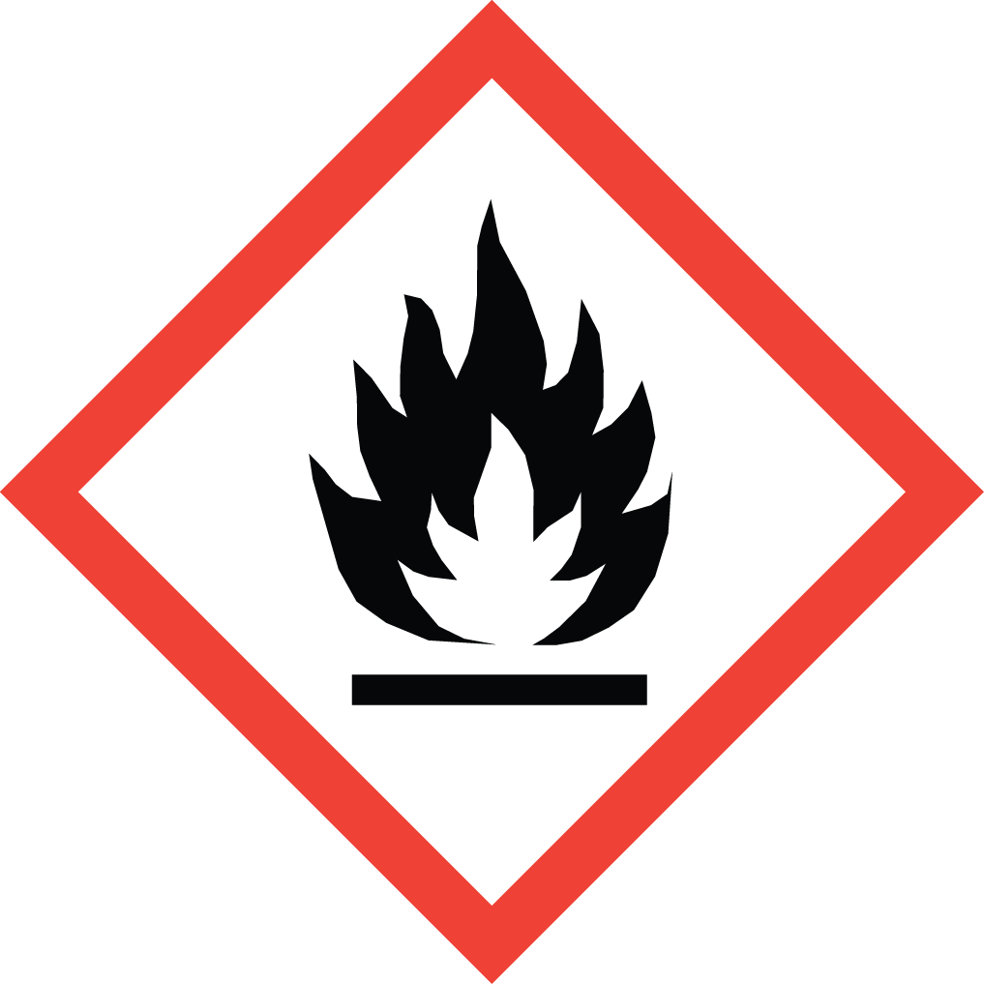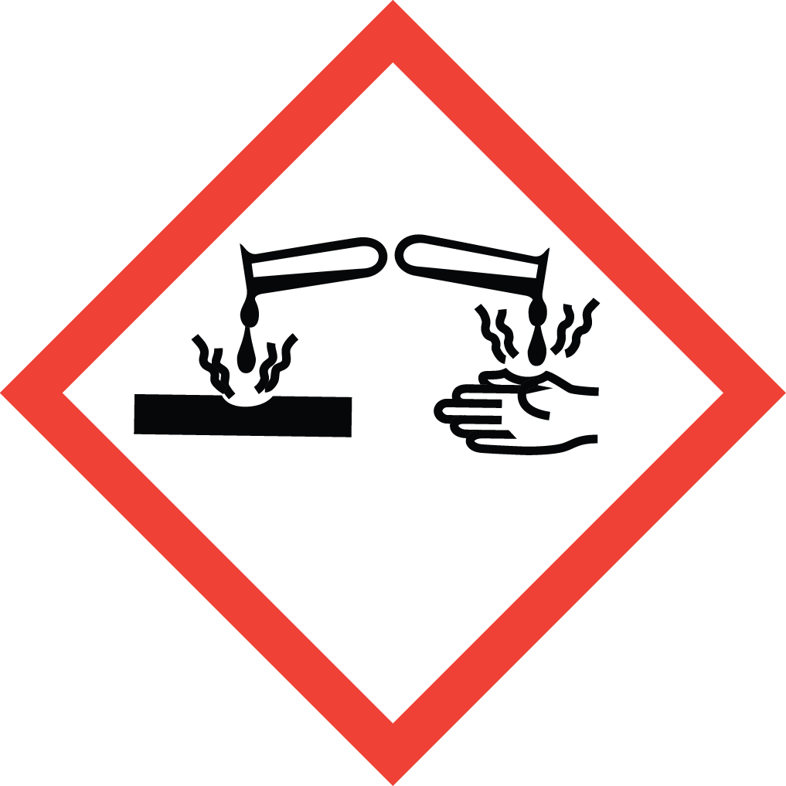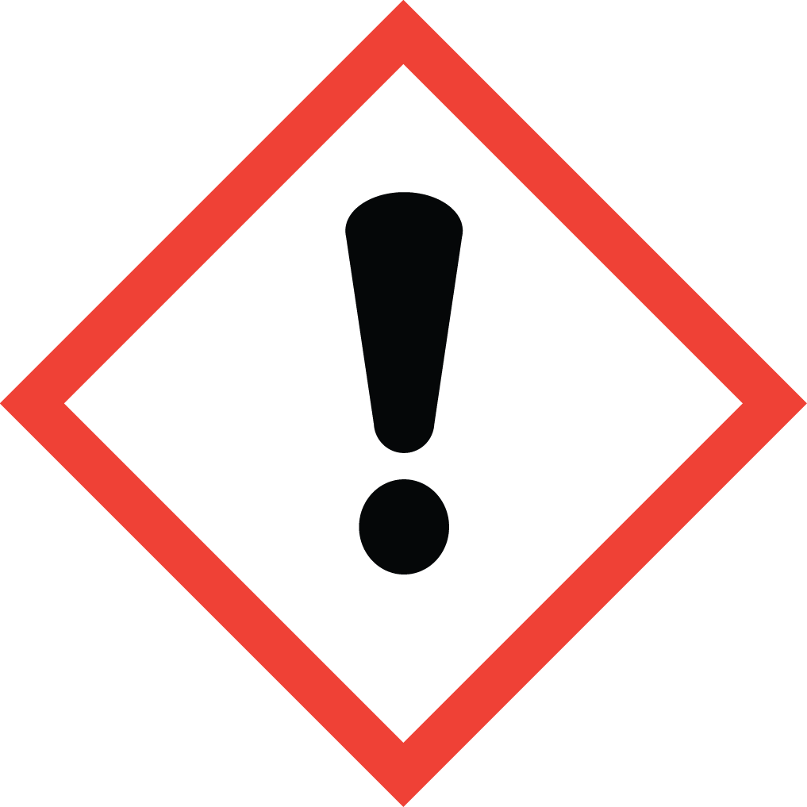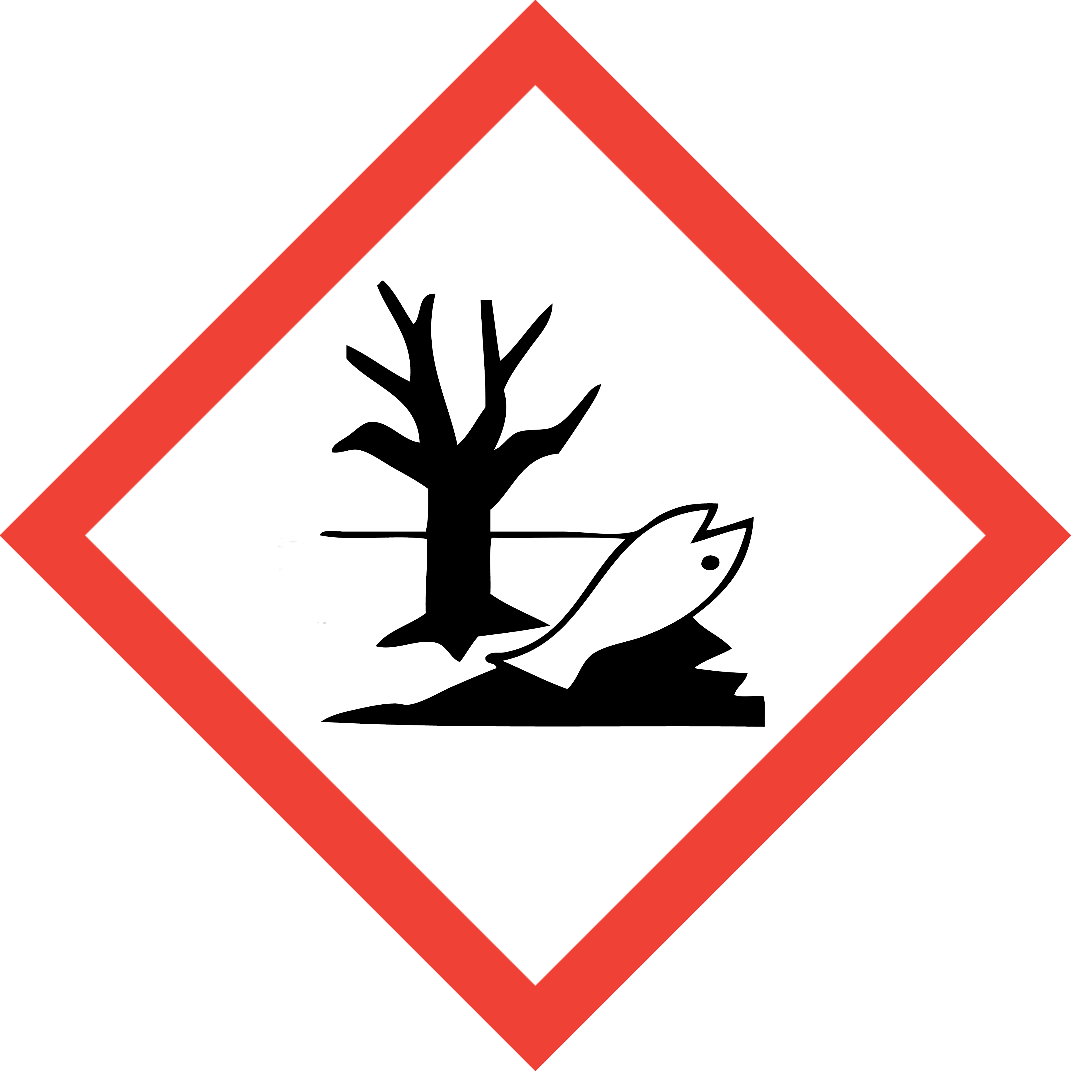
This is an SOP template and is not complete until:
1) Lab specific information is entered into Section 1
2) Lab specific protocol/procedure is added to Section 8 and,
3) Section 9, SOP has been signed and dated by the PI and relevant lab personnel.

Upload PI approved and signed SOP into SciShield PI Lab Web Page, Documents Section.
Print a copy and insert into your Laboratory Chemical Hygiene Plan.
Section 1 – Lab-Specific Information
Building/Room(s) covered by this SOP:
Department
Principal Investigator
Principal Investigator Phone
Date SOP written, approved by PI
Lab Manager
Lab Phone
Emergency Contact & Phone Number

Lab Specific Carcinogen(s) AND/OR Mutagens covered by this SOP:
Lab personnel should purchase carcinogen and mutagen chemical in smallest container size practical.
Chemical name | CAS Number | Target Organ(s) | Additional Specific hazard info and/or decontamination/clean up instructions
(PI/Authorized PI Lab Manager: add more rows as needed)
Section 2 – Potential Hazards/Toxicity
CARCINOGENS AND/OR MUTAGENS listed specific chemical(s) current manufacturer-specific Safety Data Sheet (SDS) must be available and reviewed by lab personnel prior to use.
CARCINOGEN compounds are chronic toxins with long latency periods that can cause damage after repeated or long duration exposures and often do not have immediate harmful effects. Users can be exposed to these compounds through inhalation, ingestion, and/or dermal absorption.
CARCINOGENS covered under this SOP are defined as solid and liquid materials, regulated by OSHA as a carcinogen, as follows:
- Listed under the category, “known to be carcinogens,” in the Annual Report on Carcinogens published by the National Toxicology Program (NPT) latest edition (check SDS Section 11).

- Listed under Group 1, “carcinogenic to humans” by the International Agency for Research on Cancer Monographs (IARC) latest edition (check SDS Section 11).

- Listed in either Group 2A or 2B by IARC or under the category, “reasonably anticipated to be carcinogens” by NTP (check SDS Section 11).

- OSHA GHS Carcinogenicity Category 1, 1A, 1B, or 2 (check SDS Section 2.1)

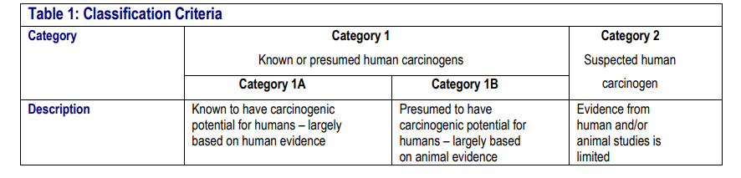
MUTAGENS covered under this SOP are defined as solid and liquid materials as follows:
- Chemical that causes permanent changes in the amount or structure of the genetic material in a cell. Chemicals classified as mutagens in accordance with the Hazard Communication Standard (§ 1910.1200) shall be considered mutagens for purposes of this section.

- GHS Germ Cell Mutagenicity Category 1, 1A, 1B, or 2 (check SDS Section 2.1)
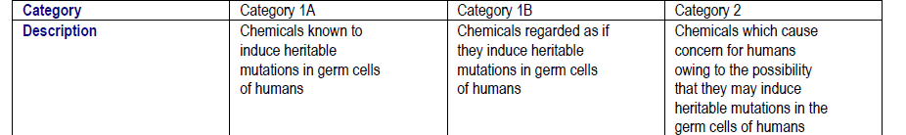

- If you are still unsure if your chemical is classified as a MUTAGEN contact DEHS at 852-6670 for assistance.
CARCINOGEN or MUTAGEN compressed gas cannot be included under this SOP. Contact DEHS at 852-6670 for separate required SOP assistance.
Section 3 – Engineering Controls and Personal Protective Equipment (PPE)
- Engineering Controls: Use of CARCINOGENS AND MUTAGENS must be conducted in a properly functioning chemical fume hood. Chemical fume hoods must be approved and certified annually by DEHS and have a face velocity between 80 – 120 feet per minute (fpm).
- Hygiene Measures: Avoid contact with skin, eyes, and clothing. Wash hands before breaks and immediately after handling the product.
- Hand Protection: Nitrile gloves. Gloves must be inspected prior to each use. Use proper glove removal technique (without touching outer surface of the gloves) to avoid skin contact with CARCINOGENS AND/OR MUTAGENS on the contaminated gloves. Dispose of gloves after use into medical waste box labeled for incineration. Wash hands thoroughly with warm water and soap.
- Eye Protection: ANSI-approved properly fitting safety glasses or chemical splash goggles are required.
- Skin and Body Protection: A chemical resistant lab coat shall be worn at a minimum. The lab coat must be appropriately sized for the individual and securely closed to its full length. Personnel must also wear full length pants, or equivalent, socks, and close-toed and closed-heeled shoes.
- Respiratory Protection: CARCINOGENS AND/OR MUTAGENS should not be opened or administered outside of a chemical fume hood; therefore, respiratory protection should not be required. If work with CARCINOGEN cannot be conducted within a chemical fume hood, or other ventilated enclosure, contact DEHS at 852-6670 for a safety assessment.
Section 4 – First Aid Procedures
  - Personnel exposure should be reported to PI immediately. For assistance contact UofL Campus Health at 502-852-2402 or preferred physician for medical advice regarding possible long-term health effects and potential recommendation for medical monitoring. PI shall also report any exposure incident to DEHS at 502-852-6670.
If inhaled: Call 502-852-6111 if victim is unconscious or not breathing. Move to fresh air. If the person is not breathing, give artificial respiration. Avoid mouth to mouth contact.
In case of skin contact: Call 502-852-6111 or consult physician. Immediately (within seconds) flush affected area for at least 15 minutes. Remove contaminated clothing and shoes. Place clean blanket around victim.
In case of eye contact: Call 502-852-6111 or consult physician. First check the victim for contact lenses and remove if present. Flush eyes with water for 15 minutes then transport patient immediately to hospital.
If swallowed: Call 502-852-6111 or consult physician. Do not induce vomiting. Rinse mouth with water. Never give anything by mouth to unconscious person.
Section 5 – Special Handling and Storage Requirements
- CARCINOGENS AND/OR MUTAGENS working solutions containing CARCINOGENS AND/OR MUTAGENS must be clearly labeled to describe contents and hazards.
- When in use, there shall be an established, designated area for CARCINOGENS AND/OR MUTAGENS (i.e. tape of area of bench where CARCINOGENS will be used, post signage, etc ).
- When not in use, CARCINOGENS AND/OR MUTAGENS and working solutions must be securely stored.
- Access and use of CARCINOGENS AND/OR MUTAGENS must be restricted to PI-authorized lab personnel who are current on DEHS Lab Safety and Hazardous Waste training and have read, understand, and been trained on this SOP as well as any other lab-specific procedure involving use of this chemical.
- A current copy of the CARCINOGENS AND/OR MUTAGENS Safety Data sheet (SDS) must be available at all times to personnel working in the laboratory.
- Do not work with CARCINOGENS AND/OR MUTAGENS alone. Lab buddy system is highly recommended.

Section 6 –Spill and Accident Procedures; Decontamination
  - Report any spills of CARCINOGENS AND/OR MUTAGENS to DEHS immediately. If there is an imminent threat to building occupants, pull the nearest fire alarm station to evacuate the building and call 502-852-6111. If personnel have become exposed and need medical assistance, call 502-852-6111.
Clean up all spills immediately. ensure others are aware of the release of CARCINOGENS AND/OR MUTAGENS outside of the chemical fume hood or other ventilated enclosure.
- Avoid breathing vapors and contact with skin and eyes. Wear protective clothing, rubber gloves and safety glasses.
- Wipe up and absorb small quantities with vermiculite or other absorbent material. Place spilled clean up materials in lab chemical solid waste container or plastic bag marked as “Hazardous waste CARCINOGENS AND/OR MUTAGENS – Carcinogen or mutagen any other known physical or health hazard “, securely close container and submit for DEHS chemical waste pick up.
  - Decontaminate any surfaces that may have contacted CARCINOGENS AND/OR MUTAGENS with detergent, such as Alconox or soap and water.
Section 7 – Waste Disposal Procedures
Labeling, Proper Disposition and/or Waste Submission,

- CARCINOGEN AND/OR MUTAGEN WASTE even Trace contaminated waste shall not be discarded into regular trash or down the sink or other drain.
- Collect CARCINOGENS AND/OR MUTAGENS containing liquid waste in a container not to exceed 1 gal. Waste collection container must have a closeable lid (i.e. screw top cap) and marked as “Hazardous waste CARCINOGENS AND/OR MUTAGENS–Carcinogen or mutagen + any other known physical or health hazard“ and submit for DEHS chemical waste pick up via Chematix.
- Trace CARCINOGENS AND/OR MUTAGENS contaminated sharps (syringe, needle, pipette tips, glass slides) shall be disposed in a puncture resistant sharps container and discarded into medical waste box to be destroyed by incineration (Stericycle Yellow QR code label) .
- Trace CARCINOGENS AND/OR MUTAGENS contaminated PPE (gloves, paper towels) and contaminated labware (no free liquids) shall be discarded into medical waste box to be destroyed by incineration (Stericycle Yellow QR code label).
- Unwanted or expired containers and stock solutions of CARCINOGENS AND/OR MUTAGENS must be submitted for DEHS chemical waste pick up via Chematix.
- If you have never used Chematix, contact DEHS at 852-6670 or chematix@louisville.edu for further assistance and training.
- For existing users of Chematix, Quick Reference Guides and Videos are available at https://louisville.edu/dehs/waste-disposal

Store Waste
- Store properly labeled hazardous waste closed containers in a designated location within the lab.
- Best management practice (BMP) is to store hazardous waste containers in secondary containment (i.e. polyethylene tray, do not use Styrofoam).
- Waste must be under control of the person generating the waste and stored at or near the process generating the waste (i.e. kept in the same lab or assigned pod).

Section 8 – Description of Lab-Specific Procedures
NOTE: Any deviation from this SOP requires approval from Principal Investigator.
List EACH CARCINOGEN AND/OR MUTAGEN lab SOP separately.
Carcinogen (or Mutagen) Name:
Carcinogen (or Mutagen) CAS Number:

Section 9 – Documentation of Training (signature and training date of all users is required)
Principal Investigator SOP Approval
Print name ____________________________________ Signature______________________________
Approval Date: ___________________
MM/DD/YYYY
Prior to conducting any work with CARCINOGENS listed in Section 1 of this SOP the Principal Investigator must ensure that all laboratory personnel receive training on the content of this SOP and have read and understand each Carcinogen lab SOP and are aware of each chemical specific hazard(s) and how to minimize their risk of exposure to themselves and others.
I have read and understand the content of this SOP:
Name | Signature | Date

