**Standard Operating Procedure (SOP)**

**ACUTELY TOXIC CHEMICALS**

**(Liquid and Solid Only)**

CASRN: View specific chemical SDS

**DANGER**

View specific chemical SDS for complete hazard details.

Toxic if inhaled, swallowed or in contact with skin; may cause cancer;

suspected of causing genetic defects.

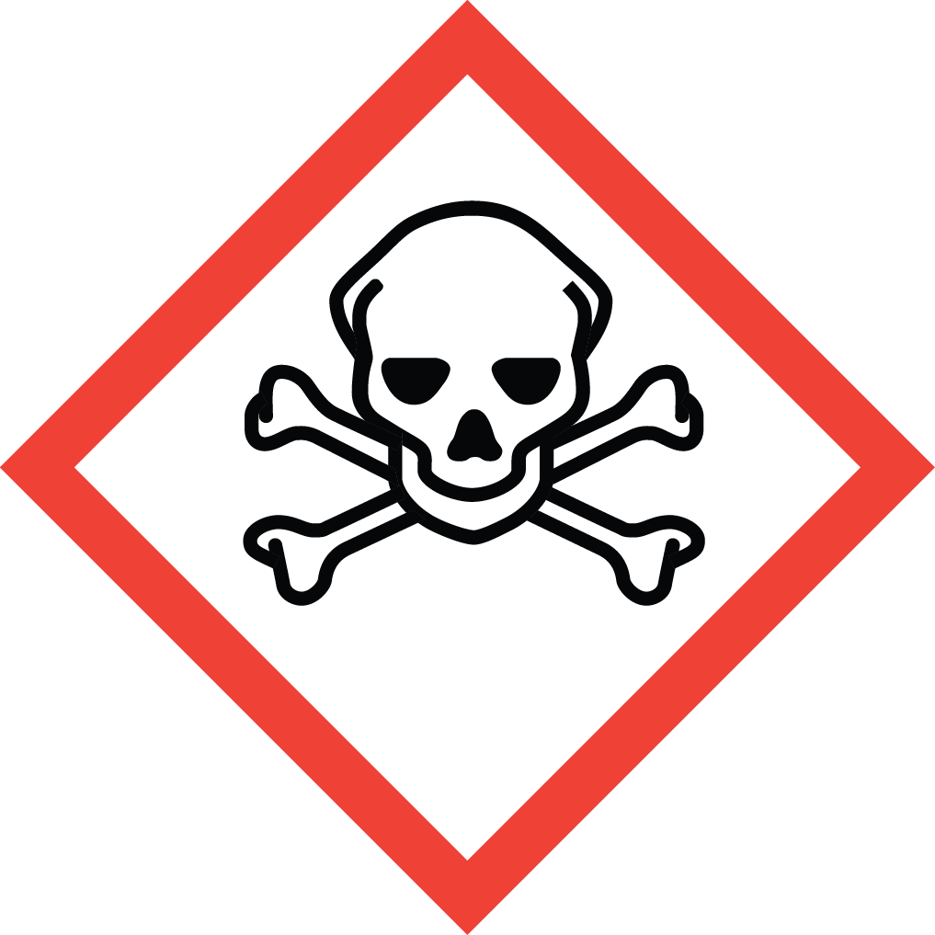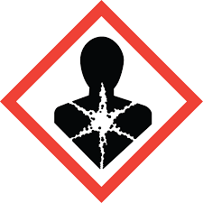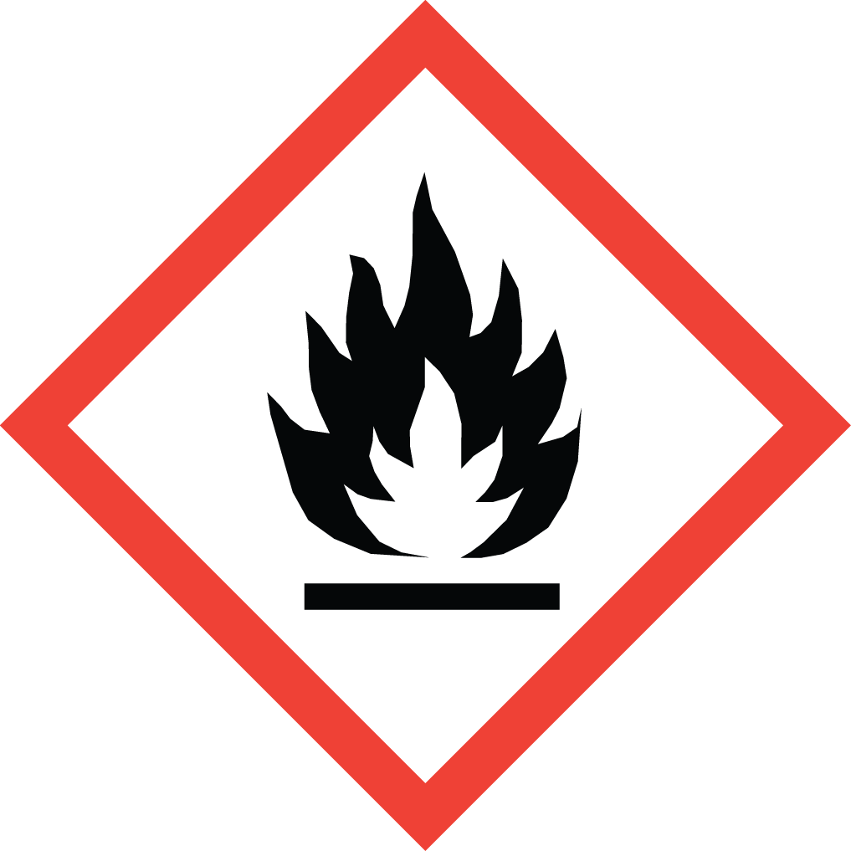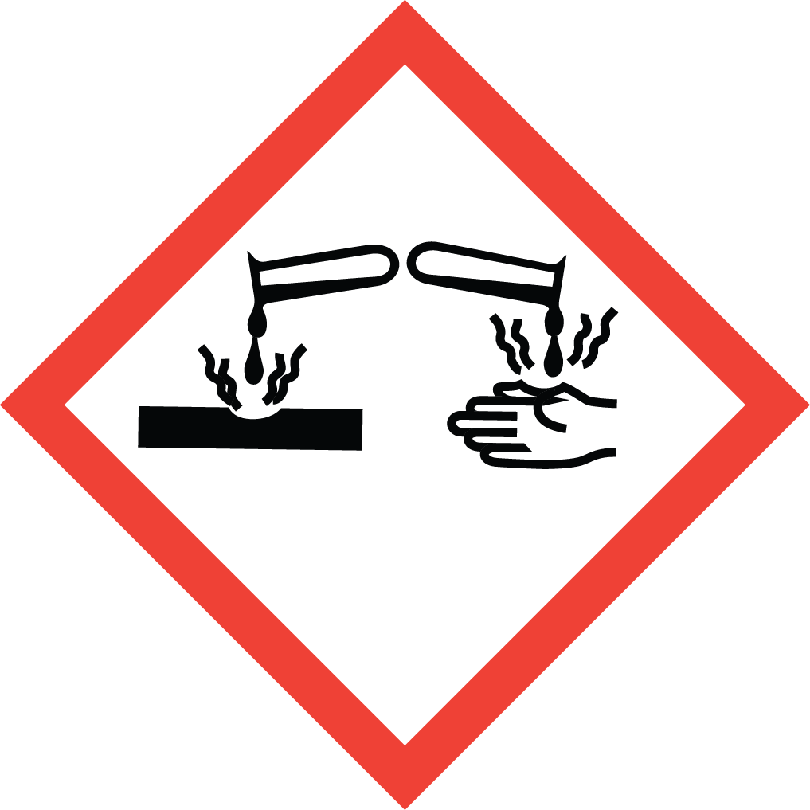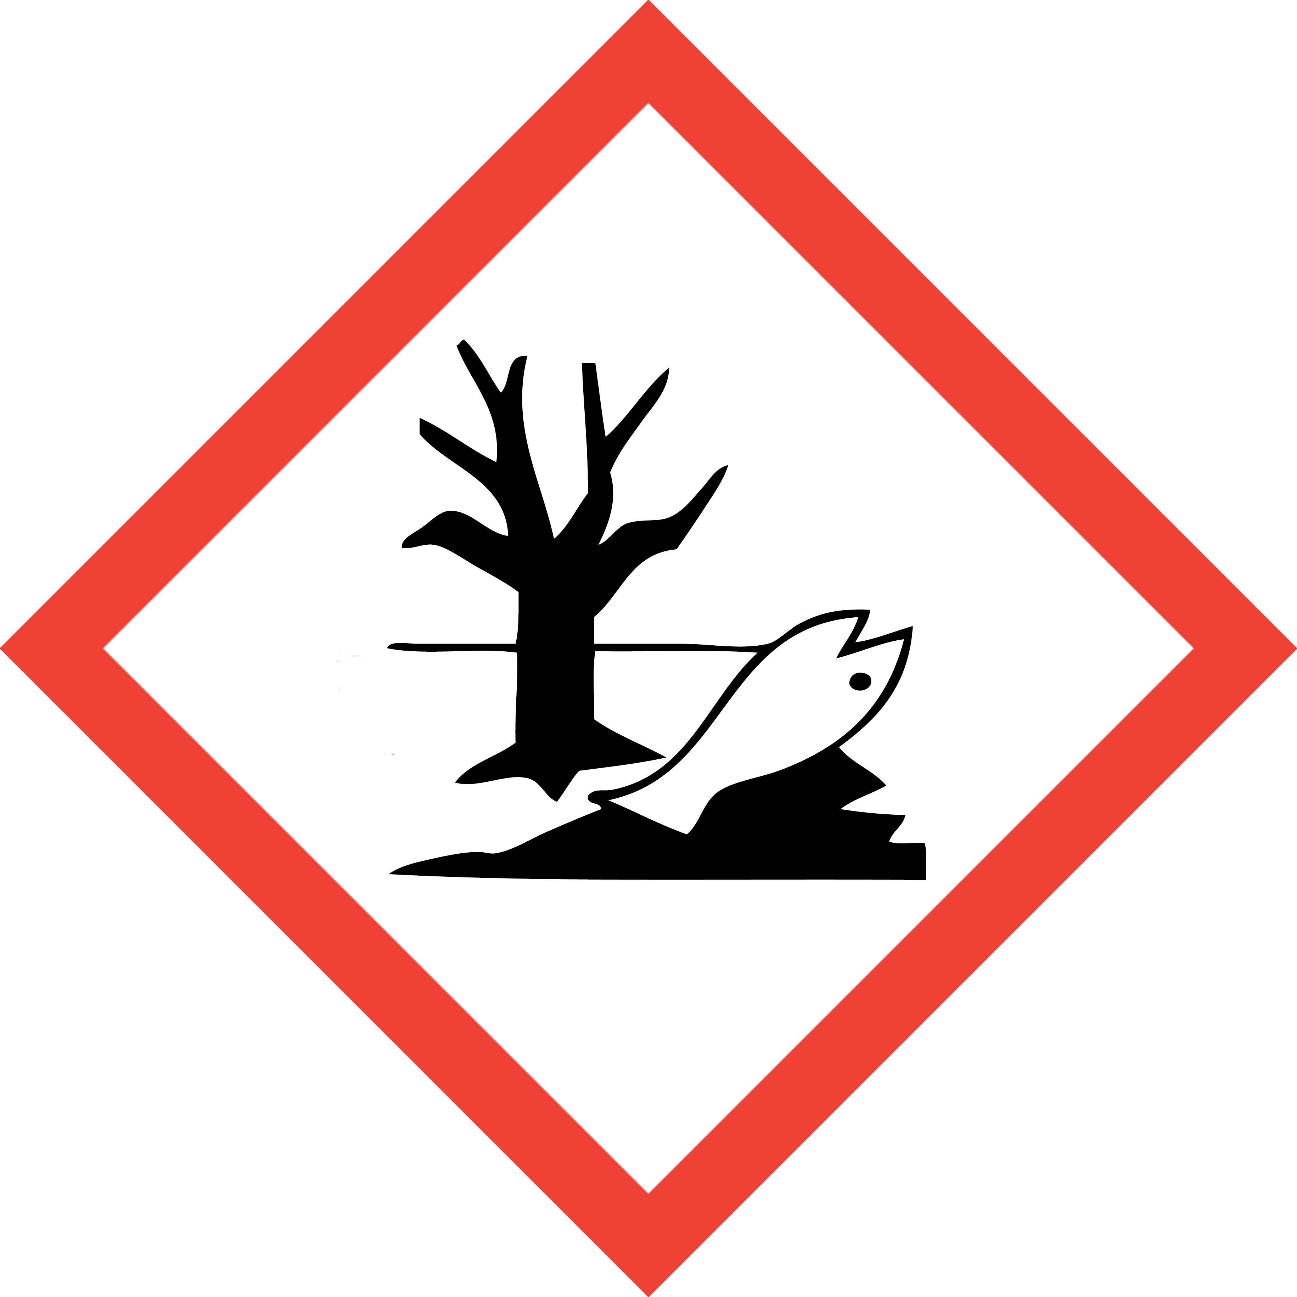

This is an SOP template and is not complete until:

1) Lab specific information is entered into Section 1

2) Lab specific protocol/procedure is added to Section 8 and,

3) Section 9, SOP has been signed and dated by the PI and relevant lab personnel.

**Upload PI approved and signed SOP into SciShield PI Lab Web Page, Documents Section.**

**Print a copy and insert into your Laboratory Chemical Hygiene Plan.**

**Section 1 – Lab-Specific Information**

| **Building/Room(s) covered by this SOP:** | Click here to enter text. | | | |
| --- | --- | --- | --- | --- |
| **Department** | Click or tap here to enter text. | | | |
| **Principal Investigator** | Click or tap here to enter text. | | | |
| **Principal Investigator Phone** |  | | | |
| **Date SOP written, approved by PI** | Click or tap to enter a date. |  |  |  |
| **Lab Manager** | Click or tap here to enter text. | | | |
| **Lab Phone** |  | | | |
| **Emergency Contact & Phone Number** |  | | | |

**Lab Specific Acutely Toxic Chemical(s) covered by this SOP:**

**Lab personnel shall purchase the smallest acutely toxic chemical container size needed.**

|  |  |  |  |
| --- | --- | --- | --- |
| **Chemical name** | **CAS Number** | **Target Organ(s)** | **Specific hazard info (i.e. OSHA PEL, personnel decontamination/clean up instructions, etc)** |
|  |  |  |  |
|  |  |  |  |

**(PI/Authorized PI Lab Manager: add more rows as needed)**

**Section 2 – Potential Hazards/Toxicity**

**ACUTELY TOXIC CHEMICAL** listed lab-specific chemical(s) current manufacturer-specific Safety Data Sheet (SDS) must be available and reviewed by lab personnel prior to use.

**ACUTELY TOXIC CHEMICAL** covered under this SOP are those liquid and solid substances that pose significant adverse health effects for immediate or short-term exposures. The route of exposure that causes the adverse effect may be inhalation, absorption (through skin, eyes, or mucous membranes), or ingestion, depending on the chemical.

A chemical is considered to be acutely toxic when it falls within any of the following categories:

* A chemical with a median lethal dose (LD50) of ≤ 50 mg per kg of body weight when administered orally to albino rats weighing between 200 and 300 gm each
* A chemical with a median lethal dose (LD50) of ≤200 mg per kg of body weight when administered by continuous contact for 24 hours (or less if death occurs within 24 hours) with the bare skin of albino rabbits weighing between 2 and 3 Kg each
* A chemical that has a median lethal concentration (LC50) in air of 500 ppm by volume or less of gas, 2.0 mg per liter for vapor, or 0.5 mg per liter or less of dust and mists, when administered by continuous inhalation for 4 hours .
* GHS Classification includes any of the following (SDS Section 2.1):
* Acute Toxicity by Inhalation or Dermal exposure — Category 1 or 2
* Acute Toxicity by Oral exposure — Category 1
* Specific Target Organ Toxicity—Single Exposure — Category 1
* Skin or Respiratory Sensitizer—Category 1A

**TOXIC AND ACUTELY TOXIC compressed gas** cannot be included under this SOP. Contact DEHS at 852-6670 for separate required SOP assistance.

**Section 3 – Engineering Controls and Personal Protective Equipment (PPE)**

* **Engineering Controls:** Use of ACUTELY TOXIC CHEMICAL must be conducted in a properly functioning chemical fume hood. Chemical fume hoods must be approved and certified annually by DEHS and have a face velocity between 80 – 120 feet per minute (fpm).
* **Hygiene Measures:** Avoid contact with skin, eyes, and clothing. Wash hands before breaks and immediately after handling the product.
* **Hand Protection:** Nitrile gloves.Gloves must be inspected prior to each use. Use proper glove removal technique (without touching outer surface of the gloves) to avoid skin contact with ACUTELY TOXIC CHEMICAL on the contaminated gloves. Dispose of gloves after use into medical waste box labeled for incineration. Wash hands thoroughly with warm water and soap.
* **Eye Protection:** ANSI-approved properly fitting safety glasses or chemical splash goggles are required**.**
* **Skin and Body Protection:** A chemical resistant lab coat shall be worn at a minimum**.** The lab coat must be appropriately sized for the individual and securely closed to its full length. Personnel must also wear full length pants, or equivalent, socks, and close-toed and closed-heeled shoes.
* **Respiratory Protection:** ACUTELY TOXIC CHEMICAL should not be opened or administered outside of a chemical fume hood; therefore, respiratory protection should not be required. If work with CARCINOGEN cannot be conducted within a chemical fume hood, or other ventilated enclosure, contact DEHS at 852-6670 for a safety assessment.

**Section 4 – First Aid Procedures**

* + Personnel exposure should be reported to PI immediately. For assistance contact UofL Campus Health at 502-852-2402 or preferred physician for medical advice regarding possible long-term health effects and potential recommendation for medical monitoring. PI shall also report any exposure incident to DEHS at 502-852-6670.

**If inhaled:** **Call 502-852-6111 if victim is unconscious or not breathing**. Move to fresh air. If the person is not breathing, give artificial respiration. Avoid mouth to mouth contact.

**In case of skin contact:** **Call 502-852-6111 or consult physician**. Immediately (within seconds) flush affected area for at least 15 minutes. Remove contaminated clothing and shoes. Place clean blanket around victim.

**In case of eye contact:** **Call 502-852-6111 or consult physician**. First check the victim for contact lenses and remove if present. Flush eyes with water for 15 minutes then transport patient immediately to hospital.

**If swallowed:** **Call 502-852-6111 or consult physician**. Do not induce vomiting. Rinse mouth with water. Never give anything by mouth to unconscious person.

**Section 5 – Special Handling and Storage Requirements**

* ACUTELY TOXIC CHEMICAL and working solutions containing ACUTELY TOXIC CHEMICAL must be clearly labeled to describe contents and hazards.
* When in use, there shall be an established, designated area for ACUTELY TOXIC CHEMICAL (i.e. tape of area of bench where ACUTELY TOXIC CHEMICAL will be used, post signage, etc ).
* When not in use, ACUTELY TOXIC CHEMICAL and working solutions must be securely stored.
* Access and use of ACUTELY TOXIC CHEMICAL must be **restricted to PI-authorized lab personnel** who are current on DEHS Lab Safety and Hazardous Waste training and have read, understand, and been trained on this SOP as well as any other lab-specific procedure involving use of this chemical.
* A current copy of the ACUTELY TOXIC CHEMICAL Safety Data sheet (SDS) must be available at all times to personnel working in the laboratory.
* Do not work with ACUTELY TOXIC CHEMICAL alone. Lab buddy system is highly recommended.

**Section 6 –Spill and Accident Procedures; Decontamination**

* + **Report any spills of ACUTELY TOXIC CHEMICAL to DEHS immediately.** If there is an imminent threat to building occupants, pull the nearest fire alarm station to evacuate the building and **call 502-852-6111**. If personnel have become exposed and need medical assistance, **call 502-852-6111**.  
    Clean up all spills immediately. ensure others are aware of the release of ACUTELY TOXIC CHEMICAL outside of the chemical fume hood or other ventilated enclosure.
* Avoid breathing vapors and contact with skin and eyes. Wear protective clothing, rubber gloves and safety glasses.
* Wipe up and absorb small quantities with vermiculite or other absorbent material. Place spilled clean up materials in lab chemical solid waste container or ziplock bag marked as **“Hazardous waste ACUTELY TOXIC CHEMICAL Specific Name – Toxic “** and submit for DEHS chemical waste pick up.
  + If ACUTELY TOXIC CHEMICAL is in aqueous solution, absorb and wipe up all liquids. Collect all clean up materials, including gloves and any other contaminated PPE, and discard into medical waste box to be destroyed by incineration (Stericycle Yellow QR code label) .
  + Decontaminate any surfaces that may have contacted ACUTELY TOXIC CHEMICAL with manufacturer SDS specified method or detergent, such as Alconox or soap and water.

**Section 7 – Waste Disposal Procedures**

**Label Waste**

* Collect ACUTELY TOXIC CHEMICAL containing liquid waste in a container not to exceed 1 L. Waste collection container must have a closeable lid (i.e. screw top cap) and marked as **“Hazardous waste ACUTELY TOXIC CHEMICAL Specific Name –Toxic “** and submit for DEHS chemical waste pick up. If empty acutely
* Empty **ACUTELY TOXIC CHEMICAL** container must be collected as chemical hazardous waste. If container is too small to reuse to collect waste, place empty container into ACUTELY TOXIC CHEMICAL solid waste container.
* ACUTELY TOXIC CHEMICAL contaminated sharps (syringe, needle, pipette tips, glass slides) shall be discarded in a puncture resistant sharps container and submitted for DEHS chemical waste pick up.
* ACUTELY TOXIC CHEMICAL contaminated solids (empty containers, contaminated paper towels, gloves, etc.) shall be discarded into waste collection container with a closeable lid and marked as **“Hazardous waste ACUTELY TOXIC CHEMICAL Specific Name –Toxic “** and submit for DEHS chemical waste pick up.
* Unwanted or expired containers of ACUTELY TOXIC CHEMICAL must be submitted for DEHS chemical waste pick up.

**Store Waste**

* Store properly labeled hazardous waste closed containers in a designated location within the lab.
* Best management practice (BMP) is to store hazardous waste containers in secondary containment (i.e. polyethylene tray, **do not use styrofoam)**.
* Waste must be under control of the person generating the waste and stored at or near the process generating the waste (i.e. kept in the same lab or assigned pod).

**Dispose of Waste**

* ACUTELY TOXIC CHEMICAL is prohibited from sink disposal or discard into trash. Submit waste containers of ACUTELY TOXIC CHEMICAL for pick up by DEHS via online University hazardous waste management system Chematix [https://louisville.chematix.com/Chematix/Login](https://nam11.safelinks.protection.outlook.com/?url=https%3A%2F%2Flouisville.chematix.com%2FChematix%2FLogin&data=05%7C01%7Ccathy.price%40louisville.edu%7C7defebafbd5b4a4708b408db2bd23558%7Cdd246e4a54344e158ae391ad9797b209%7C0%7C0%7C638151954059075029%7CUnknown%7CTWFpbGZsb3d8eyJWIjoiMC4wLjAwMDAiLCJQIjoiV2luMzIiLCJBTiI6Ik1haWwiLCJXVCI6Mn0%3D%7C3000%7C%7C%7C&sdata=ir8HFq3XcSwyBekLdNGIKGMSOUu5R%2F5GIn2KrV9Xlew%3D&reserved=0).
* If you have never used Chematix, contact DEHS at 852-6670 or [chematix@louisville.edu](mailto:chematix@louisville.edu) for further assistance and training.
* For existing users of Chematix, Quick Reference Guides and Videos are available at <https://louisville.edu/dehs/waste-disposal>

**Section 8 – Description of Lab-Specific Procedures**

**NOTE:** Any deviation from this SOP requires approval from Principal Investigator.

**Section 9 – Documentation of Training (signature and training date of all users is required)**

**Principal Investigator SOP Approval**

Print name ____________________________________ Signature______________________________

Approval Date: ___________________

MM/DD/YYYY

Prior to conducting any work with ACUTELY TOXIC CHEMICAL listed in Section 1 of this SOP the Principal Investigator must ensure that all laboratory personnel receive training on the content of this SOP and have read and understand this SOP and are aware of chemical specific hazard(s) and how to minimize their risk of exposure to themselves and others.

**I have read and understand the content of this SOP:**

| **Name** | **Signature** | **Date** |
| --- | --- | --- |
| Click or tap here to enter text. |  |  |
| Click or tap here to enter text. |  |  |
| Click here to enter text. |  | Click here to enter a date. |
| Click here to enter text. |  | Click here to enter a date. |
| Click here to enter text. |  | Click here to enter a date. |
| Click here to enter text. |  | Click here to enter a date. |
| Click here to enter text. |  | Click here to enter a date. |
| Click here to enter text. |  | Click here to enter a date. |
| Click here to enter text. |  | Click here to enter a date. |
| Click here to enter text. |  | Click here to enter a date. |