Women’s Support Group
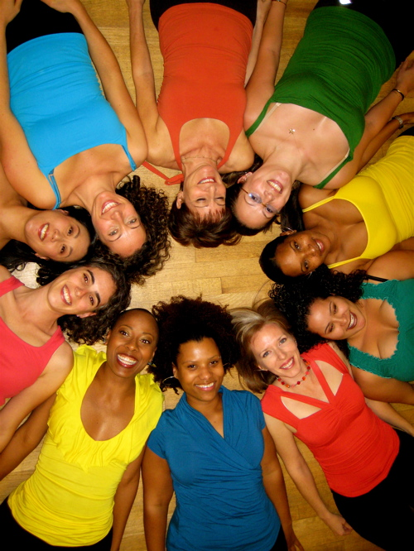

Join us for a time of healing, sharing, and empowerment in a safe, judgment-free environment for students. The group will address many issues we struggle with as women: self-esteem, identity, relationship, body image, work/school/life balance, health, family, and so much more.
Location: U of L Counseling Center at Cardinal Station, 215 Central Ave, Suite 201
Time/Date: Wednesdays 4:30 PM-5:30 PM
If you are interested in joining the group or have questions, feel free to contact the group leader, Dr. Sarah Kolb, at 852-6585 or via email skrams02@exchange.louisville.edu

