Taking Care of Your Mental Health in the Face of Uncertainty

AFSP
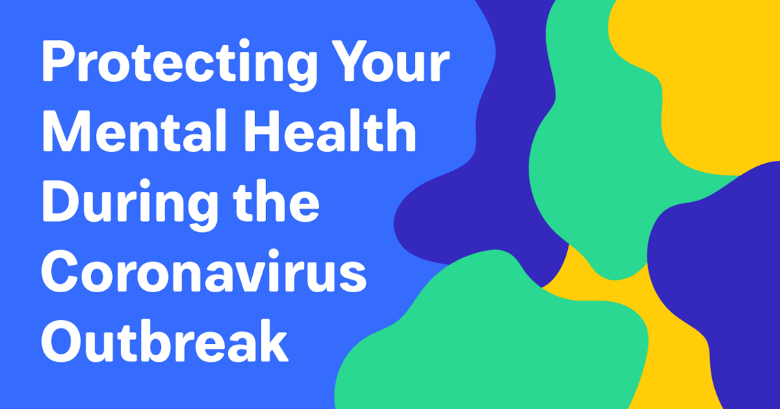
By Doreen Marshall, Ph.D.
Human beings like certainty. We are hard-wired to want to know what is happening when and to notice things that feel threatening to us. When things feel uncertain or when we don’t generally feel safe, it’s normal to feel stressed. This very reaction, while there to protect us, can cause all sorts of havoc when there is a sense of uncertainty and conflicting information around us.
A large part of anxiety comes from a sense of what we think we should be able to control, but can’t. Right now, many of us are worried about COVID-19, known as the “Coronavirus”. We may feel helpless about what will happen or what we can do to prevent further stress. The uncertainty might also connect to our uncertainty about other aspects of our lives, or remind us of past times when we didn’t feel safe and the immediate future was uncertain.
In times like these, our mental health can suffer. We don’t always know it’s happening. You might feel more on edge than usual, angry, helpless or sad. You might notice that you are more frustrated with others or want to completely avoid any reminders of what is happening. For those of us who already struggle with our mental wellness, we might feel more depressed or less motivated to carry out our daily activities.
It’s important to note that we are not helpless in light of current news events. We can always choose our response. If you are struggling, here are some things you can do to take care of your mental health in the face of uncertainty:
- Separate what is in your control from what is not. There are things you can do, and it’s helpful to focus on those. Wash your hands. Remind others to wash theirs. Take your vitamins. Limit your consumption of news (Do you really need to know what is happening on a cruise ship you aren’t on?).
- Do what helps you feel a sense of safety. This will be different for everyone, and it’s important not to compare yourself to others. It’s ok if you’ve decided what makes you feel safe is to limit attendance of large social events, but make sure you separate when you are isolating based on potential for sickness versus isolating because it’s part of depression.
- Get outside in nature–even if you are avoiding crowds. I took a walk yesterday afternoon in my neighborhood with my daughter. The sun was shining, we got our dose of vitamin D, and it felt good to both get some fresh air and quality time together. Exercise also helps both your physical and mental health.
- Challenge yourself to stay in the present. Perhaps your worry is compounding—you are not only thinking about what is currently happening, but also projecting into the future. When you find yourself worrying about something that hasn’t happened, gently bring yourself back to the present moment. Notice the sights, sounds, tastes and other sensory experiences in your immediate moment and name them. Engaging in mindfulness activities is one way to help stay grounded when things feel beyond your control.
- Stay connected and reach out if you need more support. Talk to trusted friends about what you are feeling. If you are feeling particularly anxious or if you are struggling with your mental health, it’s ok to reach out to a mental health professional for support. You don’t have to be alone with your worry and it can be comforting to share what you are experiencing with those trained to help.
We are in this together, and help is always available. If you’re feeling alone and struggling, you can also reach out to The Crisis Text Line by texting TALK to 741741 or National Suicide Prevention Lifeline at 1-800-273-TALK.

