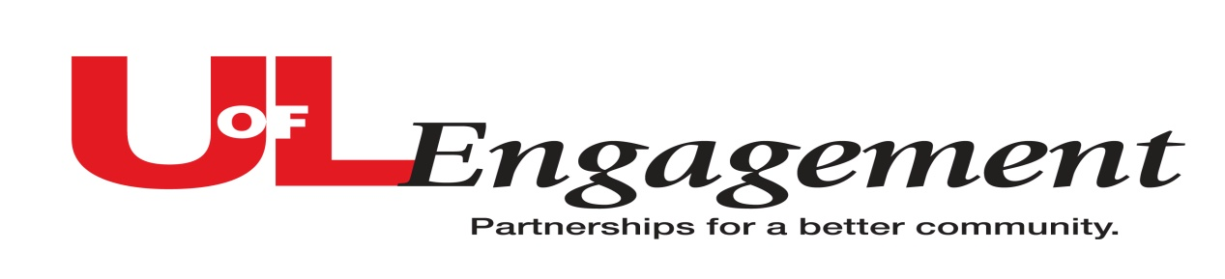
Community Engagement Partnership Data Collection

Frequently Asked Questions

Q. What should be entered as an outreach or engagement partnership?
A: You should enter any teaching, research, and service work that is conducted in partnership or collaboration with the community. It may be a community-based program, collaborative research project, service-learning, training or other type of project that engages the university with the community “beyond the campus walls.” Outreach and engagement is defined as meaningful and mutually beneficial collaborations with partners in education, business and public and social service. It is—
- That aspect of teaching that enables learning beyond the campus walls
- That aspect of research that makes what we discover useful beyond the academic community
- That aspect of service that directly benefits the public.

For more information, see the Characteristics of Community Engagement Partnerships document on the website http://louisville.edu/communityengagement/community-engagement-partnerships

Q. What happens to the information?
A. This information will be stored in the Community Engagement Partnership Database which is under development. These engagement projects will reflect the broad range of University of Louisville partnerships and collaborations. The database will demonstrate the ways in which faculty, staff, and students are partnering with the community and the way the university serves the local community, Kentucky, the region, the nation and around the world. Each unit will be able to access this data for their use and reporting needs.
Q. Who should enter outreach and engagement projects into the database?
A. If you are the engagement contact or administrator for your unit, please work with your colleagues to make sure all the outreach and engagement initiatives in your unit are represented.

Q. We have a team working on this project. Who should enter the project in the database?
A. Any member of the team can enter the project. Contact Connie Shumake or Emily Noonan in the Office of Academic Planning and Accountability to have a member added. Please supply the person’s name and UofL username (ex. jjsmit01).

Q. What information do I need before I enter a project?
A. The following basic data elements needed for each Partnership project:
- Unit/department - UofL unit/department, the primary coordinating unit should report the project. Select information from the drop-down menus for the unit and department name.
- Project Name
- Contact person – UofL contact person/director and information(name, email, phone number)
- Location of the partnership project – list city & state, if Kentucky provide county. If non-U.S., list country.
- Project Description - Include all information that will help others understand the project. Consider including WHAT the project is, WHAT are the objectives and/or expected impacts, WHO does it benefit? (Limit responses to 300 words)
- Project Category (check up to three): Adult Education, Community Outreach/service, Economic Development, Education , Environmental/Sustainability/Green projects, Government, Health Care, Health Education, Homeland Security, Homeland Security, Legal Services, Network Services/IT, Professional Development/Service, Public Health, Public Policy, Research, Social Services, Other, specify.
- Identify the community or external partner- Please provide name, address, contact person and if available website.
- Length of partnership – Provide project start date and end date (if applicable). Is the project on-going or renewable?
- Institutional Impact – indicate linkage to teaching, research service, and benefit to the unit or university.
- University Involvement:
# of Faculty / Staff Involved in Partnership
# Students Involved in Partnership
- Community Impact – indicate scope (local, state, etc…) and describe impact – number of individuals served, indicate issues addressed, benefit to the community or partner.
B. Optional Elements are the following:
- University units (other university personnel or units) involved – list if applicable
- Is the partnership associated with a center or institute? If yes, list.
- Project Website (list if available)
- University Initiatives relationship – indicate linkage to Signature Partnership, i2a, or Sustainability, if applicable. Otherwise leave blank.
- Does the project have a memorandum of agreement or other contractual agreement?
- Grants or Funding associated with the project (if applicable)
  - Name of funding agency & terms
  - Funding amount
  - Funding source – indicate type and percentage (must total 100%)
- Assessment/outcomes process – (yes/no), if yes then describe. For example, how will you measure success in this project (Project Outcomes and Impact)? What are the short-, medium-, and long-term impacts of the project? This may include information such as number of people affected; changes in knowledge, attitudes, or skills of participants (community and other participants); documented financial or social impact; publications and grants resulting from this project. If results are not currently available, list the types of data that will be gathered to document outcomes and impact.

Q. What if I need to make changes to my project?
A. Go to http://louisville.edu/communityengagement/community-engagement-partnerships and get information to log into the Sharepoint/Infopath system with your UofL username and password. Then follow the database instructions to revise or update your unit’s outreach/engagement partnership data.
Q. What is the timeline for this data collection?
A. The system was originally operational from April 1 until June 1, 2010. The system was shut down to compile data for the 2010 strategic plan scorecard report to the university President and Board of Trustees. The system will re-open September 1, 2010 and remain operational until further notice. Units are encouraged to enter data as new partnerships occur.

REQUESTS FOR ADDITIONAL INFORMATION CAN BE SENT TO:

Connie Shumake, Assistant Provost for Accreditation, Academic Programs and Engagement who will oversee the data collection ccshum01@louisville.edu

The Office of Institutional Effectiveness (MITC #338) is providing staff support for this process. Emily Noonan or Il Barrow are also available to answer questions. They can be reached at 852-5705.

