Kentucky Human Trafficking Investigators Association
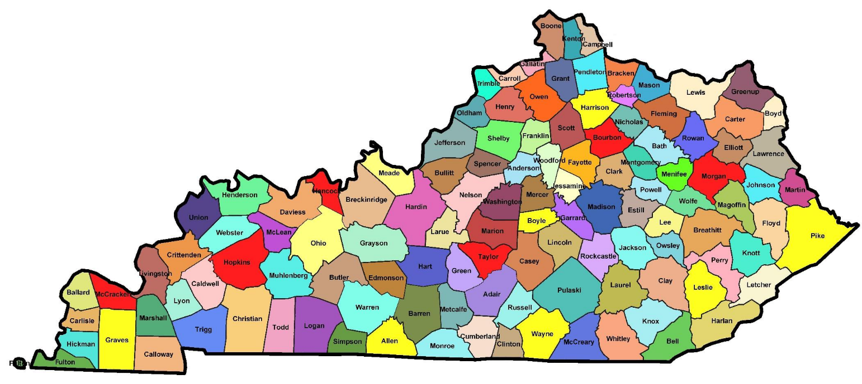
Human trafficking Screening Tool

Adult Commercial Sex Trafficking
Child Commercial Sex Trafficking
Adult Labor Trafficking and Traveling Sales Crews
Child Labor Trafficking
Table of Contents

The purpose and limitations of screening 3
Tips for conducting the interview 4
Victim center approach and trauma informed interviewing 5, 6
Labor trafficking questions 7, 8
Child labor laws 8
Adult commercial sex trafficking 9
Minor commercial sex trafficking 10, 11, 12
Traveling Sales Crew (Labor Trafficking) 13
Bibliography 14

Purpose and limitations of screening
Screening questions can help agency staff to identify victims of human trafficking and help trafficking victims obtain the protection and services they need. Before using the trafficking victims identification tool (TVIT) with persons who may be victims of human trafficking, the victim’s personal safety and comfort should be assured. Screening tool users should make every effort to establish trust and rapport before asking difficult questions that focus on traumatic experiences and other facts. Before screening, users should also be prepared to draw upon the expertise of local legal and medical staff and to refer identified trafficking victims to appropriate housing, health and social services in their area. While this user guide provides essential tips for effective screening with the TVIT, the tool is a complement to, not a substitute for, specialized training in human trafficking, good professional practices and victim-centered services.

The TVIT has been found to be valid and reliable in identifying victims of sex and labor trafficking. However, caution must be exercised in relying too heavily on the results of the screening tool alone, as negative responses to the questions do not definitively preclude the possibility of victimization. Respondents whose answers initially indicate a lack of victimization may instead be demonstrating reasonable fear or forgetfulness as a symptom of trauma. As such, for the best outcomes, questions may have to be asked at a time when the potential victim trusts the interviewer and is ready to respond. The screening tool should be used to guide interviews with potential victims, not to eliminate or deny potential victims access to needed services and legal protections. The best practices in this manual will help to ensure appropriate and successful use of the screening tool.

Tips for Conducting Interviews
The effectiveness of screening for trafficking victimization depends on allaying fear, building rapport and asking questions in an appropriate manner. Interviewers should be comfortable working with trafficking victims, sensitive to their special needs, and aware that they are likely to be suffering the impacts of traumatic experiences. The setting in which an interview takes place can be as important as the questions that are asked. Trafficking victims have often been held in servitude through threats of harm and fear of their arrest or deportation by police and immigration authorities. It is crucial to establish a safe space to help victims feel more comfortable and protected. To help allay victims’ fears from the onset of an interview, the following techniques have proven effective:
• Before conducting a screening, service providers should fulfill some basic needs, such as providing food, clothing, medical care or assurance of at least temporary shelter, if necessary. It may be difficult for a victim to engage in an interview unless these immediate needs for physical comfort and safety are met.
• Hold the interview in a non-threatening and comfortable location. Provide the victim with food and drink, and incidentals including tissues, regular breaks, and a place where the victim can gain their composure if the interview causes distress. It may be difficult for a victim to engage in an interview unless these immediate needs for emotional comfort and protection are met.
• Never interview the victim within sight of the trafficker. If the victim arrives with a person exhibiting controlling behavior, talk to the victim in private. This person may be the trafficker or someone working for the trafficker.
• Maintain a professional, but friendly, attitude and appearance. Law enforcement agents should dress in civilian clothes and make sure no weapons are in view. Others should consider dressing in casual clothing, especially when visiting agricultural labor camps to reach out to potential victims. Dressing in uniforms and other formal attire may create fears that interviewers are from immigration or other enforcement agencies.
• Be honest at the beginning about the purpose and duration of the screening. Describe the victim’s rights, the interview process, and the roles of everyone involved.
• Employ competent, trustworthy interpreters if the victim’s first language is not English. Competent interpreters ask questions using the same wording as the screener and answer as fully as the victim. The victim must be assured of confidentiality.
• Be aware of gender issues and ask victims if they would be more comfortable being interviewed by someone of the same gender. When possible, the victim’s preference for an interpreter of a specific gender or culture should also be accommodated.

Understanding the effects of trauma and victimization
Trafficking victims have often endured profound physical and psychological injuries that may impede the efforts of attorneys and other service providers to interview them and develop strong working relationships. Minimization, denial and memory loss, which are symptoms of psychological trauma, can make it extremely difficult to elicit consistent information. Below are important points regarding trauma and victimization to keep in mind:
• Be aware that trafficking victims may experience long-lasting effects of psychological and physical abuse, traumatic experiences, chronic substance abuse, or violent physical and psychological assaults. Even if not a mental health expert, a screener can learn to recognize common signs of trauma. A service provider who screens trafficking victims may be the first person to whom victims have reported trauma or mental distress.
• Express sorrow for what has happened to them, but do not appear to be judgmental or shocked by the details they reveal.
• Ask only basic questions about mental health unless you are trained as a mental health professional. A few straightforward, non-intrusive questions asked in a kind manner can convey a caring attitude and help the screener and the victim decide if a referral to a mental health professional is desirable or necessary. A user of TVIT should not expect to completely alleviate a victim’s distress or be in a position to diagnose mental illnesses.
• Be understanding when victims do not wish to repeat the details of the crime. Keep in mind that recounting stories many times for various people (social service agencies, lawyers, law enforcement, and so forth) may cause victims to re-experience trauma. Try to minimize the potential for re-traumatization when possible.
Additional considerations for law enforcement
Many law enforcement officials advocate for use of a victim-centered approach when working with potential victims of human trafficking, placing equal value on the stabilization and wellbeing of victims with that of the criminal investigation and prosecution of traffickers. Victims are the key for successful prosecutions, and law enforcement should make every effort to help victims feel safe and secure. When working with trafficking victims, law enforcement officers may wish to keep the following in mind:
• Enlist the help of victim specialists wherever possible.
• Victims often require social services for safety and recovery. Connecting victims with support services can help them get the help they need and allow them to be of greater assistance during an investigation.
• Be mindful that victims may have had prior negative experiences with law enforcement and may be afraid or distrustful as a result. Keep tactical gear, weapons, badges, and uniforms hidden from sight and convey a sincere, caring attitude.
• Since many victims have been arrested, it takes time and astute questioning to determine that they are victims, and not criminals. If arrested in a raid, the victim may have found the raid itself traumatizing. Police officers should have an established protocol for differentiating and separating the traffickers and victims during interviewing.
• Minors involved in trafficking require special protections and custodial planning. Any shelter arrangements made for children or adults should ensure a victim’s safety and meet the special needs of trafficking victims.
• Investigative procedures can be frightening and inhibit successful interviewing. Be aware that lawyers are sometimes employed by traffickers.
• Conventional interrogation techniques may be insensitive to the victim’s feelings and the pace at which they can respond to questions. All interpreters should be certified.
• Traffickers often use immigration status to control foreign-born victims. Victims are often fearful of the immigration consequences resulting from contact with authorities, and may be unable to stay in the United States or access victim assistance services if they do not have legal status. Law enforcement officials can help stabilize these victims so they can obtain immigration relief, including Continued Presence (CP) and T or U Visas, Nonimmigrant Status.
• At times, it may be appropriate to deviate from the screening tool to probe for additional details, such as for questions about payment and medical visits. These details can be important in obtaining further evidence for an investigation, but always be mindful of not re-traumatizing victims. Additional questions about highly sensitive topics may need to wait until subsequent interviews.
• Many trafficking victims have urgent medical needs that should be addressed promptly and confidentially.

Some considerations when asking these questions
• You may re-phrase the questions on the screening tool as necessary to ensure that they understand clearly what you are asking. Listen carefully to what they say, and return to topics as needed during the conversation to clarify and confirm details. • Screeners should ask all questions on the TVIT even if the respondent appears to be the victim of another crime, as trafficking may occur in conjunction with other forms of victimization. Victims of other crimes, such as domestic violence, or labor exploitation, may have experiences of abuse that are similar to those of trafficking victims and may therefore respond in similar ways. • The TVIT inquires about “work or other activities” to elicit information about sexual services and other types of informal work. However, victims of sex trafficking may not think of rape and forced prostitution as “work.” Additionally, victims of labor trafficking may not think of forced shoplifting and forced drug smuggling as “work.” Screeners should pay attention to the terms used by potential victims to describe their experiences, and should use this terminology during interviews. Screeners should also be aware that answering direct questions about sexual activities, or even forced labor, may be difficult for victims, especially when associated with violence, humiliation or shame.

Adult and Minor Labor Trafficking
- Date and time of screening
- Persons Name
- Any alias that may be used?
- Date of Birth
- Language of interview
- Was a translator required?
- Years of school completed?
- What country were you born in?
- If you are not a US citizen, what county are you from?
- Can you tell me why you left your country?
- When did you arrive in the US?
- Did anyone arrange your travel?
- What did they do?
- What was the total cost of the migration to the US?
- Did you or your family borrow money to come to the US?
- If you borrowed or owed money, have you ever been pressured to do anything you did not want to do to pay it back?
- How have you supported yourself while in the US?
- Have you worked for someone or done any other activities for which you thought you would be paid?
- What work or activities did you do?
- How did you find out about the work or activities?
- Have you worked or done other activities without getting payment where you thought you would?
- Can you describe them?
- Has anyone ever: withheld money or payment from you, give your payment or money to someone else, and controlled the payment or money that you should be paid?
- Have you ever been made to sign documents without fully understanding what it stated, example a work contract?
- Have you ever worked or done activities that were different from what you were promised or told?
- Has anyone where you worked ever made you feel scared or unsafe?
- Has anyone where you worked ever threatened to harm you or people close to you?
- Were you ever allowed to take breaks where you worked, example: to eat, use the phone or bathroom?
- Did you have to ask permission?
- What did you think what would happen if you took a break without permission?
- Do you live with others and who?
- Do you live in the same place you work?
- Have you ever felt you could not leave the place where you worked?
- Have you ever worked or lived where there were locks on the doors and windows stopping you from leaving?
- Have anyone at your place of work or lived monitored you or stopped you from contacting family, friends, or others?
- Has anyone ever taken your identification, passport or driver’s license?
- Has anyone ever forced you to get false identification, fake green card or SS Card?
- Has anyone ever told you to lie about your age?
- Has anyone ever threatened to report you to the police or other authorities?
- Have you ever see anyone at work threatened or harmed.
- Has anyone at where you worked ever tricked or pressured you into doing anything you did not want to do.
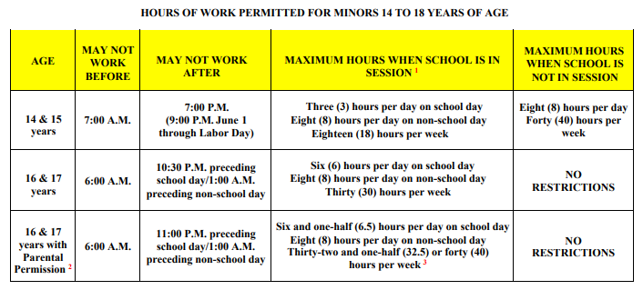
- Is there anyone else you think we should speak with?
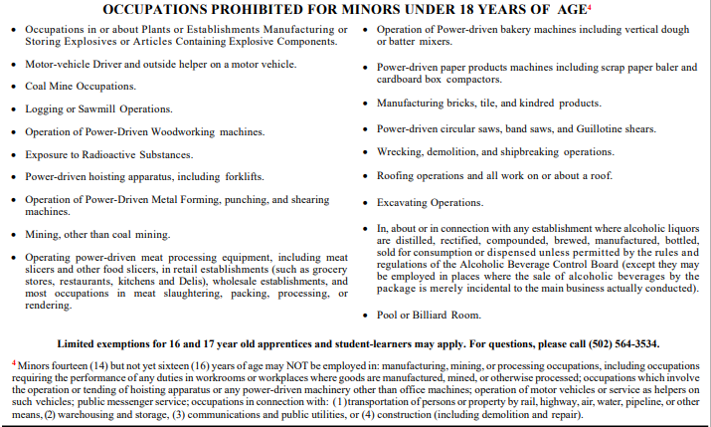

Adult Sex Trafficking
Adult’s name
DOB and Age
Date Screened
- Has anyone ever pressured you to touch someone or have any unwanted physical or sexual contact?
- Do you use any alias?
- What is your phone numbers?
- Has anyone ever taken a photo of you that you were uncomfortable with?
- Has anyone ever had you have sex for things of value? Example money, housing, food, gifts, or favors?
- If the sexual act was for money, did you get to keep all the money?
- Do you have a boy/girlfriend?
- Do they live with you?
- How old is your boy/girl friend?
- Has anyone where you worked ever taken your money for things, for example, for transportation or rent?
- Has anyone ever controlled the amount of food you could get?
- Has anyone ever controlled the amount of sleep you could have?
- Has a language barrier ever prevented you from seeking help when you needed it?
- Can you leave your job when you want to?
- Are you allowed to obtain medical care when needed?
- Has your communication ever been monitored or restricted?
- Have you ever been physically abused (shoved, slapped, strangled, scratched, punched, burned) by anyone.
- Were you ever sexually abused (sexually assault, unwanted touching, rape, sexual exploitation) by anyone?
- Did anyone introduce you to drugs?
- Would you consider yourself an addict?
- What happens if you don’t us drugs?
- What is the longest you can go without using?
- Are you ok right now?
- Has anyone else ever injected you with illegal narcotics such as heroin?
- Do you have a boy/girl friend?
- Do you support your boy / girlfriend performing sexual acts?
- If so are they an addict also?
- Do you live with you boy/girlfriend and where do you live?
- Has anyone ever withheld drugs from you to perform a sexual act?
- Can you describe the effects if you do not use drugs?
- Has anyone other than you posted nude or seminude pictures of you on the internet?
- Has anyone ever threatened you if you did not perform a sexual act?
- Has anyone ever physical assaulted you if you do not perform a sexual act.
- Have you ever witnessed anyone else being threatened or assaulted for not performing a sexual act.
- Do you owe money to anyone?
- Have you ever received profession assistance with your habit if you have one?
- Do you have any mental health issues? Have you ever self-medicated with other drugs to help your mental health?
- Has anyone exploited you used your mental health against you?
- If you have sexual ads on the internet, who posted the ads?
- If you have sexual ads on the internet, who took the pictures?
- If you have sexual ads on the internet, what internet sites do you use
- If you have sexual ads on the internet, what is the phone number used in the ads?
- If you have sexual ads on the internet, what do the ads cost?
- Is there anyone else do you think we should talk to?

Minor / Child Sex Trafficking
Date of screening__________________________
Name of Minor____________________________
Date of Birth and Age_______________________
About the minor
- How do you identify your gender? Female, Male, Genderqueer, Intersex, Transgender female, Transgender male, Transgender, other?
- What is your sexual orientation? Straight, Gay, Lesbian, Bisexual, Queer/questioning, Asexual?
- What is your race?
- Have you ever used other names or alias in person or online?
- What is your phone number?
- Have you used other phone numbers in the past?
- Have you ever used a APP for testing like Textnow or Burner Phone?
- Do you have children of your own, or are you or your partner pregnant?
School
- Are you in school?
- What is the highest level of education you finished?
- Are you currently in a GED program?
- How many times have you skipped school in the past 12 months?
- Where did you grow up?
- Where you born in the US?
If different from current location, how did you get here? Who brought you here?
- Are you US citizen or a lawful permanent resident?

Family Section
- Have you ever been in Foster Care?
- Are you currently in Foster Care?
- Describe your current Foster Care placement, Foster Parents (FP) unrelated, FP are relatives, group home?
- Total, how long have you been in Foster Care?
- Do you reside with family members?
- How is the relationship with the adults you live with?
- Do you have contact with your birth parents?
- What is the relationship like with your birth parents?
- Has anyone at home ever harmed you?

Housing
- Over the last month where did you sleep?
- How safe do you feel when you sleep there?
- Have you ever had to trade a sexual act for a place to sleep?

Running Away
- Have you ever run away from your parent or guardian’s home?
- Have you ever been kicked out of your home by your parents?
- If you have run away in the past 6 months, where did you stay or sleep most often?
- How safe do you feel sleeping there?
- How many times have you run away?
- How old were you when you ran away the first time?
- Why did you run away?
- What would keep you from running away?

Kicked out by parents
- If you were kicked out by your parents or guardian in the past six months where did you sleep?
- How safe did you feel sleeping there?
- How many time have you been kicked out of your home?
- How old were you the first time kicked out?
- Why did your parent or guardian kick you out?

Work
- Have you ever done any kind of work/other activity for something in return from an employer, relative, friend, and stranger? This could mean that you received money, food, housing, drugs, or anything else.
  - Work /other activity can be something like a server at a restaurant, working at a store, selling drugs, trading sex.
  - This could include doing it for someone even though you did not want to.
- Have you ever been unable to leave a place you worked or talked to people you wanted to talk to, even when you weren’t working, because the person you worked for threatened or controlled you?
- Did someone you worked for ever refuse to pay what they promised you and keep most of your money that you made?
- Were you ever physically beaten, slapped, hit, kicked, punched burned, or harmed in any way by someone you worked for?
- Did you ever feel emotionally abused by someone you worked for?
- Did someone you worked for ever ask, pressure, or force you to do something sexually that you did not feel comfortable doing?
- Were you ever forced to engage in sexual acts with family, friends, clients, or business associates for money or favors, by someone you work for?
- Have you ever traded sexual acts for food, clothing, money, shelter, favors, or other necessities for survival before you reached the age 18?
- In the past year have you ever traded sexual acts for food, clothing, money, shelter, favors, or other necessities for survival?
- How old were you the first time you traded sexual acts for food, clothing, money, shelter, favors, or other necessities for survival?

Internet
- Have you or someone else ever posted a nude or semi-nude photograph of you online?
- If so, was it in regards to a commercial sex ad?
- If it was a commercial sex ad, did you post the ad or did someone else?
- If it was someone else, was it a family member, boyfriend, pimp, friend?
- Did you get to keep all the money or did you have to share it?
- What was the money used for?
- What sites did you or someone post on?

Other Life Experiences
- Have you ever been arrested?
- Have you used illegal drugs in the past and are you currently using
- Have you ever tried to get help for your situation?
- What have you tried?

Traveling Sales Crews
Name
Date
DOB and age
Alias or other names used
Phone numbers
Previous phone numbers
Parent’s name and phone number?
- What is the name of the company, business, or non-profit you are selling merchandise for?
- Where is the company, business, or non-profit from?
- Who is the owner or manager and is he with you?
- Where do you reside or live?
- How long have you been away from home?
- Do you have your own transportation or does someone else drive?
- What are you selling and how much does it cost?
- Do you know what city and state you are in?
- Out of the cost of the product, how much money do you make?
- Do you know what the money is used for?
- To sell the items, do you have memorize a script?
- IS there printed material that you have to carry to sell the item?
- Do you know if the owner of the company is a non-profit or is it a business?
- Do you know what the difference is of a non-profit and a regular business?
- Where are you staying, if you’re from out of town?
- Do you have to pay for the room?
- Who pays for your room?
- How many people are sleep in the room?
- Where do you sleep in the room, bed, floor, bath tub?
- Who pays for your meals and snacks?
- Who pays for drinks if needed?
- What did you have for breakfast, lunch, and dinner for today and yesterday?
- If you do not have the money does someone pay for these items for you?
- Does this person keep record on how much you owe them?
- What would happen if you stop selling the item?
- Do you have a quota?
- What happens if you do not meet your quota?
- Have you ever been threatened or assaulted for not meeting quota?
- Did you pack your own bag, where is the bag, what did you pack?
  - Wintertime-coat, hat, gloves, long pants, etc.
  - Summertime-short pants, tee shirts, underwear, hat, etc.
- Do you have a phone or means to contact the boss when you’re out selling?
- Do you have a charging cord for the phone and do you have both with you?
- If you do not have a phone how do you contact the boss if you get hurt?
- Do your parents know where you are?
- Are you allowed to talk to any one back home or any one you wish to?
- Are you allowed to go home if you choose not to do this work?

Bibliography
Information compiled by Detective Rick Lynn

- Ohio Human Trafficking Task Force, Human Trafficking Screening Tool.
- Urban Institute, Pretesting a Human Trafficking Screening Tool in the Child Welfare and Runaway and Homeless Youth Systems.
- Human Trafficking Screening Tool (HTST) Instructions, Florida DJJ.
- Indiana Protection for Abused and Trafficked Humans Task Force, Human Trafficking Identification: Screening tool and report.
- Nevada Office of the Attorney General, Law Enforcement Screening Tool for victims of Human Trafficking.
- Vera Institute of Justice, Screening for Human Trafficking

