Instructions for Submission
of
COVID Vaccine Medical or Religious Waivers or Out of State COVID Immunization Records

Effective Sept 1, UofL Healthcare is requiring all trainees to be vaccinated for COVID or submit a medical or religious waiver. Below are instructions on how to submit documentation of medical or religious waivers or OUT OF STATE COVID vaccinations records. Please allow 5 days for Campus Health to process your records.

If you have been vaccinated in KENTUCKY you DO NOT NEED TO SUBMIT ANY DOCUMENTATION. We already have access to your immunization data through the Kentucky immunization registry.

IF YOU WERE VACCINATED OUT OF STATE:

- Have a copy of your immunization card in a PNG, JPG, GIF or PDF format ready.
- IF YOU WERE VACCINATED IN KENTUCKY, DO NOT SUBMIT ANY RECORDS.
- Go to https://louisvilleportal.pointnclick.com
- Click the “Student, Staff and Faculty” button at the top of the page.
- Microsoft login screen will open. Sign in using your ULINK ID@louisville.edu and associated password
- “Stay Signed In” screen will appear and click No.
- Confirm your identity by entering your date of birth and click proceed.
- You should now be on the main page of the Campus Health Patient Portal.
- Select Immunization Upload from the bottom of the menu (Step 1 below)
- Select Add Immunization Record bottom at top of screen (Step 2 below)
- Click Save (Step 3 below)
- Log out of the portal.

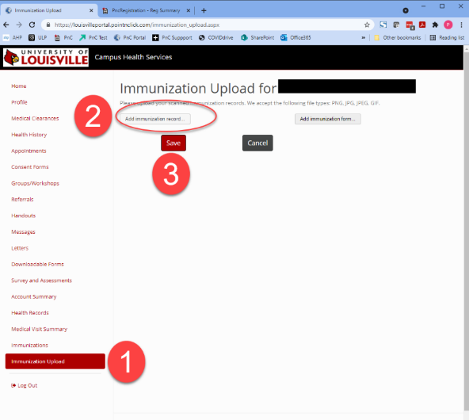

To download a copy of the medical or religious waiver for COVID vaccine:
- Go to https://louisvilleportal.pointnclick.com
- Click the “Student, Staff and Faculty” button at the top of the page.
- Microsoft login screen will open. Sign in using your ULINK ID@louisville.edu and associated password
- “Stay Signed In” screen will appear and click No.
- Confirm your identity by entering your date of birth and click proceed.
- You should now be on the main page of the Campus Health Patient Portal.
- Select “Downloadable Forms” from the menu on the left

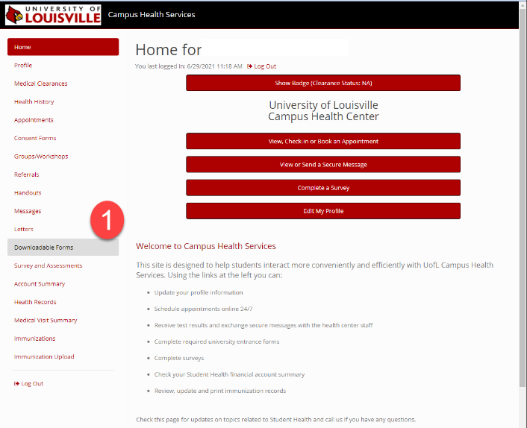

- From the available forms click the download button below the appropriate form (See image below)

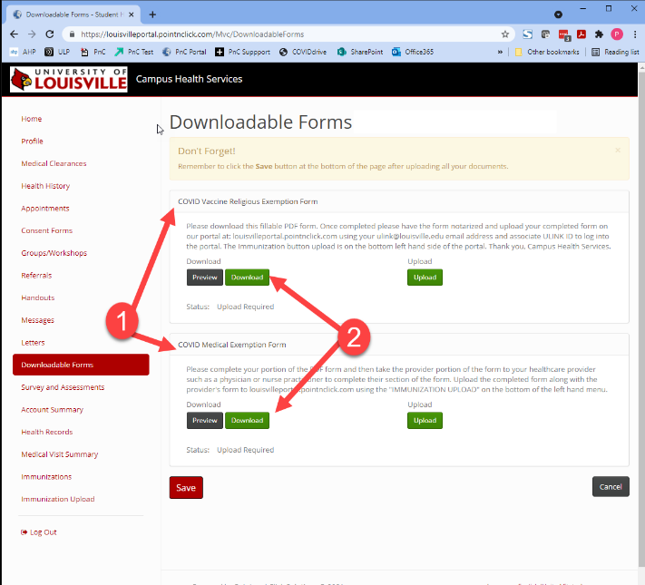

- After downloading the form, complete and sign the document. Medical waivers require a healthcare provider complete a separate statement that is included with the download.
If you are submitting a religious waiver, it must be notarized by a public notary before it can be uploaded.

To upload your completed waiver:

- Log into the patient portal as above.
- Click on Downloadable Forms again on the left-hand side of the screen
- Downloadable Forms screen appears (See below)
- Select the Upload button for the form you are submitting (Step 2)
- Once uploaded click Save (Step 3)
- Log out of the portal.

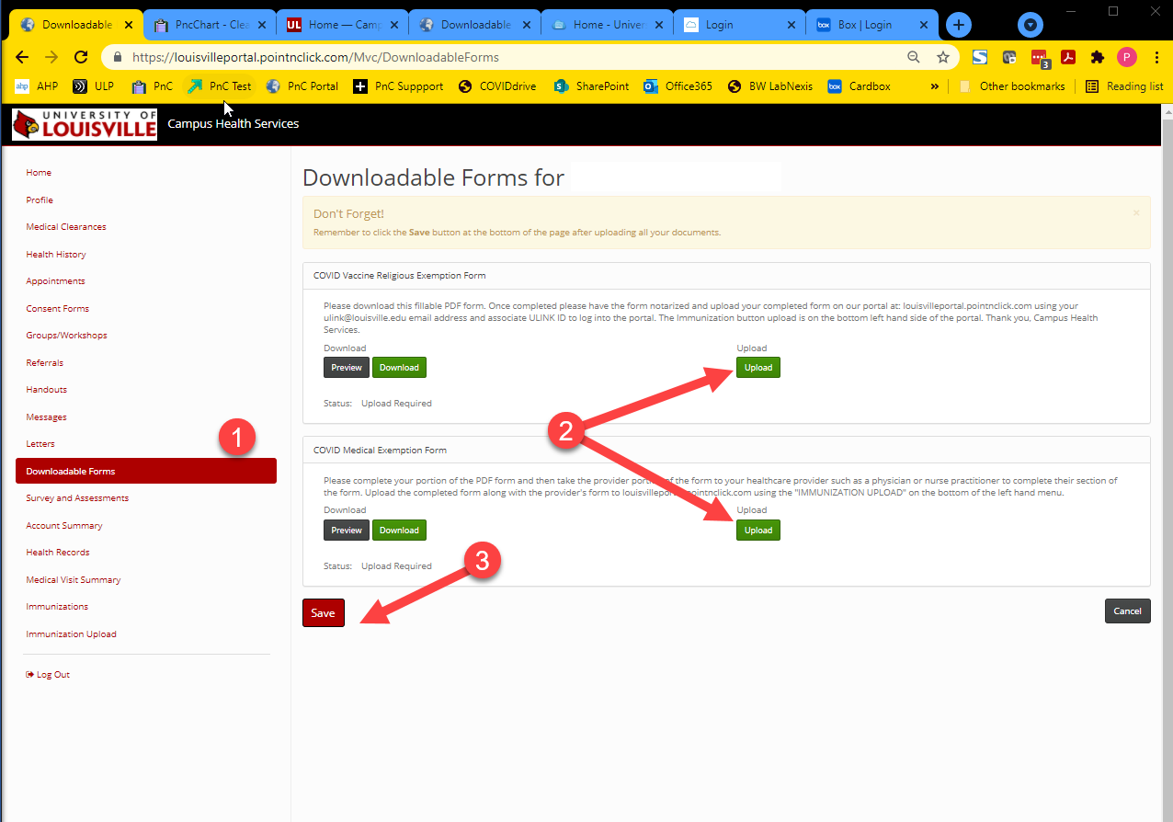

Thank you for your assistance. Please allow 5 days for Campus Health to process any records or waivers.

