**To Submit Your COVID Vaccination Records:**

1. Have a image of your COVID immunization record ready in a PNG, JPG, GIF or PDF format ready.
2. Go to [www.louisvilleportal.pointnclick.com](https://nam11.safelinks.protection.outlook.com/?url=http%3A%2F%2Fwww.louisvilleportal.pointnclick.com%2F&data=04%7C01%7Chlthoff%40louisville.edu%7C32182415c2db40a514db08d93c8fe0d2%7Cdd246e4a54344e158ae391ad9797b209%7C0%7C0%7C637607410923588390%7CUnknown%7CTWFpbGZsb3d8eyJWIjoiMC4wLjAwMDAiLCJQIjoiV2luMzIiLCJBTiI6Ik1haWwiLCJXVCI6Mn0%3D%7C1000&sdata=fB1mkdPHZFLvoVs%2FG9gMn4TEl%2FrhIOY0aeGtSqdCY38%3D&reserved=0)
3. Click the “Student, Staff and Faculty” button at the top of the page.
4. Microsoft login screen will open.  Sign in using your ULINK [ID@louisville.edu](mailto:ID@louisville.edu) and associated password
5. “Stay Signed In” screen will appear and click No.
6. Confirm your identity by entering your date of birth and click proceed.
7. You should now be on the main page of the Campus Health Patient Portal.
8. Select Immunization Upload from the bottom of the menu (Step 1 below)
9. Select Add Immunization Record bottom at top of screen (Step 2 below)
10. Click Save (Step 3 below)
11. Log out of the portal.

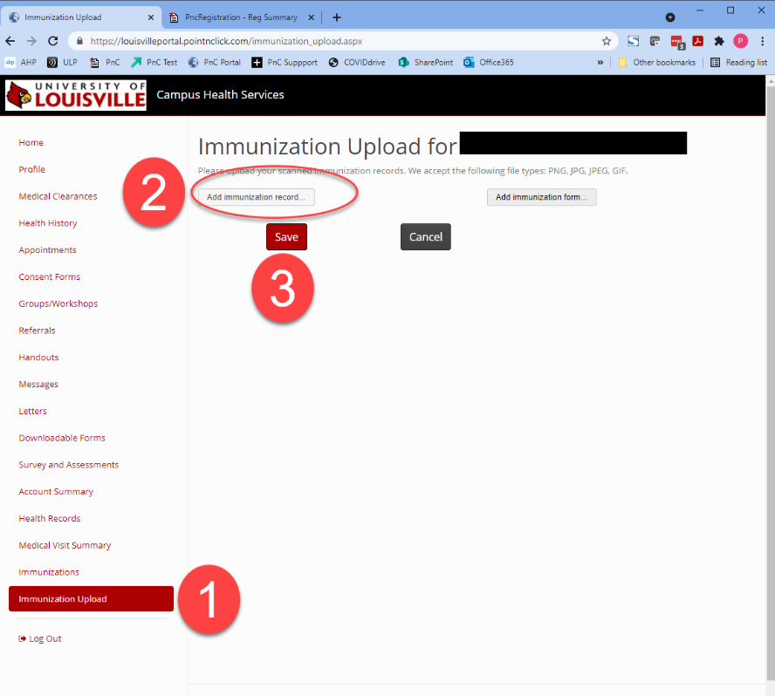

**To obtain a copy a medical or religious waiver form for COVID vaccine:**

1. Go to [www.louisvilleportal.pointnclick.com](https://nam11.safelinks.protection.outlook.com/?url=http%3A%2F%2Fwww.louisvilleportal.pointnclick.com%2F&data=04%7C01%7Chlthoff%40louisville.edu%7C32182415c2db40a514db08d93c8fe0d2%7Cdd246e4a54344e158ae391ad9797b209%7C0%7C0%7C637607410923588390%7CUnknown%7CTWFpbGZsb3d8eyJWIjoiMC4wLjAwMDAiLCJQIjoiV2luMzIiLCJBTiI6Ik1haWwiLCJXVCI6Mn0%3D%7C1000&sdata=fB1mkdPHZFLvoVs%2FG9gMn4TEl%2FrhIOY0aeGtSqdCY38%3D&reserved=0)
2. Click the “Student, Staff and Faculty” button at the top of the page.
3. Microsoft login screen will open.  Sign in using your ULINK [ID@louisville.edu](mailto:ID@louisville.edu) and associated password
4. “Stay Signed In” screen will appear and click No.
5. Confirm your identity by entering your date of birth and click proceed.
6. You should now be on the main page of the Campus Health Patient Portal.
7. Select “Downloadable Forms” from the menu on the left

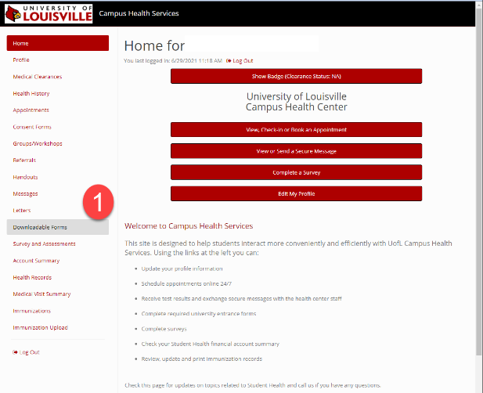

1. From the available forms click the download button below the appropriate form (See image below)

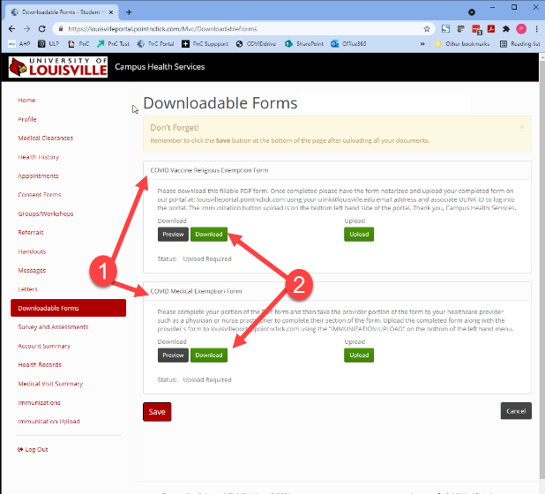

1. After downloading the form,  complete and sign the document.  Medical waivers require a healthcare provider complete a separate statement that is included with the download.

If you are submitting a religious waiver, it must be notarized by a public notary before it can be uploaded.

**See next page for instructions to upload waivers**

**To upload your completed waiver:**

1. Log into the patient portal as above.
2. Click on Immunization Upload at the bottom of the menu
3. Immunization Upload Screen will appear (See below)
4. Select the Upload Immunization Form button at the top of the page (Step 2)
5. Once uploaded click Save (Step 3)
6. Log out of the portal.

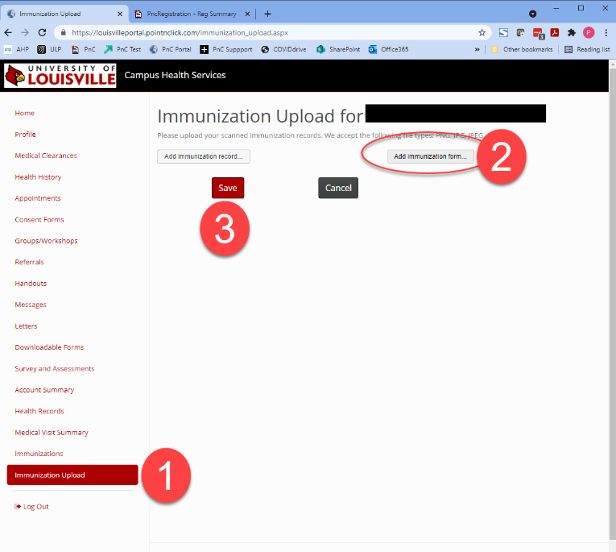

Thank you for your assistance.  Please allow 5 days for Campus Health to process any records or waivers.